Project Proposal

Our team will create a graph visualizing the average of the top leading causes of death in the United States and how they alternate since 1900-2015. The top 5 causes of death in our dataset are stroke, heart disease, influenza/pneumonia, cancer, and accidents. The axis will represent a timeline, and the Y-axis will represent the death rate of each cause of death.

Dataset link:

<https://data.cdc.gov/NCHS/NCHS-Age-adjusted-Death-Rates-for-Selected-Major-C/6rkc-nb2q/data>

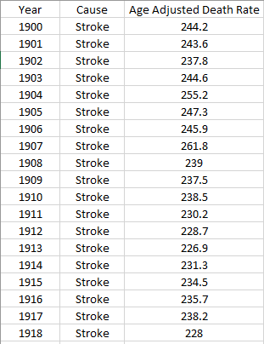

Inspiring Visualizations:

1)

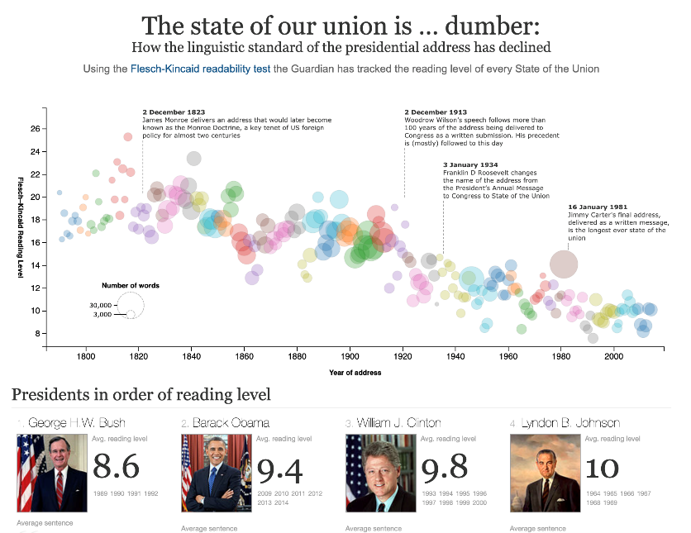

2)

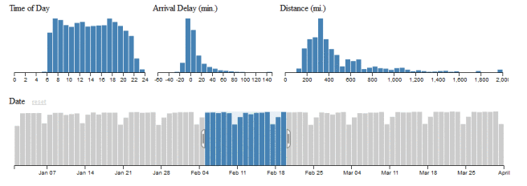

3)

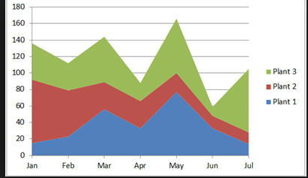

Dashboard Sketch:

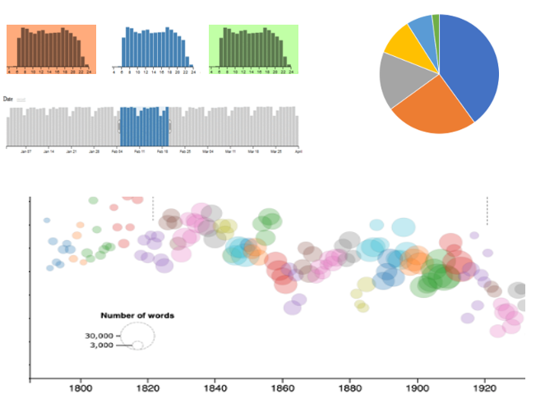

Github Repository:

https://github.com/Breyes1993/VisualProject.git