The National University of Science and Technology



Faculty of Engineering, Department of Electronic Engineering

Project Title | Automated Bank Entrance Security System
Student Number | N02125285W
Author | Ndlovu Brezhnev
Academic Supervisor | Eng. S. Nhema

Abstract

Bank-entrance interlocking booths, commonly called man-traps, are a mandatory access-control measure at financial institutions across Zimbabwe and the wider region, yet the units currently in the field remain largely passive: they isolate a visitor physically but offer no intelligent decision-making, no centralised remote visibility, no tamper-evident record of events, and no early warning of component failure. As a consequence banks remain exposed to daytime armed robbery, to operational downtime, and to compliance gaps against the supervisory expectations of the Reserve Bank of Zimbabwe.
This project presents the design and implementation of the Automated Bank Entrance Security System (ABESS), an embedded, IoT-enabled man-trap platform that augments the conventional two-door interlock with automated intelligence. The system pairs an ATmega328P real-time door co-processor with an ESP32 Wi-Fi controller that hosts a browser-accessible dashboard, streams on-site camera video, and runs on-device computer-vision inference built with the Edge Impulse framework to detect masked faces and visible weapons. Requirements were elicited through direct field engagement with bank-sector stakeholders during a year-long technical work placement, and the resulting needs were translated into a set of measurable design objectives.
The realised prototype delivers real-time monitoring of all four controlled doors, granular and emergency-mode door control, autonomous AI threat response gated by a confidence threshold, multi-category tamper-evident audit logging, authenticated operator access, occupancy counting, and resilient communication that continues to function during network disruption. Built entirely from low-cost, commercially available components and open-source software, the system demonstrates that the protective value of an expensive, imported, vision-assisted man-trap can be reproduced in a locally engineered, cloud-independent form that is maintainable by Zimbabwean technicians and aligned with national regulatory requirements.

Keywords: man-trap; access control; embedded systems; ESP32; ATmega328P; edge AI; weapon detection; bank security; Zimbabwe.

Abstract 2
Chapter 1 - Introduction 4
1.1 Background and Context 4
1.2 Description of the Interlocking Bank-Booth System 5
1.3 System Inputs, Outputs and Block Diagram 6
1.4 Significance of Bank-Booth Systems to Stakeholders 7
1.5 Problem Statement 8
1.5.1 Absence of automated threat response 8
1.5.2 Manual changing of operation modes 8
1.5.3 Lack of navigation assistance for customers 8
1.5.4 No reporting of component faults 9
1.6 Aim of the Project 9
1.7 Objectives 9
1.8 Deliverables Achieved 10
1.9 Relevance to Zimbabwe 11
1.10 Organisation of the Report 12
Chapter 2 – Literature review 13
Overview 13
2.1 Man-Trap and Interlocking Access-Control Architectures 13
2.2 Microcontroller-Based Door Control and Intrusion-Detection Systems 14
2.3 Embedded Web Servers and Real-Time Monitoring Dashboards 15
2.4 Occupancy Sensing and People Counting 16
2.5 Edge Machine Learning and On-Device Inference 17
2.6 Automatic Weapon Detection in Surveillance Imagery 18
2.7 Masked-Face and Face-Covering Detection 19
2.8 Synthesis and Identification of the Research Gap 20
Chapter 3 — System Design and Methodology 22
3.1 Design Overview 22
3.2 Hardware Circuit Design 26
Physical Components 26
Power Setup 26
Inputs to the Primary MCU 27
Locks and Signals 29
3.3 Data Circuit Design 31
Overview 31
Web Dashboards 35
Webserver 39
System Operational Mode Matrix & UART Command Processor 44
Core Booth Interlocking & Occupancy Tracking 46
3.4 Visual Circuit Design 48
AI Inference/ Runtime. 48
Model Training Methodology 50

Chapter 1 - Introduction

1.1 Background and Context
Controlling who is permitted to enter a building, and under what conditions, is one of the oldest concerns of physical security. In the banking sector this concern is acute, because a bank branch is a concentrated store of cash and a recurrent target of armed robbery. Over the past two decades the favoured engineering response in Zimbabwe, South Africa and many other countries has been the interlocking entrance booth, a regulated portal through which every customer must pass before reaching the banking hall, and again before leaving it.
An interlocking system is, at its essence, a form of access control. It is built around a small enclosed space bounded by two doors that are electronically coordinated so that they are never both released at the same time. When the branch is closed and no one is present, the booth simply sits fully locked, denying all movement in either direction. During trading hours it admits people one controlled passage at a time: a customer steps into the booth, the door behind them closes and locks, and only then is the inner door released to let them through. The same discipline governs the exit path. The purpose this serves is straightforward to state without recourse to jargon: it guarantees that only one verified person occupies the threshold at any moment, so that nobody can slip in unnoticed behind somebody who has been let through, and so that an entrance can be sealed instantly the moment something is wrong. In its strictest deployments the booth is integrated with additional verification methods before the inner door will open at all, for example a fingerprint reader or facial recognition at a data-centre or vault entrance, so that physical isolation is combined with positive identification of the individual.
The motivation for this project is rooted in direct field experience. During my fourth, work-placement, year I served as a technician at Radio Solutions, an electronic-security company that designs, installs and services alarm systems, CCTV systems, access-control systems and interlocking bank-booth systems at commercial scale. My work focused specifically on the bank-booth systems, where, under fortunate mentoring, I attended numerous service faults and took part in a major project to decommission and re-install six bank-booth installations across the southern regions of Zimbabwe. These included CABS Fife Street (commissioned through ITAS South Africa), the Steward — now TNCybertech — bank booth and the Econet Victoria Falls booth (both through Cherry-Tech South Africa), CBZ Belmont (through TurnStar South Africa), and the Nedbank installations in Bulawayo and Gweru (through ITAS). Because the booths at the different banks originated from different manufacturers, this exposure gave me a practical, cross-vendor understanding of how the hardware of these systems is interconnected and where, in practice, it tends to fail.
Crucially, attending faults and service projects also placed me in close working contact with the people who depend on these systems day to day. These stakeholders included branch and bank managers, the security guards who monitor the entrances, the regional security officers of the institutions, the bank clients who must use the booths, the auditors who review the security arrangements, and the technicians who maintain the equipment. Working alongside them made it possible to see not only what the systems do well, but also the recurring gaps between what the installed hardware provides and what these stakeholders actually need. It is from this vantage point that the present project takes its problem definition.

1.2 Description of the Interlocking Bank-Booth System
Before the limitations of the conventional installation can be examined, it is helpful to describe the system itself more fully. Physically, a bank-booth man-trap is a two-path structure. An entrance path takes a customer from the street into the banking hall through two doors in sequence, and an exit path returns them from the hall to the street through a further two doors. Each door is held shut by an electromagnetic lock and is monitored by a magnetic-contact sensor that reports to the microcontroller whether the door is open or closed. Motion within each booth is detected by a beam of IR sensor pairs that signals the presence of a person(s). A controller reads these inputs and decides, according to the security policy programmed into it, when each lock may be released.
The behaviour that customers experience as 'the booth' is therefore the visible expression of a small set of operating modes enforced by that controller. In the conventional Zimbabwean installation these modes are typically a premises-open mode that admits traffic in and out one person at a time; a premises-closed mode that keeps the entrance locked and permits only departures; an evacuation mode that unlocks every door so that the building can be cleared quickly in an emergency; and a tailgating-control behaviour that aims to admit a single person at a time. The criterion on which a door is opened depends entirely on the sophistication of the logic and the relays inside the controller, and in higher-security settings the controller is interfaced with external validation devices, such as fingerprint or facial-recognition units, that must be satisfied before a door is released.
The system developed in this project, named the Automated Bank Entrance Security System and presented to its users under the brand Connecta., retains this proven physical architecture while replacing the passive controller with a distributed, network-connected, intelligent one. The man-trap comprises two parallel paths — an entrance path (ENT.PATH) and an exit path (EXT.PATH) — each bounded by two electromagnetically locked doors. The four controlled doors are designated ENT.D1 (outside entrance), ENT.D2 (inside entrance), EXT.D3 (inside exit) and EXT.D4 (outside exit); each carries an electromagnetic lock (ENT.L1 to EXT.L4) and a magnetic-contact sensor (ENT.C1 to EXT.C4), and each booth path is watched by a passive-infrared motion sensor. Entry is permitted only when the first door is secured behind the visitor before the inner door is released, which is precisely what prevents tailgating and forced entry.
Control and intelligence are divided deliberately between two microcontrollers. An ATmega328P acts as a real-time door co-processor: it drives the mag-locks, debounces the magnetic contacts, services the motion-sensor interrupts and enforces the interlock sequence entirely in firmware, so that the booth continues to operate safely even if the rest of the system loses power or network connectivity. An ESP32 Wi-Fi microcontroller acts as the main controller and server: it hosts a browser-based dashboard over the bank's local network, streams video from an onboard camera, broadcasts state changes to every connected screen, stores audit logs in its own flash memory, and runs an on-device machine-learning model that inspects the camera frames for masked faces and visible weapons. The dashboard itself, served entirely from the ESP32, is organised into four working pages — MONITOR, CONTROL, FAULTS and AI CONTROL — through which authorised personnel observe the booth, command the doors, supervise component health and configure the automated threat response.

1.3 System Inputs, Outputs and Block Diagram
Viewed as an engineering system, the ABESS accepts a well-defined set of inputs and produces a corresponding set of outputs. The inputs are the four magnetic-contact door states, the four lock-feedback states, the two booth motion (PIR) signals, the live camera image frames, the result of the AI inference, the commands issued by an authenticated operator at the dashboard, and the operator credentials supplied at login. The outputs are the actuation signals that lock or unlock each of the four electromagnets, the real-time updates that animate the booth diagram and padlock icons on the dashboard, the live video stream, the timestamped audit-log entries and their downloadable files, the AI threat alerts with their on-screen bounding-box overlays, the operating-mode feedback returned to the operator, and the optional voice-navigation guidance played to customers in the booth. Figure 1.1 presents the top-level block diagram of the complete system, organised into the four layers through which information flows and explicitly marking the input and output sides of the system.
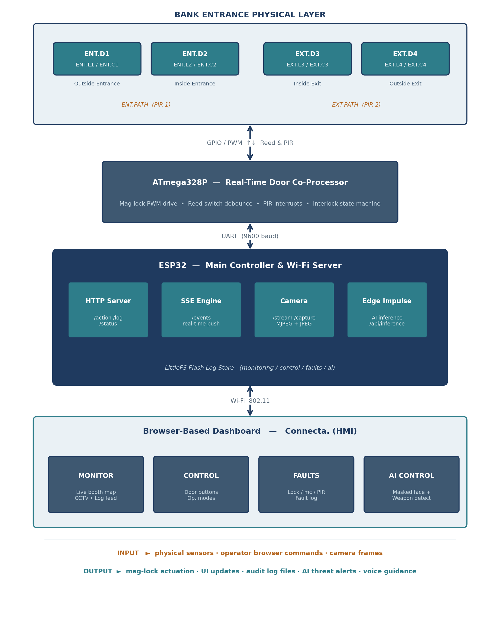
Figure 1.1 — Top-Level Block Diagram of the Automated Bank Entrance Security System (ABESS).
As the diagram shows, the physical layer feeds sensor inputs upward to the ATmega328P, which exchanges low-level control and feedback with the ESP32 over a serial link; the ESP32 in turn serves the dashboard to operators over Wi-Fi and returns their commands down the same chain to actuate the locks. The input side of the system is therefore the combination of physical sensors, operator browser commands and camera frames, while the output side is the combination of lock actuation, dashboard updates, log files, AI alerts and voice guidance.

1.4 Significance of Bank-Booth Systems to Stakeholders
Working with the stakeholders made clear why these systems are not optional and cannot simply be removed or swapped for a cheaper alternative such as a single guarded door. For the bank and its managers, the booth is the primary physical barrier that keeps an armed intruder from walking directly into the banking hall; it buys the critical seconds in which a threat can be contained at the threshold rather than confronted at the teller line. For the security guards and regional security officers, it is the controllable choke point through which the entire ingress and egress of the branch can be regulated and, if necessary, frozen. For the bank's clients, although the booth is occasionally an inconvenience, it is also their assurance that the premises they are entering are protected. For the auditors and for the Reserve Bank of Zimbabwe as supervisor, the presence of a functioning access-control portal is part of the evidence that the institution meets its obligation to maintain adequate physical security under the Banking Act and associated prudential guidelines.
Because the booth sits on the single most security-critical path in the building, it cannot be replaced by anything that offers less assurance, and any improvement must preserve the proven interlock while adding to it rather than weakening it. This constraint — that the physical protection must remain intact and fail-safe at all times — is a defining boundary condition of the present work, and it is the reason the project augments the conventional controller rather than discarding it.

1.5 Problem Statement
Despite their central protective role, the interlocking bank-booth systems encountered in the field share a set of recurring limitations. These limitations were not theorised; they were observed repeatedly while attending faults and while working with the stakeholders who must live with the systems' shortcomings. Modern banks face an increasing threat of robbery and unauthorised access, particularly during daytime operations, and the conventional booth — effective as a passive barrier — does little to meet that threat intelligently. Four specific gaps were identified, and together they constitute the problem this project sets out to address.

1.5.1 Absence of automated threat response
The conventional booth has no capacity to recognise a threat and act on it. Banks are most often robbed during the day precisely because the installed systems contain no mechanism to protect the premises automatically against an approaching robber. Whether a person presenting at the entrance is masked, or is carrying a visible weapon, makes no difference to the controller; the decision to deny entry rests entirely on a human operator who may be distracted, fatigued, absent, or simply too slow to react in the few seconds available. There is no autonomous, vision-based denial of entry.

1.5.2 Manual changing of operation modes
Each time the controller must be placed in a different operating mode, a manual key-switch is operated, which means human intervention is required at all times. In the scenarios where speed matters most — a robbery or a fire, in which an immediate switch to evacuation is essential — manual intervention is slow and inconvenient. The continual mechanical operation of key-switches also accelerates the wear of the circuitry, and reliance on a human introduces avoidable errors, such as tellers forgetting to switch the branch to its closed mode at the correct time, or closing it prematurely.

1.5.3 Lack of navigation assistance for customers
Most customers, and the elderly in particular, do not understand that the booth admits only one person at a time, and they frequently crowd onto the first door together. When this happens they become stuck inside, and in their attempts to force the second door open they inflict accelerated mechanical wear on the booth. They are often unaware that the first door must close before the second can open, and that further pass criteria apply. The traditional systems in the field provide no navigation help to guide customers through the correct sequence, so a security officer must intervene to explain the process, which interrupts the flow of traffic.

1.5.4 No reporting of component faults
The moving components of a traffic-control booth wear out and fail. When the hardware fails — a motion sensor that has fallen out of alignment, a door-open sensor that has detached, a lock or a battery that has degraded — the system may stop counting people correctly or fail to open a door at all. Traditional systems provide no facility to report these faults, so failures are discovered reactively, very often early in the morning when the branch is due to open and a door will not release. Because there is no health reporting, the operators of the system cannot schedule predictive maintenance and are instead forced to wait for an outright failure.
In summary, the conventional interlocking bank-booth provides sound passive isolation but no intelligence, no remote visibility, no automatic emergency response, no customer guidance, no tamper-evident record of events, and no early warning of failure. The problem this project addresses is the closing of these gaps in a manner that preserves the proven physical interlock and remains affordable, locally maintainable and operable without dependence on the cloud or continuous internet connectivity.

1.6 Aim of the Project
The aim of this project is to design and implement an automated, intelligent bank-entrance security system that augments the conventional interlocking man-trap with automated threat detection and denial of entry, automatic switching of operation modes, navigation assistance for customers, real-time remote monitoring and control, tamper-evident audit logging, and component-fault reporting for predictive maintenance — realised using low-cost, commercially available embedded hardware and open-source software so that it can be deployed, maintained and extended by local engineers without dependence on imported proprietary systems or continuous connectivity.

1.7 Objectives
To realise this aim, and to deliver against the four gaps identified above, the project pursues the following specific objectives. Each is expressed so that its achievement can be assessed against the delivered system.
- Real-time visual monitoring. To provide an animated, top-down view of the man-trap booth on which every door and lock state updates live, co-located with a live camera stream, so that an operator can confirm the physical and locked state of every door and the presence of anyone in the booth from any authorised device.
- Granular and emergency-mode door control. To provide individual, per-door control together with a set of operating modes — normal traffic, evacuate, exit-only, entrance-only and lock-all — including a one-press evacuation command, so that the booth can be reconfigured instantly and safely in response to operational and emergency conditions, replacing the manual key-switch.
- Automated AI threat detection and denial of entry. To integrate an on-device computer-vision model that detects masked faces and visible weapons from the booth camera and, above a defined confidence threshold, autonomously reconfigures the doors to deny entry or lock down the premises, providing the automated protection that conventional booths lack.
- Component-fault detection and predictive maintenance. To monitor the health of the locks, door-motion controllers and motion sensors, to flag degrading components with a warning state before they fail, and to allow operators to report faults, so that maintenance can be scheduled proactively rather than discovered through failure.
- Tamper-evident, multi-category audit logging. To record every door event, operator command, fault and AI detection as a timestamped entry attributable to an identified operator, stored on the controller itself and exportable for audit, so that the system produces the evidence required by the bank's auditors and the regulator.
- Authenticated operator access. To require authentication before any dashboard function is available and to attribute every command to the logged-in operator, so that only trained, authorised staff can interact with the system.
- Customer navigation assistance. To provide configurable voice or display guidance that helps customers, and the elderly in particular, traverse the booth in the correct sequence, reducing congestion, misuse and the mechanical wear caused by customers forcing the doors.
- Resilient, cloud-independent operation. To serve the entire interface, logic and storage from the embedded controller so that the system continues to monitor and protect the branch during internet outages, with a communication fallback that keeps the dashboard current under degraded network conditions.

1.8 Deliverables Achieved
The design and implementation reported in the chapters that follow have produced the following concrete deliverables, each of which maps directly to one or more of the objectives above:
- A distributed embedded control system comprising an ATmega328P real-time door co-processor and an ESP32 main controller, interfaced to four electromagnetic locks, four magnetic-contact sensors and two booth motion sensors, that enforces the man-trap interlock in firmware independently of the network.
- A browser-based monitoring and control dashboard served directly from the ESP32 under the Connecta. brand, with four functional pages (MONITOR, CONTROL, FAULTS and AI CONTROL), an authenticated login, a live animated booth schematic, an embedded MJPEG camera stream, and real-time updates delivered over Server-Sent Events with an automatic polling fallback.
- An on-device AI threat-detection subsystem built with the Edge Impulse framework, performing masked-face and weapon detection on the ESP32, gating its automated door responses on a confidence threshold and drawing detection bounding boxes on the dashboard canvas.
- A multi-category, timestamped audit-logging facility storing monitoring, control, fault and AI logs on the ESP32 flash memory, each entry attributable to an authenticated operator and exportable for offline audit review.
- A fault-monitoring and reporting panel that displays the health of locks, door-motion controllers and motion sensors with normal, warning and error states and supports operator-initiated fault reporting for predictive maintenance.
- Operator-configurable settings for single-person versus group traffic volume and for voice navigation assistance, addressing tailgating risk and customer guidance respectively.

1.9 Relevance to Zimbabwe
The project is shaped throughout by the Zimbabwean context in which it is intended to operate. Armed robbery at financial institutions remains a persistent threat, and a system that can detect a weapon or a masked individual and lock down the booth autonomously, before any human has reacted, addresses that threat in real time rather than merely recording it for later review. Zimbabwean branches handle both Zimbabwe Gold (ZiG) and United States Dollar transactions, which makes them high-value targets and reinforces the case for the man-trap's physical isolation as a standard of protection. The system also supports the bank in demonstrating compliance with the supervisory expectations of the Reserve Bank of Zimbabwe and with the broader legal framework governing physical security, electronic records and emergency egress.
Equally important are the engineering and infrastructural realities of the country. Proprietary imported security systems carry high foreign-currency costs, ongoing licence fees and a dependence on foreign technical support; by building the ABESS from low-cost microcontrollers and open-source frameworks, the project keeps the system within local financial and technical reach and allows Zimbabwean engineers to service and extend it. Because the embedded server, the control logic and the audit log all reside on the device itself, the system continues to protect the branch during the internet and power interruptions that are a routine feature of the local environment, treating network connectivity as an enhancement rather than a prerequisite.

1.10 Organisation of the Report
The remainder of this report is organised as follows. Chapter 2 reviews the existing body of research and engineering practice surrounding the principal subsystems of the ABESS — the man-trap interlock, microcontroller-based door control, embedded web servers and monitoring dashboards, occupancy sensing, on-device machine learning, and weapon and masked-face detection — and from this review identifies the precise gap that the project fills. Chapter 3 presents the detailed system design and methodology, documenting the distributed two-microcontroller architecture, the dashboard software, the AI inference pipeline and the engineering rationale for each design decision. The subsequent chapters present the results, their discussion and the conclusions drawn, together with recommendations for further work. The links between the chapters are stated at their boundaries so that the line of reasoning from problem to solution can be followed throughout.

Chapter 2 – Literature review

Overview
This chapter surveys the body of existing research and engineering practice that surrounds the principal subsystems of the Automated Bank Entrance Security System (ABESS). The review is organised around the major technological pillars on which the system is built: the man-trap interlocking access-control architecture, microcontroller-based door and intrusion control, embedded web servers and real-time monitoring dashboards, occupancy sensing, on-device (edge) machine-learning inference, automatic weapon detection, and masked-face detection. For each pillar, representative works are examined critically rather than merely summarised: their methods and hardware are described, their reported strengths are acknowledged, and their limitations are exposed. Particular attention is paid to studies originating from developing-country contexts, since the ABESS is conceived for the Zimbabwean banking environment with its attendant constraints of foreign-currency scarcity, intermittent power and unreliable connectivity. The chapter closes by drawing these threads together to identify the gap that the ABESS is designed to fill, and to show how the conclusions reached in the literature have informed the specific design decisions documented in Chapter 3.

2.1 Man-Trap and Interlocking Access-Control Architectures
The man-trap, also referred to in the security literature as a security vestibule, sally port, access-control portal or airlock, is a long-established physical-security construct comprising a small enclosed space bounded by two sets of interlocking doors, arranged such that the first door must close and lock before the second may be released [1]. The defining purpose of this arrangement is the prevention of tailgating and piggybacking, the two attack patterns in which an unauthorised person follows an authorised user through a single door release [1]. Historically, man-traps were deployed in military, correctional and high-security installations and were supervised manually by a guard who locked and unlocked each door in sequence, often aided by an intercom and a remote camera [1]. While effective, the manual approach is labour-intensive and its reliability degrades with operator fatigue, which motivated the progressive automation of the interlock logic.
Contemporary commercial man-trap systems automate the door-sequencing logic using Programmable Logic Controllers (PLCs) that manage the interlocks, authentication, alarms and fail-safe conditions, and these installations are typically backed by uninterruptible power supplies to maintain security during outages [2]. More advanced products augment the basic two-door interlock with a single-person detection subsystem; the Newton Security T-DAR system, for example, uses ceiling-mounted stereo-vision cameras and tracking algorithms to confirm that only one human form is present within the vestibule before the inner door is released, thereby blocking tailgating with greater certainty than break-beam or pressure-mat alternatives [3]. These systems represent the current state of the art and demonstrate the value of fusing computer vision with door-interlock control. However, they are proprietary, expensive, and engineered for the data-centre, airport and government markets of the developed world; their cost structure, dependence on vendor support, and reliance on specialised stereo-camera hardware place them beyond the practical reach of a typical Zimbabwean bank branch. This observation directly motivates the ABESS design philosophy of reproducing the security value of an automated, vision-assisted man-trap using low-cost, locally maintainable embedded hardware and open-source software.

2.2 Microcontroller-Based Door Control and Intrusion-Detection Systems
A substantial body of work addresses the automation of door access and intrusion detection using low-cost microcontrollers, and this literature is especially rich in African and other developing-country contexts where the deterrence of burglary and armed robbery is an acute concern. The recurring architecture couples a microcontroller to passive infra-red (PIR) motion sensors, magnetic-contact or reed switches, an actuator (an electric strike, solenoid or electromagnetic lock) and an alerting channel.
Owen and colleagues designed a real-time intrusion-detection system built around an ATmega32 microcontroller, a passive infra-red sensor, a SIM900a GSM modem, a liquid-crystal display and a buzzer [4]. The PIR sensor continuously monitors a defined perimeter and signals the microcontroller, which raises a local alarm and transmits an SMS alert to a pre-programmed mobile number when an intrusion is confirmed. A noteworthy design feature is a thirty-second confirmation window after the initial trigger, during which the signal must persist before an alarm is raised; this is a deliberate measure to suppress false positives from transient movement [4]. The system is praised for its low power draw and the value of real-time SMS notification, and it is explicitly framed as a response to the rising rates of theft and armed robbery in Nigeria. Its principal limitations, however, are that it is purely reactive and notification-based: it detects and reports an intrusion but does nothing to physically contain the intruder, it offers no remote visual verification, and it maintains no tamper-evident record of events for later audit. These gaps are precisely the deficiencies that an integrated, logging, man-trap system seeks to close.
Focusing more specifically on the banking environment, a number of authors have proposed GSM-based bank-vault security systems. One representative design integrates an Arduino microcontroller with four sensor types — sound, motion, laser and gas — together with an IP camera and a GSM module, so that the activation of any sensor automatically transmits a warning SMS to a dedicated number while sounding a local alarm, and the IP camera permits remote visual inspection of the vault room [5]. The use of multiple complementary sensors improves detection robustness, and the inclusion of a camera for remote monitoring is a clear advance over notification-only designs. Nevertheless, the system remains oriented towards the vault rather than the entrance, it is alarm-centric rather than access-controlling, and it does not implement the interlocking door logic needed to regulate who may physically enter the banking hall. The ABESS adopts the multi-sensor and remote-camera principles validated by such work but relocates the point of control to the entrance vestibule and adds active door actuation.
At the level of access authorisation itself, RFID and keypad door systems are widely reported. An ESP32-based access-control implementation combining an RC522 RFID reader, a relay-driven electric lock and a PHP/MySQL back-end illustrates the typical pattern: a scanned badge UID is checked against a database, the relay releases the lock only on a GRANTED decision, and every access attempt is written to a log accessible through a web dashboard with administrator authentication [6]. The explicit emphasis on access logging and a browser-based management interface in this work mirrors two of the ABESS objectives — namely tamper-evident audit logging and an authenticated dashboard — and confirms that database-backed logging of every access decision is regarded in the literature as essential to a credible security system. The ABESS extends this idea from a single logged door to four interlocking doors whose state, mode and operator commands are all logged in separate audit streams stored on the controller's own flash memory.

2.3 Embedded Web Servers and Real-Time Monitoring Dashboards
The ESP32 system-on-chip has become the de facto platform for low-cost embedded web servers because it integrates a dual-core Xtensa processor, Wi-Fi and Bluetooth connectivity, ample memory and excellent peripheral support at a very low unit cost, and it is well documented as functioning directly as a web server using Wi-Fi communication [7]. In a detailed treatment of an ESP32-based home-monitoring and security system, the authors exploit the dual-core architecture so that one core handles data acquisition while the other manages communication, and the device both detects intruders — triggering an alarm and capturing camera images for transmission to the owner — and serves sensor data to a web interface [7]. This dual-role pattern, in which a single inexpensive module simultaneously performs real-time sensing and hosts a browser-accessible interface, is exactly the architecture adopted for the ABESS, in which the ESP32 hosts the dashboard, streams camera video, broadcasts state changes and stores logs without any dependence on an external server or cloud service.
At a larger scale, the design of web-based supervisory control and data acquisition (SCADA) systems offers important lessons in real-time human-machine interface design. An IoT-based industrial SCADA system reported by its authors as a complete, self-built supervisory platform demonstrates the value of an event-driven update model: when a new event occurs in the server-side program it is broadcast to all related clients, giving every connected browser a real-time view of the monitored nodes, and the responsive web design supports operator devices of differing screen sizes [8]. The architectural insight that state changes should be pushed to clients as events occur, rather than retrieved only by repeated client-initiated polling, underpins the ABESS decision to use Server-Sent Events as the primary channel for propagating door and occupancy state to every connected dashboard. The same literature also highlights, by contrast, the cost and complexity of full SCADA suites and their frequent dependence on continuous connectivity and cloud back-ends — constraints that the ABESS deliberately avoids by serving its entire interface from the embedded controller itself, so that monitoring continues during internet outages.
Comparable IoT monitoring architectures appear in the energy-management literature. Kurniawan and colleagues present an IoT-based system that monitors solar-plant performance and automates power-source switching through an automatic transfer switch using a NodeMCU ESP32 microcontroller and voltage and current sensors, transmitting the collected data to a database server and visualising it in real time on an Android application [9]. The system is reported to achieve full functionality during trials with a reliable data-refresh rate, and its advantages of real-time remote monitoring and reduced manual intervention are clear. Its authors candidly note, however, that the design depends on a stable internet connection for data synchronisation and that its scalability to larger configurations may require further adjustment [9]. This honest acknowledgement of internet dependence as a vulnerability reinforces a central ABESS design choice: because a bank's physical security cannot be allowed to fail when connectivity does, the ABESS keeps its server, logic and storage entirely local and treats network access as an enhancement rather than a prerequisite.

2.4 Occupancy Sensing and People Counting
Accurate counting of people entering and leaving a controlled space is fundamental both to occupancy-based control and to evacuation verification. Passive infra-red sensors are the most widely adopted technology for this purpose owing to their low cost, low power consumption and non-intrusive nature [10]. A comprehensive review of PIR-based occupancy monitoring in smart buildings distinguishes binary-based from signal-based detection methods and surveys door-monitoring techniques in which sensors placed at a doorway count individuals as they pass; it also documents the well-known weakness of conventional PIR sensors in failing to register stationary occupants, and reports approaches in which the sequence in which an inner and an outer sensor are triggered is used to infer the direction of travel and thereby maintain a running count [10].
A concrete realisation of this principle is the building-occupancy monitor described by Abdallah and colleagues, which uses two HC-SR501 PIR sensors and an Arduino microcontroller to distinguish entry from exit events and maintain a real-time count of occupants, validated both in Proteus simulation and in hardware and reported to achieve an occupancy-detection accuracy of approximately 89 per cent at a fraction of the cost of camera-based alternatives [11]. The authors note that the dual-sensor, single-microcontroller arrangement scales naturally to multiple entrances, each requiring only its own pair of sensors [11]. The relevance to the ABESS is direct: the system likewise derives its entry, exit and clients-inside counters from booth PIR events correlated with magnetic-contact transitions. The literature's documented limitation — that a single PIR cannot reliably resolve simultaneous multiple occupancy — also explains and justifies the ABESS design decision to pair occupancy counting with a configurable single-person traffic mode, so that the man-trap can be constrained to admit one person at a time precisely when counting accuracy and anti-tailgating assurance matter most.

2.5 Edge Machine Learning and On-Device Inference
The migration of machine-learning inference from the cloud onto resource-constrained microcontrollers — the field known as Tiny Machine Learning, or TinyML — is the enabling technology behind the ABESS threat-detection subsystem. TinyML allows data to be processed locally on the device without transmission to the cloud, which preserves privacy, removes network latency and permits inference on devices with very limited memory and processing power [12]. The dominant deployment toolchain in this space is Edge Impulse, described by Hymel and colleagues as a cloud-based machine-learning operations (MLOps) platform that streamlines the TinyML design cycle by managing datasets, feature extraction (DSP), neural-network training and the generation of an optimised, portable C++ inference library for a wide range of embedded targets [12]. The platform was created specifically to overcome the fragmented software stacks and heterogeneous hardware that previously made embedded ML difficult and unportable, and by late 2022 it already hosted over 118,000 projects from more than 50,000 developers [12]. The ABESS uses precisely this pipeline; Edge Impulse was selected because it encapsulates the mathematical complexity of inference deployment and emits an Arduino-compatible library that integrates directly with the ESP32 firmware, allowing development effort to be concentrated on system integration rather than low-level model implementation.
Underlying the object-detection capability is the MobileNetV2 architecture of Sandler and colleagues, which introduced an inverted-residual structure with linear bottlenecks and lightweight depth-wise separable convolutions to deliver strong accuracy at a small fraction of the computational cost of conventional convolutional networks, making it well suited to mobile and embedded vision [13]. Edge Impulse's FOMO (Faster Objects, More Objects) algorithm builds on this MobileNetV2 backbone to perform object detection — producing object locations rather than mere whole-image labels — on general-purpose microcontrollers with very limited on-board resources, and it has been reported to run dramatically faster than conventional detectors such as MobileNet-SSD on such platforms [14]. The choice of FOMO for the ABESS masked-face and weapon detectors is therefore well grounded in the literature: it is the architecture that makes bounding-box detection feasible on the ESP32, and its bounding-box output is what permits the dashboard to highlight a detected threat on the live camera canvas rather than merely flagging that something was seen.
The practical effectiveness of this class of edge models is further confirmed by recent work on energy-efficient object detection for low-power edge-AI systems, in which a MobileNetV2 model is quantised from 32-bit floating point to 8-bit integers using TensorFlow Lite Micro, substantially reducing model size and memory footprint and increasing inference speed without a significant loss of performance, so that deep-learning capability can be brought to constrained microcontroller units [15]. This validated quantisation workflow is the same one the ABESS relies upon: its models are exported as INT8-quantised TensorFlow Lite graphs through the Edge Impulse EON compiler, and it is precisely this reduction in feature-vector size and peak RAM — achieved in the ABESS partly by adopting a grayscale rather than RGB input — that makes continuous on-device inference tractable on the ESP32 alongside the web server and camera-streaming workloads.

2.6 Automatic Weapon Detection in Surveillance Imagery
The autonomous detection of firearms in video is one of the most actively researched problems in intelligent surveillance, and it is central to the ABESS objective of detecting visible weapons at the bank entrance. The seminal contribution is that of Olmos, Tabik and Herrera, who framed automatic handgun detection in video as a problem to be solved with deep convolutional neural networks, training a Faster R-CNN detector on a purpose-built dataset of handgun images and introducing an alarm-activation metric to evaluate the system as a practical alert mechanism rather than as a frame-by-frame classifier [16]. Their work established that real-time automatic firearm detection from ordinary surveillance video is achievable and that purpose-collected training data is decisive for performance. It also exposed the field's central difficulty: minimising false positives while preserving the recall needed for a credible security alarm [16]. This tension between false positives and recall recurs throughout the weapon-detection literature and directly shapes the ABESS use of a confidence threshold to gate automated responses.
Subsequent research has pursued false-positive reduction through richer contextual cues. Ruiz-Santaquiteria and colleagues showed that combining human-pose information with weapon appearance improves detection in realistic, dynamic scenes, reporting that a RetinaNet detector with a ResNet-50 backbone reached an average precision of 96.36 per cent and a recall of 97.23 per cent, while a YOLOv3 model trained on data enriched with pose information achieved the best precision and F1-score, expressly because encoding the way a handgun is held in the hand suppresses spurious detections [17]. The clear message of this and related studies is that detector accuracy is governed at least as much by the composition and contextual richness of the training dataset as by the choice of network architecture. This insight is reflected in the deliberate, security-focused dataset-construction methodology adopted for the ABESS detectors, in which confounding background features are explicitly added to the negative class to suppress false positives.
Of particular relevance to the resource constraints of the ABESS is the work on weapon detection at the network edge. A deep-learning framework for handgun and knife detection from indoor video-surveillance cameras, designed explicitly from an edge-computing perspective, addresses the twin challenges that weapons occupy a very small portion of the camera's field of view and that real-time feedback is required even on low-cost edge devices; the authors employ a first convolutional network to detect people and use it to guide a second network that searches for handguns and knives only within the relevant image regions [18]. This region-focusing strategy — concentrating scarce computation on the parts of the frame where a threat is plausible — is the same economy of attention that allows the ABESS to perform meaningful inference on the ESP32 within a bounded time budget, and the indoor, close-range deployment scenario it targets closely matches the controlled geometry of a man-trap booth in which a subject is presented to the camera at a known distance and orientation.

2.7 Masked-Face and Face-Covering Detection
The detection of face coverings has been studied intensively, although the bulk of the literature is framed around public-health compliance during the COVID-19 pandemic rather than around security. Loey and others, and many subsequent authors, have demonstrated real-time facemask detection using the MobileNetV2 architecture as a transfer-learning backbone, achieving training and test accuracies of around 99 per cent and outperforming heavier networks such as ResNet-50, DenseNet and VGG-16 in the joint consideration of accuracy and training time, with the trained models deployable at the network edge for real-time operation [19]. A representative two-stage pipeline first detects and tracks faces using classical computer-vision methods and then classifies each detected facial region with a MobileNetV2 transfer-learning model, reporting validation accuracy approaching 99.8 per cent and demonstrating effective multi-target personnel surveillance [20]. These works robustly establish that lightweight MobileNet-family models are an effective and deployable basis for detecting whether a face is covered.
It is essential, however, to recognise a fundamental difference in objective between this literature and the ABESS. The pandemic-era systems are designed to identify the absence of a mask in order to enforce mask-wearing, treating a covered face as the compliant, desirable state. The ABESS inverts this entirely: a covered face — specifically a balaclava or a full motorcycle helmet that defeats identification — is treated as a threat indicator, while a person wearing an ordinary surgical or cloth medical mask must be regarded as a legitimate customer and must not trigger a response. The literature's near-universal conflation of all face coverings into a single 'masked' class is therefore unsuitable for the banking-security application and would, if adopted directly, generate an unacceptable false-positive rate against innocent mask-wearing customers. This gap is the reason the ABESS defines its positive 'masked face' class narrowly to include only security-relevant coverings and deliberately places surgical and medical masks in the negative class, a design decision grounded directly in the recognition that the existing face-mask-detection literature solves a different and, for this purpose, inverted problem.
Finally, the broader review literature on lightweight face-mask detection for real-time edge environments confirms that the MobileNet family remains the most widely adopted backbone in this domain precisely because of its balance between representational power and computational cost, and that MobileNetV2-based detectors are repeatedly chosen for deployment-oriented implementations on constrained hardware [21]. This consensus lends further support to the ABESS choice of a MobileNetV2-derived FOMO model for its face-covering detector, while the security-specific reframing of the detection objective described above constitutes the system's distinct contribution relative to the existing body of work.

2.8 Synthesis and Identification of the Research Gap
Taken together, the works reviewed in this chapter demonstrate that each individual capability required by the ABESS has a sound foundation in the existing literature. The man-trap interlock is a mature physical-security concept, now automated commercially with PLCs and, in its most advanced form, with stereo-vision single-person detection [1]–[3]. Microcontroller-based door control, intrusion sensing and access logging are extensively documented, particularly in African contexts where they respond to high rates of theft and armed robbery [4]–[6]. The ESP32 is well established as a capable embedded web server, and event-driven dashboards drawn from the SCADA and IoT-monitoring literature show how operator interfaces can be updated in real time [7]–[9]. PIR-based people counting provides a validated, low-cost basis for occupancy tracking and evacuation verification [10], [11]. TinyML toolchains, the MobileNetV2 architecture and the FOMO algorithm make on-device object detection feasible on inexpensive microcontrollers [12]–[15], and a deep and active literature on weapon detection and face-covering detection establishes both the achievability of these tasks and the central importance of dataset composition and false-positive control [16]–[21].
What the literature does not provide, however, is a single, cohesive system that unifies these capabilities into an automated, vision-assisted bank entrance — one that closes the interlocking man-trap loop, detects masked and armed threats on the device itself, reconfigures the doors autonomously in response, exposes the whole through an authenticated real-time dashboard, and records every event in a tamper-evident audit trail, all on commodity hardware that continues to function without the cloud or the internet. The advanced man-trap products that approach this vision are proprietary, costly and dependent on vendor support; the academic prototypes that are affordable and locally reproducible each address only a fragment of the problem — they alert but do not contain, they control a door but do not see, or they see but only to enforce a public-health rule rather than to interdict a threat. Moreover, the recurring and explicit acknowledgement across the reviewed works that internet dependence is a liability [9], that false positives undermine credibility [16], [17], and that dataset composition determines real-world performance [17], translates directly into the ABESS design decisions documented in Chapter 3: the local, cloud-independent embedded server architecture; the confidence threshold gating automated door responses; the security-specific narrowing of the masked-face class with surgical masks excluded; and the deliberate addition of confounding background features to the training data.
It is within this gap that the present research is positioned. The Automated Bank Entrance Security System integrates an automated four-door man-trap, an ATmega328P real-time door controller, an ESP32 embedded web server and AI host, on-device masked-face and weapon detection built with Edge Impulse and a FOMO MobileNetV2 model, PIR-based occupancy tracking, an authenticated real-time dashboard, and multi-category tamper-evident logging — assembled from low-cost, commercially available components and open-source frameworks so that it can be deployed, maintained and extended by local engineers without dependence on imported proprietary systems or continuous connectivity. The detailed design and methodology by which these subsystems are realised, and the engineering rationale for each design decision, are presented in the chapter that follows.

Chapter 3 — System Design and Methodology

3.1 Design Overview

Identified Gaps This Design Addresses
Conventional bank entrance vestibules are passive structures: they isolate a visitor physically but provide no automated intelligence about who is entering, no real-time remote visibility for security staff, and no tamper-evident audit record. Existing proprietary systems that address these gaps carry high import costs, foreign licence fees, and dependence on external technical support — a significant constraint in Zimbabwe's foreign-currency-scarce environment. Four specific gaps were identified:

- No automated threat response — a guard must manually observe and react to a masked or armed individual entering the booth.
- No centralised remote monitoring — security staff cannot see live door states or occupancy counters without being physically present.
- No tamper-evident audit trail — no timestamped record of who entered, under what mode, or what commands were issued.
- No operator-configurable emergency modes — transitioning between Normal, Evacuation, Lockdown, and Bank-Closed states requires manual key-switch intervention.

This project serves as a solution with a focus on digital automation; a locally engineered addition that closes all four gaps using commercially available embedded hardware and open-source frameworks. The system design lays out as in the diagram.
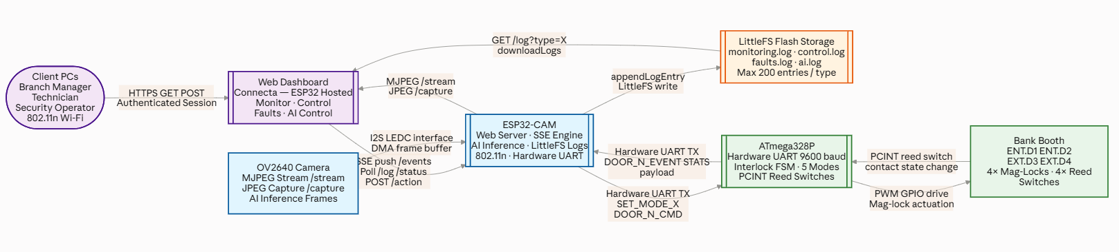

Walkthrough Path A: Manual Control Override via Browser Dashboard
- User Action: A bank branch manager logs into the dashboard and clicks a button on the Control Page to manually toggle a door or change the system's global state (e.g., forcing an emergency evacuation.
- Browser UI to Network Layer: The dashboard serialises the manager's configuration into a compact JSON payload. It executes an asynchronous HTTP POST request to the network endpoint POST /action.
- ESP32-CAM Web Endpoint Hook: The asynchronous Port 80 server worker intercepts the incoming TCP socket request. It passes the JSON body directly to the local parsing function processActionPost(const String& body).
- ESP32 Memory & Logging Registration: The ESP32 parses the action token. It immediately logs the event by calling appendLogEntry(LOG_CONTROL, action + " received"), which writes a timestamped entry into the /control.log file on the internal LittleFS partition.
- Inter-MCU Cross-Chip Transmission: To propagate this change to the physical hardware, the ESP32 invokes applyOperationMode and transmits an explicit ASCII string token out of its hardware TX pin via Serial1 (or Serial2) at 9600 baud (e.g., sending SET_MODE_EVAC\r\n).
- ATmega328P Central Dispatch Parsing: The ATmega handles the incoming string buffer in its runtime execution frame through processIncomingCommand(const String &cmd). It matches the string token and shifts its internal currentMode state variable to MODE_EVACUATION.
- Physical Actuation: The ATmega immediately drops the execution loop of the normal core interlock state machine. It calls updateSystemLEDs(), which instantly modifies its GPIO digital output pins via PWM-driven relays, cutting power to all four electromagnetic mag-locks. The doors swing open freely to comply with emergency egress codes.
- Live State Synchronisation: The ATmega transmits a hardware acknowledgement payload back across the RX line to the ESP32. The ESP32 receives the snapshot, updates its status cache, and executes broadcastSSE("status", buildStatusPayload()). This instantly pushes the updated door states out to all connected browser UIs over a persistent Server-Sent Events (SSE) /events channel, changing the padlock icon graphics on the manager's screen in real time.

Walkthrough Path B: Automated Machine Vision Threat Mitigation
- Image Acquisition Layer: The hardware system is configured with ai_system_enabled == true. The onboard OV2640 camera continuous-capture pipeline pipes data into the ESP32's internal registers. Every 500 milliseconds, a dedicated background FreeRTOS task awakens to drive the inference pipeline.
- DSP Pre-Processing Pipeline: The processor allocates stack heap memory, grabs the raw image frame buffer via esp_camera_fb_get, and runs format translation using fmt2rgb888. The image profile data is downsampled and normalised to match the specific Int8 input tensor dimensions required by the Edge Impulse deployed SDK.
- TensorFlow Lite Edge Inference Execution: The processor calls the optimised model classification pipeline via run_classifier(). The dual-core Xtensa processor executes the model's forward pass locally. If an execution or sensor error occurs, the pipeline halts and posts an alert flag to /faults.log.
- Algorithmic Threshold Evaluation: Upon a successful return, the inference system checks the resulting classification probability:
  - If the top bounding-box confidence score falls below the hardcoded safety limit of 70%, the system calls releasePendingInferenceFrame to drop the current frame buffer from memory and clear the heap, resetting the loop.
  - If a security threat signature matches a critical class (such as weapon or masked_face) at or above the 70% confidence threshold, the system locks the frame cache block into memory using promotePendingInferenceFrame.
- Autonomous Threat Logging: The pipeline saves the diagnostic footprints and model predictions into the /ai.log file on the local flash partition.
- Autonomous Over-the-Bus Command Propagation: The ESP32 checks ai_door_control_enabled. Finding it active (true), it retrieves the pre-configured behaviour variable assigned to that specific threat category (e.g., ai_weapon_operation_mode mapped to MODE_LOCKDOWN). It passes this to applyOperationMode(), which sends a high-priority override command packet (SET_MODE_LOCK\r\n) across the hardware serial bus (Serial1 TX) directly to the main door controller.
- ATmega Bare-Metal Execution & Facility Lockdown: The ATmega328P intercepts the incoming UART token. It bypasses all normal user sensor flags and PIR readings. It assigns currentMode = MODE_LOCKDOWN, and calls updateSystemLEDs(), instantly driving its GPIO lines to force-lock all magnetic plates. Access is completely barred across both the entrance and exit vestibule paths, neutralising the threat at the perimeter.

Distributed MCU Architecture
The system separates real-time physical control from networking and intelligence into two dedicated microcontrollers. The ATmega328P owns the hardware layer — it drives four electromagnetic mag-locks via PWM-controlled GPIO outputs, reads four reed-switch magnetic-contact sensors through Pin Change Interrupt handlers, and enforces the man-trap interlock sequence entirely in firmware, independent of any network connection. This separation is a deliberate fault-tolerance decision: if the ESP32 loses power or its Wi-Fi connection fails, the ATmega continues to operate the booth correctly, ensuring physical security is never contingent on network availability.

ESP32 as the Intelligence and Network Hub
The ESP32-CAM (Xtensa LX6 dual-core, 240 MHz) consolidates Wi-Fi connectivity, an HTTP/SSE web server, MJPEG camera streaming, and Edge Impulse TensorFlow Lite inference into a single low-cost module. The board hosts the dashboard to any authenticated browser on the bank LAN without cloud dependency. This embedded-server architecture means the system remains fully operational during internet outages, directly addressing Zimbabwe's intermittent connectivity environment. Logs are stored on the ESP32's own LittleFS flash partition, ensuring the audit trail is retained regardless of network state. Together these features close the remote monitoring and audit trail gaps identified above.

AI Threat Detection
The Edge Impulse framework was selected to develop and deploy two TensorFlow Lite classification models — Weapon Detection and Masked Face Detection — because it provides an integrated pipeline (dataset management, DSP pre-processing, neural network training, and C++ SDK generation) that encapsulates the mathematical complexity of inference deployment. This allowed development effort to focus on system integration rather than low-level ML implementation. The OV2640 camera captures frames continuously; at a 500 ms inference interval the classifier runs run_classifier(), and any bounding-box result exceeding a 70% confidence threshold triggers an automated UART command to the ATmega, reconfiguring the booth to the operator's pre-configured threat response mode without requiring human intervention. This directly addresses the absence of automated threat response in conventional systems.

3.2 Hardware Circuit Design

Physical Components
The hardware layer consists of the physical security peripherals mounted on or around the bank entrance booth. In the prototype, every peripheral is connected to the ATmega328P via solid-core copper cable terminated at the MCU's GPIO header pins implemented on a soldered and wired Vero-board prototype model. The components are grouped into three categories: sensor inputs that detect physical state, actuator outputs that enforce access decisions, and indicator outputs that communicate status visually.
The 8-bit ATmega328PU is the primary MCU, with each pin connected as in the Appendix: ATmega Circuit Design Pinout Table.

Power Setup
The system uses a 12 V power source. A readily available 240 V AC to 12 V DC voltage converter (e.g., SecuriProd, ZKTeco, approximately $25) is used. The housing for most of these supports a 7AH, 3A, 12V rated output battery for back-up.
12 V powers higher-voltage components such as magnetic locks and signal lights through transistors switch-controlled by the primary microcontroller. 12 V is also the input to an LM7805 voltage regulator which provides 5 V to power both microcontrollers, the magnetic contact switches, the PIR sensors, and the mode selector variable resistor.
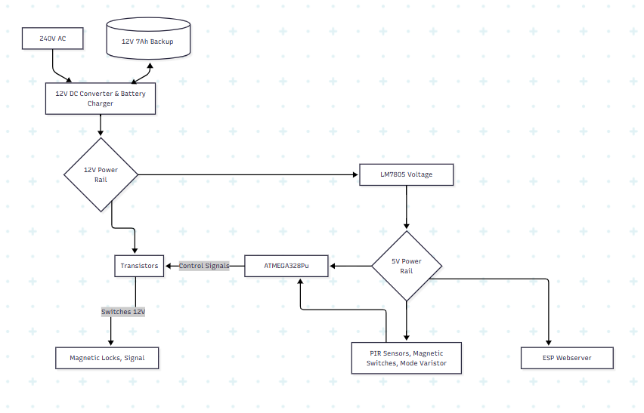

Inputs to the Primary MCU

Magnetic Contact Sensors (Door State Sensing)
To detect whether a door is open or closed, magnetic contact sensors are used. The switch is mounted on the door frame and the magnet is mounted on the moveable door. The model uses four sensors — one for each door — all wired in the pull-down configuration such that when the sensor pair is closed, 5 V is supplied to the MCU input pin; when opened, the input pin is grounded.
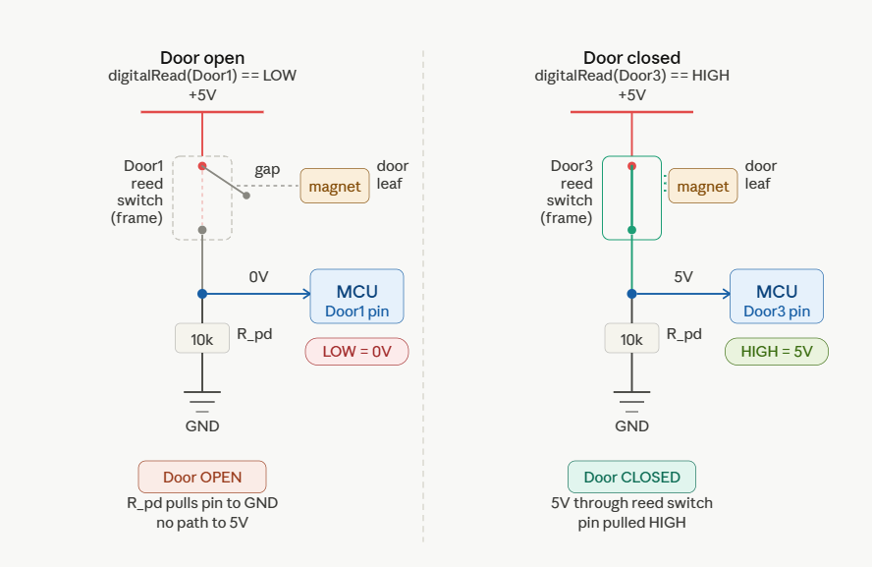

The four reed-switch sensor pins are connected to ATmega pins that support Pin Change Interrupts. When a door opens or closes, the voltage transition fires an ISR that sets a lightweight volatile event flag. No state-machine transitions happen inside the ISR — only flag-setting — keeping interrupt latency under 5 µs.

ATmega328P Low-Level Register Initialisation for PCINT:

void setupPCINT() {
// Enable Pin Change Interrupt Groups 1 and 2
PCICR |= (1 << PCIE1); // Enables Port C (A0–A5 Pins)
PCICR |= (1 << PCIE2); // Enables Port D (D0–D7 Pins)

// Assign Specific Hardware Masks to Targeted Reed Switch Pins
PCMSK1 |= (1 << PCINT10) | (1 << PCINT11); // Tracks Entry Path: Doors 1 and 2
PCMSK2 |= (1 << PCINT22) | (1 << PCINT23); // Tracks Exit Path: Doors 3 and 4

sei(); // Globally arm all hardware interrupts within the AVR core
}

// Asynchronous ISR Handler for Port C Door Sensor Mask Alerts
ISR(PCINT1_vect) {
unsigned long current_time = millis();
// 50 ms Hardware Debounce Verification Window
if ((current_time - lastInterruptTime1) > 50) {
eventDoor1Open = (digitalRead(door1) == LOW);
eventDoor1Close = (digitalRead(door1) == HIGH);
lastInterruptTime1 = current_time;
}
}

Operation Mode Selector
To select the operation mode manually, a variable resistor V_{out} is connected to analogue pin 25 of the MCU in a pull-down configuration. The input to the variable resistor is 5 V, with Vout ranging from 0 V to 5 V. The ATmega328PU has a 10-bit ADC providing 1024 discrete steps. With pin 20 connected to VAREF = 5 V, the resolution is 5 V ÷ 1024 ≈ 0.00488 V per step. Five modes where equally spaced across this range, with undefined gap zones between them acting as a software debounce to prevent false triggering between adjacent modes.

V_{out} from Variable resistor | ADC Conversion | Mode Definition
0.2 V – 0.8 V | ADC 41 – 164 | Lock All Doors
1.0 V – 1.8 V | ADC 205 – 369 | Entrance Only
2.0 V – 3.5 V | ADC 410 – 717 | Bi-Directional Traffic
3.7 V – 4.2 V | ADC 758 – 860 | Exit Only
4.3 V – max | ADC 881 – 1023 | Unlock All Doors

PIR Sensors
The booth has two pathways — one for entrance and one for exit. To detect whether a booth is occupied, deployed booths use a beam of infrared sensors for each booth mounted on the sides at stomach level. For prototyping, one PIR sensor module per pathway was used. The difference being a beam can detect multiple versus singular occupancy; the prototype is limited to occupancy logic only.
The PIR module outputs ~2 V for detection (HIGH) and 0 V for no detection (LOW). The ATmega328P digital input threshold is:
Logic HIGH ≥ 0.6 × VCC = 3.0 V and
Logic LOW ≤ 0.3 × VCC = 1.5 V (at 5 V supply).

The 2 V signal therefore falls in the undefined/noise zone, requiring a signal boost to a clean 5 V logic level.
To achieve the man-trap logic time delay, the design implements an RC network with R = 10 kΩ. This delays the Pin Change Interrupt by 2 s (confirming that the person is inside before the inner door can open). Using the relation t = RC and solving for C:

t = 2 s, R = 10 kΩ
C = t / R
C= 2 / 10,000 = 200 µF
→ Using a standard 220 µF capacitor achieves a 2.2 s delay.
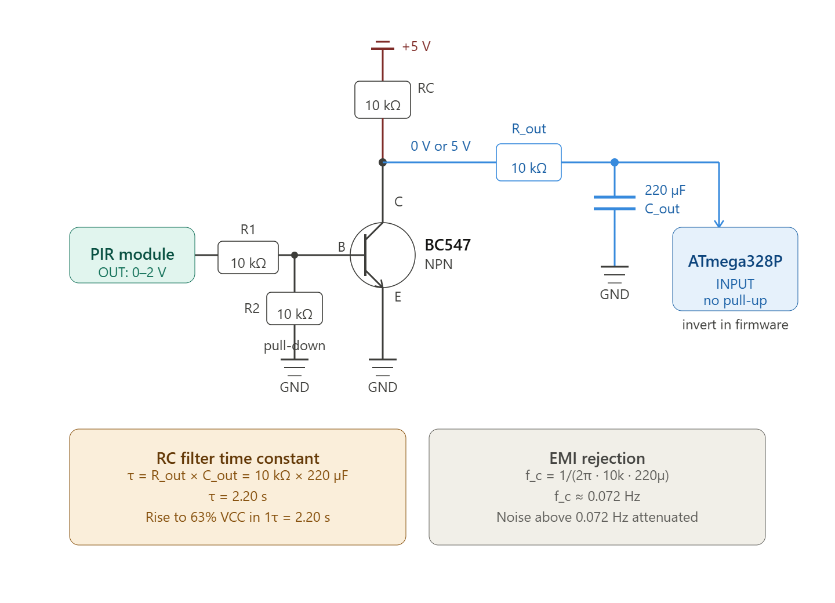

Locks and Signals
All man-traps use an automatic mechanical door closer. Each door top is mounted with a magnetic iron plate; the door frame is mounted with an electromagnet that, when powered, locks the iron plate with forces typically exceeding 600 lbs.
For each door- when the lock is powered, the door is locked and a red LED signals this to users. When unlocked, a green LED is powered. In the prototype, red and green signal LEDs represent field mag-locks for each door.

Signal LEDs and electromagnets use 12 V while the MCUs use 5 V. The higher-power components are controlled by the MCU pin, which is connected to the base of a BC547 transistor operating in either saturation or cut-off region, programmably switching the locks on/off. A fly-back diode is not required as there is highly inductive electromagnetic locks are not actually used in this prototype switching path.
The ATmega drives all LED outputs via digitalWrite() through the setDoorOutput() function.
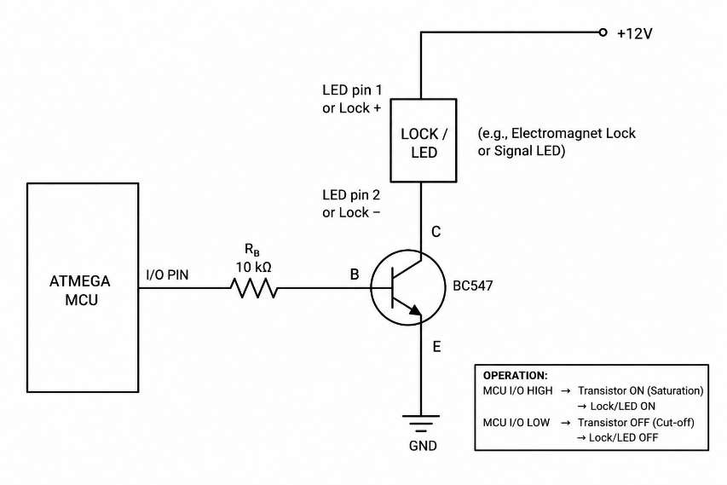

void setDoorOutput(int index, bool green, bool red) {
const int greenPins[4] = {DOOR1G, DOOR2G, DOOR3G, DOOR4G};
const int redPins[4] = {DOOR1R, DOOR2R, DOOR3R, DOOR4R};

digitalWrite(greenPins[index], green ? HIGH : LOW);
digitalWrite(redPins[index], red ? HIGH : LOW);

// Report state change over UART only when it changes
if (lastGreenState[index] != green || lastRedState[index] != red) {
lastGreenState[index] = green;
lastRedState[index] = red;

if (green && !red)
Serial.println(String("DOOR_") + (index+1) + "_UNLOCKED");
else if (!green && red)
Serial.println(String("DOOR_") + (index+1) + "_LOCKED");
}
}

3.3 Data Circuit Design

Overview
The system network is a three-tier distributed embedded architecture that chains physical door hardware through two cooperating microcontrollers to a multi-client web dashboard. Each tier communicates over a different protocol suited to its latency and reliability requirements: direct GPIO wiring at the hardware edge, asynchronous UART between the two MCUs, and TCP/IP (HTTP REST + Server-Sent Events) between the ESP32-CAM and the operator workstations. This layered separation ensures that the physical security layer — locks, sensors, interlock logic — continues to operate autonomously even if the network or intelligence tier fails entirely.

Network Topology
The following diagram illustrates the complete four-node communication chain, from physical booth hardware through to operator browser clients, with each protocol layer colour-coded.
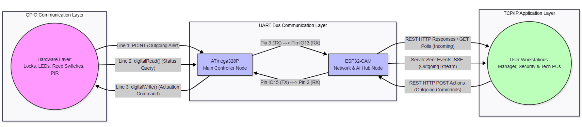
Figure 1 — ABESS Four-Node Network Topology with Protocol Layers

Layer | Designs | Responsibility
User App – ESP32 | A dashboard page | User interface, operator commands, real-time display, audit logs
Esp32 – Atmega328p | Data Parsing Function | Network hub, AI inference, UART bridge, LittleFS storage
ATmega328p-Transducers | Operation Mode | Physical door control, man-trap interlock, hardware interrupts

This section presents the complete design for the system information flow through three interconnected layers. The narrative follows a single action — a Branch Manager clicking the Control page and toggling Door 1 — and traces it through every layer of the system from browser click to physical mag-lock. This single action crosses all three layers and involves seven distinct function calls. The Finite State Ms that follow document each layer in full.

Tracing a Single Action Through the Full System
Consider this concrete example carried through each subsequent section: a Branch Manager opens the Control page and toggles Door 1 to UNLOCKED.

- Dashboard: The manager's browser renders the Control page served from the ESP32 over GET /. They click the Door 1 toggle button. toggleDoor(1) in control.js advances the state from locked to unlocked and calls fetch('/action', { method:'POST', body: JSON.stringify({ action:'TOGGLE', door:1, state:'unlocked' }) }). A control.log entry is written immediately.
- ESP32 Web API: The ESP32's AsyncWebServer receives the POST /action request. processActionPost() deserialises the JSON body and calls Serial2.println("DOOR_1_UNLOCKED") over the hardware UART TX line. It then calls appendLogEntry(LOG_CONTROL, ...) and broadcastSSE("status", ...) so the Monitor page updates live.
- ATmega328P: The ATmega's loop() reads the incoming UART string "DOOR_1_UNLOCKED" and passes it to processIncomingCommand(), which sets doorOverrideMode[0] = FORCE_UNLOCKED. On the next updateSystemLEDs() call, setDoorOutput(0, true, false) drives the Door 1 GPIO GREEN high, releasing the electromagnetic lock. The ATmega echoes "DOOR_1_UNLOCKED" back over UART, which the ESP32 relays to all SSE clients.

ESP32-to-Users TCP/IP Layer

Network Mode and Connectivity
The ESP32-CAM operates as an embedded HTTP web server on Port 80 over the bank's 802.11n Wi-Fi LAN. It connects in STA (Station) mode to the existing bank Wi-Fi infrastructure, receiving a DHCP-assigned IP address. If the Wi-Fi connection fails after retries, it falls back to SoftAP mode at 192.168.4.1, ensuring a technician can always reach the dashboard locally. This embedded-server architecture means the system remains fully operational during internet outages, directly addressing Zimbabwe's intermittent connectivity environment. Logs are stored on the ESP32's own LittleFS flash partition, ensuring the audit trail is retained regardless of network state.
Multiple operator workstations (the diagram shows three PCs representing the Branch Manager, Technician, and Security Operator) connect simultaneously over Wi-Fi. The ESP32 serves the complete Connecta dashboard — four HTML5/CSS3/JavaScript pages — directly from its LittleFS flash partition.
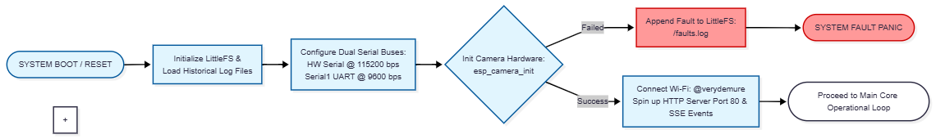

Three Communication Channels
Channel 1 — SSE (Server → Clients, Push)
A persistent GET /events connection using the Server-Sent Events protocol. The ESP32 pushes two named event types: door (individual contact state change) and status (full booth snapshot with occupancy counters). All connected browsers update simultaneously in real time without polling.

Channel 2 — REST GET (Server → Clients, Pull)
Standard HTTP GET requests for data retrieval: /status.json for current state, /log?type=X for historical logs, /stream for MJPEG live video, /capture for a single JPEG frame, and /api/inference for the latest AI classifier result.

Channel 3 — REST POST (Clients → Server, Command)
Operator commands arrive as POST /action with a JSON body. The ESP32 parses the body, forwards the command to the ATmega over UART, logs the event, and broadcasts an SSE update to all connected clients.

POST /action Example — Complete Request-to-Hardware Trace
The following table shows a concrete example: the operator clicks "Set Evacuation Mode" on the Control page, and traces the POST /action request through the ESP32's server.on() handler to the UART transmission.

Browser Sends (POST /action) | ESP32 Parses with server.on()
JavaScript fetch() in control.js:  fetch('/action', {  method: 'POST',  headers: {  'Content-Type':  'application/json'  },  body: JSON.stringify({  action: 'MODE_CHANGE',  mode: 'EVAC'  })  });  // Raw HTTP on the wire:  POST /action HTTP/1.1  Content-Type: application/json  {"action":"MODE_CHANGE",  "mode":"EVAC"} | server.on() split-callback handler:  server.on("/action",  HTTP_POST,  [](AsyncWebServerRequest *req){  req->send(200,  "application/json",  "{\"status\":\"ok\"}");  },  NULL,  [](AsyncWebServerRequest *req,  uint8_t *data, size_t len,  size_t idx, size_t total) {  String body;  for (size_t i=0; i<len; i++)  body += (char)data[i];  processActionPost(body);  // → deserialises JSON  // → Serial1.println("SET_MODE_EVAC")  // → appendLogEntry(...)  // → broadcastSSE(...)  }  );

Complete API Endpoint Map: Appendix

Endpoint | Method | Direction | Purpose
/events | GET (SSE) | Server → Client | Persistent push stream for door and status events
/status.json | GET | Server → Client | Current system state (doors, counters, mode, uptime)
/api/inference | GET | Server → Client | Latest AI classifier result (bboxes, confidence, timing)
/api/ai-config | GET | Server → Client | Current AI toggle states (system, threat, door control)
/api/mode.json | GET | Server → Client | Current operational mode
/api/faults.json | GET | Server → Client | Component health status
/api/logs.json | GET | Server → Client | All four log buffers as JSON
/log?type=X | GET | Server → Client | Specific log type (monitoring, control, faults, ai)
/stream | GET | Server → Client | MJPEG live video from OV2640
/capture | GET | Server → Client | Single JPEG frame (last inference snapshot)
/action | POST | Client → Server | Operator commands (mode change, door toggle, AI config)
/ | GET | Server → Client | Dashboard HTML files served from LittleFS

Unified System Logging & Audit Trail
The whole systems shares a single logging architecture. Every loggable event — hardware state change, operator command, fault detection, or AI inference result — is routed to appendLogEntry(category, payload) on the ESP32, which writes a timestamped line to the appropriate LittleFS file. The ESP32 maintains four independent circular buffers (max 200 entries each for prototyping). Any connected browser retrieves logs via GET /log?type=X. Logs are downloadable as a plain-text audit file satisfying the RBZ tamper-evident record-keeping obligation.
When the logs page loads on the client PC, the browser triggers a standard GET request to server.on("/api/logs"). To prevent data corruption, the ESP32-CAM pauses active file appending operations, opens a safe read-only file pointer stream to the internal LittleFS storage, reads the targeted tracking file (/monitoring.log, /control.log, /faults.log, or /ai.log), dumps the plain ASCII contents into a structured JSON string wrapper, and returns it to the browser.
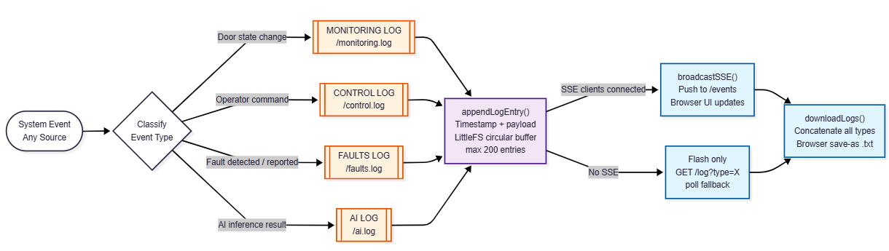
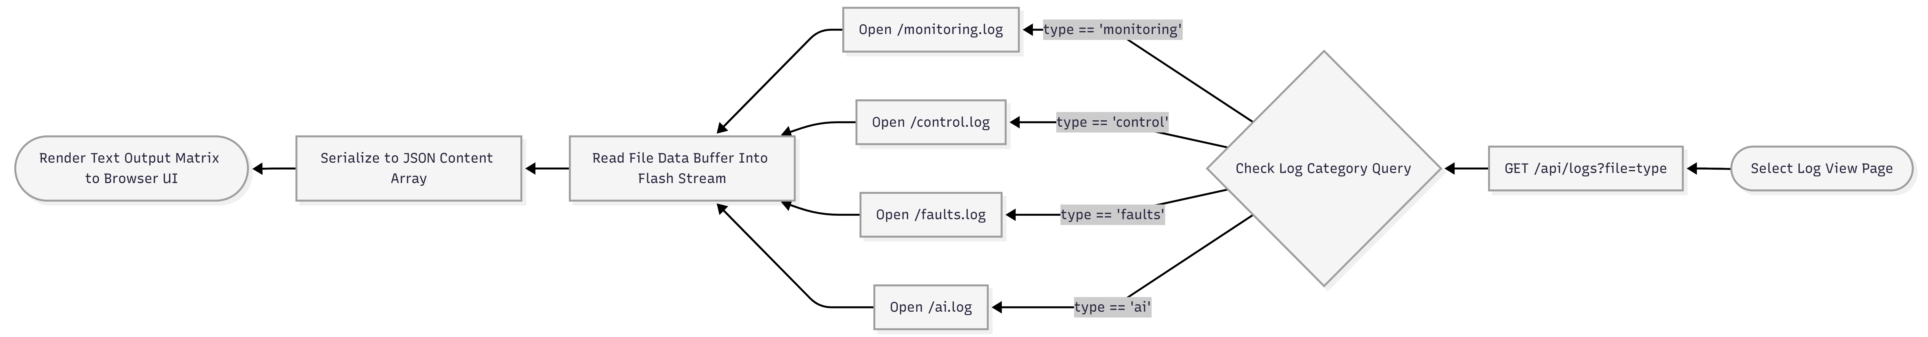

ESP32 — appendLogEntry (simplified):

void appendLogEntry(LogType type, const String& msg) {
String line = "[" + buildTimestamp() + "] " + msg;
logBuffers[type].push_back(line);
if (logBuffers[type].size() > 200)
logBuffers[type].erase(logBuffers[type].begin()); // discard oldest
broadcastSSE("status", buildStatusPayload()); // push to browsers
}

Web Dashboards
The user session originates at the root web server index. When an administrative supervisor requests access, the browser fires an HTTP GET handshake to the root URI.
The dashboard is a four-page HTML5 application served directly from the ESP32's AsyncWebServer on port 80. All pages share a common log-in authentication session, a global SSE connection to /events, and a header EVACUATE button that bypasses all page-specific state and posts directly to /action with { mode: "Evacuation" }.

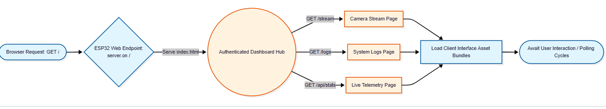

Monitoring Page

The Monitor page is a read-only situational awareness interface. On load it opens a persistent SSE channel to /events; it issues no commands except EVACUATE. The ESP32 pushes two named event types: door (individual contact state change, originating from ATmega UART telemetry) and status (full booth snapshot including occupancy counters). The booth SVG overlay and padlock icons update in real time. A live MJPEG stream from /stream is refreshed every 100 ms for CCTV continuity.
Every door event received here originated as a PCINT interrupt on the ATmega, was serialised as DOOR_N_OPENED/CLOSED over hardware UART, received by the ESP32, appended to monitoring.log, and broadcast over SSE — the complete signal chain from reed-sensor switch to browser. This page directly delivers the remote monitoring capability that was absent in conventional passive vestibule systems.
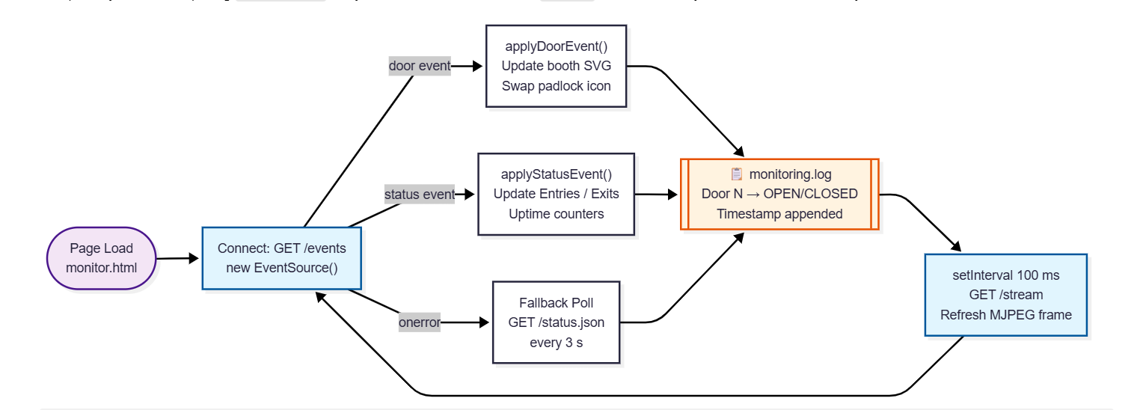

Figure X — DASH-1 Monitor Page DESIGN

Control Page
The Control page is the primary operator command interface. It exposes four door toggle buttons (LOCKED → UNLOCKED → AUTO) and five operation mode selectors, giving operators real-time control over the booth configuration that previously required physical key-switch intervention. Every operator action is serialised as a JSON body and dispatched via POST /action. The ESP32 receives the payload, parses the action field, and forwards the appropriate UART command string to the ATmega.
The EVACUATE button — present in the shared header on every page — also routes through this same pipeline with { mode: "Evacuation" }.

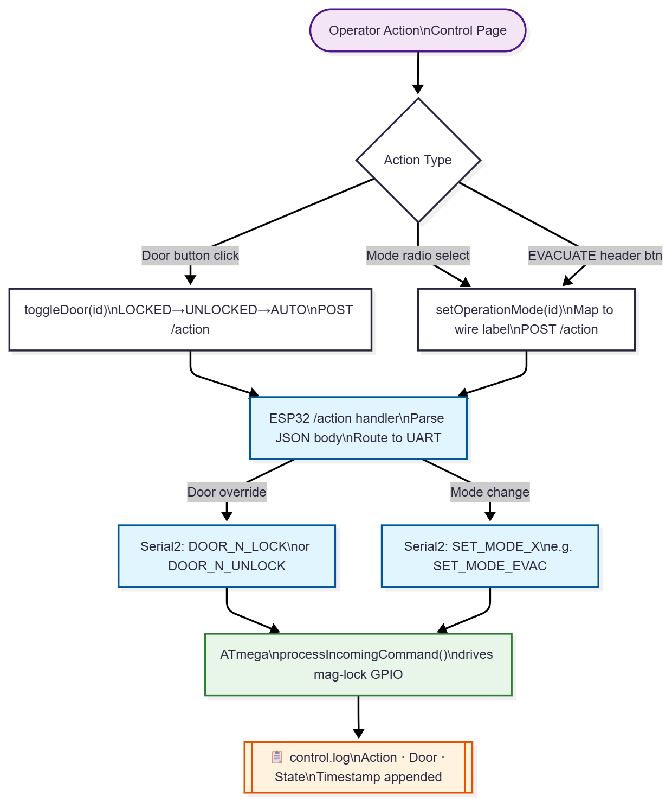
Figure X — Control Page DESIGN

control.js — unified action dispatcher:

function sendDoorAction(actionData) {
fetch('/action', { method:'POST',
headers:{'Content-Type':'application/json'},
body: JSON.stringify(actionData)
}).then(r => r.json())
.then(d => { if(d.status==='ok') showNotification('Door updated'); });
// control.log entry written on ESP32 side
}

// Wire label mapping for modes
const modeLabels = {
evacuate: 'Evacuation', normal: 'Normal-Traffic',
exit: 'Exit-Only', entrance: 'Entrance-Only', lock: 'Lock-All'
};

AI Control Page
The AI Control page is the operator interface for the Edge Impulse inference subsystem running on the ESP32. Three toggle switches arm the system: a master AI System switch, a Masked Face detector, and a Weapon detector. When both the master and at least one detector are active, the browser polls GET /api/inference every 3 seconds. Results with bounding-box confidence above 70% trigger a JPEG frame fetch from /capture, bounding-box overlay on a canvas element, and — if AI Door Control is enabled — an automatic POST /action dispatching the pre-configured mode change.
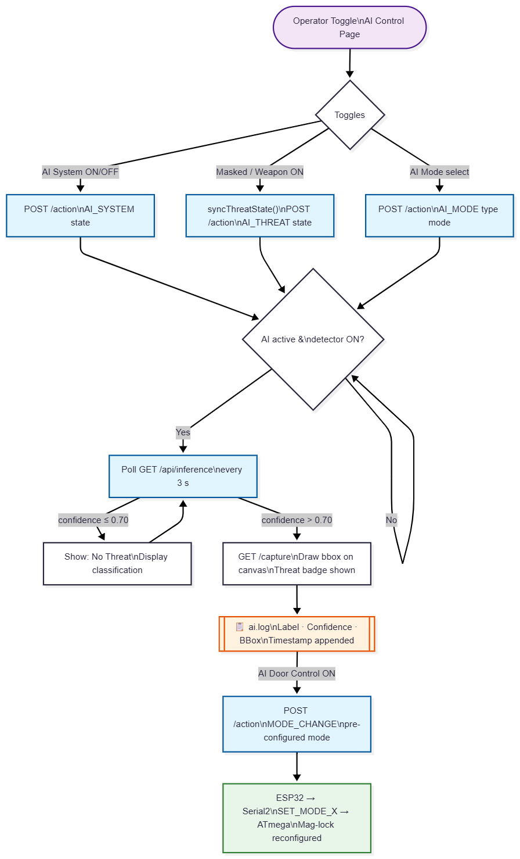
Figure X — AI Control Page DESIGN

aicontrol-inference.js — 70% confidence gate:

if (confidencePct > 70) {
fetch('/capture').then(r => r.blob()).then(blob => {
feedImg.src = URL.createObjectURL(blob);
_drawBoundingBoxes(data); // canvas bbox overlay
});
// ai.log entry written; if aiDoorControl ON → POST /action
}

Faults Page
The Faults page provides a real-time health grid for all hardware subsystems: Door Locks (×4), Motion Controllers (×4), and PIR Sensors (×2). The browser polls GET /faults every 5 seconds and updates each component tile to NORMAL, WARNING, or ERROR. When a status change is detected, a log entry is written immediately. Operators may also manually submit a fault report through a modal form, logging the component name, description, and timestamp.
Faults in conventional systems are discovered reactively, often during an incident. This page surfaces component health proactively in a technician-readable dashboard, allowing preventive maintenance before a failure affects security operations.

faults.js — new fault detection and logging:

function checkForNewFaults(faults) {
['locks','motionControllers','pirSensors'].forEach(cat => {
(faults[cat] || []).forEach(f => {
if (f.status !== 'normal')
window.API.addLogEntry(f.id, 'FAULT', f.status.toUpperCase());
// faults.log entry written here
});
});
}

Webserver

ESP Web API Request Handler
This flowchart models how the ESP32 serves as the communication hub between the browser dashboard and the ATmega hardware. Every inbound HTTP request is dispatched through the registered route handlers. POST /action commands are parsed and forwarded to the ATmega over UART.
The user session originates at the root web server index. When an administrative supervisor requests access, the browser fires an HTTP GET handshake to the root URI. The ESP32-CAM's asynchronous worker intercepts the TCP socket request, verifies access clearance parameters, and renders the baseline HTML layout frame.

The ESP32 broadcasts an SSE event so all connected browser clients update simultaneously.
The UART string emitted here — Serial2.println("SET_MODE_X") or Serial2.println("DOOR_N_LOCK") — is the exact string received by processIncomingCommand() by the ATmega.
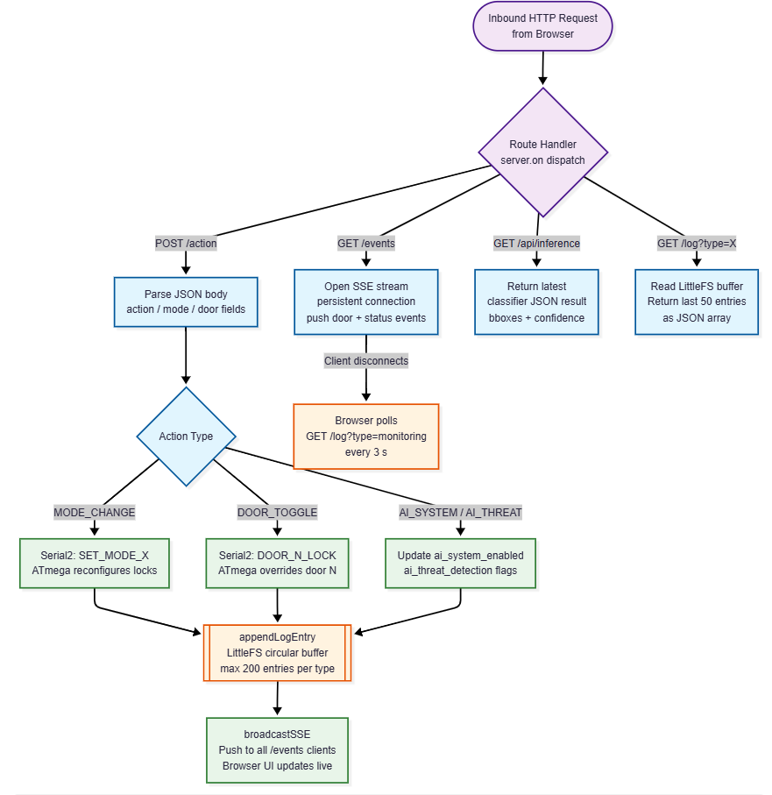
Figure X — ESP-3 Web API Handler DESIGN

ESP32 — POST /action handler (simplified):

void processActionPost(const String& body) {
DynamicJsonDocument doc(512);
deserializeJson(doc, body);
String action = doc["action"];

if (action == "MODE_CHANGE")
Serial2.println("SET_MODE_" + String(doc["mode"]));
else if (action == "AI_SYSTEM")
ai_system_enabled = (doc["state"] == "ON");

appendLogEntry(LOG_CONTROL, action + " received");
broadcastSSE("status", buildStatusPayload());
}

Reference Table — Dashboard Pages
Page | Endpoint | ESP32 Action | ATmega Effect | Log Type
Monitor | GET /events SSE | Push door/status events | — | monitoring
Control | POST /action | Parse → UART | processIncomingCommand → GPIO | control
Faults | GET /faults poll | Return component health | — | faults
AI Control | POST /action + GET /api/inference | run_classifier → mode | SET_MODE_X via UART | ai
All | GET /log?type=X | appendLogEntry → flash | — | all four

ESP32-ATmega UART Link

Physical Pin Cross-Connection
The two microcontrollers communicate over a dedicated hardware UART link. UART was chosen over SPI or I²C because it is asynchronous and full-duplex, requiring only two wires — making it robust against the timing jitter that the ESP32's busy Wi-Fi interrupt context would introduce on a clocked bus. The TX output of each MCU connects to the RX input of the other.

Command Comparison — ESP32 Sends, ATmega Receives
The following table traces the actions when the ESP32 creates a command using information from the webpage data packet and transmits it versus how the ATmega receives and executes it.

ESP32 Sends (TX on IO15) | ATmega Does (RX on Pin 2)
processActionPost() — parses browser JSON, transmits UART string:  void processActionPost(  const String& body) {  DynamicJsonDocument doc(512);  deserializeJson(doc, body);  String action = doc["action"];  if (action == "MODE_CHANGE")  Serial1.println(  "SET_MODE_" +  String(doc["mode"]));  else if (action == "DOOR_TOGGLE")  Serial1.println(  "DOOR_" +  String(doc["door"]) + "_" +  String(doc["state"]));  appendLogEntry(LOG_CONTROL,  action + " received");  broadcastSSE("status",  buildStatusPayload());  } | processIncomingCommand() — string-matches UART input, actuates GPIO:  void processIncomingCommand(  const String &cmd) {  if (cmd == "SET_MODE_NORMAL")  currentMode = MODE_NORMAL;  else if (cmd == "SET_MODE_EVAC")  currentMode = MODE_EVACUATION;  else if (cmd == "SET_MODE_LOCK")  currentMode = MODE_LOCKDOWN;  else if (cmd == "SET_MODE_CLOSED")  currentMode = MODE_BANK_CLOSED;  else if (cmd == "SET_MODE_STAFF")  currentMode = MODE_STAFF_ENTRY;  else if (cmd.startsWith("DOOR_")){  int id = cmd.substring(5,6)  .toInt();  if (cmd.endsWith("_LOCKED"))  doorOverrideMode[id-1]  = FORCE_LOCKED;  else if (cmd.endsWith("_UNLOCKED"))  doorOverrideMode[id-1]  = FORCE_UNLOCKED;  }  updateSystemLEDs();  }

Event Comparison — ATmega Sends, ESP32 Receives
The following table traces the reverse path: the ATmega transmits a hardware event and the ESP32 parses and distributes it to all connected browser clients via SSE.
The ATmega serialises flat key-value pairs (STATS:ENTRIES=14;EXITS=11;INSIDE=3) using simple Serial.print() concatenation. The ESP32 parses them by tokenising substrings with parseStatValue(), then re-packages the data as JSON for the browser via buildStatusPayload().

ATmega Sends (TX on Pin 3) | ESP32 Does (RX on IO13)
loop() flag drain — serialises ISR flags as UART strings:  if (eventDoor1Open) {  Serial.println("DOOR_1_OPENED");  eventDoor1Open = false;  }  if (eventDoor2Close) {  totalEntries++;  Serial.println("DOOR_2_CLOSED");  sendStatusUpdate();  eventDoor2Close = false;  }  void sendStatusUpdate() {  clientsInside =  totalEntries - totalExits;  Serial.print("STATS:ENTRIES=");  Serial.print(totalEntries);  Serial.print(";EXITS=");  Serial.print(totalExits);  Serial.print(";INSIDE=");  Serial.println(clientsInside);  }  // Example output:  // DOOR_3_CLOSED  // STATS:ENTRIES=14;EXITS=11;INSIDE=3 | processAtmegaLine() — tokenises UART input, publishes SSE to webpage:  if (Serial1.available()) {  String data =  Serial1.readStringUntil('\n');  data.trim();  if (data.length() > 0)  processAtmegaLine(data);  }  void processAtmegaLine(  const String &line) {  if (line.startsWith("DOOR_")) {  int id = line.charAt(5)-'0';  String sfx = line.substring(7);  appendLogEntry(LOG_MONITORING,  "Door "+String(id)+" "+sfx);  if (sfx.equalsIgnoreCase("OPENED"))  publishDoorEvent(id,  "opened", line);  }  else if (line.startsWith("STATS:")){  totalEntries =  parseStatValue(line,"ENTRIES")  .toInt();  totalExits =  parseStatValue(line,"EXITS")  .toInt();  events.send(  buildStatusPayload().c_str(),  "status", lastDoorEventId);  }  }

System Operational Mode Matrix & UART Command Processor
This flowchart acts as the global executive supervisor of the ATmega328P. It governs how all four mag-locks behave during security overrides received from the ESP32 over the bidirectional UART link. Commands originate from either the web dashboard operator or the Edge Impulse AI inference engine (ESP-2). A centralised dispatcher node (processIncomingCommand) routes each UART token to the correct OperationMode, then updateSystemLEDs() immediately applies the resulting GPIO state to all four mag-lock output pins.
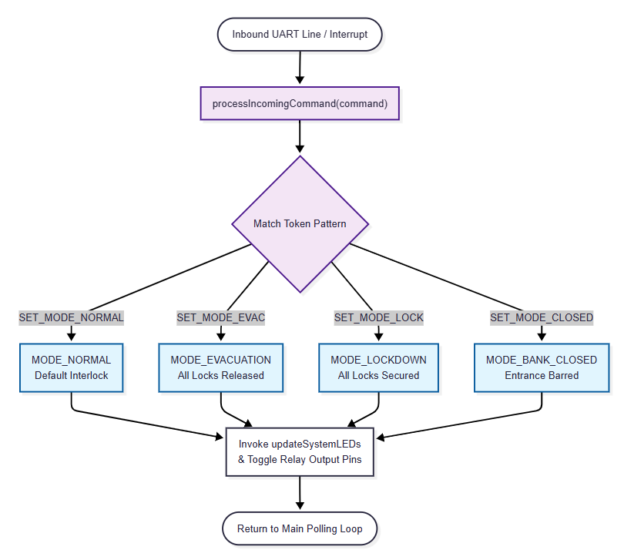
Figure X — MCU Operational Mode Matrix

void processIncomingCommand(const String &cmd) {
if (cmd == "SET_MODE_NORMAL") currentMode = MODE_NORMAL;
else if (cmd == "SET_MODE_EVAC") currentMode = MODE_EVACUATION;
else if (cmd == "SET_MODE_LOCK") currentMode = MODE_LOCKDOWN;
else if (cmd == "SET_MODE_CLOSED") currentMode = MODE_BANK_CLOSED;
else if (cmd.startsWith("DOOR_")) {
int id = cmd.substring(5,6).toInt() - 1;
if (cmd.endsWith("_UNLOCKED")) doorOverrideMode[id] = FORCE_UNLOCKED;
else if (cmd.endsWith("_LOCKED")) doorOverrideMode[id] = FORCE_LOCKED;
}
updateSystemLEDs(); // immediately drive all GPIO outputs
}

One of five operational modes is then selected by the centralised dispatcher:
- MODE_NORMAL — Default dual-interlocking state; MEGA-1 interlock controls door sequencing.
- MODE_EVACUATION — Emergency override. Instantly cuts power to all electromagnetic locks so doors swing open freely.
- MODE_LOCKDOWN — Threat mitigation state. Force-locks all magnetic plates; access is barred regardless of sensor inputs.
- MODE_BANK_CLOSED — Restricts customer entrance while permitting the exit booth to follow normal interlock.
- MODE_STAFF_ENTRY — Permits validated staff passage via entrance booth only.

In emergency modes (EVACUATION, LOCKDOWN), MEGA-1's interlock state machine is bypassed entirely (both doors can open simultaneously) and all outputs are driven directly, ensuring emergency response is never delayed by the booth cycle state.

Core Booth Interlocking & Occupancy Tracking
This design part governs the deterministic man-trap interlock logic — the ATmega's primary security function. Four BoothState values enforce the physical rule that the inner door can only release after the outer door has fully closed behind a visitor, eliminating tailgating.

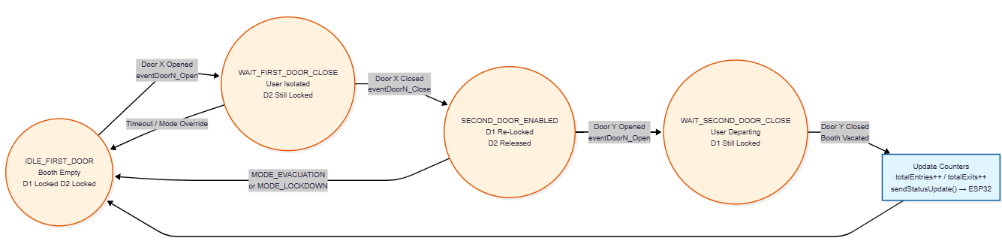
Figure X — MCU Booth Interlock State Machine

Both booth paths (ENT.D1→D2 entrance, EXT.D3→D4 exit) run identical mirrored state sequences. Occupancy counters are incremented on each completed cycle and three statistics variables are calculated:
ENTRIES +=; EXITS += ;
INSIDE = ENTRIES - EXITS.

This allows the ATmega328P to achieve the following:
- Indirectly display banking hall occupancy stats on the Monitor page by transmitting the three values as a UART string to the ESP32 via sendStatusUpdate(). The ESP32 then parses this data to serve the polling client page.

- Instead of the guard going out of the bank to physically count in ten people to avoid overcrowding inside the banking hall, the system uses the INSIDE variable. It is compared against the "Max Capacity" value set by the bank manager on the dashboard, automatically toggling between Exit-Only mode and Bi-Directional mode.

All state transitions are driven by hardware interrupt flags set in the PCINT ISR_{S} keeping the interlock response deterministic and independent of UART activity. In emergency modes (MODE_EVACUATION, MODE_LOCKDOWN), this DESIGN is bypassed entirely and the system switches to simpler state, which drives all outputs directly without interlocking.

loop() — booth state transitions on event flags:

if (eventDoor1Close && booth1State == WAIT_FIRST_DOOR_CLOSE) {
booth1State = SECOND_DOOR_ENABLED; // D1 shut → unlock D2
Serial.println("DOOR_1_CLOSED");
}

if (eventDoor2Close && booth1State == WAIT_SECOND_DOOR_CLOSE) {
booth1State = IDLE_FIRST_DOOR; // cycle complete
totalEntries++;
sendStatusUpdate(); // → "STATS:ENTRIES=N;EXITS=N;INSIDE=N"
}

// Booth 2 (EXT path) mirrors this with booth2State and totalExits++

3.4 Visual Circuit Design

AI Inference Pipeline & Automated Threat Response
This design part is the core intelligence sub-process of the ESP32. A FreeRTOS task runs the Edge Impulse classifier every 500 ms when the master AI switch is active. The OV2640 grabs a JPEG frame, the DSP pre-processing stage normalises and resizes it to the model input dimensions (Int8 format via the EON Compiler), then run_classifier() executes the TensorFlow Lite forward pass.

AI Inference/ Runtime.
If an inference execution error occurs, an error flag is appended to /faults.log. If it returns successfully, the top confidence score is evaluated against the 70% threshold. Below 70%, releasePendingInferenceFrame() instantly drops the frame buffer from memory. At or above 70%, promotePendingInferenceFrame() commits the frame to static storage, saves diagnostics to /ai.log, and — if automated intervention is active — resolveInferenceDetectionType() identifies the threat class and passes the configured response mode to applyOperationMode(), which transmits a high-priority override packet over Serial2 to the ATmega.
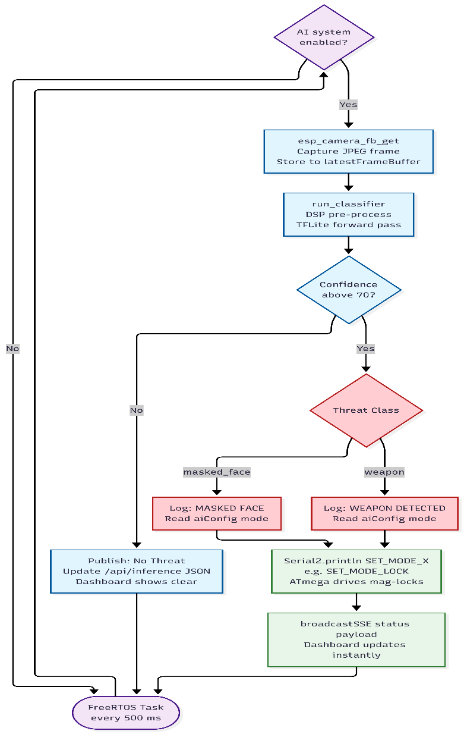
Figure X — ESP-2 AI Inference Pipeline DESIGN

Inference task (simplified):

if (ai_system_enabled && ai_threat_detection) {
run_inference_task(); // calls run_classifier(&signal, &result, false)
}

// On threat confirmed:
if (result.bounding_boxes[0].confidence > 0.70f) {
String mode = aiConfig.operationModes[label]; // e.g. "SET_MODE_LOCK"
Serial2.println(mode); // → ATmega UART
appendLogEntry(LOG_AI, label + " detected");
broadcastSSE("status", buildStatusPayload());
}

Model Training Methodology
All model training was conducted on Edge Impulse Studio (cloud-based). Edge Impulse was selected because it provides a complete end-to-end pipeline — dataset management, DSP feature extraction, neural network training, and TensorFlow Lite export — optimised for deployment on microcontrollers such as the ESP32. It also generates a C++ Arduino library that integrates directly with the ESP32 inference firmware already written for this project.

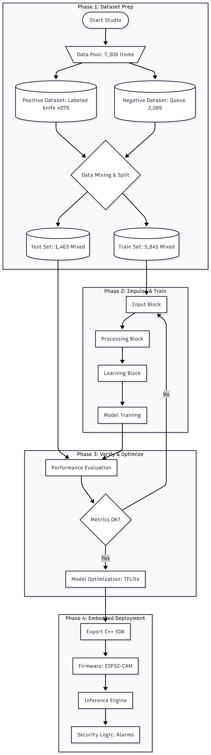

Impulse Design of the Masked face detector

The final dataset totalled 4,918 labelled items, split 80/20 between training (3,945 items) and test (973 items). Building this dataset required multiple iterations across several Roboflow public datasets, with deliberate decisions made at each stage regarding class composition, demographic diversity, and the subtraction of confounding features.

Dataset Construction
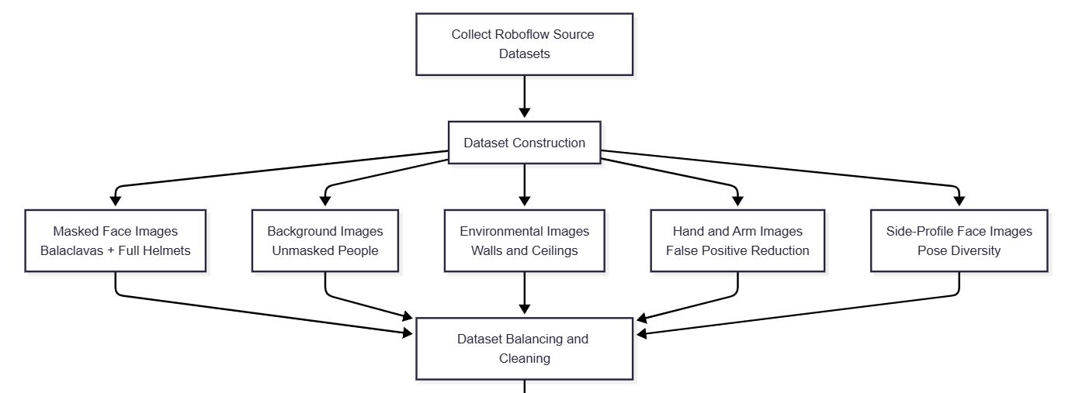

Class Definition: What Counts as a 'Masked Face'
The definition of the Masked Face class was deliberately narrow and security-focused. Only face coverings that are both (a) capable of defeating facial recognition and (b) associated with criminal entry were included in the positive class:
- Balaclavas (ski masks): full-head cloth coverings that leave only the eyes exposed. These are the most common face covering used in Zimbabwean bank robberies and were the primary target class.
- Full motorbike helmets: visored helmets that obscure the entire face and are close and also only face the direction of the camera. Source images came from the BankSecurityDetection dataset.
Surgical masks and N95/cloth medical face masks were explicitly excluded from the Masked Face class, even though they technically cover part of the face. This was a considered design decision: during and following the COVID-19 period, surgical masks are worn by a significant proportion of legitimate bank customers in Zimbabwe for health reasons. Including them in the positive class would generate an unacceptable false-positive rate, discriminating against innocent customers. The model was therefore trained to treat surgical-mask wearers as belonging to the background/unmasked class. The confidence threshold of 70% further provides a safeguard against borderline cases.

Demographic Diversity and Dataset Balance
A conscious effort was made to ensure the dataset included faces from diverse ethnic backgrounds. A model trained predominantly on one demographic group would exhibit racially biased detection performance — higher recall for some groups and lower for others. Because the ABESS is intended for deployment in Zimbabwean bank branches serving a predominantly Black African customer base, it was especially important that the unmasked (negative) class included sufficient representation of darker skin tones, which are sometimes underrepresented in publicly available face datasets.
The BankSecurityDetection dataset (banksecuritydetection-fsezj) was selected in part because it included a broad ethnicity mix across both its masked and unmasked classes. The face-side-view dataset (face-side-view-skeek-u5pk5) provided synthetic orthodontic profile images that added diversity in pose and angle. The aa-person dataset provided a large general population sample used to build a robust background class.
Class balance was actively managed across multiple iterations. Because FOMO is particularly sensitive to class imbalance — where a heavily over-represented background class causes the model to learn to always predict background — the ratio of positive (Masked Face) to background annotations was monitored throughout. The ski-mask dataset (ski-mask-ocnsh, 203 images) was added in a later iteration specifically because early training runs showed that recall for balaclavas was lower than for helmets; adding targeted balaclava-only images directly addressed this imbalance within the positive class itself.

Feature Subtraction to Reduce False Positives

One of the most important and non-obvious steps in the dataset construction was the deliberate inclusion of arm and hand images in the negative class. During early model iterations, the model was producing false positive detections when a person raised their hand or arm toward their face — a natural gesture when a customer is holding a phone or gesturing during conversation. The model was confusing the dark silhouette of a sleeve or gloved hand against a face with a balaclava.
To address this, two datasets of hand and arm images — hand-holding-and-empty-4l0ce (2,503 images) and 1213-g4fcd-i9e9m (737 images) — were introduced into the background class. Crucially, none of these images contained a knife or gun, ensuring that the weapon-detection model (trained separately) would not be contaminated. The effect was a measurable reduction in false positives, as the model learned to distinguish a bare arm from a face-covering.
Similarly, background images from ceiling and wall datasets (wall-ceiling-instance-segmentn-plb0h and ceiling-y9dkm-1fp1p) were incorporated to teach the model to ignore environmental features. The OV2640, being ceiling-mounted, frequently captures portions of the ceiling, doorframes, and walls in the frame edges. Without ceiling images in the background class, textured plasterwork, cornices, or mould patches were occasionally misclassified.
Source Datasets
Table 1 summarises every dataset used and its specific role:

Dataset (Roboflow ID) | Images | Role in Training
banksecuritydetection-fsezj | 3,155 | Primary source: balaclava and full-motorbike-helmet images → Masked Face class; exposed-face images (various ethnicities) → Unmasked class
aa-person-mmgw4 | 7,615 | Background/negative class: general person images with no masked face, helping the model learn what a non-threat looks like
wall-ceiling-instance-segmentn-plb0h | 780 | Background/negative: indoor ceiling and wall textures used to reduce false positives on environmental features
ceiling-y9dkm-1fp1p | 500 | Background/negative: additional ceiling images (cracks, shapes, moulds) to suppress background noise
hand-holding-and-empty-4l0ce | 2,503 | Negative arm/hand images (no weapon held) — subtracted this model feature to reduce false positive triggered by raised arms
1213-g4fcd-i9e9m | 737 | Additional hand/arm images reinforcing negative arm class — further reduced false positive detections
face-side-view-skeek-u5pk5 | 596 | Side-profile face images to improve recall on oblique angles typical of a person walking through an entrance
ski-mask-ocnsh | 203 | Targeted balaclava images to improve recall on the most security-critical face-covering variant
WeaponDetection-xx3lz | — | Reference dataset; classes used to verify weapon-class separation and avoid cross-class contamination
Table 1: Source datasets used in masked face detection model training.

Impulse Training Configurations:
- Input block: Image data, 96×96 pixels, resize mode set to 'Fit shortest axis', 100% of training data used.
- Processing block: Image DSP block (colour depth: Grayscale). Grayscale was selected over RGB because it halves the input feature vector (9,216 features for a 96×96 image) without significant loss of the texture and shape information needed to distinguish a balaclava or helmet from a bare face. This also reduces the ESP32 peak RAM usage during feature extraction to 4 KB, and the DSP processing time to 15 ms.
- Learning block: Object Detection (Images) using the FOMO MobileNetV2 0.35 architecture. FOMO was chosen because it outputs bounding box coordinates rather than just a classification label, allowing the dashboard to visually highlight the detected threat on the live camera canvas.
- Output class: 1 class — 'Masked face'. Background is treated implicitly as the null class by FOMO.

Training Hyperparameters
- Training cycles (epochs): 60
- Learning rate: 0.001
- Batch size: 40
- Training processor: GPU
- Data augmentation: Enabled
- Validation set size: 20% (carved out of training split)
- INT8 quantised model profiling: Enabled
- Deployment target: ESP32-CAM (EON Compiler, RAM-optimised engine)

