### REPUBLIC OF YEMEN SANA'A UNIVERSITY

ذ



FACULTY OF ENGINEERING

MECHATRONICS ENGINEERING DEPARTMENT

### **OP Amp Amplifire**

**Done by:**

Student’s Name: Ibrahim Alkhlydy

AC.NO: 202073007

System(Parallel)

**Supervised by:**

**Prof: Abdalkaphy Alaryay**

**Abstract**

Op amp amplifier from this lesson we design a op amp project is a sensor of motion with op amp LM358 the op amp is a [DC-coupled](https://en.wikipedia.org/wiki/Direct_coupling) high-[gain](https://en.wikipedia.org/wiki/Gain_(electronics)) electronic voltage [amplifier](https://en.wikipedia.org/wiki/Electronic_amplifier) with a [differential input](https://en.wikipedia.org/wiki/Differential_input) and, usually, a [single-ended](https://en.wikipedia.org/wiki/Single-ended_signaling) output.[[1]](https://en.wikipedia.org/wiki/Operational_amplifier#cite_note-2) In this configuration, an op amp produces an output potential (relative to circuit ground) that is typically 100,000 times larger than the potential difference between its input terminals. Operational amplifiers had their origins in [analog computers](https://en.wikipedia.org/wiki/Analog_computers), where they were used to perform mathematical operations in linear, non-linear, and frequency-dependent circuits. Operational Amplifiers, also known as Op-amps, are basically a voltage amplifying device designed to be used with components

The LDR symbol used in electronic circuits is based around the resistor circuit symbol, but shows the light, in the form of arrows shining on it.

* LM 358 has eight (8) pins in total having different individual functions associated with each of them.
* All the pins along with their sequence number are given in the table shown below.

Contents

REPUBLIC OF YEMEN SANA'A UNIVERSITY 1

**OP Amp Amplifire** 1

Operational amplifier: 5

Objective: 5

Methodology: 6

Data Chet of LM358 6

Pin configuration of LM358: 7

LM358 Rating: 8

Component: 8

Procedure: 9

Simulation: 9

Reference: 10

#### Introduction:

Op amps are used widely in electronic devices today, including a vast array of consumer, industrial, and scientific devices. he op amp is one type of [differential amplifier](https://en.wikipedia.org/wiki/Differential_amplifier). Other types of differential amplifier include the [fully differential amplifier](https://en.wikipedia.org/wiki/Fully_differential_amplifier) (similar to the op amp, but with two outputs), the [instrumentation amplifier](https://en.wikipedia.org/wiki/Instrumentation_amplifier) (usually built from three op amps), the [isolation amplifier](https://en.wikipedia.org/wiki/Isolation_amplifier) (similar to the instrumentation amplifier, but with tolerance to [common-mode voltages](https://en.wikipedia.org/wiki/Common-mode_signal) that would destroy an ordinary op amp), and [negative-feedback amplifier](https://en.wikipedia.org/wiki/Negative-feedback_amplifier) (usually built from one or more op amps and a resistive feedback network). Op amp amplifier from this lesson we design a op amp project is a sensor of motion with op amp LM358 The LM358 is one type of dual-channel operational amplifier (Op-Amp). This Op-Amp IC designed and introduced by the **national semiconductor**. It consists of two independent, high-gain, frequency-compensated operational amplifiers (Op-Amp). The IC is designed like that the Op-Amps are operating from a single supply or split supplies over a wide range of voltages. Operational Amplifiers, also known as Op-amps, are basically a voltage amplifying device designed to be used with components like capacitors and resistors, between its in/out terminals. They are essentially a core part of analog devices. Feedback components like these are used to determine the operation of the amplifier.

1. The opamp's input terminals, V+ and V-, draw no current.
2. The voltage of V+ and V- are always equal. This property is sometimes called the *virtual short approximation*.

The LDR symbol used in electronic circuits is based around the resistor circuit symbol, but shows the light, in the form of arrows shining on it. In this way it follows the same convention used for photodiode and phototransistor circuit symbols where arrows are used to show the light falling on these components.

LDR works without delving into complicated explanations. It is first necessary to understand that an electrical current consists of the movement of electrons within a material.

**LDR**– LDR is a device whose sensitivity depends upon the intensity of light falling on it. The resistance of LDR decreases when intensity of light falling on it increases and vice versa (resistance increases when intensity of light falling on it decreases). In dark or in absence of light, LDR exhibits a resistance in the range of mega ohms, which decreases to few hundred ohms in presence of bright light.

**Testing of LDR**

You can check LDR with the help of multi-meter. Keep your multi-meter in ohm or resistor measurement region. When you cover the LDR its resistance will be very high and when you place it in light it decreases. This phenomenon indicates LDR is working correctly. We are utilizing this property of LDR to act at your LDR is working correctly. A sensor, since a varying voltage drop can be obtained with varying light.

## ****Operational amplifier:****

An **Operational Amplifier**, or op-amp for short, is fundamentally a DC coupled high gain voltage amplifying device they are ideally designed for signal conditioning, DC amplification, filtering and to be used with external feedback components such as capacitors and resistors between its output and input terminals.

The op-amp perform different function depending upon its feedback configuration whether it resistive, capacitive or both on the bases of this it can be used differential amplifier, integrator or summer.

## Objective:

1. To explain mechanism and operating Bourdon-tube pressure gauge
2. Depends upon the intensity of light falling on it
3. In dark or in absence of light.

# Methodology:

From this project Op amp amplifier from this lesson we design a op amp project is a sensor of motion with op amp LM358. The LDR symbol used in electronic circuits is based around the resistor circuit symbol, but shows the light, in the form of arrows shining on it.

LM358 IC can also be used as transducer standard [operational amplifier](https://www.elprocus.com/operational-amplifiers/) and it is suitable for our needs. It can handle voltage from 3V to 32V DC supply and current up to 20mA per channel. It consists of 8 pins which contains two operational amplifiers.

An **Operational Amplifier**, or op-amp for short, is fundamentally a DC coupled high gain voltage amplifying device they are ideally designed for signal conditioning,

## Data Chet of LM358

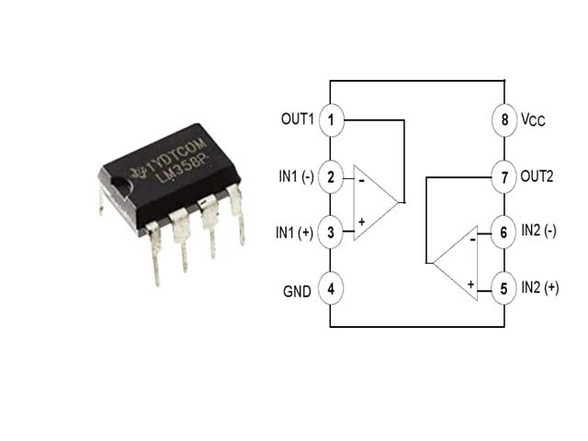

From the above figure you can see that operational amplifier has two inputs and one output in one independent LM358. Inputs are at pin 2 (negative pin) and 3 (positive pin), positive pin is used for positive feedback and negative pin is used for negative feedback. In ideal condition when no feedback is applied, gain of the operational amplifier should be infinite. When voltage at pin 2 is more than voltage at pin 3 it will raise the output towards the positive maximum voltage and a slight increase at negative pin compared to positive pin will lower the output towards the negative maximum. This feature of operational amplifier makes it suitable for the purpose of level detection.

DC gain block etc. It has large dc voltage gain of 100dB. This IC can be operated on wide range of power supply from 3V to 32V for single power supply or from ±1.5V to ±16V for dual power supply and it also support large output voltage swing.

## ****Pin configuration of LM358:****

|  |  |  |
| --- | --- | --- |
| **Pin Number** | **Pin Name** | **Description** |
| 1 | OUTPUT 1 | This pin is the output of first operational amplifier |
| 2 | INPUT  1 – | This pin is the inverting input of first op-amp |
| 3 | INPUT 1 + | This pin is the non-inverting input of first op-amp |
| 4 | GND or | This ground or negative supply to op-amp |
| 5 | INPUT 2 + | This pin is the non-inverting input of second op-amp |
| 6 | INPUT 2 – | This pin is the inverting input of second op-amp |
| 7 | OUTPUT 2 | This pin is the output of the second op-amp |
| 8 |  | This pin is the positive voltage supply to both op-am |

## ****LM358 Rating:****

If the rating of the LM-358 exceed from these values it will be damage it will work on the rating given below:

* Integrated with two Op-Amps in a single package
* Wide power supply Range
* Singe supply – 3V to 32V
* Dual supply – ±1.5V to ±16V
* Input differential voltage range ±32
* Low Supply current – 700uA
* Input common mode voltage range -0.3 to 32
* Single supply for two op-amps enables reliable operation
* Junction temperature 150˚C
* Operating ambient temperature – 0˚C to 70˚C
* Storage temperature range – 65˚C to 150˚C
* Soldering pin temperature – 260 ˚C (for 10 seconds – prescribed)
* Short circuit protected outputs
* Available packages: TO-99, CDIP, DSBGA, SOIC, PDIP,  DSBGA

## Component:

1) IC op amp (LM358).

2) One 10 k ohm resistors.

3) One 100 ohm resistor.

4) One 10 k ohm resistor potaial.

5) LDR.

6) Wires.

7) Board.

8)Led.

# Procedure:

1) We connect a ground with pin (4) and LDR of LM358.

2)Connect 10K ohm resistor between pin (3) and VCC.

3)Connect another 10k ohm resistor botanail between pin (3) and ground.

4)Connect LDR between pin (3) and (4).

5)Connect 100 ohm resistor between pin (1) LED

6)Connect ground to anode of LED.

## Simulation:

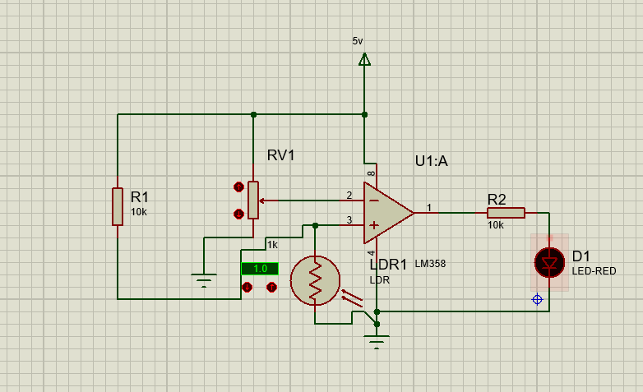

1The Circular of Project

#### Discussion and Conclusions:

The IC is designed like that the Op-Amps are operating from a single supply or split supplies over a wide range of voltages. Operational Amplifiers, also known as Op-amps, are basically a voltage amplifying device designed to be used with components like capacitors and resistors, between its in/out terminals. They are essentially a core part of analog devices. Feedback components like these are used to determine the operation of the amplifier.

In this IC we have two operational amplifier which can we use as a comparator. LM- The low power drain also makes the LM358 a good choice for battery operation. Generally we obtain signal from sensor are usually have small rating. We cannot do anything with this rating for example we obtain 0.3V from sensor. By using 0.3V we cannot ON/OFF led or relay. The LM-358 IC get signal from the sensor and compare to the reference voltage. Then this IC will decide whether the voltage is greater or less than reference voltage by giving output high or low.

## Reference:

[1] <https://www.theengineeringprojects.com/2017/07/introduction-to-lm358.html>

[2]<https://workforce.libretexts.org/Bookshelves/Electronics_Technology/Book%3A_Electric_Circuits_III__Semiconductors_(Kuphaldt)/08%3A_Operational_Amplifiers/8.01%3A_Introduction_to_Operational_Amplifiers_(Op-amps)>

[3] <https://www.electronics-notes.com/articles/electronic_components/resistors/light-dependent-resistor-ldr.php>