**Gulomekeda … ancient center for hidden civilization**

By: Hagos Gebremariam/Department of Sociology/ hagosg@gmail.com

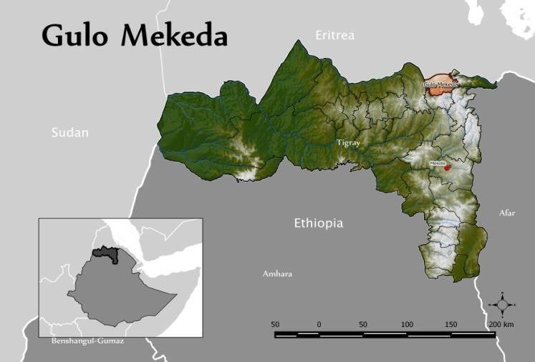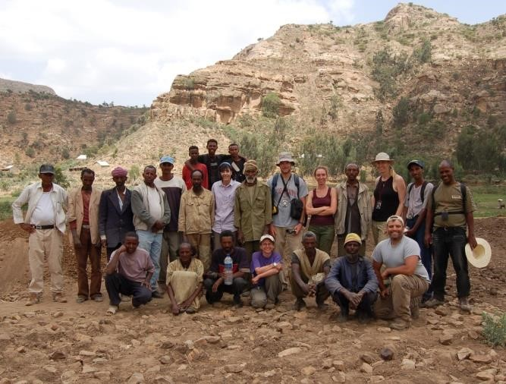

*Gulomekeda is one of the Administrative wredas of the Eastern part of Tigray where towns like Zalambesa, Fatsi and Sobeya are located in. According to oral traditions, this district is the origin of Qeen of Sheba (Makeda) where the name is taken from Mekeda (Gulomekeda) and Sobeya from Saba (Sheba). Today my interest is not in relation to the Queen of Sheba or Makeda. Beyond its historical hegemony, Gulomekeda is now becoming an international attraction for surprising Archaeological Research and Excavations.*

*Professor Catherine D’Andrea from Simon Fraser University, Canada is the director of a Project Called Eastern Tigray Archeological Project (ETAP) engaged in massive Archaeological excavation in Gulomekeda. Archaeological excavations by ETAP show that far from being a rural hinterland, Gulomakeda had large towns with elite groups who had access to exotic trade goods during that time. The survey research by ETAP also identified cultural links to ancient* [*Eritrean*](http://en.wikipedia.org/wiki/Eritrea) *settlements, which included* [*Matara*](http://en.wikipedia.org/wiki/Matara,_Eritrea) *and the ancient* [*Ona culture.*](http://en.wikipedia.org/w/index.php?title=Ona_culture&action=edit&redlink=1)

*The excavation which took more than a decade including surveying possible sites is still continuing. Professor Catherine (also a visiting professor at Addis Ababa University) has different international publications including some about Ethiopia and African Archaeology. Last year in the Meskel Archaeological conference held by Adigrat University, Professor Catherine was held a presentation about some of the results of this research. Beyond that she brought archaeological books to strengthen the new department the whole way from Canada. Our Archaeology students are now visiting the excavation center and archaeological lab in Adigrat for a practical field work.*

*In This project there are different international researchers from Ethiopia, Canada, Italy and other countries. Although Adigrat University is established very few years ago comparing to this project, it is dedicated to collaborate, facilitate and cooperate with this project in Gulomekeda and Tigray in general.*

*I am sure most of you will be exited to hear what the result of this undergoing research is. I have an interview with Professor Catherin D’Andrea. I am thankful for her time and interest for our annual magazine’s interview and enjoy it. (You can also see more about Professor Catherin in this website*

*http://www.sfu.ca/archaeology/faculty/dandrea.html)*

**Adigrat University:** First of all thank you very much for your time and being voluntary for the interview. Would you please introduce yourself?

**Prof. Catherine:** My name is Catherine D’Andrea. I am a professor of Archeology at Simon Fraser University in Canada. My areas of interests are African Archeology specially the horn of Africa early origins of agriculture and developments of earliest kingdoms in the horn of Africa

**Adigrat University:** Great! Now you are engaged in Archaeological research in Ethiopia. Would you please tell me about it?

**Prof. Catherine:** Our project title is called EasternTigray Archaeological Project (ETAP). We have been working for more than ten years in Gulomekeda wereda north of Adigrat. We began with Archaeological survey because that area contains as many antiquities has never been systematically studied. So we did two years of survey and we found over

130 sites. Many of them were documented for the first time. So the Archaeology of this area is extremely rich. After that we decided to excavate and studied in detail two sites. One site is called “Mezber” which was pre-Axumite village or per Axumite town of some kind. We selected it because there was latter building by Axumite or later people so one of the few sites where we expected to have undisturbed pre Axumite deposits dating from over 800 BC to about the 1st century AD. The second site is called “Ona-Adi “and we selected this site because it had remains of both pre Axumite and Axumite remains. And our main goal there was to study the transition between these two important cultural periods. So Mezber looked at with interested in the earliest kingdoms the pre-Axumite kingdom; and the Ona Adi caries forward in to the transition between the pre-Axumite and Axumite period.

**Adigrat University:** What are the major findings from your excavation in both sites?

**Prof. Catherine:** We are finished over excavation at “Mezber” and we excavated there for five years. Actually there are so many new discoveries from that site. It is difficult to remember them all. The main discovery that we made is that, in the pre Axumite period the Eastern Tigray had longer history than its west. So we have clear dates for the pre-Axumite period starting as earliest 1500 BC or 1600 BC up until the first century AD. In the Western part of this area at Yeha and Axum, the per-Axumite period only starts from 800 BC to about 450 BC. So in Mezber we have a much longer occupation and more importantly we have evidence for the pre –Axumite period prior to the coming of immigrants from South Asia; the Sabian immigrants. Archaeologists many years ago believed that the early civilizations in Ethiopia were the results of contacts and influences from external groups like the Sabians. Now we know from Eastern Tigry- from Mezber – that is not true. Because, the pre-Axumite culture was inexistence 800 years before the coming of those migrants. So that is probably our most important result. Another important result is we have a very complete list now of the lives stock species that was domesticated by this people. Now, we have confirmed not only sheep. Camel and goat, but also chicken, donkey and domesticated dog. This work which is completed

by Dr. Helina is now being published. We have evidence now for the earliest directly dated chicken in Africa from Mezber. That is very exciting. Also another important result is in the area of stone tool technology. Mezber produced thousands of stone tools specially scrapers. From studying (this is the work of Dr.Steven Brand and my student Elisabeth Peterson) there are able to suggest that there was a craft industry at Mezber, where people were on large scale processed heights. This could have been a source of wealth for the inhabitants of Mezber. Those are I think the top three results of Mezber. From Ona-Adi we are only in our third year of excavating now. We are still in the mixed of finding results. We are just beginning now. But what we expect to find is we expect to be able to compare the per-Axumite and Axumite economy, stone tool technology, pottery (which is the study of my other student Haftamu). The result from Ona Adi is still pending.

**Adigrat University:**  Is Ona Adi another name for Menebeiti?

**Prof. Catherine:** Yes, Ona Adi is next to Menebeyti, next to enda Teklehaymanot church in Menebeyti. But actually Ona Adi also extends to” Echmare” village. It is a very large site. It is about over ten hectares. So it includes parts of Menebeiti and also parts of Echmare. Our excavations have only been in Menebeti so far.

**Adigrat University:** I visited Menebeiti two times while excavation was going on. I saw human remains and some underground houses. What can we predict from this site?

**Prof. Catherine:** So far what we were trying to find at Membeiti was the transition between the pre-Axumite and Axumite in one excavation unit. So we can document the changes through time. So did finally in our second year we found one unit and you can see that now while excavating it? At the bottom we have clear pre-Axumite Architecture associated with perAxumite pottery-and above that we have Axumite architecture which is different although the pottery is different. We are finding (Habtamu) late per-Axumite , Early Axumite, middle and classic and late Axumite. So we have evidence now that this is really been found in Ethiopia of the transition within one unit. So we can study slowly the transition through time. In the western part, we don’t find this. There seems to be a break in different sites associated with the pre-Axumite and Axumite, but here at Ona Adi we have one continuous unit. And what is that mean? We don’t know the broader interpretation of that but one possible reason is that if the leadership in Axumite which we know for sure in Axumite time was in Axum, the leadership of this center was in Yeha and Axum, and then this area here was an important trade route from Ethiopia through to Adulis. Thus, Menebeyti was an important ancient trade route. So it would have been very beneficial between the rules even though the rules changed to western part of this area, they would want maintain the continuity of the control of the trade. So then it would be worthwhile for them to have important cities and to insure continuity and protection of the trade that big cities would be continuously occupied through that period. One of the reasons may be because they want to control the trade coming from Adulis down to Axum and Yeha.

**Adigrat University:** As you said if Ona Adi includes a big area up to the village of Echmare, do you think Menebeit was a town, a big village or a city may be?

**Prof.** **Catherine**: In the pre- Axumite times the wall is fairly substantial. So it could have been important center like a town. In later classic Axumite period we have had a lot of architecture degrees from monumental buildings. So for sure it was may be an urban center in the Axumite period. Some of the walls that we find , the Axumite period was have a certain construction techniques called stepped walls which are associated with elite buildings like homes of wealthy individuals or people associated with the royal administration there may have been temples or churches built in the church of Enda Tek lehaymanot. You can see all the degree of huge monumental buildings.

**Adigrat University**: I saw some hexagonal like stele around the church at Ona Adi. Does it have any relations with the results of the undergoing excavation?

**Prof.Catherine:** They are not really stele. Stele is seemed to be confined to mostly western part of Tigray like in Axum and there is a stele in Hawzen which is in Eastern Tigray. What we find here is more pillars. Pillars are like the pillars in buildings today that is architectural elements to hold up large buildings. For some reason we don’t have stele here. It seems to be a feature of the Western Tigray. Pillars are more common that we find here.

**Adigrat University:** The excavation is still going on for the last decade. What can we say in terms of its uniqueness?

**Profe.Catherine:** As I said before the uniqueness of this area is that was founding continuity in the occupation of Archaeological site. And the big question is how we interpret those interims of the political organization. We still have to figure out if Axum was the center of power, if Yeha was the center of power, how was the trade organized? How was the royal distribution network of artifacts? Did people here have their own external relations with other groups? Or was it through the center? These are still being questions that we have to answer. Which we hope can answer through the artifacts and continuing excavation. We are only in our third year of excavation at Ona Adi. Mezber was a very small siteone hectare and five years was enough. But at Ona Adi who knows maybe we can still find important results after 7 or 8 and may be then 10 years. Thus, we have a lot of work to do here in this region.

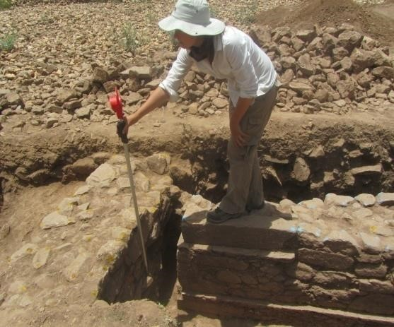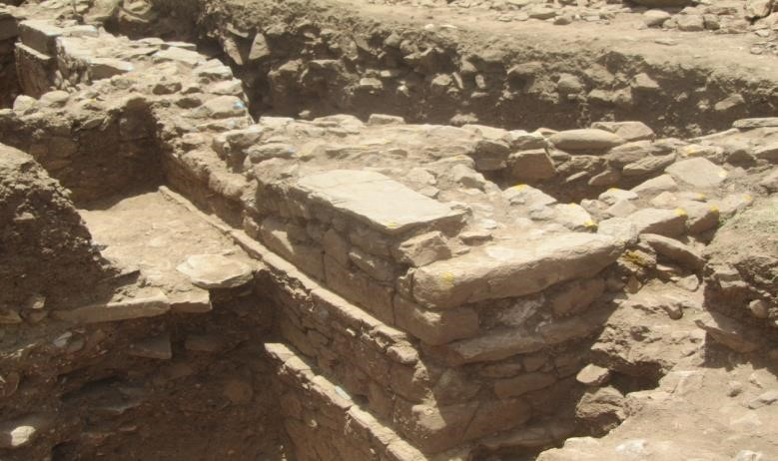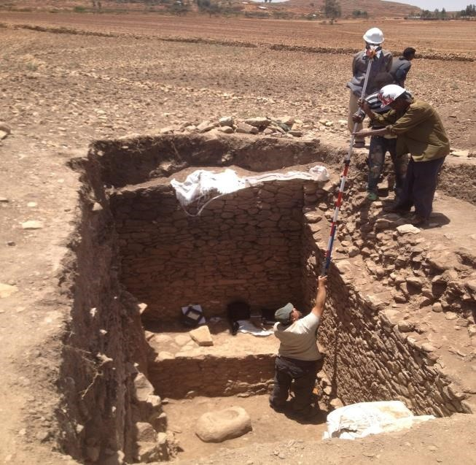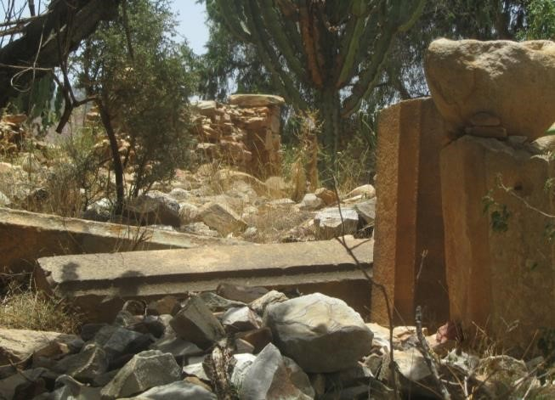

**Adigrat University:** I visited rooms full of analyzed and packed artifacts in Adigrat from the research areas. Why these artifacts aren’t in museum and at first place can we say those artifacts are deteriorating because of being closed in the rooms for years?

**Profe. Catherine:** They are not detonating. Because, we are doing our best to preserve them. It is unwise and unacceptable to invest this money in excavation hiring people and make analysis and then enclosing the artifacts in a store room. That would be tried to avoid in Archaeology. The next step really is for us to preserve them. Hope fully next year we will bring a conservation expert, the most important and the most instructive artifacts will be cured. We do some amount of curation now. You can see here Shannon is for example is curetting some human bone collection. We need to bring someone because we have metal and glass artifacts; we need to bring someone to prepare those for display in a museum, that really is an addition to continuing the academic research which should continuing as well. We need to have parallel activities in our project to bring those items to the public view so that people from this region, school children can go and they can see the exhibits in Tigrina, in Amharic and English. They can learn about the history. It can also help bring more tourism to this region. Next year that will be our next focus in line with the academic research. We will focus on community based activities like developing a museum.

**Adigrat University:** What is your expectation from different local regional and federal stakeholders like Adigrat University to open the possible museum?

**Profe. Catherine:** That is very easy question. We have the artifacts; we have the budget to display the artifacts. What we need is a room. What we need is a building. This is something that research grants from Canada and I think mostly from the United States they don’t support infrastructure. They only support research and communication of research results. So from my end we have the artifacts that we have excavated we can prepare them, we can fund the exhibit cases but what the people here have to decide that has to be done with consultation of Tigray bureau of Tourism Agency, ARCCH Adigrat city Administration and Adigrat University have to decide where the museums can be and when this can happen too. I am waiting for that decision. My role here is a facilitator. That is how I see it. I mean we can advice interims of what thing is the best way to go but ultimately it has to come from the people here. The decision making is here. That is what we are waiting for. There are certain regulations that we have to follow and I fully believe that there should be one governmental organization in charge of antiquates management. If you don’t have that and if you have different regions having different policies you know it can be very confusing and this may not be the best way to advance the national interest. So it has to be a governing body to manage to ensure high quality treatment of antiquities to ensure their preservation, to ensure they are not sold illegally and so forth. And also there has to be both rural (in Menebeit) and urban (Adigrat) museums. I think this is the thing that the people here need to come together and decide to do that.

**Adigrat University:** So I understood that if the respective stakeholders are ready for what you suggest, the museums can be opened by next year?

**Profe. Catherine:** Definitely

**Adigrat University:** Tigray in general is rich in Archaeological potential sites.

What is your suggestion to attract for more international researchers?

**Profe. Catherine:** I think we have already done it. The way to do is to publish. Mezber is not published yet. But we have published the result of two of our surveys. I think that really surprises a lot of people. There are large numbers of sites here. Already after our first article I know that some people have come based on that survey. They are working now in Wukro, Edagahamus and other projects. Publication is key. If Adigrat University (the department of Archeology) eventually does survey that is the show way to attract international groups to come and collaborate together for Archaeological investigations in this region. The other thing that this region is in favor is that the fact that Ethiopia is the most stable country in the broader region beyond the horn of Africa. We are seeing already. Yemeni Archaeologists are coming here. Even in Egypt it is difficult to work. There are problems in Sudan. Right now I think not only Tigray but also Ethiopia in general is becoming very attractive for international researchers because of the stability, because of the development, and also because now there are Archeology departments bringing up in all different parts of the country. So the international people need Ethiopian to collaborate with. While some people are worried that there are many Archaeology departments in Ethiopia but it is still a good thing in a way it gives a chance to link with international projects and develop the potential.

**Adigrat University:** You are working in this project for a decade so far. Do you already produce complete publication?

**Profe.Catherine:** We have some out already. The chicken paper is under review now that Dr. Helina is working on. I hope the really key result about the choreology is taking a longer time. We are working as a monograph; we want to produce a book as well as articles. It is taking us a bit longer because the results are so unusual. We have to be very certain about everything. We have been very careful about the dating and about the presentation of the site. So I hope by the end of this year to have at least all other articles and I hope to make significant progress on the monograph the book- and may be the book will publish by next year.

**Adigrat University:** Last year in 2014 of Meskel celebration in Adigrat, you were presented a paper about the results of this project in the international Archeological conference hosted by Adigrat University. How do you find it?

**Prof. Catherine:** Actually I have met people by chance who attended that international conference. We were trying to find some acetum so we went the Addis pharmaceutical company and they were very kind to us. They actually donated the acetum to us. I am very grateful for them. We met the head chemist who said he attended the conference in Adigrat and he really thought it is a great thing. And also I have met people when I come back that they saw the documentary of the conference by television and I have seen that people are remembering it. Last week we had a surprised visit from elementary school in Mekele. The owner of the school is called Makeda School from GuloMekeda , Dongolo and he came and he was very excited. He brought some 50 students and we explain to them the site of Menebeiti. They were very happy with the result. So the results are penetrating in to the general public which is actually difficult. As an academic we are not well trained to do that, we are only trained to communicate with our academics. But the message is grafting through. To me this is very gratifying. The Meskel Conference is a great way to really publicize the results and gets in to the peoples’ minds. Here there is a museum project in Adigrat and may be they will remember it and it will be good for publicity for the eventual museum might establish.

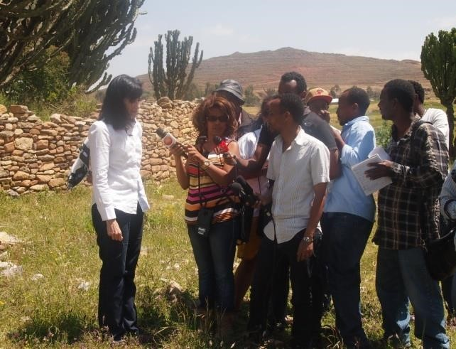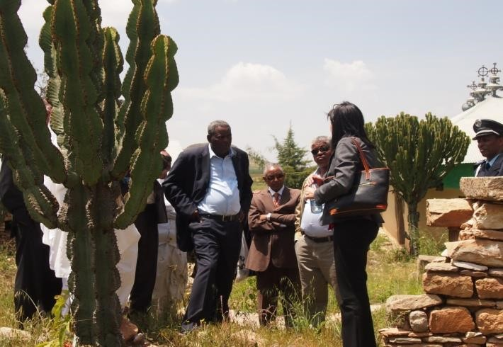

**Adigrat University:** I think the university is working to have an annual Meskel Conference related to Archeology and tourism. Is there any possibility that you can or your colleague can attend in the coming Meskel too?

**Profe. Catherine:** That will be great. I would love to have. You know our team members’ participation may be difficult. The flight is expensive. But from my experience last year it made it clear and important for us to do that. So you know I am going to try that at least a member of our group comes. If I can’t come then for sure I will try to make sure that somebody arrives.

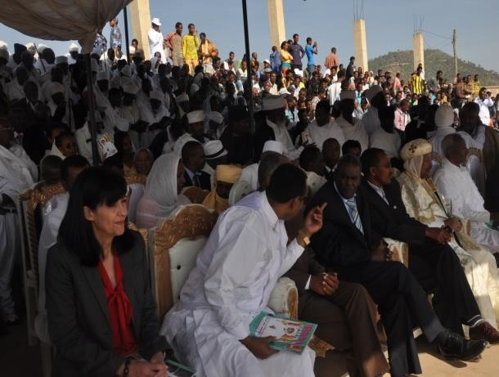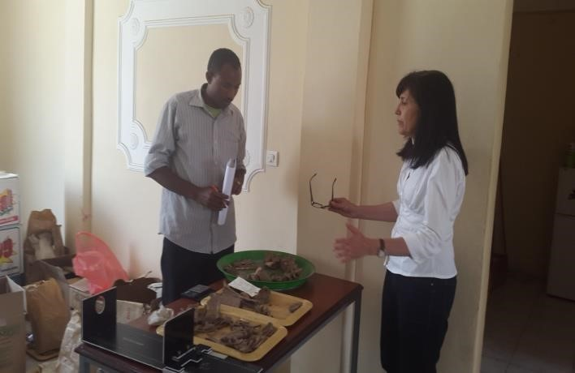

**Adigrat University:** What is the plan to work with ADU?

**Profe.Catherine:** I would really open to that so far one of your staff members is working last year and this yearwith us. Certainly next year we are trying to get additional fund for the museum I hope to include another staff from Adigrat University to become part of the staff to develop the exhibits. As we continue working and excavating and as the staff becomes professional more and more, it would be great to have more participation. Now we have participants from Addis Ababa University, Axum University. So it makes sense for us to work closely with Adigrat University which is right here. I would like hope to do that more in the future.

**Adigrat University:** I am going to finish and may be let me give you a chance to anything you went add.

**Profe.Catherine:** when I heard about Adigrat University, I heard it is going to focus more on other disciplines but now for me it is a big surprise to find and to have an Archeology Department is also a priority. I think this is mostly through the efforts of the university Administration Dr. Zaid and Dr. Alem who are very enthusiastic supporters. Our work as have the department of Archaeology, the social sciences and humanities college and also the department of Sociology, for us this is something that I am happy. So I look forward to continuing cooperation for sure.

**Adigrat University:** I know the university is also very much dedicated for such collaboration to promote and facilitate different academic research for the country. I thank you very much for your golden time.

**Profe.Catherine:** I am very happy too for the time we had and thank you.