***Information and communication technologies \info ing section : B***

***prepared by : Bahri Nourhane younsi anfel madour sirine Brahimi Mouhammed challal rafik ahmed yacine***

***Table of Contents***

***1. Introduction***

***1.1 Background***

***1.2 Purpose of the Report***

***2. Technologies and Tools by Industry Leaders***

***2.1 Google Services***

***2.1.1 Google Search***

***2.1.2 Gmail***

***2.1.3 Google Maps***

***2.1.4 Google Drive***

***2.1.5 Google Docs, Sheets, and Slides***

***2.1.6 YouTube***

***2.1.7 Google Photos***

***2.1.8 Google Calendar***

***2.1.9 Google Translate***

***2.1.10 Google Chrome***

***2.1.11 Android OS***

***2.1.12 Google Ads***

***2.2 Microsoft Office***

***2.2.1 Word, Excel, PowerPoint***

***2.2.2 Outlook***

***2.2.3 Microsoft 365***

***2.2.4 Microsoft Teams***

***2.2.5 Azure DevOps***

***2.2.6 Visual Studio***

***2.2.7 Azure Cloud Services***

***2.2.8 Power Platform***

***2.2.9 Dynamics 365***

***2.2.10 Windows Virtual Desktop***

***2.2.11 GitHub***

***2.2.12 Power BI***

***2.2.13 Microsoft Edge***

***2.3 GitHub***

***2.3.1 Platform Introduction***

***2.3.2 Version Control***

***2.3.3 Key Features***

***2.3.4 Community and Collaboration***

***2.3.5 Open Source Contributions***

***2.3.6 Security and Integrations***

***2.3.7 Education and Learning***

***2.3.8 Continuous Development***

***3. Emerging Technologies in TIC***

***3.1 5G Technology***

***3.2 Artificial Intelligence (AI) and Machine Learning (ML)***

***3.3 Internet of Things (IoT)***

***3.4 Edge Computing***

***3.5 Quantum Computing***

***3.6 Blockchain Technology***

***3.7 Augmented Reality (AR) and Virtual Reality (VR)***

***3.8 Cybersecurity Innovations***

***3.9 Sustainable TIC***

***4. Conclusion***

***4.1 Recap of Key Technologies***

***4.2 Implications and Future Trends***

***5. References***

***Introduction :***

Information and Communication Technologies (TIC) have become integral components of our interconnected global society, shaping the way individuals, businesses, and government, collaborate, and access information. The rapid evolution of TIC has ushered in a new era of technological advancements, revolutionizing the way we work, learn, and interact. This report delves into the broad landscape of TIC and focuses on prominent technologies and tools offered by industry leaders, such as Google, Microsoft, and GitHub, which play pivotal roles in shaping the digital ecosystem.

TIC encompasses a diverse range of technologies that facilitate the gathering, processing, storage, and dissemination of information. From the foundational elements of computer networks and telecommunications to cutting-edge developments in cloud computing and artificial intelligence, TIC serves as the backbone for the modern digital age. This transformative force not only accelerates innovation but also brings about significant changes in the socio-economic and cultural fabric of societies worldwide.

Among the key players in the TIC domain, Google has emerged as a tech giant with a vast array of services that span search engines, cloud computing, productivity tools, and more. Microsoft, another industry titan, offers a comprehensive suite of software and services, ranging from operating systems to productivity applications. ***GitHub***, a platform for version control and collaborative software development, has become a linchpin for developers and organizations fostering open-source collaboration.

As we navigate through this report, we will explore the pivotal role of these technologies in shaping the digital landscape, their impact on various sectors, and the evolving trends that continue to redefine the boundaries of TIC. Understanding the dynamics of these technologies is crucial for businesses, educators, policymakers, and individuals seeking to leverage the power of TIC to drive innovation, efficiency, and connectivity in an increasingly interconnected world

* **GOOGLE SERVICES** :As of my last knowledge update in January 2022, Google offers a wide range of services that have become integral parts of our digital lives. Please note that there may have been changes or updates since then, so it's a good idea to check for the latest information. Here is a general overview of some key Google services:

1. **Google Search :**
   * Google Search is the most popular search engine globally, providing users with access to a vast amount of information on the internet.
2. **Gmail :**
   * Gmail is a widely used email service with features like spam filtering, organized inbox, and integration with other Google services.
3. **Google Maps :**
   * Google Maps offers navigation, real-time traffic updates, street view, and location-based services. It is a go-to tool for finding directions and exploring places.
4. **Google Drive :**
   * Google Drive is a cloud storage service allowing users to store and share files, documents, photos, and more. It integrates with other Google services like Google Docs, Sheets, and Slides.
5. **Google Docs, Sheets, and Slides:**
   * These are productivity tools that offer online document creation, spreadsheet editing, and presentation design, respectively.
6. **YouTube :**
   * Google owns YouTube, a video-sharing platform that has become a major source of entertainment, education, and information.
7. **Google Photos :**
   * Google Photos provides cloud storage for photos and videos. It includes features like automatic backup, image recognition, and easy sharing options.
   * Google Calendar is a time-management and scheduling tool that allows users to organize events, set reminders, and share schedules.
8. **Google Translate :**
   * Google Translate is a language translation service that supports translations for text, speech, and images.
9. **Google Chrome :** 
   * Google's web browser, Chrome, is widely used for its speed, simplicity, and integration with various Google services.
10. **Android OS :**
    * While not a service per se, Google's Android operating system powers a significant portion of the world's mobile devices, providing access to various Google services.

|  |  |
| --- | --- |
| Service | Description |
| Google Search | The most popular global search engine providing access to a vast amount of information on the internet. |
| Gmail | Widely used email service with features like spam filtering, organized inbox, and integration with other Google services. |
| Google Maps | Offers navigation, real-time traffic updates, street view, and location-based services. A go-to tool for finding directions and exploring places |
| Google Drive | Cloud storage service allowing users to store and share files, documents, photos, and more. Integrates with other Google services like Docs, Sheets, and Slides. |
| Google Docs Sheets ,Slides | Productivity tools for online document creation, spreadsheet editing, and presentation design, respectively |
| Youtube | Video-sharing platform owned by Google, serving as a major source of entertainment, education, and information. |
| Google Photos | Cloud storage for photos and videos with features like automatic backup, image recognition, and easy sharing options. |
| Google Calendar | Time-management and scheduling tool allowing users to organize events, set reminders, and share schedules. |
| Google Translate | Language translation service supporting translations for text, speech, and images. |
| Google Chrome | Web browser widely used for its speed, simplicity, and integration with various Google services. |
| Android OS | Operating system powering a significant portion of the world's mobile devices, providing access to various Google services. |
| Google Ads | Advertising platform allowing businesses to promote products or services through online channels, including Google's search and display networks. |

**12Google Ads :**

* + Google Ads is an advertising platform that allows businesses to promote their products or services through various online channels, including Google's search and display networks.

It's important to be aware that Google's services and products may evolve over time, and new offerings may be introduced. Additionally, privacy concerns and regulatory changes may impact how these services operate. For the latest and most accurate information, please refer to Google's official announcements and documentation.

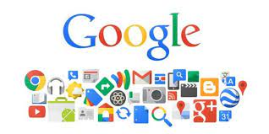

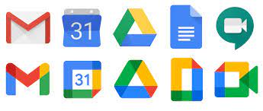

* **MICROSOFT OFFICE :**

As of my last knowledge update in January 2022, Microsoft offers a wide range of tools and software solutions that cater to various needs, including productivity, collaboration, development, and more. Keep in mind that there might have been updates or new releases since then. Here is a general overview of some key Microsoft tools:

**Microsoft Office :**

Word, Excel, PowerPoint: These applications are standard for word processing, spreadsheet creation, and presentation development, respectively.

Outlook: An email client that also includes a calendar, task manager, and contact manager.

**Microsoft 365:**

Formerly known as Office 365, Microsoft 365 is a cloud-based subscription service that includes the Office applications along with other productivity services such as OneDrive (cloud storage), Teams (collaboration platform), and more.

**Microsoft Teams:**

A collaboration platform that integrates chat, video conferencing, file storage, and application integration. It is widely used for remote work and team collaboration.

**Azure DevOps:**

A set of development tools that includes services for version control, build automation, release management, and more. It supports the entire DevOps lifecycle.

**Visual Studio:**

An integrated development environment (IDE) for creating applications for various platforms, including Windows, Android, iOS, and the web.

**Azure Cloud Services:**

Microsoft Azure offers a comprehensive set of cloud services, including computing power, storage, databases, networking, and AI services.

**Power Platform:**

Includes Power BI (for business analytics), Power Apps (for app development), and Power Automate (for workflow automation). These tools empower users to create custom solutions without extensive coding skills.

**Dynamics 365:**

A suite of business applications that includes modules for customer relationship management (CRM), enterprise resource planning (ERP), and more.

Windows Virtual Desktop:

Allows users to access a Windows desktop environment virtually from any device. It's useful for remote work scenarios.

**GitHub:**

Microsoft acquired GitHub, a leading platform for version control and collaboration in software development. It provides Git repository hosting, code review, and collaboration features.

***Power BI:***

A business analytics tool that enables users to visualize and share insights from their data. It supports interactive dashboards and reports.

**Microsoft Edge:**

A web browser developed by Microsoft, replacing Internet Explorer. It is built on the Chromium engine and offers integration with Microsoft services.

It's important to note that Microsoft regularly updates its tools and introduces new features. For the latest and most accurate information, it's recommended to check Microsoft's official website or documentation. 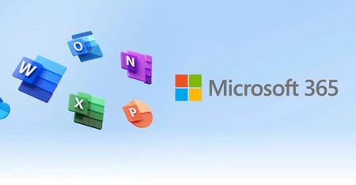 MICROSOFT

|  |  |
| --- | --- |
| TOOL | DESCRIPTION |
| Word,Excel,PowerPoint | Standard applications for word processing, spreadsheet creation, and presentation development, respectively. |
| Outlook | Email client with a calendar, task manager, and contact manager. |
| Microsoft 365 | Cloud-based subscription service including Office applications, OneDrive (cloud storage), Teams (collaboration platform), and more. |
| Microsoft teams | Collaboration platform integrating chat, video conferencing, file storage, and application integration. Widely used for remote work and team collaboration. |

* **GITHUB :**As of my last knowledge update in January 2022, I can provide you with a general overview of GitHub, but keep in mind that there may have been changes or developments since then.

*GitHub Overview:*

**1. Platform Introduction:**

Purpose: GitHub is a web-based platform that uses Git for version control. It facilitates collaboration among developers by providing tools for source code management and sharing.

Ownership: Microsoft acquired GitHub in 2018.

**2. Version Control:**

Git: GitHub is built on Git, a distributed version control system. It allows multiple developers to work on projects simultaneously without conflicting with each other.

**3. Key Features:**

Repositories: Projects on GitHub are stored in repositories, where code, images, and other project files are kept.

Branching and Merging: Developers can create branches to work on specific features or fixes, and then merge them back into the main branch.

Pull Requests: Developers propose changes to the main branch through pull requests, enabling discussion, review, and collaboration before merging.

Issues and Bug Tracking: GitHub provides a system for issue tracking, allowing users to report bugs, suggest enhancements, and discuss project-related topics.

Actions: GitHub Actions automate workflows, allowing developers to build, test, and deploy their code directly from GitHub.

Wikis and Projects: GitHub supports project management with wikis for documentation and project boards for task tracking.

**4. Community and Collaboration:**

Social Coding: GitHub encourages social coding, enabling users to follow each other, star repositories, and contribute to open-source projects.

Forks: Users can fork repositories to create their own copy, make changes, and then submit pull requests to the original repository.

**5. Open Source Contributions:**

Open Source Ecosystem: GitHub hosts a vast number of open-source projects, fostering collaboration and allowing developers worldwide to contribute.

Licensing: Projects on GitHub typically include licenses specifying how others can use, modify, and distribute the code.

**6. Security and Integrations:**

Security Features: GitHub has security features such as vulnerability scanning, dependency insights, and code scanning.

Third-Party Integrations: It integrates with various tools and services, facilitating continuous integration, deployment, and project management.

**7. Education and Learning:**

GitHub Learning Lab: Provides interactive courses on Git, GitHub, and various development topics.

Student Developer Pack: GitHub offers free access to several tools and services for students.

**8. Continuous Development:**

Updates and Enhancements: GitHub undergoes regular updates and improvements, with new features and functionalities being introduced.

* EMERGING TECHNOLOGIES IN TIC:

Information and Communication Technology (ICT) is a rapidly evolving field, and several emerging technologies are shaping the future landscape. This report provides an overview of key technologies that are transforming the ICT sector.

**5G Technology:**

The fifth generation of wireless technology, 5G, is revolutionizing communication networks. With faster data speeds, lower latency, and increased device connectivity, 5G is enabling a wide range of applications, from augmented reality to the Internet of Things (IoT).

**Artificial Intelligence (AI) and Machine Learning (ML)**

AI and ML are becoming integral to ICT, driving advancements in automation, data analysis, and decision-making. These technologies are applied in areas such as natural language processing, computer vision, and predictive analytics, enhancing the efficiency and capabilities of various systems.

**Internet of Things (IoT)**

IoT is expanding, connecting devices and systems to create a smart and interconnected world. From smart homes to industrial applications, IoT is driving efficiency, automation, and data-driven decision-making.

**Edge Computing**

Edge computing brings computational power closer to the data source, reducing latency and improving real-time processing. This is particularly crucial for applications like autonomous vehicles, smart cities, and industrial IoT.

**Quantum Computing**

Quantum computing is on the horizon, promising unprecedented computational power. While still in its early stages, advancements in quantum computing could revolutionize cryptography, optimization problems, and complex simulations.

**Blockchain Technology**

Blockchain is gaining prominence beyond cryptocurrencies, finding applications in secure and transparent transactions, supply chain management, and decentralized finance. It provides a tamper-resistant and distributed ledger, enhancing trust in digital transactions.

**Augmented Reality (AR) and Virtual Reality (VR):**

AR and VR are transforming the way we interact with digital content. In addition to gaming and entertainment, these technologies are being applied in education, healthcare, and training, providing immersive and engaging experiences.

**Cybersecurity Innovations:**

As technology advances, so do cyber threats. Emerging technologies in cybersecurity include AI-driven threat detection, zero-trust security models, and advanced encryption techniques to protect data and systems from evolving cyber threats.

**Sustainable TIC:**

The ICT sector is increasingly focused on sustainability, with innovations in energy-efficient hardware, eco-friendly data centers, and responsible technology practices. Green ICT initiatives aim to reduce the environmental impact of digital technologies.

The rapid evolution of emerging technologies in TIC is reshaping the way we communicate, work, and live. As these technologies continue to mature, they will bring about transformative changes, offering new opportunities and challenges for businesses, individuals, and societies worldwide. It is essential for stakeholders to stay informed and adapt to these technological shifts to harness their full potential.

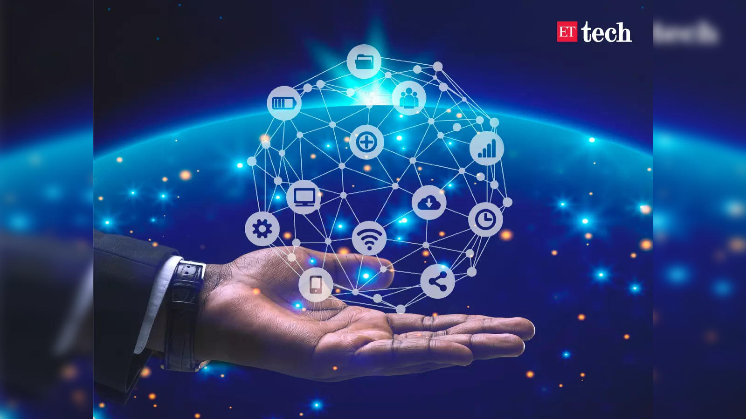

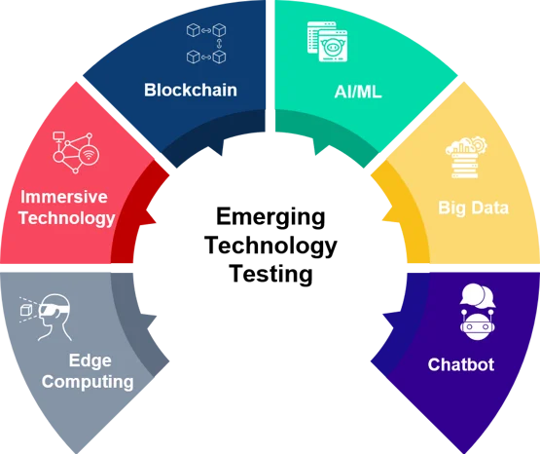

|  |  |
| --- | --- |
| Technology | Description |
| 5G Technology | Fifth generation of wireless technology revolutionizing communication networks with faster data speeds, lower latency, and increased device connectivity. |
| Artificial Intelligence (AI) and Machine Learning (ML) | Integral to ICT, driving advancements in automation, data analysis, and decision-making. Applied in natural language processing, computer vision, and predictive analytics |
| Internet of Things (TOI) | Expanding connectivity, connecting devices and systems to create a smart and interconnected world, driving efficiency, automation, and data-driven decision-making. |