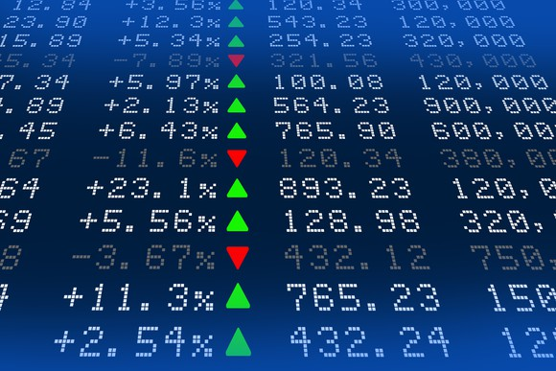

**Background**

You are well on your way to becoming a programmer and Excel expert! In this homework assignment, you will use VBA scripting to analyze generated stock market data.

**Before You Begin**

1. Create a new repository for this project called VBA-challenge. **Do not add this assignment to an existing repository**.
2. Inside the new repository that you just created, add any VBA files that you use for this assignment. These will be the main scripts to run for each analysis.

**Files**

Download the following files to help you get started:

[Module 2 Challenge filesLinks to an external site.](https://static.bc-edx.com/data/dl-1-2/m2/lms/starter/Starter_Code.zip)

**Instructions**

Create a script that loops through all the stocks for one year and outputs the following information:

* The ticker symbol
* Yearly change from the opening price at the beginning of a given year to the closing price at the end of that year.
* The percentage change from the opening price at the beginning of a given year to the closing price at the end of that year.
* The total stock volume of the stock. The result should match the following image:

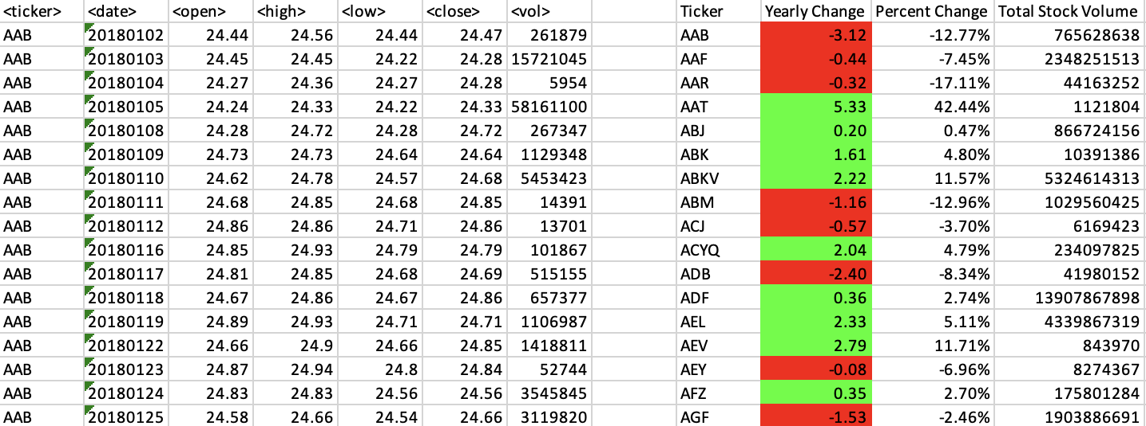

* Add functionality to your script to return the stock with the "Greatest % increase", "Greatest % decrease", and "Greatest total volume". The solution should match the following image:

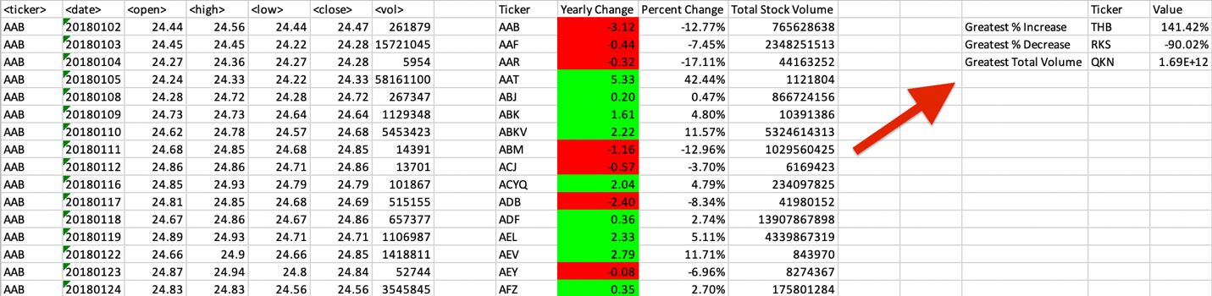

* Make the appropriate adjustments to your VBA script to enable it to run on every worksheet (that is, every year) at once.

**NOTE**

Make sure to use conditional formatting that will highlight positive change in green and negative change in red.

**Other Considerations**

* Use the sheet alphabetical_testing.xlsx while developing your code. This dataset is smaller and will allow you to test faster. Your code should run on this file in under 3 to 5 minutes.
* Make sure that the script acts the same on every sheet. The joy of VBA is that it takes the tediousness out of repetitive tasks with the click of a button.