s

|  |
| --- |
|  |
| **Coursework Part 2 Trimester B 20/21**  Web Platform Development 1 |
| |  |  |  | | --- | --- | --- | | BRIAN GATHUI | April 30th 2021 | BSc (Hons) Computing | |

TABLE OF CONTENTS

Coursework Specifications

Coursework Overview Page 3

Quick Notes Page 4 Required for Submission Page 4

Marking Schedule Page 5

Appendix A Page 8

Part 1: Development Plan & Coursework Report

Development Plan Page 9

Coursework Report Page 10

Part 2: Sources Sheet

Source Sheet Table Page 14

**Coursework Specifications**

**Course Work Overview**

1. You are tasked with designing a website to help the next cohort of students learn CSS. The site should have an introductory page giving a brief overview of the aims of the site.
2. This page should allow access to a quiz and a Contact page.
3. The site will require a clearly laid out interface and an attractive design to keep students engaged.

*The structure of the Quiz is your choice. Some possible options are listed below. You can then choose what type of Quiz you want to create.*

* The **first option** could give users feedback as soon as they have answered each question. Feedback should be given as text output on the page which either congratulates the user for getting the answer correct or gives a short explanation of the correct answer if they get the answer wrong. Remember to think about the look and feel of the site – do you need to have a button next to each question or is there a better kind of interaction you can use for example should the answer be displayed as soon as the user selects an option? Also think about the learning experience for the student – each of the possible options given in a multiple-choice quiz is a possible solution to the question. If a student picks an incorrect answer, they should be given detailed feedback explaining why the choice they made was incorrect and explaining the misconceptions which may have led to them picking the incorrect answer. So, each response should have a separate piece of feedback.
* The **second option** could allow users to answer all of the questions before being given their score for the quiz. Users should score 1 mark for a correct answer and 0 for an incorrect answer. Once they finish the quiz, they should be given their score along with some feedback on which topics they answered correctly and where they made mistakes.
* The **third option** could be to design and implement a quiz which uses a range of other forms of input (i.e., not multiple-choice using radio buttons) and which provides meaningful feedback to users on their performance. Some possible interaction methods include dropdown lists, sliders, number pickers, and drag and drop games, hot spots and text entry. Each question could use a different type of interaction but you should still score the questions and provide feedback to the

*Below is some additional information to consider.*

* You should use your knowledge of the subject area to come up with questions and answers. It is expected that you will have five questions for this quiz. The 3 questions/answers in Appendix A can be used. You can then add your own 2 questions
* Finally, you should demonstrate a way of students contacting the lecturer to ask questions about the module.
* For the purposes of the prototype it is sufficient to produce a form which, when submitted will echo a message out onto the screen thanking the user for their enquiry and stating that they will be contacted within three working days.

**Quick Notes**

* Although there are numerous quiz templates available you are expected to write your own code for this. In order to evidence that you have done so you are required to comment each block of code to explain what is happening
* This coursework focuses mostly on client-side technologies so do not spend time on creating login systems or on storing scores in a database.
* Please read the section about plagiarism carefully. You must be very careful to acknowledge if you have used an online tutorial or code from any other source as a starting point for any of your work. Please also be careful to state where any images you have used have been sourced and that you check that they are copyright free before using them.
* Finally, be aware that you cannot submit the same work twice – this is particularly relevant to stylesheets. This site should have a different ‘look and feel’ than your first coursework and so the CSS are expected to be significantly different.

**Required for Submission**

1. Development plans which could include the following
   * structure charts, wireframes and sample visuals showing the ‘look and feel’ of the site.
2. The interactive website
3. A report of around 500 words which
   * justifies the design you have created
   * describes how you have implemented the quiz
   * explains the difference in approach which would be required if the site was going to store students’ scores and track their progress
   * The ‘Sources Part 2’ document should also be added to the end of the report ( refer to GCULearn).

**Marking Schedule**

**Document Demonstration**

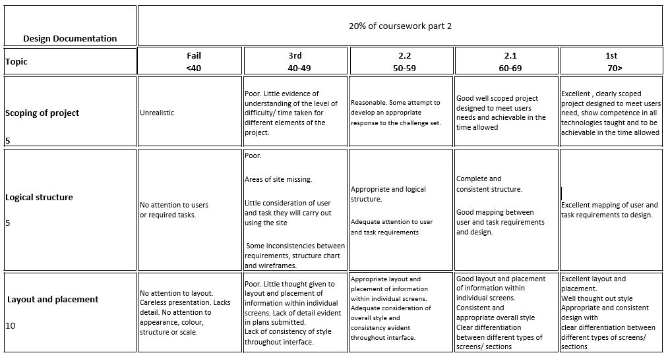

**Electronic Presentation**

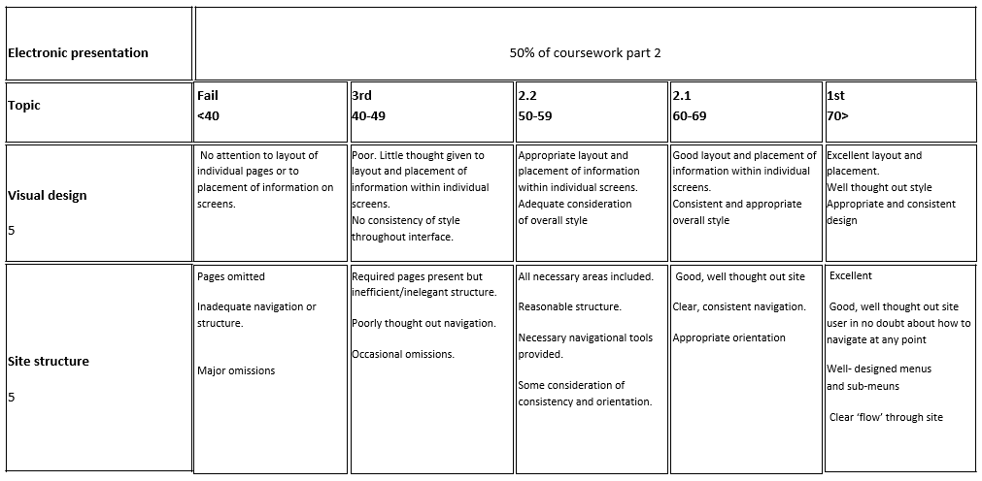

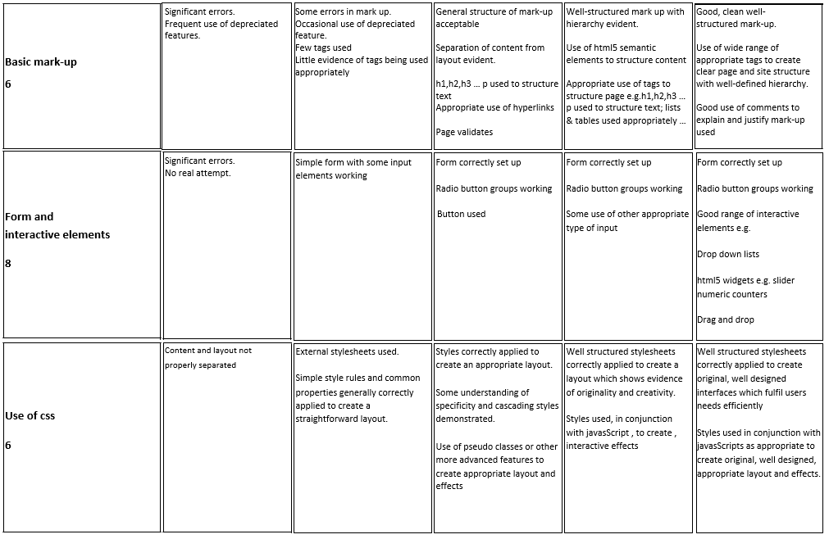

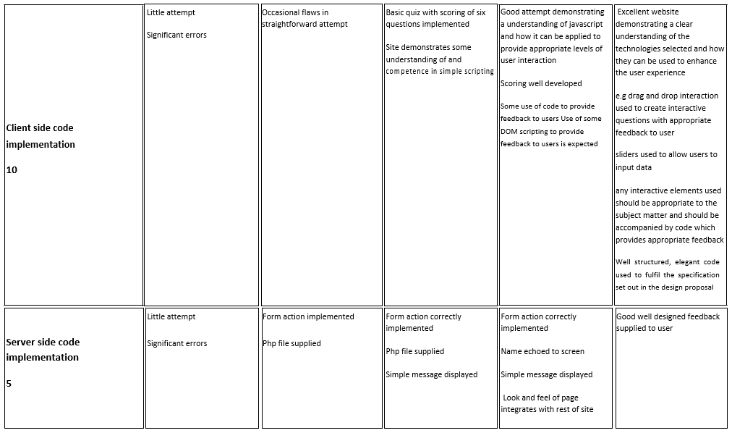

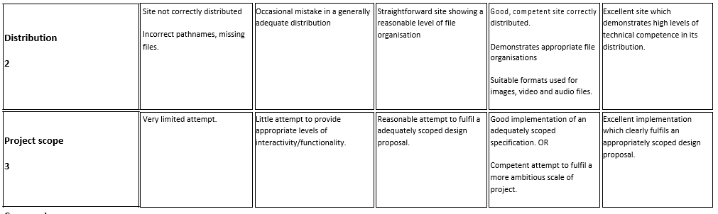

**Report**

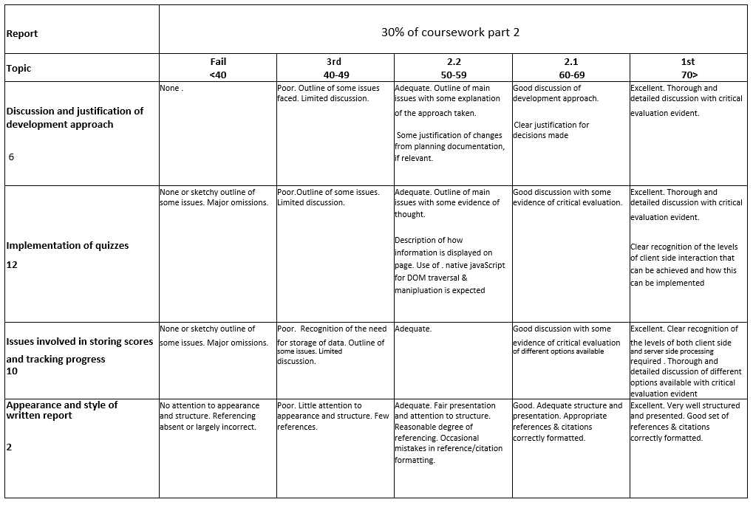

**Appendix A**

You should use the three questions/answers below. You should add 2 questions of your own (based on CSS)

1. Which of the following is the correct format for the CSS?

A. p {

color: red,

text-align: center;

}

B. p {

color: red;

text-align: center;

}

C. p {

color -red;

text-align - center;

}

D. p {

color: red;

text-align: center;

Correct answer B

p {

color: red;

text-align: center;

}

Feedback: CSS syntax is composed of selector and declaration wherein selector points to the HTML element you want to style. The declaration block contains one or more declarations separated by semicolons.Each declaration includes a CSS property name and a value, separated by a colon and declaration blocks are surrounded by curly braces.

See https://www.w3schools.com/css/css_syntax.asp for more information.

2. Which of the following examples is the correct way to use CSS ID selector?

A. #1sen {

text-align: center;

color: red;

}

B. *sen1 {

text-align: center;

color: red;

}

C. #sen1 {

text-align: center;

color: red;

}

Correct answer C.

Hash (#) character is being used to select an element with a specific id. An ID name cannot start with a number

See <https://www.w3schools.com/css/css_selectors.asp> for more information

3. Which of the following can be a possible value for margin properties?

1. auto
2. ?
3. %
4. implement

Correct answer A and C

B and D do not exist as values in CSS margin properties.

See <https://www.w3schools.com/css/css_margin.asp> for more information

**Part 1: Development Plan & Coursework Report**

**Development Plan**

For the Development plan I used Figma. Figma is a vector-based graphics editor that is used for web design, prototyping, and UI/UX design. I thought that it was the best tool for me to fully realize my vision for my website. I tried my best to stick to the original design as much as possible, but there are some changes I made for the better.

***Below is here is the shareable link to my design:*** <https://www.figma.com/file/xM9czoN8iBeAAKXeTTKXmu/Web-Platform-Development-Coursework-2?node-id=0%3A1>

**Coursework Report**

**Design Justification:**

When starting the coursework, I had originally jumped straight into designing it on a piece of paper in order to get all my ideas out on the table. However, soon after I ran into a road block of how I would like my website to flow and feel, what I wanted to include on the website and who was I designing my website for. As response to being stumped, I listed on my design what where the required goals for the website and who as my target audience. This helped me create a three-page design: a home page, contact page, and syllabus page.

**Home Page**

I wanted to create a hero section that was familiar to my target audience (2nd year ALU students) and that would guide the target audience to the syllabus page (which includes the course registration) of the website.

***Navigation***

For the navigation section, which includes the logo (which was designed for free using WIX Logo) is in a familiar format that is recognizable for most of the target audience. The Syllabus link is actually a button that is highlighted using #ff9900 because it is where we want our customers to naturally progress towards this page.

***Hero Section***

I wanted the bold type script of “join one of our courses, develop your CSS skills” to tell the target audience that Ctrl is a website that offers a CSS course that will develop a skill that I desire. There is also a button that is uses the color: #ff9900 which pops off the page and invites the user to interact with it (it would scroll down to the next section ‘Become’).

***Taught by Us Section***

I added this section to increase credibility of the website, to show that Ctrl’s teacher/facilitators work or have worked in world-class institutions that means that this course is credible and worthwhile partaking in.

***Different & Become Sections***

These sections just give more information about the course, what CSS is (since the target audience are 2nd years who are generally unfamiliar about the language), and how Ctrl’s course operates

***How it works***

This section is here to get a sense/ summary of the registration process for Ctrl’s CSS course. There is also a button that will link to the syllabus page further enforcing to the target audience that the syllabus page is a natural progression to go to from the homepage.

***Pricing Package***

This section details payment packages that are available, the only differences are whether there is a facilitator and/ or a certificate included upon completion. This essentially means that the course is virtually entirely for free, meaning college level students (who are generally broke) can definitely afford to join the course and complete it.

***Certified Section***

This section is included in order to further instill Ctrl’s course credibility by showing which agencies have reviewed and certified Ctrl’s course information and structure.

***Call to Action Section:***

If the target audience users haven’t navigated to the syllabus page, this section is guaranteed to do so, only if the rest of the page has grabbed their attention. The section has a button the leads directly to the Syllabus section.

***Footer***

Just has information on a hypothetical downloadable app (which would be a natural progression for the project if necessary), the logo, hyperlinks to navigate anywhere on the website, and follow links (if there were actual socials set up).

**Contact Page**

The contact page is much simpler than the home page, it just contains a hero section, a picture that will be the Google iFrame section, and contact section what has contact information and contact section.

***Hero Section:***

The navigation is the same as the homepage, only there is information on how the page works and a different image.

***Google iFrame:***

This is just a live google map embed of the location (the ALU Campus – as if students created the website on campus and run the customer services).

***Contact Information and Contact Form Section***

This section displays contact information: the customer service email, HQ location for mailing, and phone number. The Contact Form Section has fields to fill in, in order to send a message all fields must be completed. The contact section was designed to be specifically simple to use for ease of use.

**Syllabus Page**

Is of similar design to the homepage, with a hero section that gives information specifically for the syllabus, however there is a video in place of an image for more interactivity. Then there are sections that just give more information on the CSS course about topics covered, prerequisites needed, and why CSS is so important. The only section of not is the course registration section, which is comprised of two parts: Registration Quiz and Registration Form.

***Registration Quiz***

This is section is how I implemented the quiz. Once the prospective student (part of the target audience) decides he, she, or non-binary wants to wants to register, they would need to take a Registration Quiz that hypothetically would log their answers, note which were incorrect and correct- then customize their/his/or her CSS course topics base on the incorrect and correct answers (hypothetically focusing on problem areas). The registration quiz was based on the **first option** quiz formatthat was detailed in the coursework overview above. It was designed with JavaScript jQuery. I added a jQuery function where as soon as an answer (radio or checkbox was selected it would lock the answer in place, meaning that once the answer is shown as correct or incorrect the target audience couldn’t go back and change their answer. The first question is only display because there is a hide and show function used. The next (and previous) buttons were hidden with an on-click hide and show function. I did all the CSS for the Quiz

***Registration Form***

This section is just a simple form where there are fields that are required to be filled in with a submit button at the end which “submits” the form (refreshes the page).

**Difference in Approach:**

If the site was going to store students’ scores and track their progress, there would be a number of ways I would change the design. Firstly, I would add a Registration and Log in section/ page dedicated logging and tracking students registering information w/ date of registration and registering of login w/ date of login. Separating the Syllabus section from the Course Registration section in the process. The login section would be for logging the time and frequency of how many times my students logged in. I would also have a section that appears once logged called ‘My Course” were course information is and engagement is measured. Logging and storing the scores and keeping track of students would require a DBMS, whether it is a RDBMS (like Oracle Database) or a NRDBMS (like NoSQL), and the necessary technologies used to connect them servers if necessary.

**Part 2: Sources Sheet**

**Source Sheet Table**

**Matric Number:**  [M1I324173-20-B](https://blackboard.gcal.ac.uk/webapps/blackboard/execute/courseMain?course_id=_109643_1)

**Name:** Brian Gathui

**Program:** [20/21 B - Web Platform Development 1](https://blackboard.gcal.ac.uk/webapps/blackboard/execute/courseMain?course_id=_109643_1)

*I confirm that the material contained within the submitted coursework is all my own work unless otherwise stated below*

|  |  |
| --- | --- |
|  | **Sources** |
| **JavaScript** | **AOS Library**   * [*https://michalsnik.github.io/aos/*](https://michalsnik.github.io/aos/)   **jQuery**   * [*https://jquery.com/download/*](https://jquery.com/download/) *(specifically:* [***Download the compressed, production jQuery 3.6.0***](https://code.jquery.com/jquery-3.6.0.min.js)*) (*[*https://code.jquery.com/jquery-3.6.0.min.js*](https://code.jquery.com/jquery-3.6.0.min.js) *)*   **Registration Quiz (help with just the Java/ no CSS was Used)**   * [*https://www.eduonix.com/courses/Web-Development/Learn-HTML5-Quiz-Application*](https://www.eduonix.com/courses/Web-Development/Learn-HTML5-Quiz-Application)   **Help with if/else Statements**   * [*https://www.w3schools.com/js/js_if_else.asp*](https://www.w3schools.com/js/js_if_else.asp) * [*https://stackoverflow.com/questions/54539090/display-a-true-false-as-a-yes-no-with-if-else-statment-jquery*](https://stackoverflow.com/questions/54539090/display-a-true-false-as-a-yes-no-with-if-else-statment-jquery)   **Help with if/else multiple conditions**   * [*https://www.youtube.com/watch?v=N4V0FZASK60*](https://www.youtube.com/watch?v=N4V0FZASK60)   **Clarification with Selector Syntax**   * [*https://www.w3schools.com/jquery/jquery_syntax.asp*](https://www.w3schools.com/jquery/jquery_syntax.asp)   **Disable Input (basecode)**   * <https://help.alchemer.com/help/disable-radio-button-once-option-is-selected> |
| **PHP** |  |
| **HTML** | **Home Page**   * ***Navigation/ Header Section:*** *Base code for layout is from this link:* [*https://www.youtube.com/watch?v=yQimoqo0-7g*](https://www.youtube.com/watch?v=yQimoqo0-7g) * ***Become and Different Section:*** *Base code for layout is from* [*https://www.youtube.com/watch?v=yQimoqo0-7g*](https://www.youtube.com/watch?v=yQimoqo0-7g) * ***Taught By and Certified section:*** *Base code for layout:* [*https://www.youtube.com/watch?v=yQimoqo0-7g*](https://www.youtube.com/watch?v=yQimoqo0-7g) * ***Package Pricing:*** *Base code for layout:*   [*https://www.youtube.com/watch?v=jfh0ZJFhj2w*](https://www.youtube.com/watch?v=jfh0ZJFhj2w)  **Contact Page**   * ***Navigation/ Header Section:*** *Base code for layout is from this link:* [*https://www.youtube.com/watch?v=yQimoqo0-7g*](https://www.youtube.com/watch?v=yQimoqo0-7g) * ***Contact Section***   [*https://www.youtube.com/watch?v=oYRda7UtuhA*](https://www.youtube.com/watch?v=oYRda7UtuhA)  **Syllabus Page**   * ***Navigation/ Header Section:*** *Base code for layout is from this link:* [*https://www.youtube.com/watch?v=yQimoqo0-7g*](https://www.youtube.com/watch?v=yQimoqo0-7g) * ***Useful, Prerequisites, and Topics Section:*** *Base code for layout is from* [*https://www.youtube.com/watch?v=yQimoqo0-7g*](https://www.youtube.com/watch?v=yQimoqo0-7g) * ***Registration Quiz (help with just the Java/ no CSS was Used)***   [*https://www.eduonix.com/courses/Web-Development/Learn-HTML5-Quiz-Application*](https://www.eduonix.com/courses/Web-Development/Learn-HTML5-Quiz-Application)   * ***Country Options for Select Input***   [*https://stackoverflow.com/questions/53388003/select-country-dropdown-in-html-page*](https://stackoverflow.com/questions/53388003/select-country-dropdown-in-html-page) |
| **CSS**  **(most same as HTML)** | **Home Page**   * ***Navigation/ Header Section:*** *Base code for layout is from this link:* [*https://www.youtube.com/watch?v=yQimoqo0-7g*](https://www.youtube.com/watch?v=yQimoqo0-7g) * ***Become and Different Section:*** *Base code for layout is from* [*https://www.youtube.com/watch?v=yQimoqo0-7g*](https://www.youtube.com/watch?v=yQimoqo0-7g) * ***Taught By and Certified section:*** *Base code for layout:* [*https://www.youtube.com/watch?v=yQimoqo0-7g*](https://www.youtube.com/watch?v=yQimoqo0-7g) * ***Package Pricing:*** *Base code for layout:*   [*https://www.youtube.com/watch?v=jfh0ZJFhj2w*](https://www.youtube.com/watch?v=jfh0ZJFhj2w)  **Contact Page**   * ***Navigation/ Header Section:*** *Base code for layout is from this link:* [*https://www.youtube.com/watch?v=yQimoqo0-7g*](https://www.youtube.com/watch?v=yQimoqo0-7g) * ***Contact Section***   [*https://www.youtube.com/watch?v=oYRda7UtuhA*](https://www.youtube.com/watch?v=oYRda7UtuhA)  **Syllabus Page**   * ***Navigation/ Header Section:*** *Base code for layout is from this link:* [*https://www.youtube.com/watch?v=yQimoqo0-7g*](https://www.youtube.com/watch?v=yQimoqo0-7g) * ***Useful, Prerequisites, and Topics Section:*** *Base code for layout is from* [*https://www.youtube.com/watch?v=yQimoqo0-7g*](https://www.youtube.com/watch?v=yQimoqo0-7g)   **Hover Image (black and white/ greyscale)**   * [*https://codepen.io/nxworld/pen/ZYNOBZ*](https://codepen.io/nxworld/pen/ZYNOBZ)   **Scrollbar**   * [*https://www.w3schools.com/howto/howto_css_custom_scrollbar.asp*](https://www.w3schools.com/howto/howto_css_custom_scrollbar.asp)   **Change highlight (with ::selection)**   * [*https://www.w3schools.com/cssref/sel_selection.asp*](https://www.w3schools.com/cssref/sel_selection.asp) |
| **Images** | **Homepage**   * *Photo by* [*ConvertKit*](https://unsplash.com/@convertkit?utm_source=unsplash&utm_medium=referral&utm_content=creditCopyText) *on* [*Unsplash*](https://unsplash.com/photos/wsFAsd-6B1I) * *Photo by* [*LinkedIn Sales Solutions*](https://unsplash.com/@linkedinsalesnavigator?utm_source=unsplash&utm_medium=referral&utm_content=creditCopyText) *on* [*Unsplash*](https://unsplash.com/photos/EI50ZDA-l8Y) * [*https://burst.shopify.com/photos/friends-look-on-laptop*](https://burst.shopify.com/photos/friends-look-on-laptop)   **Contact Page**   * *Photo by* [*LinkedIn Sales Solutions*](https://unsplash.com/@linkedinsalesnavigator?utm_source=unsplash&utm_medium=referral&utm_content=creditCopyText) *on* [*Unsplash*](https://unsplash.com/photos/W3Jl3jREpDY)   **Syllabus**   * *Video:* [*https://www.youtube.com/watch?v=qKoajPPWpmo*](https://www.youtube.com/watch?v=qKoajPPWpmo)   *cover image:* [*https://tuhoclaptrinh.edu.vn/bai-viet/ngon-ngu-css-la-gi-213.html*](https://tuhoclaptrinh.edu.vn/bai-viet/ngon-ngu-css-la-gi-213.html)   * *Photo by* [*Kevin Canlas*](https://unsplash.com/@kvncnls?utm_source=unsplash&utm_medium=referral&utm_content=creditCopyText) *on* [*Unsplash*](https://unsplash.com/photos/cFFEeHNZEqw) * [*https://miro.medium.com/max/1250/0*Fw6SXrtOiQe2AgTB.jpg*](https://miro.medium.com/max/1250/0*Fw6SXrtOiQe2AgTB.jpg) * *Photo by* [*Ray Fragapane*](https://unsplash.com/@rayfra?utm_source=unsplash&utm_medium=referral&utm_content=creditCopyText) *on* [*Unsplash*](https://unsplash.com/photos/QM5-lbqzREc)   **All Logos:**   * [*https://worldvectorlogo.com/*](https://worldvectorlogo.com/) * [*https://www.alueducation.com/*](https://www.alueducation.com/) * [*https://code.visualstudio.com/*](https://code.visualstudio.com/) * [*https://www.eahea.org/*](https://www.eahea.org/) * [*https://education.govmu.org/SitePages/Index.aspx*](https://education.govmu.org/SitePages/Index.aspx) * [*https://www.mineduc.gov.rw/*](https://www.mineduc.gov.rw/) * [*https://www.gcu.ac.uk/*](https://www.gcu.ac.uk/) * [*https://asic.gov.au/*](https://asic.gov.au/) |
| **Text** | <https://www.codecademy.com/learn/learn-css>  <https://www.joshwcomeau.com/css/the-importance-of-learning-css/> |