**Accident**

**Symbol Name: Accident**

**Symbol Picture:** 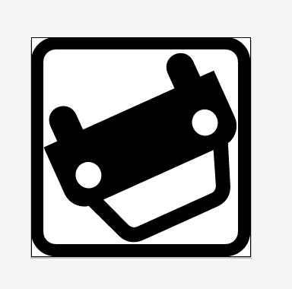

**Symbol Source: Public Domain “Car” symbol from the Noun Project**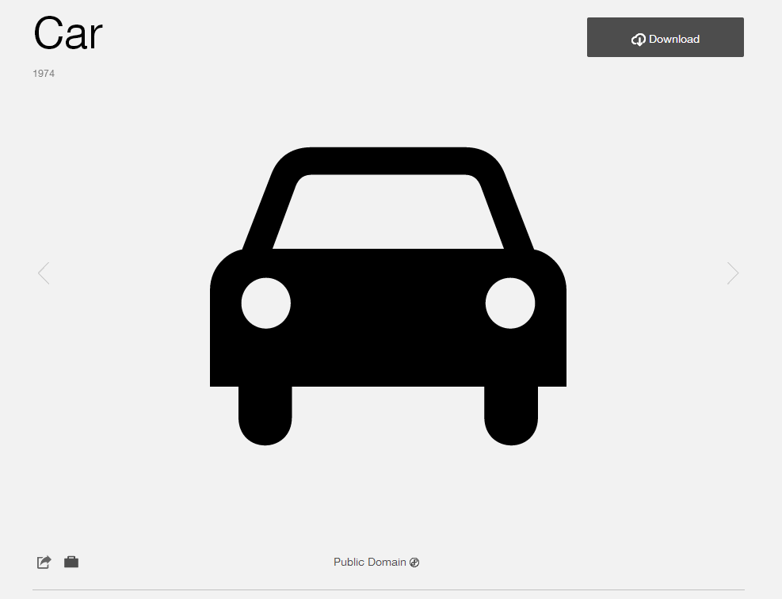

**Source Date: March 2014**

**Modified: Modified by Esri Solutions Team**

**License: Public Domain**

**Acknowledgement: None required**

**Notes: None**

**Arrest Symbol**

**Symbol Name: Arrest**

**Symbol Picture:**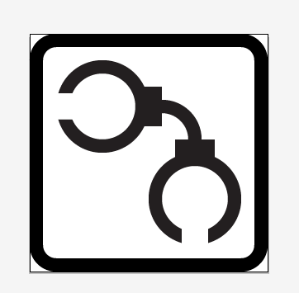

**Symbol Source: Developed by Esri Graphic Department**

**Modified: Modified by Esri Solutions Team**

**License:**

**Arson Symbol**

**Symbol Name: Arson**

**Symbol Picture:** 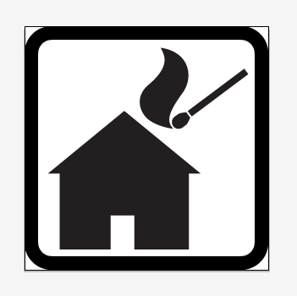

**Symbol Source: Public Domain “Match” symbol from the Noun Project** [**http://thenounproject.com/term/match/1120/**](http://thenounproject.com/term/match/1120/)

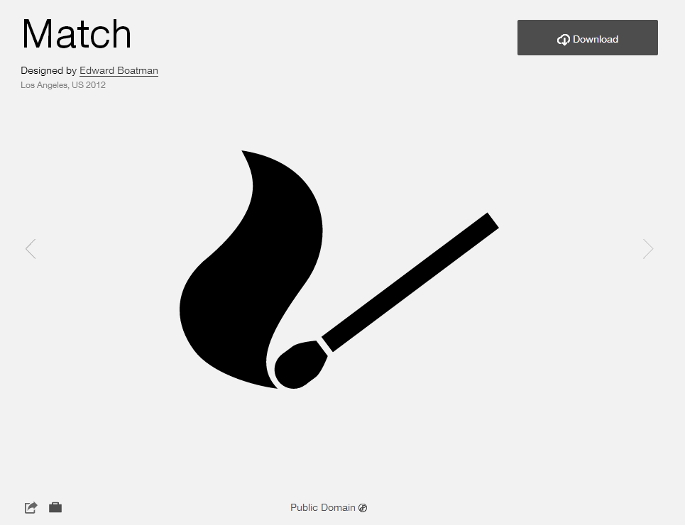

**Source Date: March 2014**

**Modified: Modified by Esri Solutions Team to include house**

**License: Public Domain**

**Acknowledgement: None required**

**Notes: None**

**Assassination Symbol**

**Symbol Name: Assisination**

**Symbol Picture:** 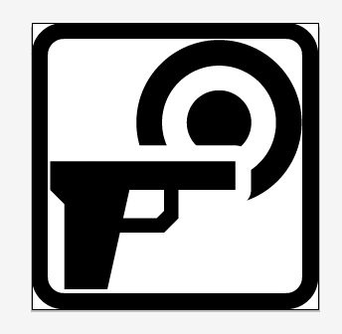

**Symbol Source: Developed by Esri Graphic Department**

**Modified: Modified by Esri Solutions Team**

**License:**

**Attack Symbol**

**Symbol Name: Attack**

**Symbol Picture:**

**Symbol Source: Developed by Esri Graphic Department**

**Modified: Modified by Esri Solutions Team**

**License:**

**Demonstration Symbol**

**Symbol Name: Demonstration**

**Symbol Picture:**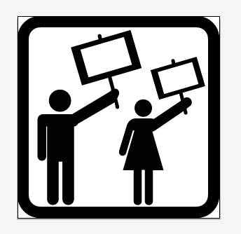

**Symbol Source: Man icon from the Noun Project** [**http://thenounproject.com/term/man/2/**](http://thenounproject.com/term/man/2/)

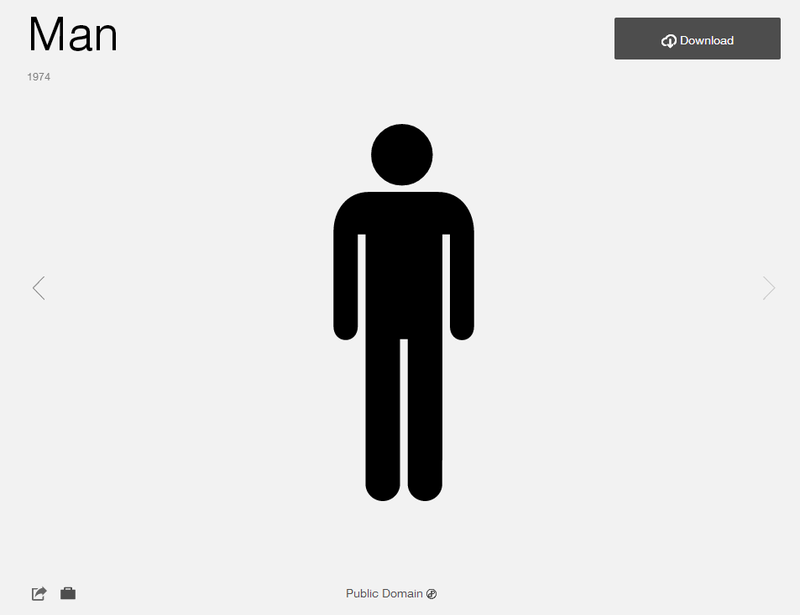

**Woman icon from the Noun Project** [**http://thenounproject.com/term/woman/5/**](http://thenounproject.com/term/woman/5/)

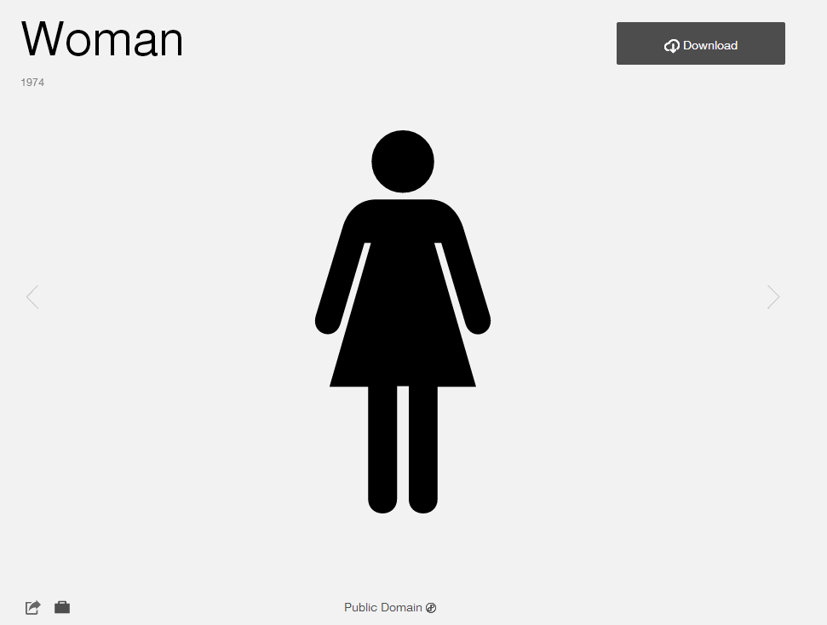

**Source Date: March 2014**

**Modified: Modified by Esri Solutions Team**

**License: Public Domain**

**Acknowledgement: None required**

**Notes: None**

**Detain Symbol**

**Symbol Name: Detain**

**Symbol Picture:** 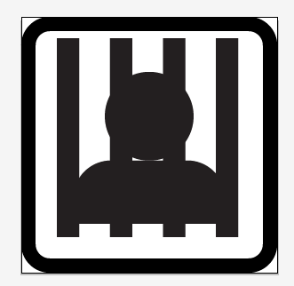

**Symbol Source: Developed by Esri Graphic Department**

**Modified: Modified by Esri Solutions Team**

**License:**

**Direct Fire Symbol**

**Symbol Name: Direct Fire**

**Symbol Picture:** 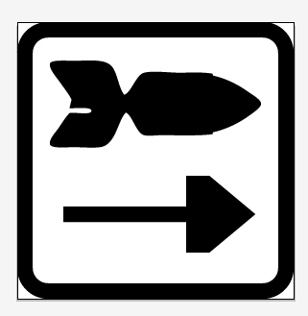

**Symbol Source: Developed by Esri Solutions Team**

**Modified:**

**License:**

**IED Symbol**

**Symbol Name: IED**

**Symbol Picture:** 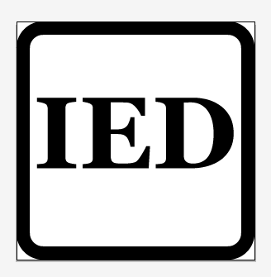

**Symbol Source: Developed by Esri Solutions Team**

**Modified:**

**License:**

**Font Used: Georgia Font**

**Indirect Fire Symbol**

**Symbol Name: Indirect Fire**

**Symbol Picture:** 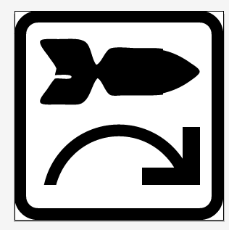

**Symbol Source: Developed by Esri Solutions Team**

**Modified:**

**License:**

**Med Evac Symbol**

**Symbol Name: MedEvac**

**Symbol Picture:**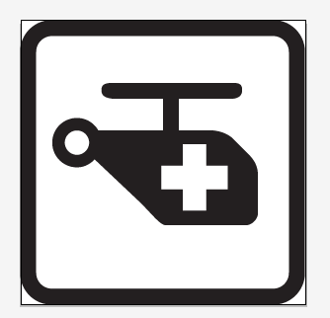

**Symbol Source: Helicopter symbol from the Noun Project** [**http://thenounproject.com/term/heliport/2432/**](http://thenounproject.com/term/heliport/2432/)

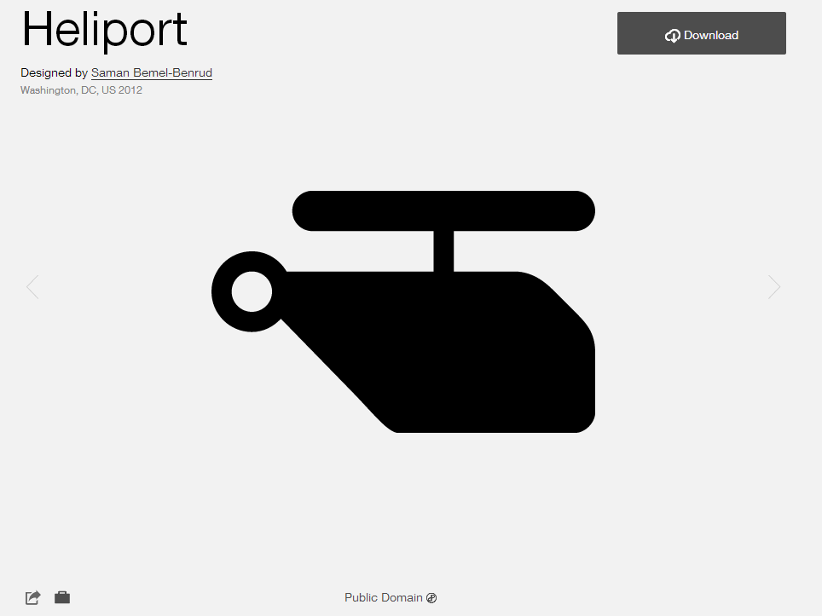

**Modified: Modified by Esri Solutions Team**

**License: Public Domain**

**Acknowledgement: None required**

**Notes: None**

**Mine Found and Cleared**

**Symbol Name: Mine Found and Cleared**

**Symbol Picture:** 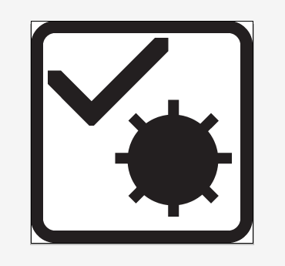

**Symbol Source: Developed by Esri Graphic Department**

**Modified: Modified by Esri Solutions Team**

**License:**

**Mine Strike Symbol**

**Symbol Name: Mine Strike**

**Symbol Picture:** 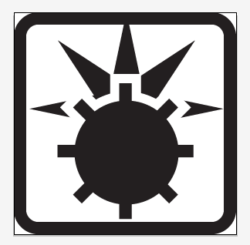

**Symbol Source: Developed by Esri Graphic Department**

**Modified: Modified by Esri Solutions Team**

**License:**

**Murder Symbol**

**Symbol Name: Murder**

**Symbol Picture:** 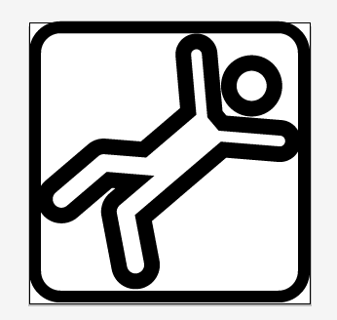

**Symbol Source: “Falling” icon from the Noun Project** [**http://thenounproject.com/term/falling/12969/**](http://thenounproject.com/term/falling/12969/)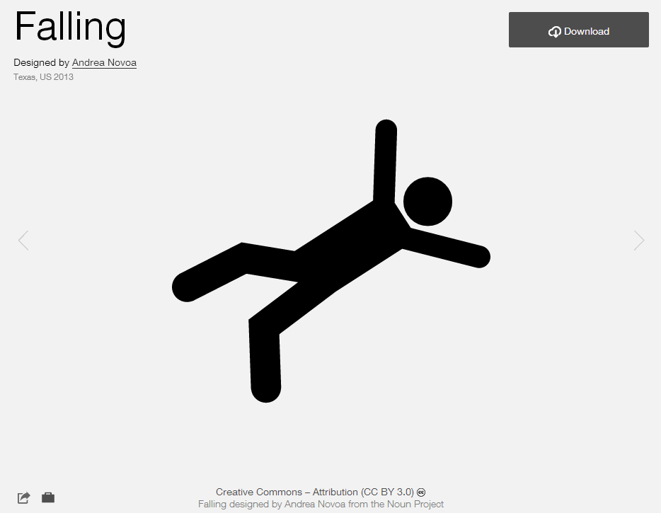

**Modified: Modified by Esri Solutions Team**

**License: CC BY 3.0**

**Acknowledgement: Andrea Novoa from the Noun Project**

**Notes: None**

**Other Defensive Symbol**

**Symbol Name: Other Defensive**

**Symbol Picture:** 

**Symbol Source: Developed by Esri Solutions Team**

**Modified:**

**License:**

**Font Used: Georgia Font**

**Other Offensive Symbol**

**Symbol Name: Other Offensive**

**Symbol Picture:** 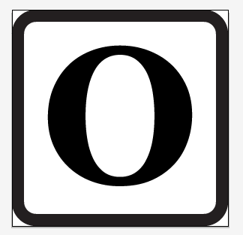

**Symbol Source: Developed by Esri Solutions Team**

**Modified:**

**License:**

**Font Used: Georgia Font**

**Propaganda Symbol**

**Symbol Name: Propaganda**

**Symbol Picture:**

**Symbol Source:“Megaphone” icon from The Noun Project http://thenounproject.com/term/megaphone/5311/**

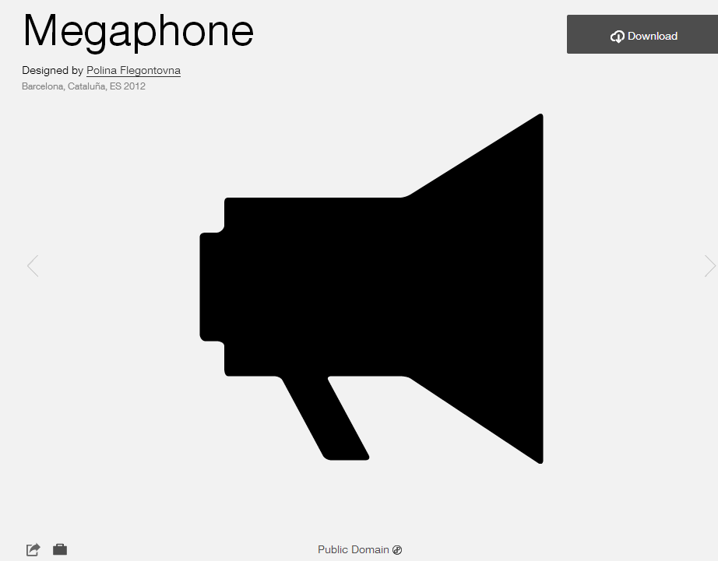

**Modified: Modified by Esri Solutions Team**

**License: Public Domain**

**Acknowledgement: None required**

**Notes: None**

**Small Arms Fire Symbol**

**Symbol Name: Small Arms Fire**

**Symbol Picture:**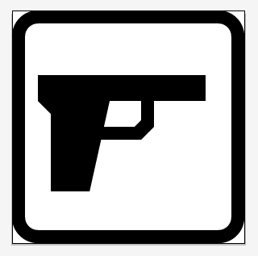

**Symbol Source: Developed by Esri Graphic Department**

**Modified: Modified by Esri Solutions Team**

**License:**

**Surveillance Symbol**

**Symbol Name: Surveillance**

**Symbol Picture:** 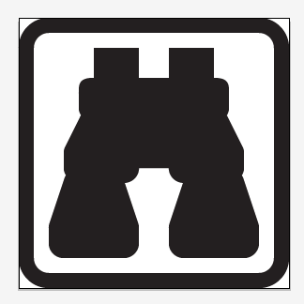

**Symbol Source: Developed by Esri Graphic Department**

**Modified: Modified by Esri Solutions Team**

**License:**

**Unexploded Ordinance Symbol**

**Symbol Name: Unexploded Ordinance**

**Symbol Picture:** 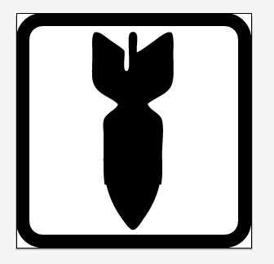

**Symbol Source: Developed by Esri Solutions Team**

**Modified:**

**License:**

**Unknown Explosion Symbol**

**Symbol Name: Unknown Explosion**

**Symbol Picture:** 

**Symbol Source: Developed by Esri Graphic Department**

**Modified: Modified by Esri Solutions Team**

**License:**