**Air Incident**

**Symbol Name: Air Incident**

**Symbol Picture:** 

**Symbol Source: Homeland Security Working Group http://www.fgdc.gov/HSWG/index.html**

**Source Date: April 2014**

**Modified: Modified by Esri Solutions Team**

**License: Public Domain**

**Acknowledgement: None required**

**Notes: None**

**Avalanche**

**Symbol Name: Avalanche**

**Symbol Picture:** 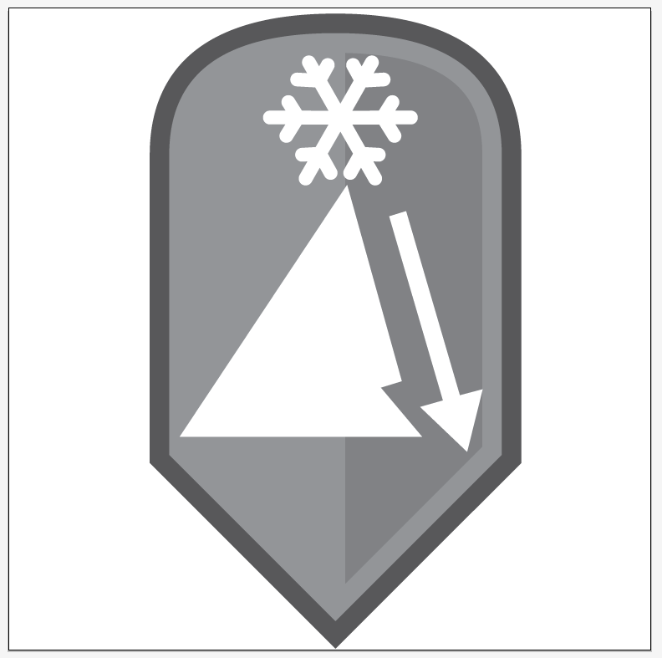

**Symbol Source: Homeland Security Working Group** [**http://www.fgdc.gov/HSWG/index.html**](http://www.fgdc.gov/HSWG/index.html) **and “Snowflake”** [**http://thenounproject.com/term/snowflake/3777/**](http://thenounproject.com/term/snowflake/3777/)

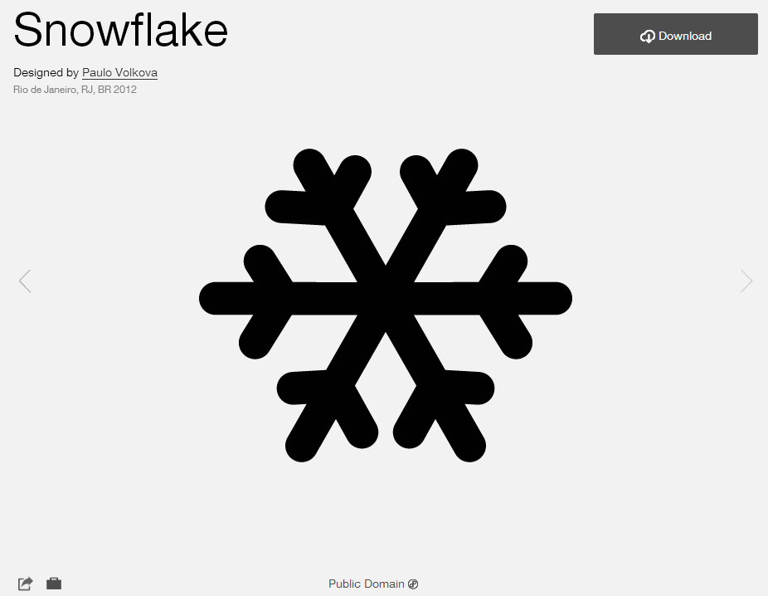

**Source Date: April 2014**

**Modified: Modified by Esri Solutions Team**

**License: Public Domain.**

**Acknowledgement: none required**

**Notes: None**

**Bomb**

**Symbol Name: Bomb**

**Symbol Picture:** 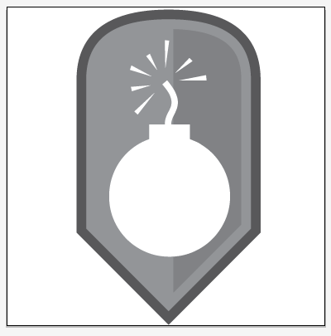

**Symbol Source: Homeland Security Working Group http://www.fgdc.gov/HSWG/index.html**

**Source Date: April 2014**

**Modified: Modified by Esri Solutions Team**

**License: Public Domain**

**Acknowledgement: None required**

**Notes: None**

**Civil Disturbance**

**Symbol Name: Civil Disturbance**

**Symbol Picture:** 

**Symbol Source: Esri Solutions Team**

**Source Date: April 2014**

**Modified:**

**License:**

**Acknowledgement: None required**

**Notes: None**

**Criminal Activity**

**Symbol Name: Criminal Activity**

**Symbol Picture:** 

**Symbol Source: Homeland Security Working Group http://www.fgdc.gov/HSWG/index.html**

**Source Date: April 2014**

**Modified: Modified by Esri Solutions Team**

**License: Public Domain**

**Acknowledgement: None required**

**Notes: None**

**Drought**

**Symbol Name: Drought**

**Symbol Picture:** 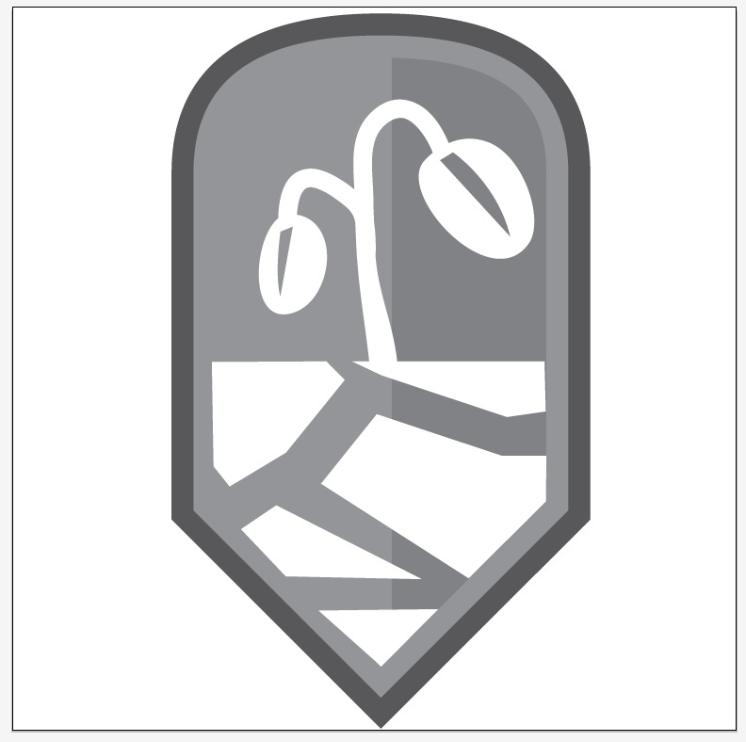

**Symbol Source: “Drought” from The Noun project http://thenounproject.com/term/drought/4231/**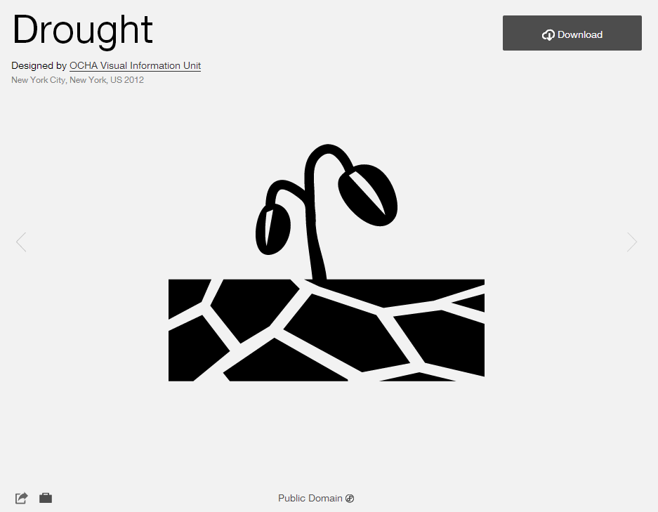

**Source Date: April 2014**

**Modified: Modified by Esri Solutions Team**

**License: Public Domain**

**Acknowledgement: None required**

**Notes: None**

**Earthquake**

**Symbol Name: Earthquake**

**Symbol Picture:** 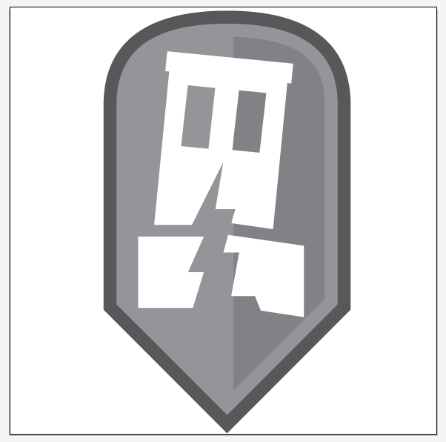

**Symbol Source: “Earthquake” from The Noun project http://thenounproject.com/term/earthquake/8681/** 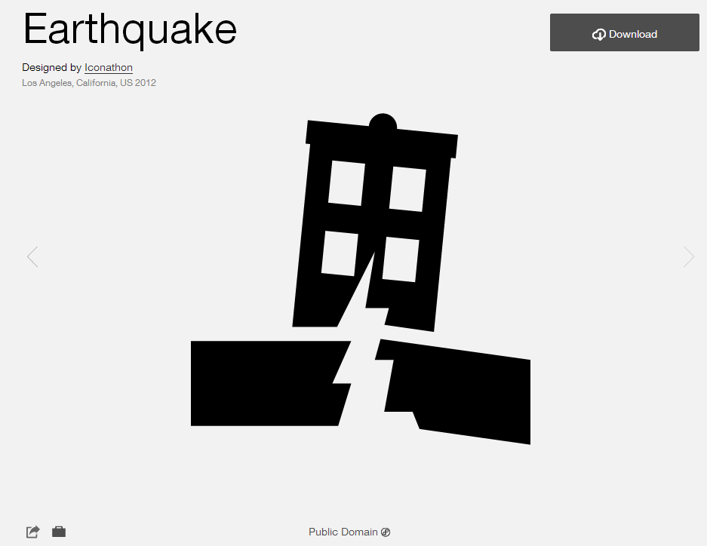

**Source Date: April 2014**

**Modified: Modified by Esri Solutions Team**

**License: Public Domain**

**Acknowledgement: None required**

**Notes: None**

**Fire**

**Symbol Name: Fire**

**Symbol Picture:** 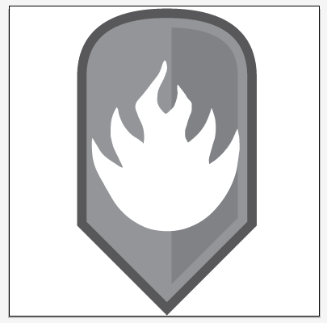

**Symbol Source: Homeland Security Working Group http://www.fgdc.gov/HSWG/index.html**

**Source Date: April 2014**

**Modified: Modified by Esri Solutions Team**

**License: Public Domain**

**Acknowledgement: None required**

**Notes: None**

**Flood**

**Symbol Name: Flood**

**Symbol Picture:** 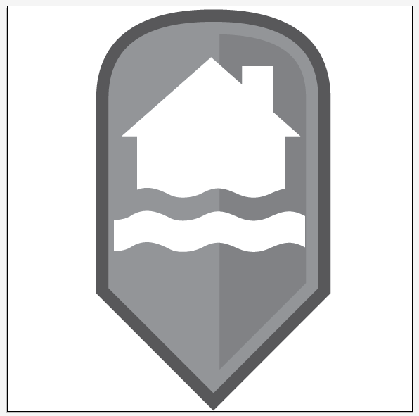

**Symbol Source: “Flood” from The Noun project http://thenounproject.com/term/flood/752/** 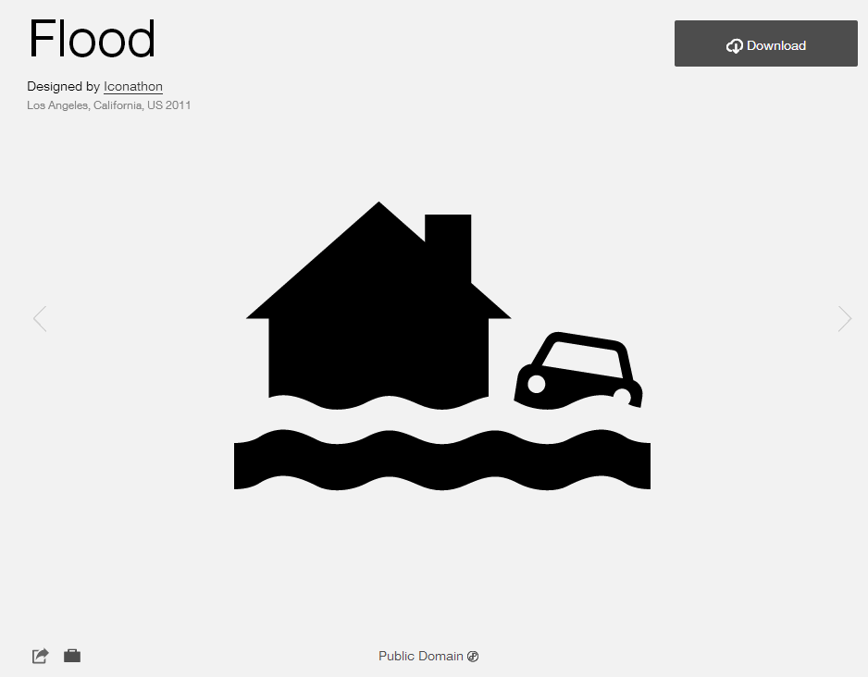

**Source Date: April 2014**

**Modified: Modified by Esri Solutions Team**

**License: Public Domain**

**Acknowledgement: None required**

**Notes: None**

**Hail**

**Symbol Name: Hail**

**Symbol Picture:** 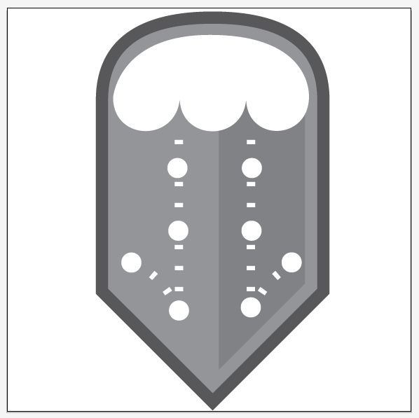

**Symbol Source: Esri Solutions Team**

**Source Date: April 2014**

**Modified:**

**License:**

**Acknowledgement: None required**

**Notes: None**

**HazMat**

**Symbol Name: HazMat**

**Symbol Picture:** 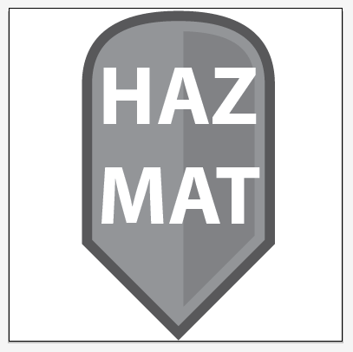

**Symbol Source: Esri Solutions Team**

**Source Date: April 2014**

**Modified:**

**License:**

**Acknowledgement: None required**

**Notes: None**

**Infestation**

**Symbol Name: Infestation**

**Symbol Picture:** 

**Symbol Source: Esri Solutions Team**

**Source Date: April 2014**

**Modified:**

**License:**

**Acknowledgement: None required**

**Notes: None**

**Landslide**

**Symbol Name: Landslide**

**Symbol Picture:** 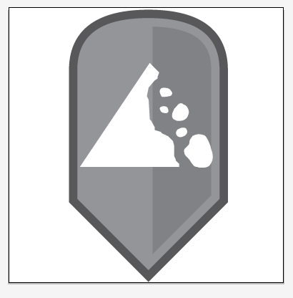

**Symbol Source: Homeland Security Working Group http://www.fgdc.gov/HSWG/index.html**

**Source Date: April 2014**

**Modified: Modified by Esri Solutions Team**

**License: Public Domain**

**Acknowledgement: None required**

**Notes: None**

**Marine Incident**

**Symbol Name: Marine Incident**

**Symbol Picture:** 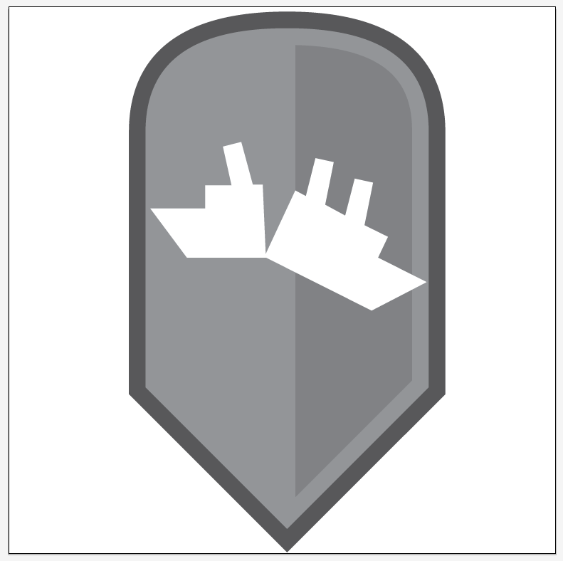

**Symbol Source: Homeland Security Working Group http://www.fgdc.gov/HSWG/index.html**

**Source Date: April 2014**

**Modified: Modified by Esri Solutions Team**

**License: Public Domain**

**Acknowledgement: None required**

**Notes: None**

**Radioactive Material**

**Symbol Name: Radioactive Material**

**Symbol Picture:** 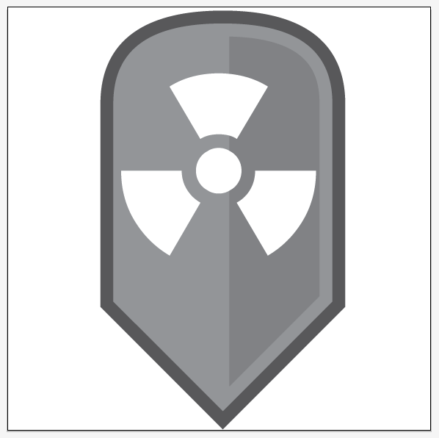

**Symbol Source: Homeland Security Working Group http://www.fgdc.gov/HSWG/index.html**

**Source Date: April 2014**

**Modified: Modified by Esri Solutions Team**

**License: Public Domain**

**Acknowledgement: None required**

**Notes: None**

**Rail Incident**

**Symbol Name: Rail Incident**

**Symbol Picture:** 

**Symbol Source: Homeland Security Working Group http://www.fgdc.gov/HSWG/index.html**

**Source Date: April 2014**

**Modified: Modified by Esri Solutions Team**

**License: Public Domain**

**Acknowledgement: None required**

**Notes: None**

**Snow**

**Symbol Name: Snow**

**Symbol Picture:** 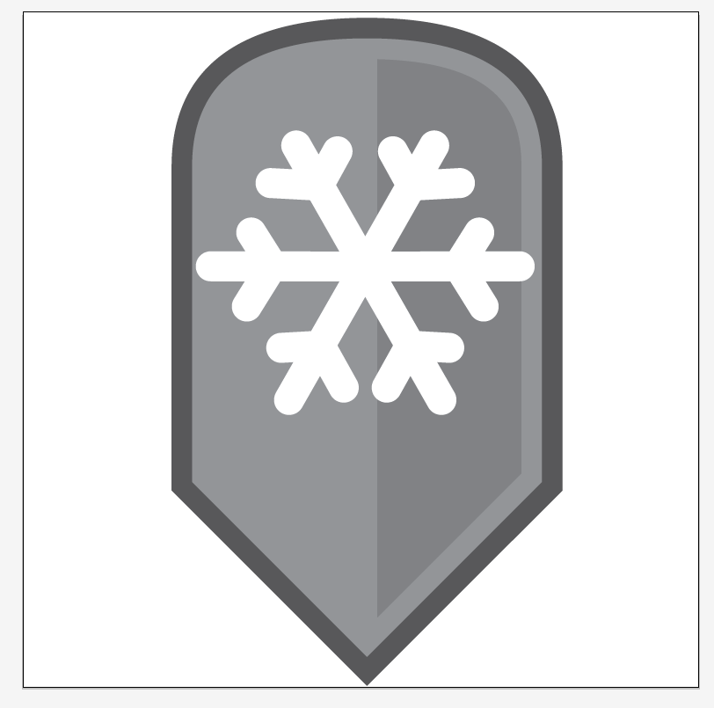

**Symbol Source: “Snowflake”** [**http://thenounproject.com/term/snowflake/3777/**](http://thenounproject.com/term/snowflake/3777/)



**Source Date: April 2014**

**Modified: Modified by Esri Solutions Team**

**License: Public Domain.**

**Acknowledgement: none required**

**Notes: None**

**Subsidence**

**Symbol Name: Subsidence**

**Symbol Picture:** 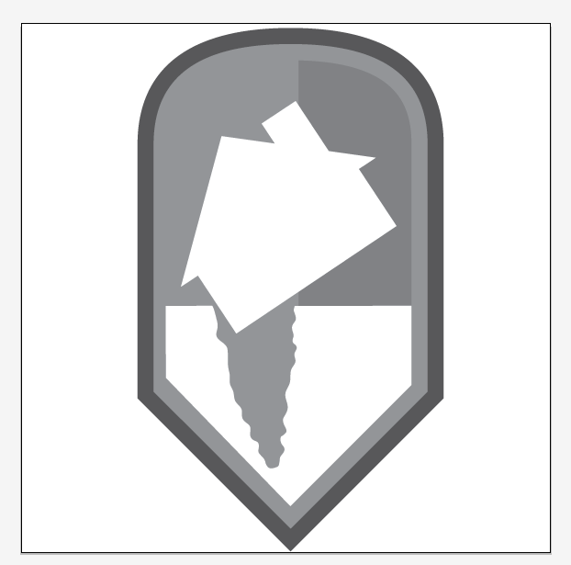

**Symbol Source: Homeland Security Working Group** [**http://www.fgdc.gov/HSWG/index.html**](http://www.fgdc.gov/HSWG/index.html) **and house symbol from “Flood” from The Noun project http://thenounproject.com/term/flood/752/** 

**Source Date: April 2014**

**Modified: Modified by Esri Solutions Team**

**License: Public Domain.**

**Acknowledgement: none required**

**Notes: None**

**Tornado**

**Symbol Name: Tornado**

**Symbol Picture:** 

**Symbol Source: Esri Solutions Team**

**Source Date: April 2014**

**Modified:**

**License:**

**Acknowledgement: None required**

**Notes: None**

**Tropical Cyclone**

**Symbol Name: Tropical Cyclone**

**Symbol Picture:** 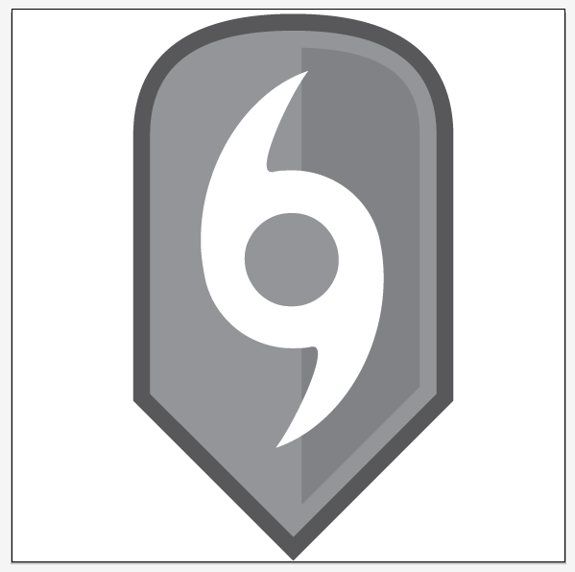

**Symbol Source: Homeland Security Working Group http://www.fgdc.gov/HSWG/index.html**

**Source Date: April 2014**

**Modified: Modified by Esri Solutions Team**

**License: Public Domain**

**Acknowledgement: None required**

**Notes: None**

**Tsunami**

**Symbol Name: Tsunami**

**Symbol Picture:** 

**Symbol Source: Homeland Security Working Group http://www.fgdc.gov/HSWG/index.html**

**Source Date: April 2014**

**Modified: Modified by Esri Solutions Team**

**License: Public Domain**

**Acknowledgement: None required**

**Notes: None**

**Vehicle Incident**

**Symbol Name: Vehicle Incident**

**Symbol Picture:** 

**Symbol Source: Esri Solutions Team**

**Source Date: April 2014**

**Modified:**

**License:**

**Acknowledgement: None required**

**Notes: None**

**Volcano**

**Symbol Name: Volcano**

**Symbol Picture:** 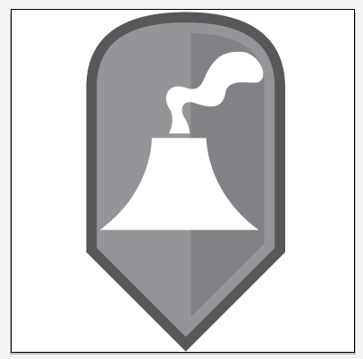

**Symbol Source: Homeland Security Working Group http://www.fgdc.gov/HSWG/index.html**

**Source Date: April 2014**

**Modified: Modified by Esri Solutions Team**

**License: Public Domain**

**Acknowledgement: None required**

**Notes: None**

**Zombie Attack**

**Symbol Name: Zombie Attack**

**Symbol Picture:** 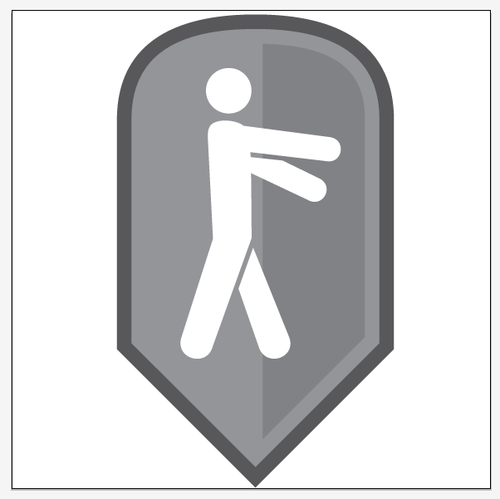

**Symbol Source: “Zombie” http://thenounproject.com/term/zombie/1117/** 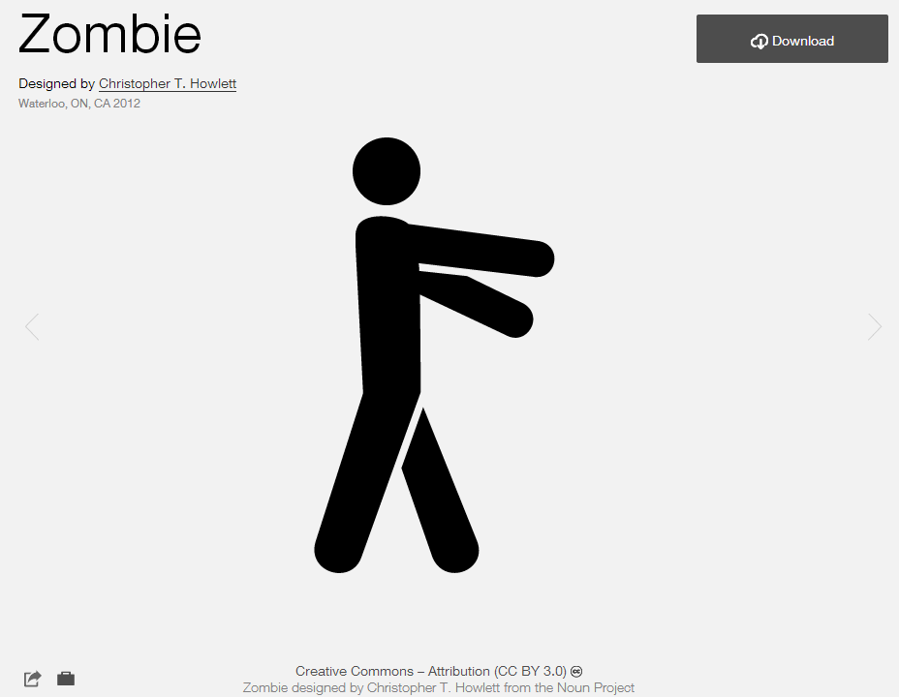

**Source Date: April 2014**

**Modified: Modified by Esri Solutions Team**

**License: Creative Commons BY 3.0**

**Acknowledgement: Christopher T. Howlett**

**Notes: None**