Web programming Lab w13

Geolocation_1 Screenshots and Descriptions

2018312039 Joon Yong Hwang

1. Get the JavaScript API key from Kakao developers.

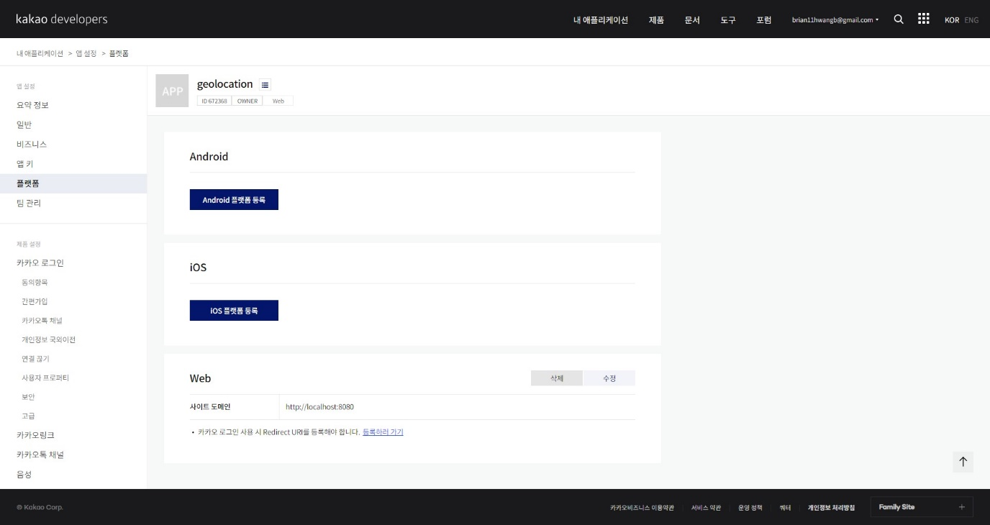

1. Start localhost from python with python -m http.server 8080

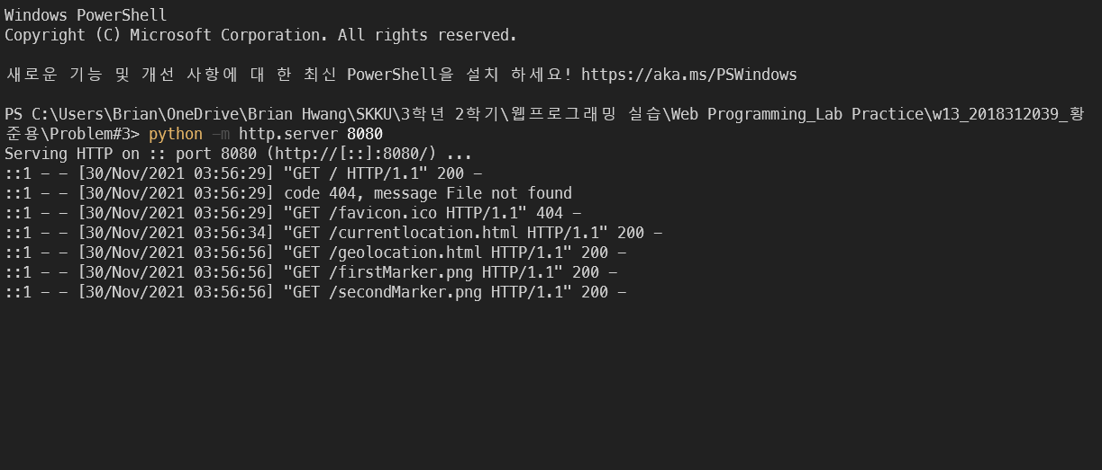

1. Write code to get current location

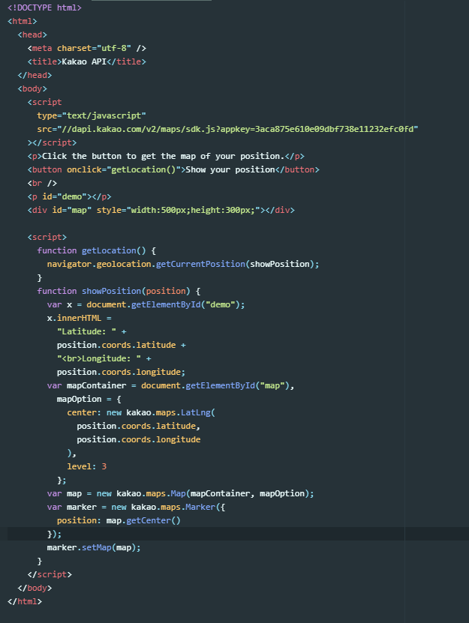

1. Check on web (finish)

