Future Value Annuity Formula:

* Investopia

<https://www.investopedia.com/retirement/calculating-present-and-future-value-of-annuities/>

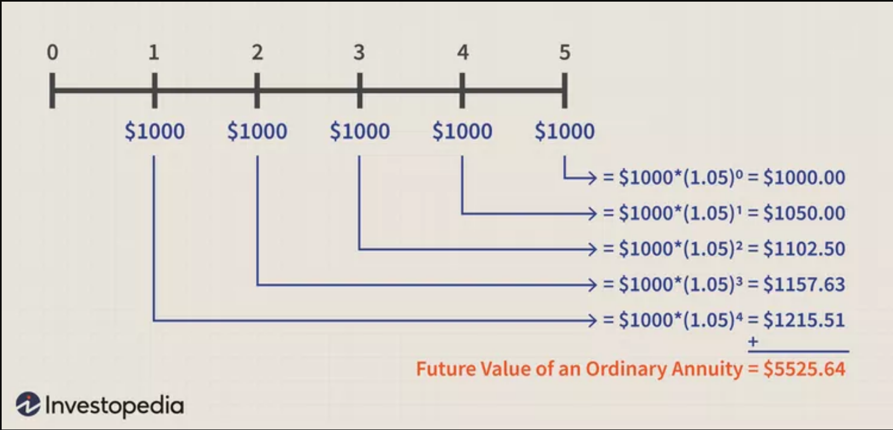

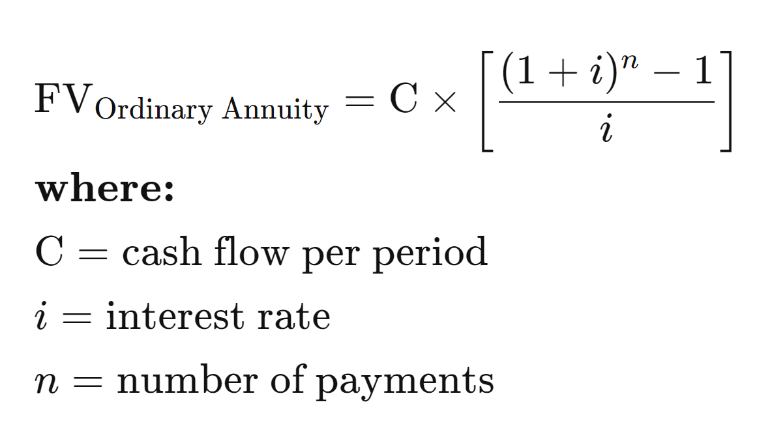

Future Value Annuity Calculator:

* Free-online-calculator-use

<https://www.free-online-calculator-use.com/future-value-annuity-calculator.html>

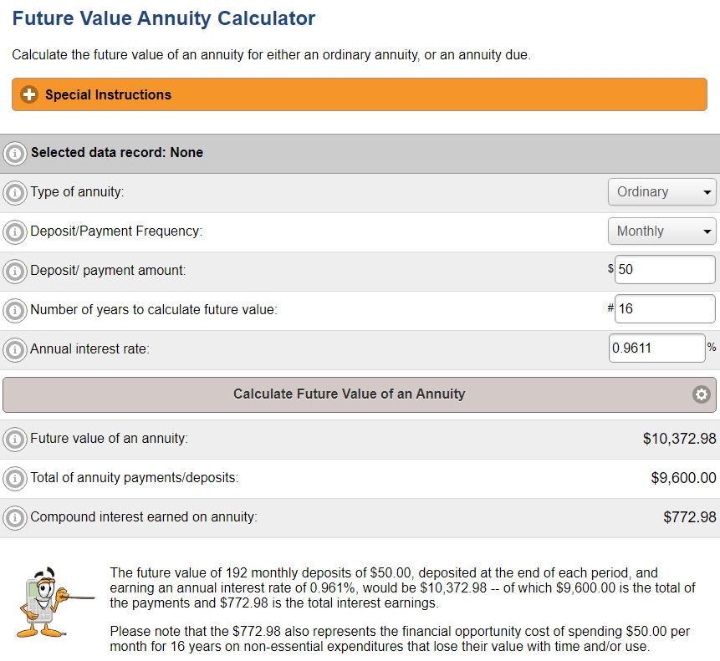

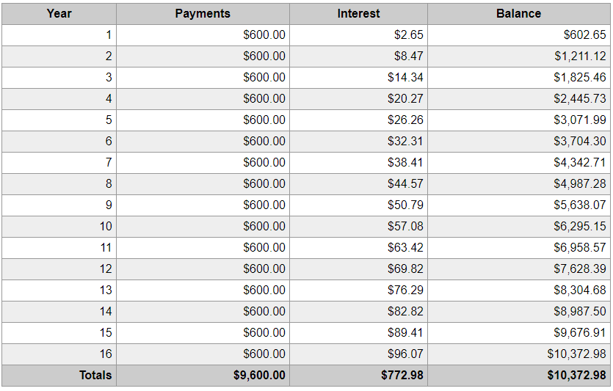

Interest Rate (Federal Funds Effective Rate)

* FRED
* <https://fred.stlouisfed.org/series/FEDFUNDS>

