

**REPORT MANUAL OF JOBSHEET**

**Practicum, Tasks and Questions**

**(Network Programming)**

|  |  |  |  |  |
| --- | --- | --- | --- | --- |
|  | **Name** | **:** | **Brian Sayudha** |  |
|  | **Class / NIM** | **:** | **3G / 1841720158** |  |
|  | **Major** | **:** | **D-IV Informatics Enginering** |  |
|  |  |  |  |  |
|  |  |  |  |  |

Praktikum 1

Code

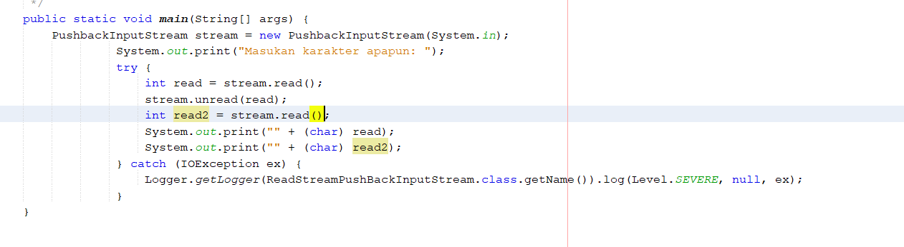

Or

/*

 * To change this license header, choose License Headers in Project Properties.

 * To change this template file, choose Tools | Templates

 * and open the template in the editor.

 */

package pushback;

import java.io.IOException;

import java.io.PushbackInputStream;

import java.util.logging.Level;

import java.util.logging.Logger;

/**

 *

 * @author Asus

 */

public class ReadStreamPushBackInputStream {

    /**

     * @param *args* the command line arguments

     */

    public static *void* main(*String*[] *args*) {

*PushbackInputStream* stream = **new** PushbackInputStream(System.in);

                 System.out.print("Masukan karakter apapun: ");

                 try {

*int* read = stream.read();

*int* read2 = stream.read();

                     System.out.print("" + (*char*) read);

                     System.out.print("" + (*char*) read2);

                 } catch (*IOException* *ex*) {

                     Logger.getLogger(ReadStreamPushBackInputStream.class.getName()).log(Level.SEVERE, null, ex);

                 }

    }

}

Result



Add sintaks stream.unread(read); Below int read = stream.read();

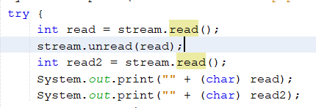

Result (it’ll print the first char, because we do the unread, so the read repeated from start)



QUESTION FOR PRAKTIKUM 1

1. Create coba.txt in our pushback project

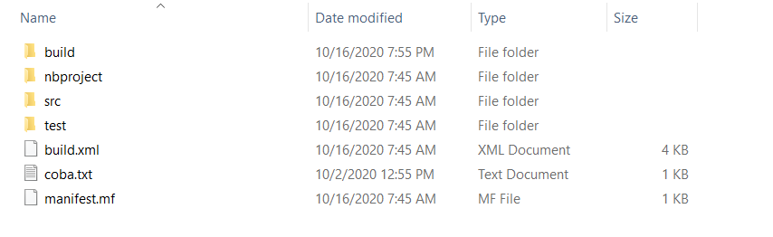

Content of coba.txt

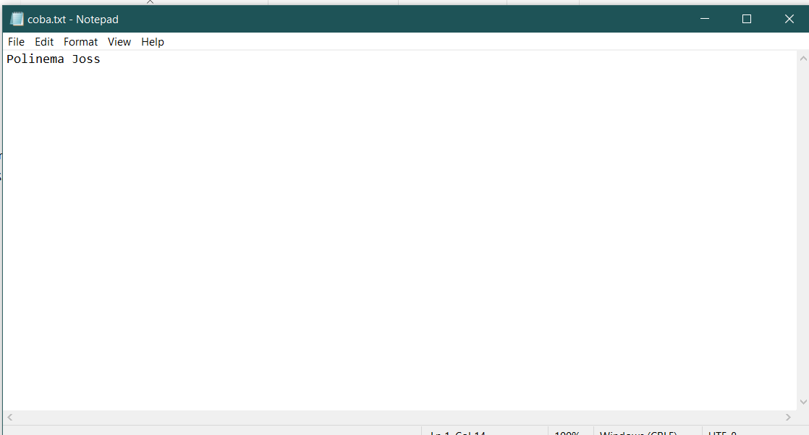

2. Read File coba.txt using Class PushbackInputStream without do the looping

Code

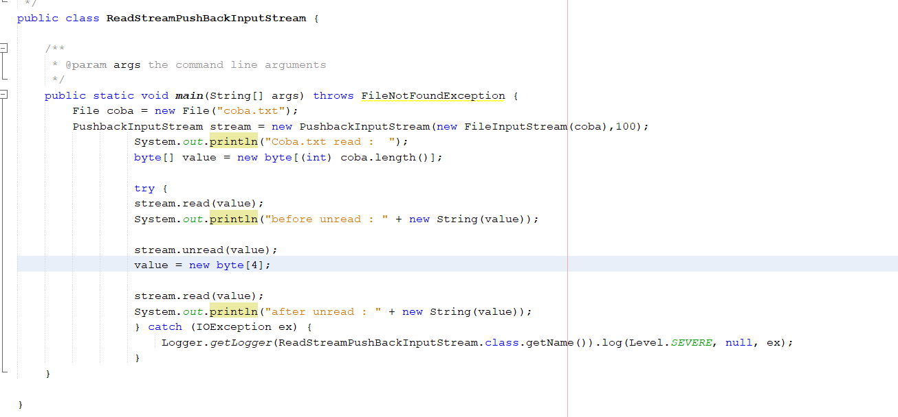

OR

/*

 * To change this license header, choose License Headers in Project Properties.

 * To change this template file, choose Tools | Templates

 * and open the template in the editor.

 */

package pushback;

import java.io.FileInputStream;

import java.io.File;

import java.io.FileNotFoundException;

import java.io.IOException;

import java.io.PushbackInputStream;

import java.util.logging.Level;

import java.util.logging.Logger;

/**

 *

 * @author Asus

 */

public class ReadStreamPushBackInputStream {

    /**

     * @param *args* the command line arguments

     */

    public static *void* main(*String*[] *args*) throws *FileNotFoundException* {

*File* coba = **new** File("coba.txt");

*PushbackInputStream* stream = **new** PushbackInputStream(**new** FileInputStream(coba),100);

                 System.out.println("Coba.txt read :  ");

*byte*[] value = **new** *byte*[(*int*) coba.length()];

                 try {

                 stream.read(value);

                 System.out.println("before unread : " + **new** String(value));

                 stream.unread(value);

                 value = **new** *byte*[4];

                 stream.read(value);

                 System.out.println("after unread : " + **new** String(value));

                 } catch (*IOException* *ex*) {

                     Logger.getLogger(ReadStreamPushBackInputStream.class.getName()).log(Level.SEVERE, null, ex);

                 }

    }

}

Result

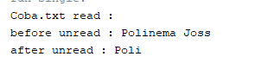

Praktikum 2

Code (because code at jaringan.sinaungoding.com is at unread, so i add some integer to add the pushbackreader into 100 (the default is 1) and the new char [] and unread is switched)

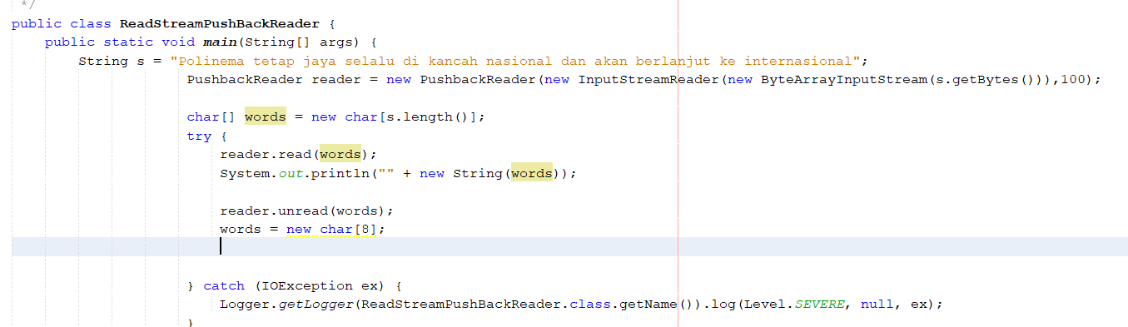

OR

/*

 * To change this license header, choose License Headers in Project Properties.

 * To change this template file, choose Tools | Templates

 * and open the template in the editor.

 */

package pushback;

import java.io.ByteArrayInputStream;

import java.io.IOException;

import java.io.InputStreamReader;

import java.io.PushbackReader;

import java.util.logging.Level;

import java.util.logging.Logger;

/**

 *

 * @author Asus

 */

public class ReadStreamPushBackReader {

    public static *void* main(*String*[] *args*) {

*String* s = "Polinema tetap jaya selalu di kancah nasional dan akan berlanjut ke internasional";

*PushbackReader* reader = **new** PushbackReader(**new** InputStreamReader(**new** ByteArrayInputStream(s.getBytes())),100);

*char*[] words = **new** *char*[s.length()];

                     try {

                         reader.read(words);

                         System.out.println("" + **new** String(words));

                         reader.unread(words);

                         words = **new** *char*[8];

                     } catch (*IOException* *ex*) {

                         Logger.getLogger(ReadStreamPushBackReader.class.getName()).log(Level.SEVERE, null, ex);

                     }

    }

}

Result



QUESTION FOR PRAKTIKUM 2

1. Add command to read all stream after syntax  reader.unread(words);

Code

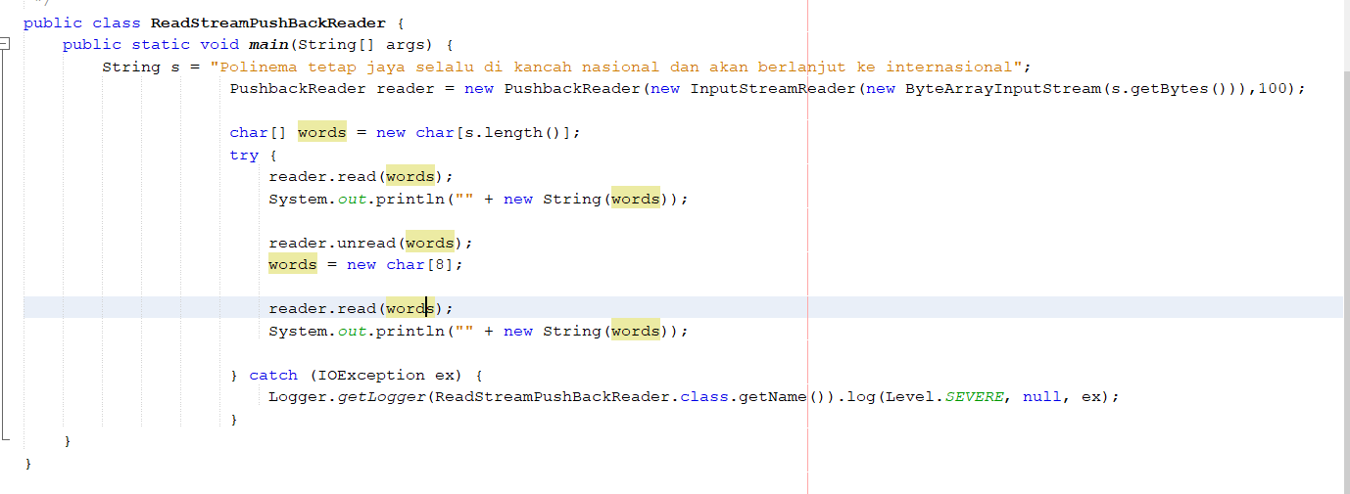

OR

/*

 * To change this license header, choose License Headers in Project Properties.

 * To change this template file, choose Tools | Templates

 * and open the template in the editor.

 */

package pushback;

import java.io.ByteArrayInputStream;

import java.io.IOException;

import java.io.InputStreamReader;

import java.io.PushbackReader;

import java.util.logging.Level;

import java.util.logging.Logger;

/**

 *

 * @author Asus

 */

public class ReadStreamPushBackReader {

    public static *void* main(*String*[] *args*) {

*String* s = "Polinema tetap jaya selalu di kancah nasional dan akan berlanjut ke internasional";

*PushbackReader* reader = **new** PushbackReader(**new** InputStreamReader(**new** ByteArrayInputStream(s.getBytes())),100);

*char*[] words = **new** *char*[s.length()];

                     try {

                         reader.read(words);

                         System.out.println("" + **new** String(words));

                         reader.unread(words);

                         words = **new** *char*[8];

                         reader.read(words);

                         System.out.println("" + **new** String(words));

                     } catch (*IOException* *ex*) {

                         Logger.getLogger(ReadStreamPushBackReader.class.getName()).log(Level.SEVERE, null, ex);

                     }

    }

}

Result

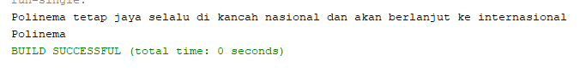

2. Buatlah file coba.txt, kemudian baca file tersebut menggunakan class PushbackReader

Code

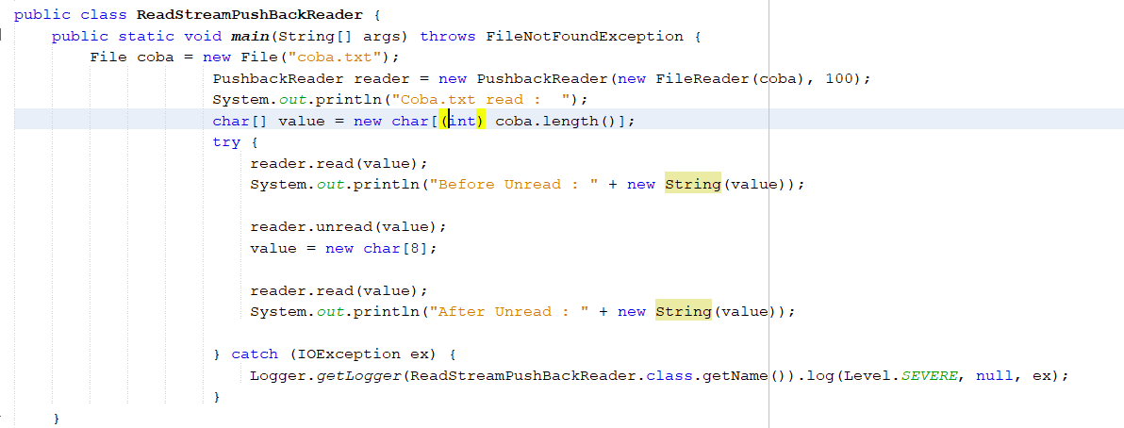

OR

/*

 * To change this license header, choose License Headers in Project Properties.

 * To change this template file, choose Tools | Templates

 * and open the template in the editor.

 */

package pushback;

import java.io.ByteArrayInputStream;

import java.io.File;

import java.io.FileInputStream;

import java.io.FileNotFoundException;

import java.io.FileReader;

import java.io.IOException;

import java.io.InputStreamReader;

import java.io.PushbackReader;

import java.util.logging.Level;

import java.util.logging.Logger;

/**

 *

 * @author Asus

 */

public class ReadStreamPushBackReader {

    public static *void* main(*String*[] *args*) throws *FileNotFoundException* {

*File* coba = **new** File("coba.txt");

*PushbackReader* reader = **new** PushbackReader(**new** FileReader(coba), 100);

                     System.out.println("Coba.txt read :  ");

*char*[] value = **new** *char*[(*int*) coba.length()];

                     try {

                         reader.read(value);

                         System.out.println("Before Unread : " + **new** String(value));

                         reader.unread(value);

                         value = **new** *char*[8];

                         reader.read(value);

                         System.out.println("After Unread : " + **new** String(value));

                     } catch (*IOException* *ex*) {

                         Logger.getLogger(ReadStreamPushBackReader.class.getName()).log(Level.SEVERE, null, ex);

                     }

    }

}

RESULT

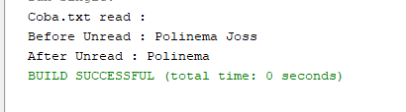

3.Call method unread() To read some spesific charactrer in coba.txt

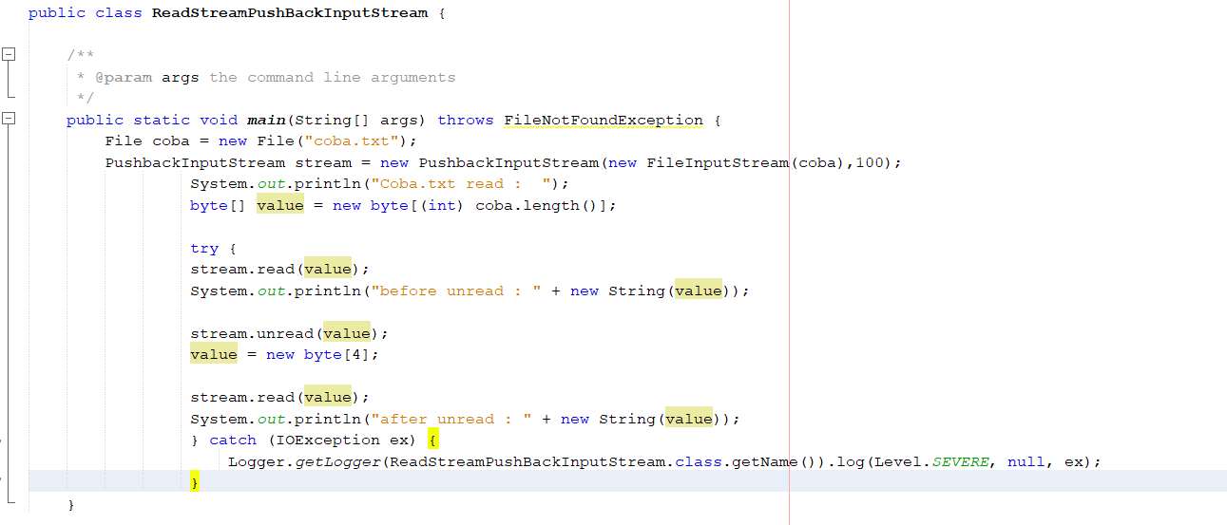

OR

/*

 * To change this license header, choose License Headers in Project Properties.

 * To change this template file, choose Tools | Templates

 * and open the template in the editor.

 */

package pushback;

import java.io.FileInputStream;

import java.io.File;

import java.io.FileNotFoundException;

import java.io.IOException;

import java.io.PushbackInputStream;

import java.util.logging.Level;

import java.util.logging.Logger;

/**

 *

 * @author Asus

 */

public class ReadStreamPushBackInputStream {

    /**

     * @param *args* the command line arguments

     */

    public static *void* main(*String*[] *args*) throws *FileNotFoundException* {

*File* coba = **new** File("coba.txt");

*PushbackInputStream* stream = **new** PushbackInputStream(**new** FileInputStream(coba),100);

                 System.out.println("Coba.txt read :  ");

*byte*[] value = **new** *byte*[(*int*) coba.length()];

                 try {

                 stream.read(value);

                 System.out.println("before unread : " + **new** String(value));

                 stream.unread(value);

                 value = **new** *byte*[4];

                 stream.read(value);

                 System.out.println("after unread : " + **new** String(value));

                 } catch (*IOException* *ex*) {

                     Logger.getLogger(ReadStreamPushBackInputStream.class.getName()).log(Level.SEVERE, null, ex);

                 }

    }

}

RESULT

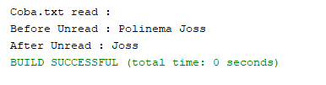

ASSIGNMENT

1. Please use the previous form so you can browse the files to be read using the PushbackInputStream or PushbackReader

Code (pushbackinputStream)

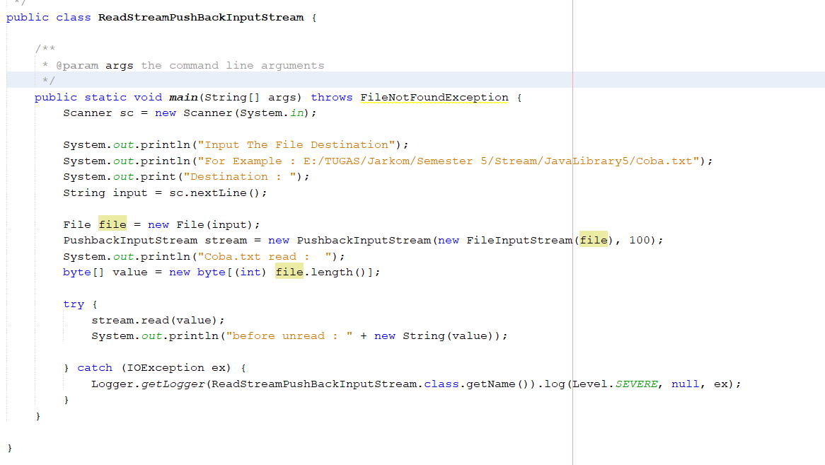

OR

/*

 * To change this license header, choose License Headers in Project Properties.

 * To change this template file, choose Tools | Templates

 * and open the template in the editor.

 */

package pushback;

import java.io.FileInputStream;

import java.io.File;

import java.io.FileNotFoundException;

import java.io.IOException;

import java.io.PushbackInputStream;

import java.util.Scanner;

import java.util.logging.Level;

import java.util.logging.Logger;

/**

 *

 * @author Asus

 */

public class ReadStreamPushBackInputStream {

    /**

     * @param *args* the command line arguments

     */

    public static *void* main(*String*[] *args*) throws *FileNotFoundException* {

*Scanner* sc = **new** Scanner(System.in);

        System.out.println("Input The File Destination");

        System.out.println("For Example : E:/TUGAS/Jarkom/Semester 5/Stream/JavaLibrary5/Coba.txt");

        System.out.print("Destination : ");

*String* input = sc.nextLine();

*File* file = **new** File(input);

*PushbackInputStream* stream = **new** PushbackInputStream(**new** FileInputStream(file), 100);

        System.out.println("Coba.txt read :  ");

*byte*[] value = **new** *byte*[(*int*) file.length()];

        try {

            stream.read(value);

            System.out.println("before unread : " + **new** String(value));

        } catch (*IOException* *ex*) {

            Logger.getLogger(ReadStreamPushBackInputStream.class.getName()).log(Level.SEVERE, null, ex);

        }

    }

}

RESULT

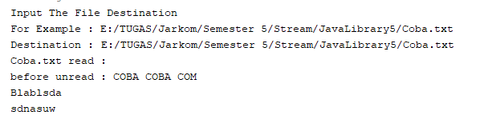

3. Please display information on the number of lines, the number of words, and the number of characters the file has read!

Code

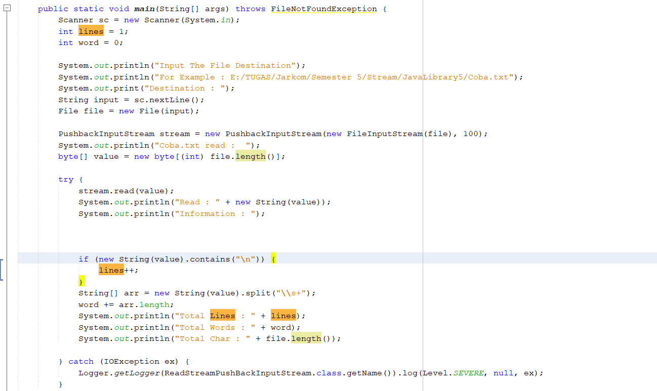

OR

/*

 * To change this license header, choose License Headers in Project Properties.

 * To change this template file, choose Tools | Templates

 * and open the template in the editor.

 */

package pushback;

import java.io.FileInputStream;

import java.io.File;

import java.io.FileNotFoundException;

import java.io.IOException;

import java.io.PushbackInputStream;

import java.util.Scanner;

import java.util.logging.Level;

import java.util.logging.Logger;

/**

 *

 * @author Asus

 */

public class ReadStreamPushBackInputStream {

    /**

     * @param *args* the command line arguments

     */

    public static *void* main(*String*[] *args*) throws *FileNotFoundException* {

*Scanner* sc = **new** Scanner(System.in);

*int* lines = 1;

*int* word = 0;

        System.out.println("Input The File Destination");

        System.out.println("For Example : E:/TUGAS/Jarkom/Semester 5/Stream/JavaLibrary5/Coba.txt");

        System.out.print("Destination : ");

*String* input = sc.nextLine();

*File* file = **new** File(input);

*PushbackInputStream* stream = **new** PushbackInputStream(**new** FileInputStream(file), 100);

        System.out.println("Coba.txt read :  ");

*byte*[] value = **new** *byte*[(*int*) file.length()];

        try {

            stream.read(value);

            System.out.println("Read : " + **new** String(value));

            System.out.println("Information : ");

            if (**new** String(value).contains("\n")) {

                lines++;

            }

*String*[] arr = **new** String(value).split("\\s+");

            word += arr.length;

            System.out.println("Total Lines : " + lines);

            System.out.println("Total Words : " + word);

            System.out.println("Total Char : " + file.length());

        } catch (*IOException* *ex*) {

            Logger.getLogger(ReadStreamPushBackInputStream.class.getName()).log(Level.SEVERE, null, ex);

        }

    }

}

RESULT

