Brian Webb – ID: 34775506  
GW 2022 SPRING-CSC120 10187

I used this section of the lesson as a reference to confirm accuracy of my gate code.

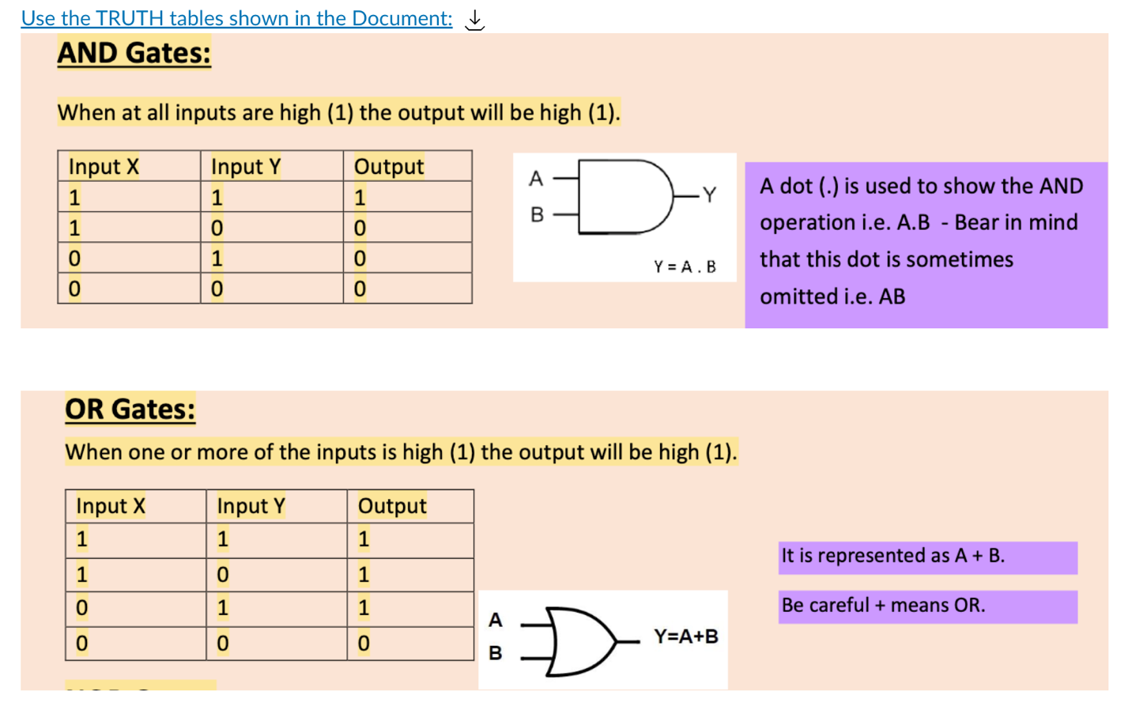

I found this tool to be pretty cool!

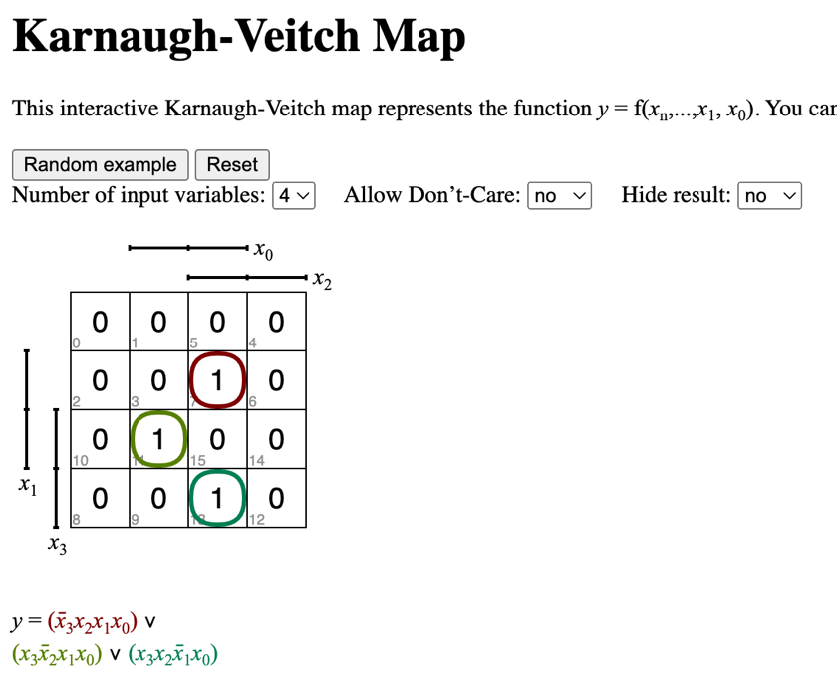

This style of diagram seems like it would help significantly to implement this in code.

