Brian Webb – ID: 34775506  
GW 2022 SPRING-CSC120 10187

1 ) [Visual Studio 2019 Community Edition.  (Links to an external site.)https://visualstudio.microsoft.com/thank-you-downloading-visual-studio/?sku=Community&rel=16 (Links to an external site.)](https://visualstudio.microsoft.com/thank-you-downloading-visual-studio/?sku=Community&rel=16)

I’ll be using Rider instead (I am more familiar with Jet Brains products), if that won’t cause any issues.

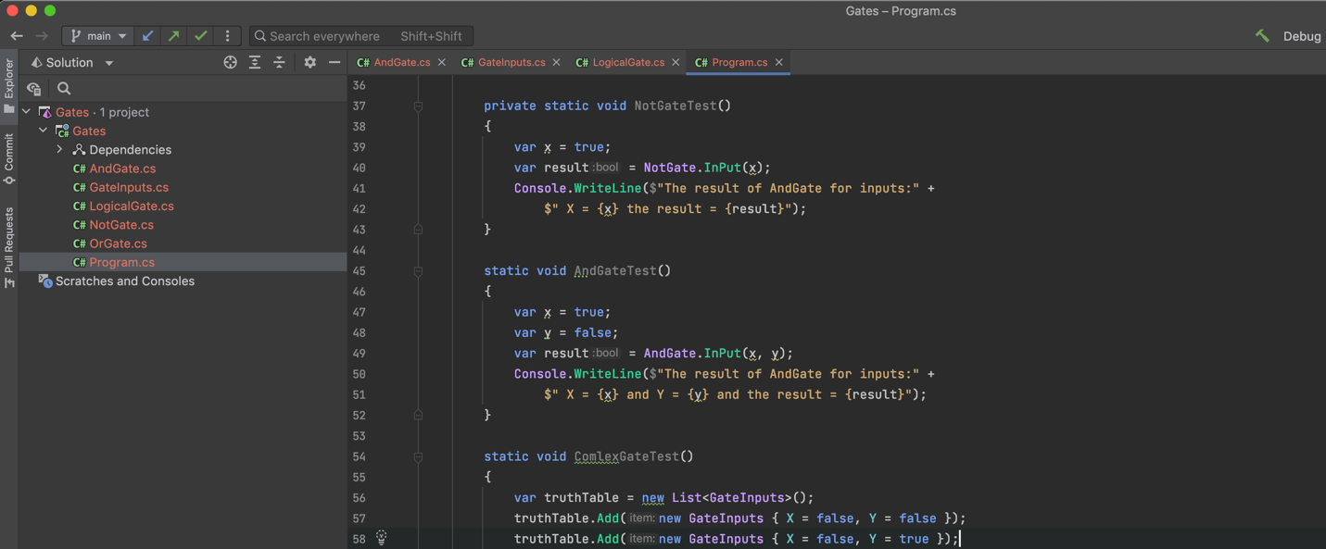

2) Create an account in Git Hub: <https://github.com/>

<https://github.com/brian-webb>

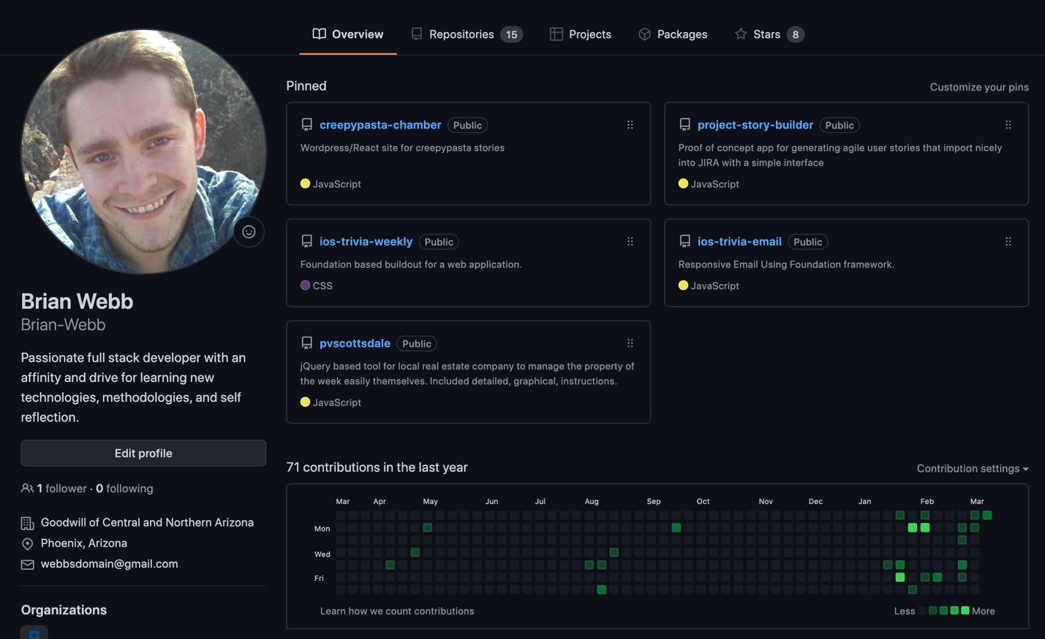

3) Install GitHub for desktop: [https://git-scm.com/ (Links to an external site.)](https://git-scm.com/)

I’ll be using GitKraken.

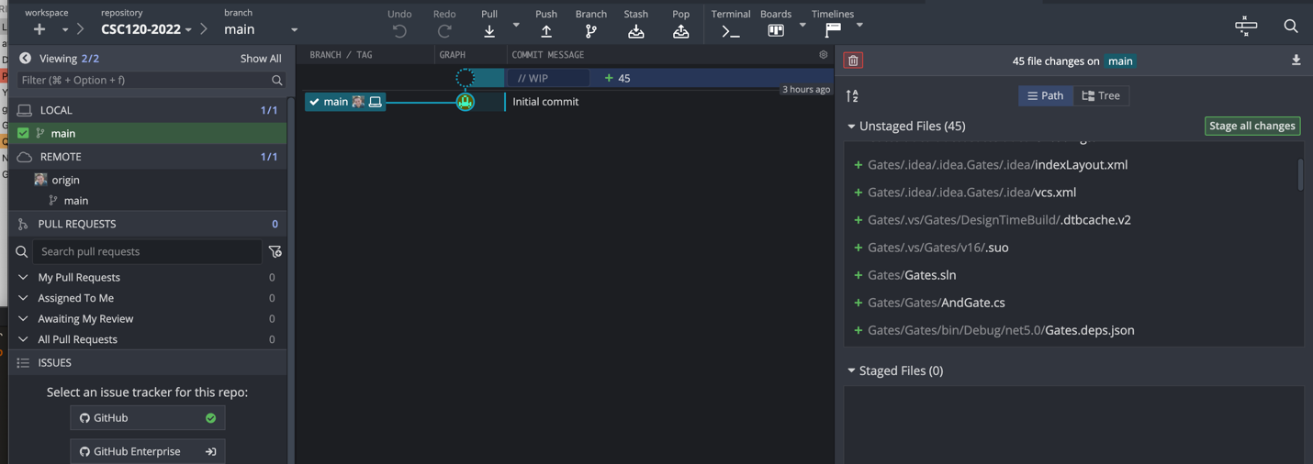

**In Step 4: Save all the instructions in Notepad or Word document**

4) Create a public repository named CSC120-2020 <https://github.com/new>

<https://github.com/brian-webb/CSC120-2022>

