**Describe any FOUR critical items that MUST be contained in an IT Consultancy**

**strategic plan.**

1. Mission and Vision - Defines the consultancy's purpose and goals that aligns with the desires of the client and objectives.
2. Market Analysis – study the latest market trends, competition and client pain points.
3. Risk Management Plan – identify the potential risks like data breaches and establish a clear strategy to mitigate the risks.
4. Resource Allocation Plan - describe the necessary resources, specifying the timelines and deliverables for efficient execution

**Describe any TWO risks that an organization may face if it contracts a  
consultant to upgrade its enterprise information system.**

1. Data Security Risks - Consultants gain access to sensitive organizational data, increasing the risk of leaks or unauthorized use if proper security measures aren't in place.
2. Dependency - Organizations may become over reliant on the consultant’s expertise, leading to challenges in maintaining the system.

**Discuss factors that may drive change in organization and with the aid of a**

**suitable diagram, use the Force-Field Model of Change, to explain how the how**

**change is realized.**

1. Technological Advancements – rapid technology developments and adoption of new systems can lead to change.
2. Regulatory Requirements – compliance to the new set of rules and regulations can lead to change.
3. Competition – competition with the latest market trends hence increasing the pressure to remain innovative.
4. Customer Expectations – increased demand for personalized products.

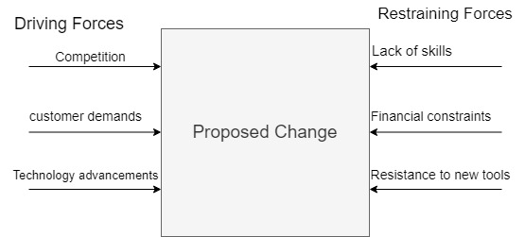

**Describe in details, any FOUR strategies that may be employed by a consultancy  
firm in its effort to create awareness of its presence and the consultancy services on  
offer.**

1. Webinars and workshops – hosting interactive sessions on trending IT topics to attract clients.
2. Networking – Collaborating with other firms to build long-term relationship.
3. Case Studies – showcase successful projects and satisfied client testimonials to build trust.
4. Social Media – using social media tools like linkedIn to reach a bigger audience.