PSP EXCERSISE FINAL
University laboratory computer management system
The system was developed using Extreme Programming (XP) practices, particularly Test-Driven Development (TDD) and iterative refinement. GenAI pair programming was used where prompts were given to ChatGPT to generate initial code, which was then refined through additional prompts. This iterative approach improved both functionality and code quality.
Programs of the system: Equipment Maintenance AND Computer Inventory Management
Phase One: Requirements
Computer Inventory Management
- The system shall allow adding new computers to the laboratory inventory
- The system shall display all available computers
- The system shall allow updating computer status (Available, In Use, Under Maintenance, Functional)
- The system shall allow searching for a computer by ID
- The system shall allow removal of computers from the inventory
Equipment Maintenance System
- The system shall allow creation of maintenance logs for computers
- The system shall validate that maintenance service dates are not in the past
- The system shall allow viewing maintenance records
- The system shall allow marking maintenance as complete
- The system shall automatically update computer status to "Functional" after maintenance completion
Phase Two: Design Phase
The system uses Object-Oriented Programming with classes: Computer, InventoryManager, MaintenanceLog, and EquipmentMaintenanceSystem.
The system follows a modular design where:
- The computer class is shared between both modules
- The Inventory system manages computer data
- The Maintenance system updates inventory status after repairs

Phase Three: Implementation Phase
The system was implemented in Python using object-oriented programming principles. The Computer, InventoryManager, and MaintenanceLog classes were developed to handle different system functionalities.
GenAI (ChatGPT) was used to generate initial code based on prompts. The generated code was then refined through iterative prompt improvements and manual corrections. Enhancements included validation checks, integration between modules, and the addition of interactive menu-driven interfaces.
Phase Four: Testing Phase
Testing included unit testing for date validation and manual testing using interactive menus. Edge cases such as invalid dates and missing IDs were tested.
Equipment Maintenance System
Initial prompt
“We are now building the Maintenance System. Before writing the logic, write a unit test in Python that checks if a maintenance log can be created with a future 'Next Service Date'. It should fail if the date is in the past.”
import unittest
from datetime import datetime

class MaintenanceLog:

def __init__(self, computer_id, next_service_date):
self.computer_id = computer_id
self.next_service_date = next_service_date

if next_service_date < datetime.today():
raise ValueError("Next service date cannot be in the past")

class TestMaintenance(unittest.TestCase):

def test_future_service_date(self):
future_date = datetime(2030, 1, 1)
log = MaintenanceLog(101, future_date)
self.assertEqual(log.computer_id, 101)

def test_past_service_date(self):
past_date = datetime(2020, 1, 1)

with self.assertRaises(ValueError):
MaintenanceLog(101, past_date)

if __name__ == "__main__":
unittest.main()
Output
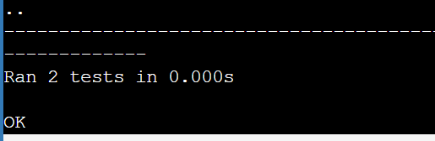
Refined Prompt
“Now integrate this with the Inventory system. When a maintenance log is marked 'Complete', automatically update the status of the corresponding computer in the Inventory to 'Functional'.”
from datetime import datetime
class Computer:
def __init__(self, computer_id, model):
self.id = computer_id
self.model = model
self.status = "Under Maintenance"

def __str__(self):
return f"ID: {self.id}, Model: {self.model}, Status: {self.status}"

class MaintenanceLog:
def __init__(self, computer_id, issue, next_service_date):
if next_service_date.date() < datetime.today().date():
raise ValueError("Next service date cannot be in the past")

self.computer_id = computer_id
self.issue = issue
self.next_service_date = next_service_date
self.status = "Pending"

def complete(self, computers):
if self.status == "Complete":
print(" Maintenance already completed.")
return

self.status = "Complete"

for c in computers:
if c.id == self.computer_id:
c.status = "Functional"
print("Maintenance completed. Computer updated to Functional.")
return

print("Computer not found.")

class EquipmentMaintenanceSystem:
def __init__(self):
self.computers = []
self.logs = []

def add_computer(self):
cid = int(input("Enter Computer ID: "))
model = input("Enter Model: ")
self.computers.append(Computer(cid, model))
print(" Computer added.\n")

def create_log(self):
try:
cid = int(input("Enter Computer ID: "))
issue = input("Enter Issue: ")
date_input = input("Enter next service date (YYYY-MM-DD): ")
next_date = datetime.strptime(date_input, "%Y-%m-%d")

# Check if computer exists
for c in self.computers:
if c.id == cid:
log = MaintenanceLog(cid, issue, next_date)
self.logs.append(log)
print("Maintenance log created.\n")
return

print("Computer not found.\n")

except ValueError as e:
print(f"Error: {e}\n")

def complete_maintenance(self):
cid = int(input("Enter Computer ID to complete maintenance: "))

for log in self.logs:
if log.computer_id == cid:
log.complete(self.computers)
return

print("Maintenance log not found.\n")

def view_computers(self):
print("\n--- Computers ---")
for c in self.computers:
print(c)
print()

def view_logs(self):
print("\n--- Maintenance Logs ---")
for log in self.logs:
print(f"Computer ID: {log.computer_id}, Issue: {log.issue}, Status: {log.status}")
print()

def run(self):
while True:
print("===== Equipment Maintenance System =====")
print("1. Add Computer")
print("2. Create Maintenance Log")
print("3. Complete Maintenance")
print("4. View Computers")
print("5. View Logs")
print("6. Exit")

choice = input("Choose an option: ")

if choice == "1":
self.add_computer()
elif choice == "2":
self.create_log()
elif choice == "3":
self.complete_maintenance()
elif choice == "4":
self.view_computers()
elif choice == "5":
self.view_logs()
elif choice == "6":
print("Exiting system...")
break
else:
print("Invalid choice.\n")

if __name__ == "__main__":
system = EquipmentMaintenanceSystem()
system.run()
Output
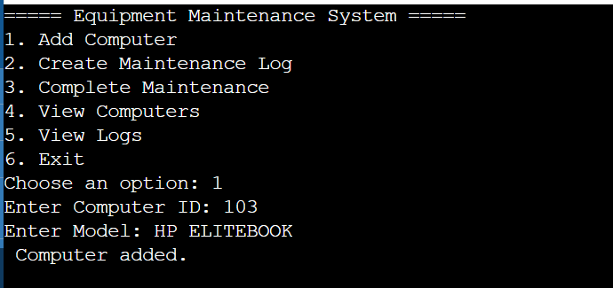
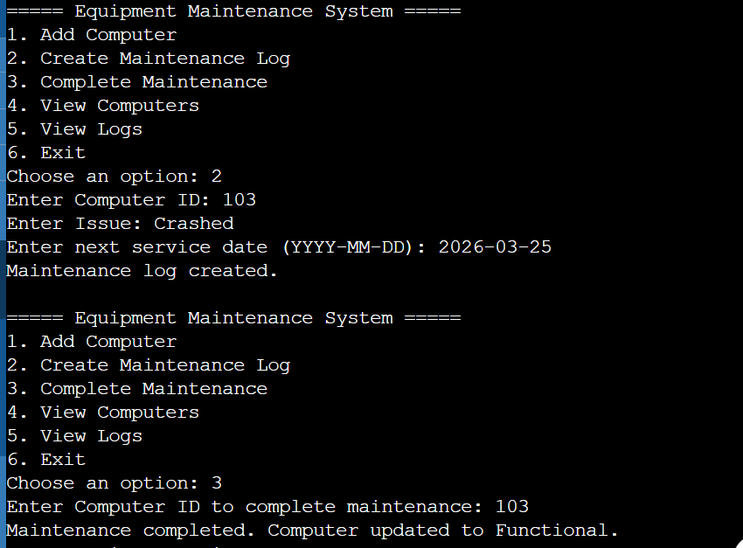
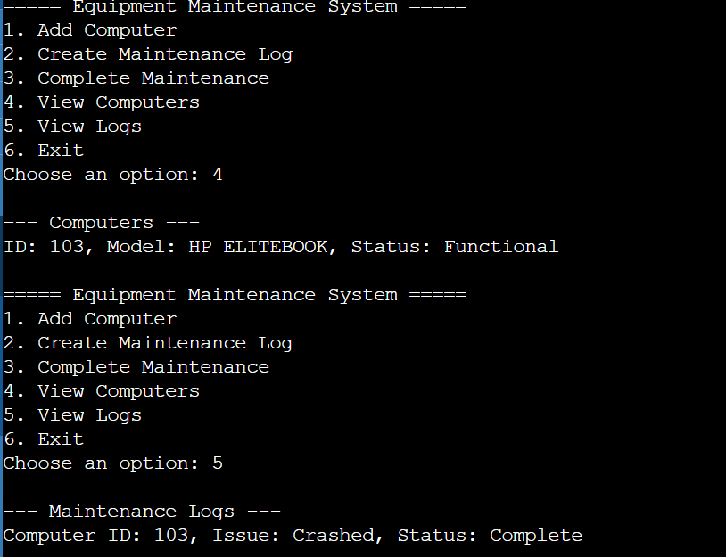
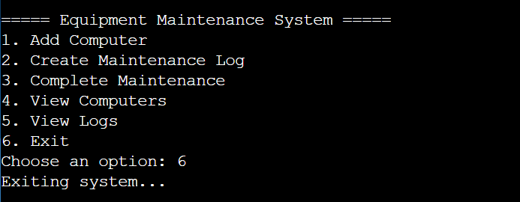
Computer Inventory Management
Initial Prompt
“Write a python program for managing computer inventory in a university laboratory. Include functions to add computers, remove computers and display all computers.”
Code
class Computer:
def __init__(self, computer_id, model, status="Available"):
self.id = computer_id
self.model = model
self.status = status

def __str__(self):
return f"ID: {self.id}, Model: {self.model}, Status: {self.status}"

class InventoryManager:
def __init__(self):
self.computers = []

def add_computer(self, computer_id, model):
self.computers.append(Computer(computer_id, model))
print(" Computer added successfully.")

def view_computers(self):
if not self.computers:
print(" No computers in inventory.")
return

for c in self.computers:
print(c)

def remove_computer(self, computer_id):
self.computers = [c for c in self.computers if c.id != computer_id]
print(" Computer removed.")

# Demo
if __name__ == "__main__":
system = InventoryManager()
system.add_computer(101, "Dell Optiplex")
system.add_computer(102, "HP EliteDesk")
system.view_computers()
Output
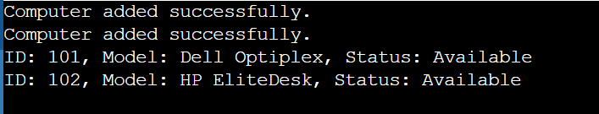
Refined prompt
“Improve the program by adding a function to update computer status such as Available, In Use or Under Maintenance.” Also allow searching for a computer by ID.
Refined program code
class Computer:
def __init__(self, computer_id, model, status="Available"):
self.id = computer_id
self.model = model
self.status = status

def __str__(self):
return f"ID: {self.id}, Model: {self.model}, Status: {self.status}"

class InventoryManager:
def __init__(self):
self.computers = []

def add_computer(self):
cid = int(input("Enter Computer ID: "))
model = input("Enter Model: ")
self.computers.append(Computer(cid, model))
print("Computer added.\n")

def view_computers(self):
print("\n--- Inventory ---")
if not self.computers:
print("No computers available.\n")
return

for c in self.computers:
print(c)
print()

def update_status(self):
cid = int(input("Enter Computer ID: "))
new_status = input("Enter new status (Available/In Use/Under Maintenance): ")

for c in self.computers:
if c.id == cid:
c.status = new_status
print("Status updated.\n")
return

print("Computer not found.\n")

def search_computer(self):
cid = int(input("Enter Computer ID to search: "))

for c in self.computers:
if c.id == cid:
print(" Computer Found:")
print(c, "\n")
return

print("Computer not found.\n")

def remove_computer(self):
cid = int(input("Enter Computer ID to remove: "))
self.computers = [c for c in self.computers if c.id != cid]
print( "Computer removed.\n")

def run(self):
while True:
print("===== Inventory Management System =====")
print("1. Add Computer")
print("2. View Computers")
print("3. Update Status")
print("4. Search Computer")
print("5. Remove Computer")
print("6. Exit")

choice = input("Choose an option: ")

if choice == "1":
self.add_computer()
elif choice == "2":
self.view_computers()
elif choice == "3":
self.update_status()
elif choice == "4":
self.search_computer()
elif choice == "5":
self.remove_computer()
elif choice == "6":
print(" Exiting system...")
break
else:
print("Invalid choice.\n")

if __name__ == "__main__":
system = InventoryManager()
system.run()
Output
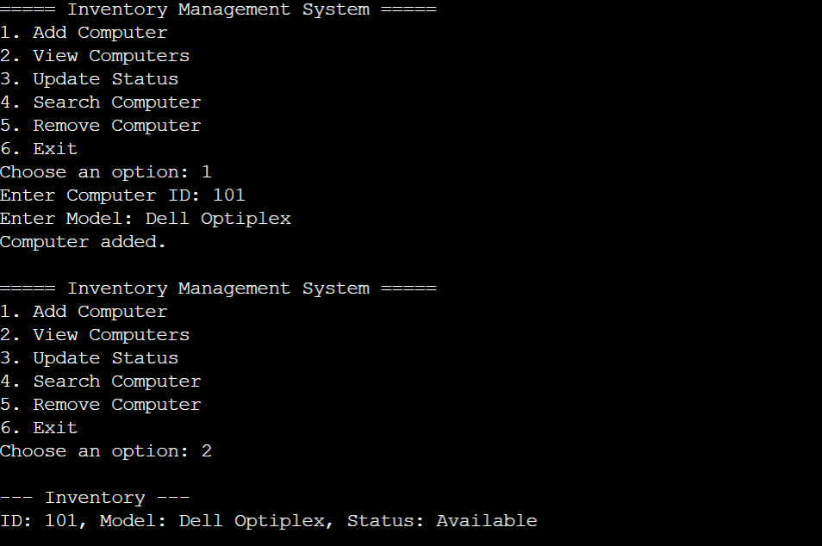
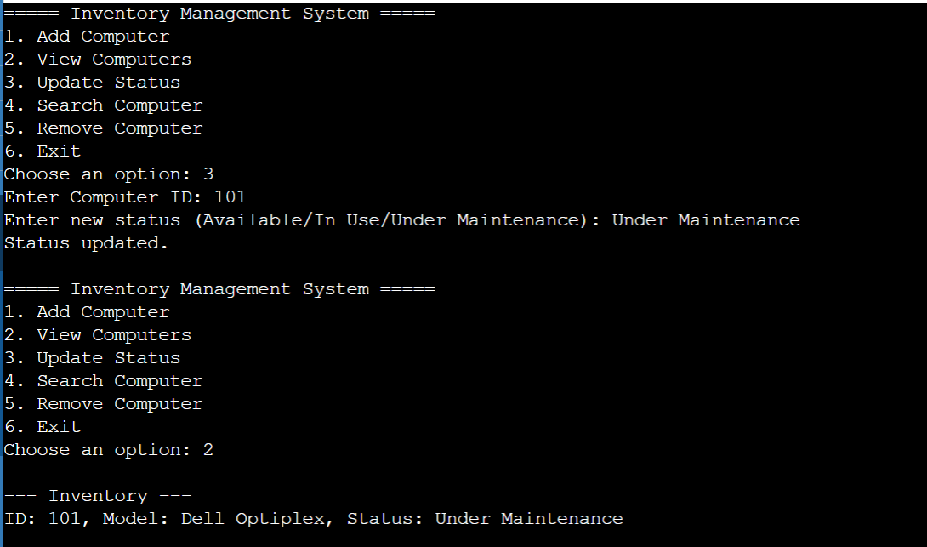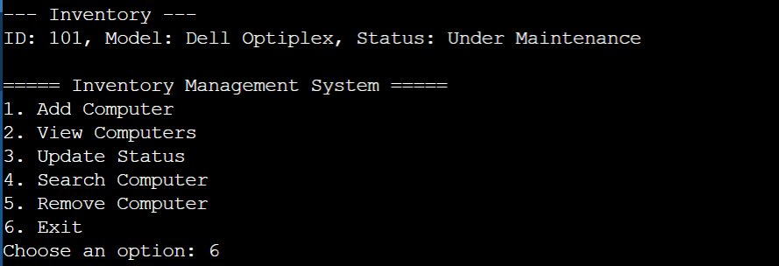
Phase Five: PSP Table
Testing was carried out using both unit testing and manual testing approaches.
Unit testing was applied in the maintenance system to validate that service dates cannot be set in the past.
Manual testing was conducted through the interactive menu system to verify system behavior under different user inputs.
Test cases included:
- Creating maintenance logs with valid and invalid dates
- Searching for existing and non-existing computers
- Updating computer status
- Completing maintenance and verifying automatic status updates

The Personal Software Process (PSP) was used to track defects during the development of the system. Each defect was recorded based on when it was introduced (Inject phase) and when it was detected and corrected (Remove phase). This helped in identifying common errors such as syntax, logic, and integration issues, improving the overall quality of the software.

Date | Number | Type | Inject | Remove | Fix time | Fix defect
16/03/2026 | 1 | Validation | Coding | Unit testing | 3 minutes | Past service dates allowed
16/03/2026 | 2 | Logic | Coding | Testing | 4 minutes | Search function failed due to incorrect condition
17/03/2026 | 3 | Data | Design | Testing | 5 minutes | Computer status not initialized correctly
17/03/2026 | 4 | Integration | Integration | System Testing | 7 minutes | Maintenance system failed to update inventory status
18/03/2026 | 5 | Logic | Coding | Testing | 6 minutes | Maintenance completion did not update status properly
18/03/2026 | 6 | Data | Coding | Testing | 6 minutes | Maintenance logs not stored correctly
18/03/2026 | 7 | Logic | Coding | Testing | 4 minutes | Removing computer did not check if it existed

References
Pressman, R. S., & Maxim, B. R. (2020).Software engineering: A practitioner’s approach (9th ed.).McGraw-Hill Education.
Sommerville, I. (2016).Software engineering (10th ed.).Pearson Education.

