a

*by* A A

**Submission date:** 05-May-2021 05:35PM (UTC-0400)

**Submission ID:** 1579016437

**File name:** BR-210503145302.docx (20.99K)

**Word count:** 1635

**Character count:** 9198

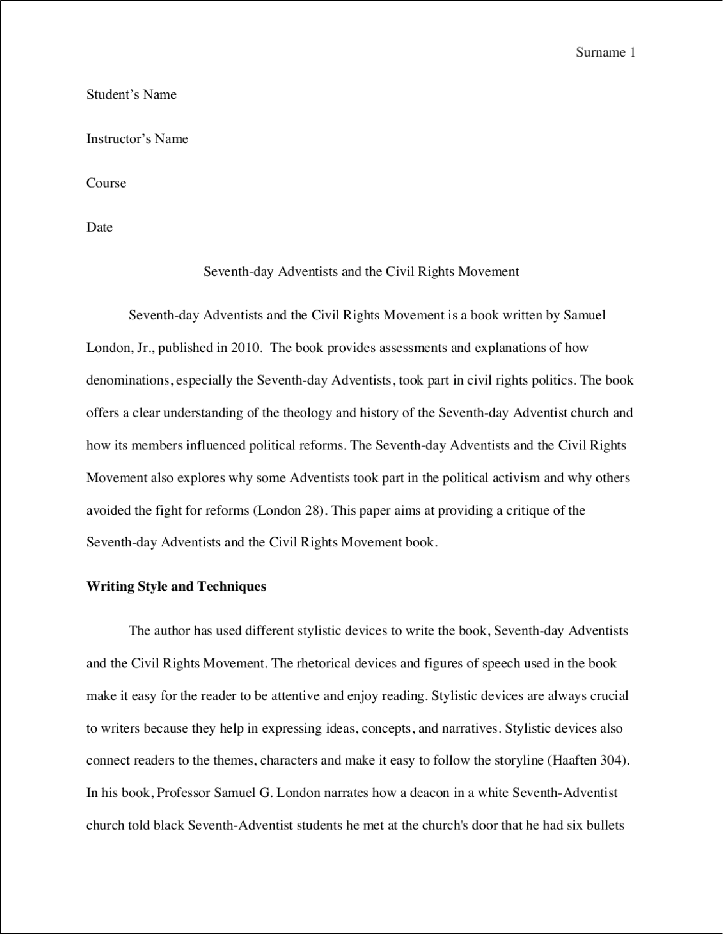

4

6

1

1

3

1

1

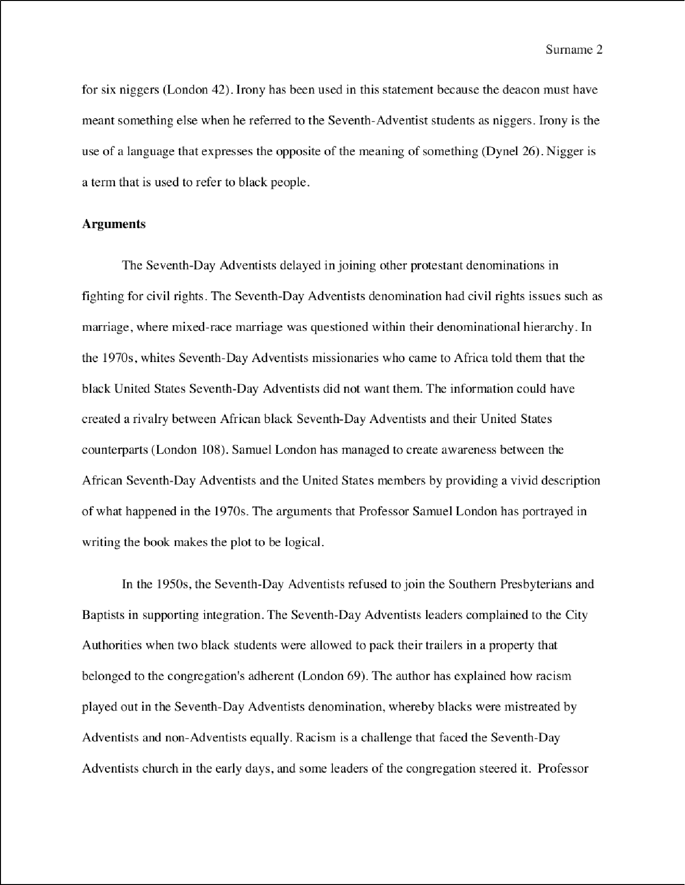

2

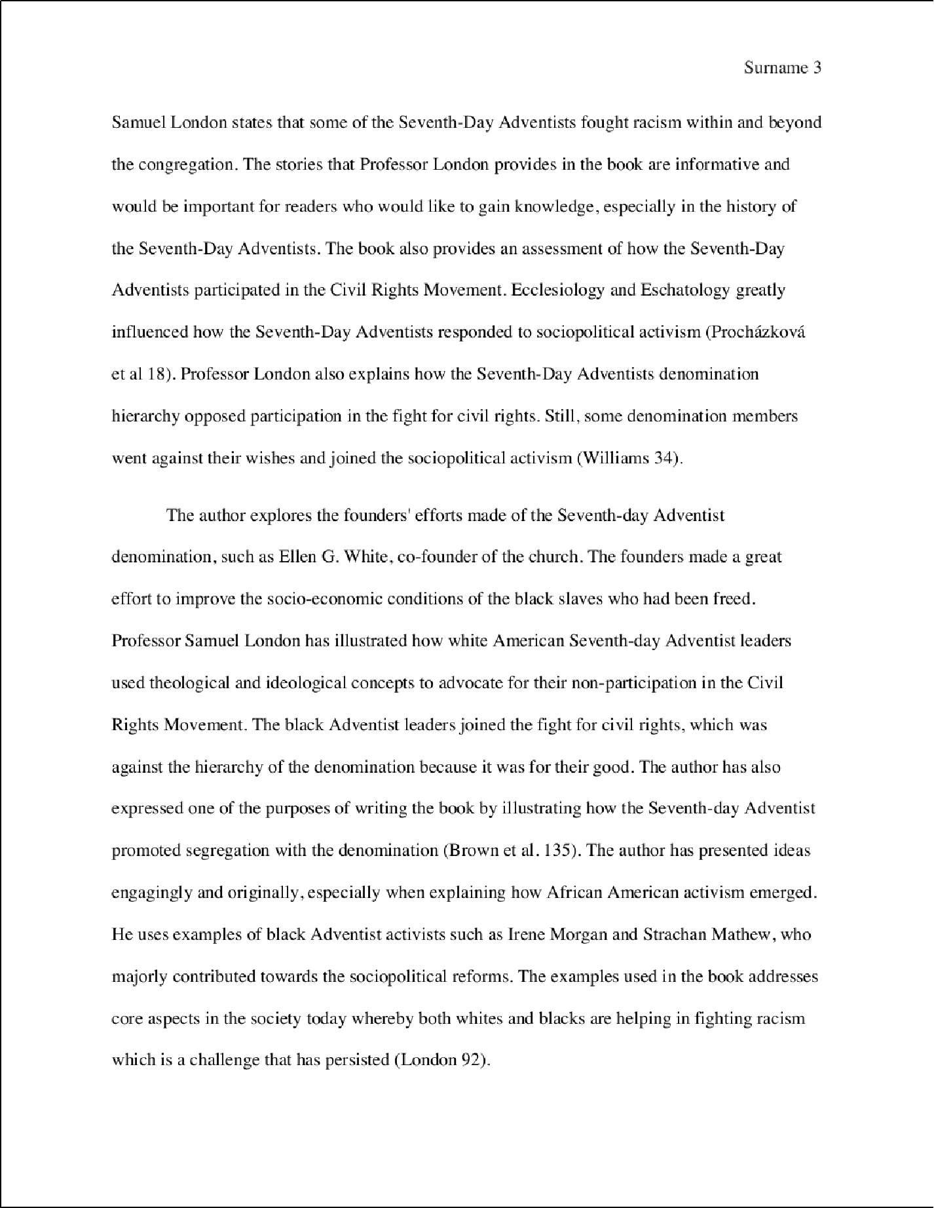

2

1

5

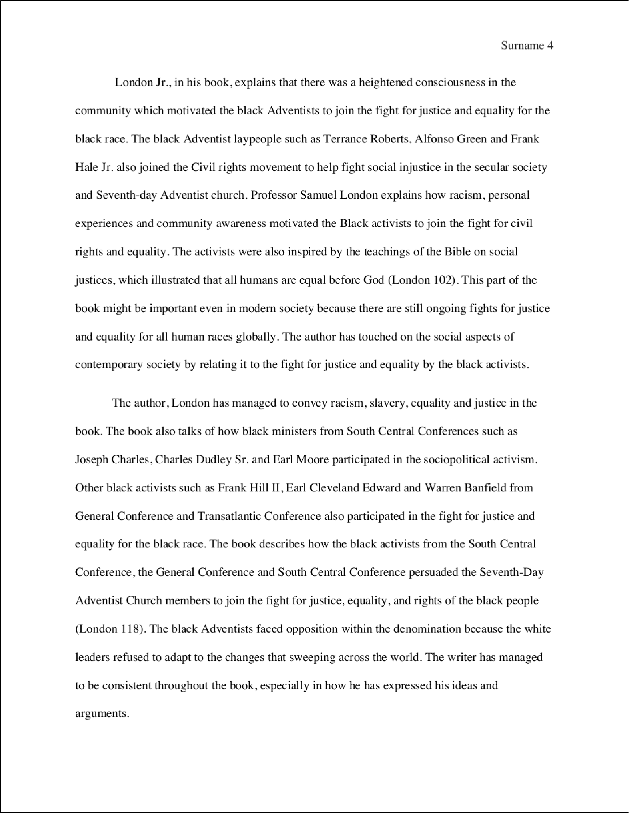

2

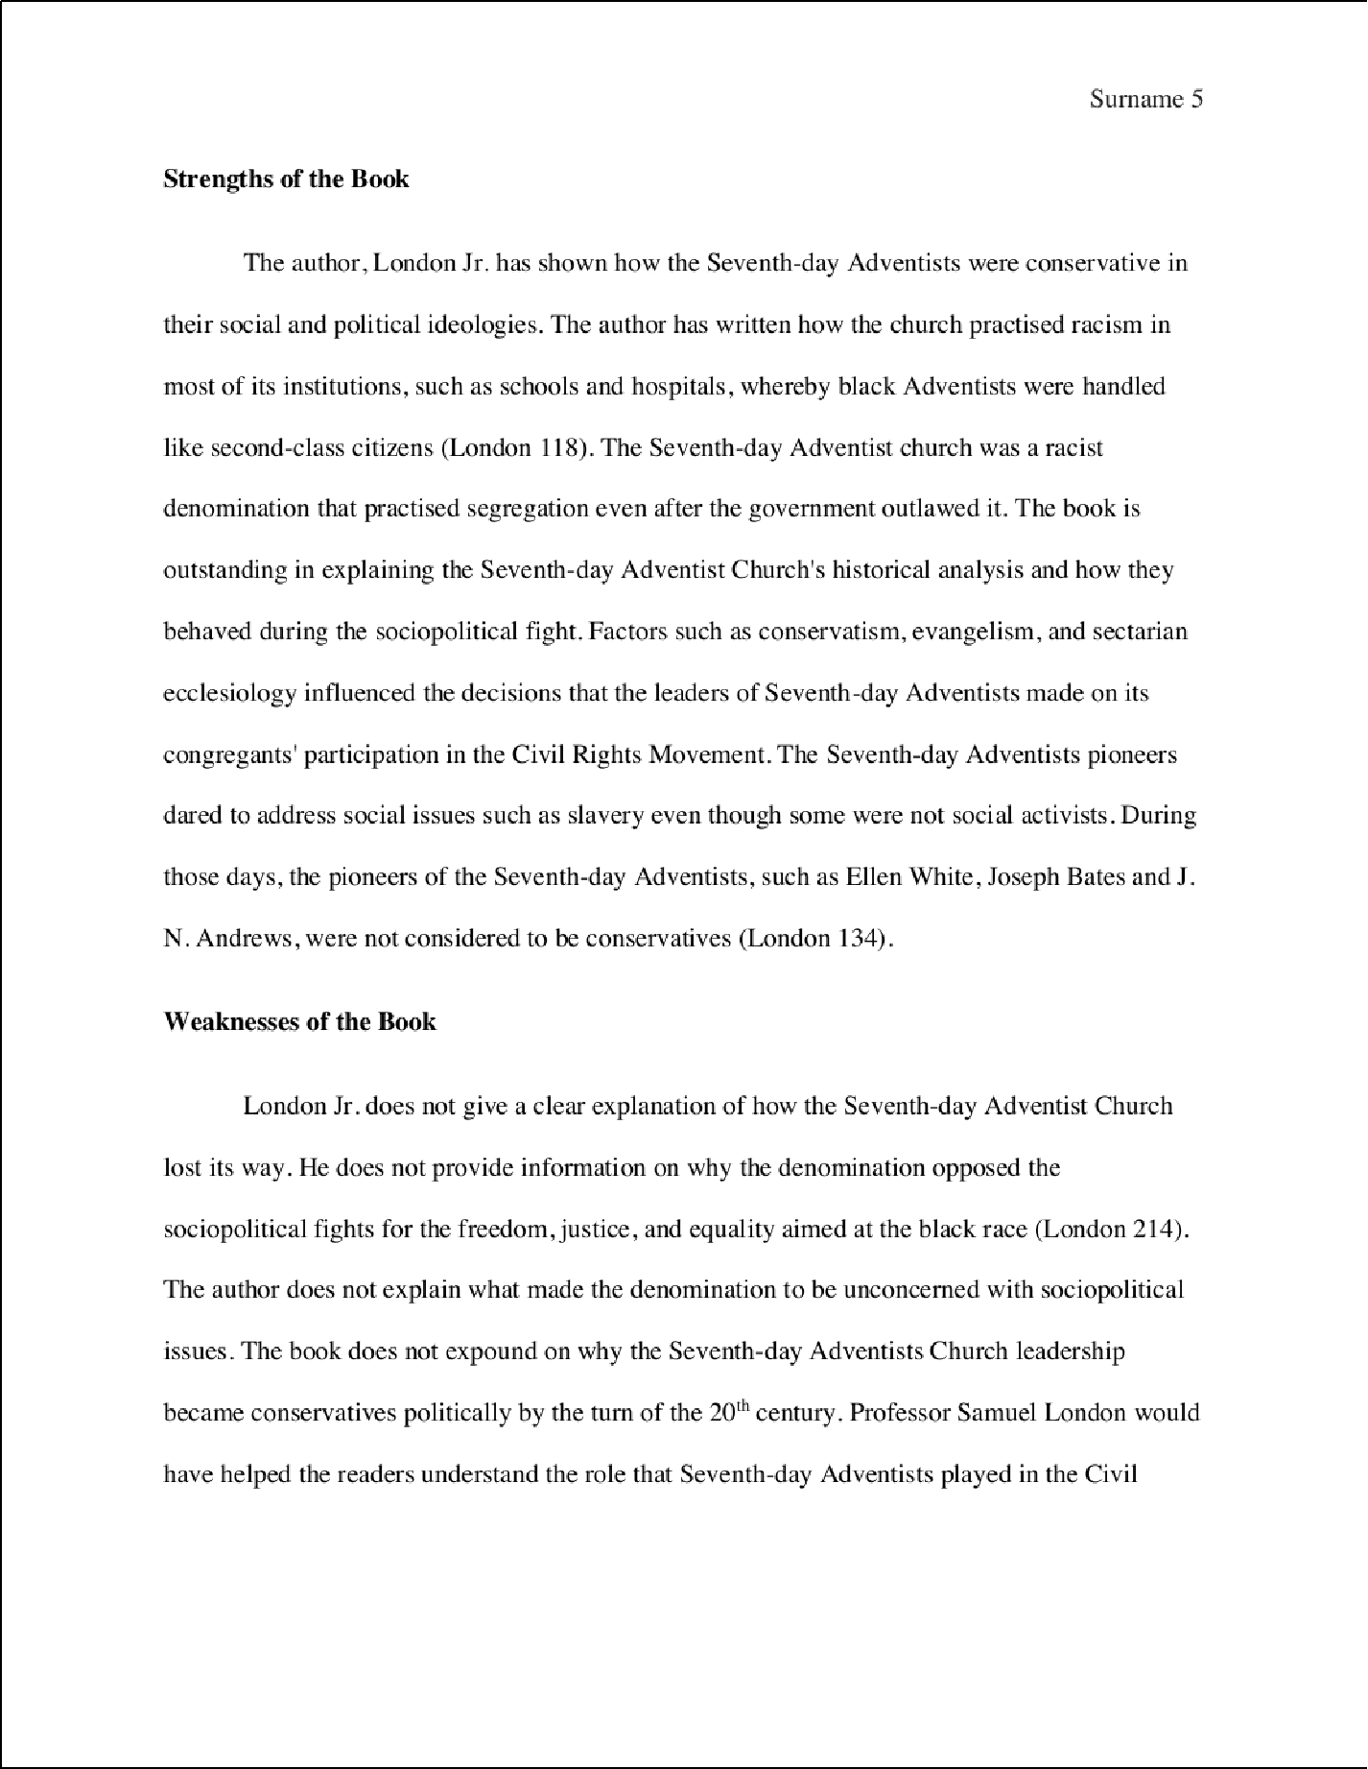

2

2

3

2

7

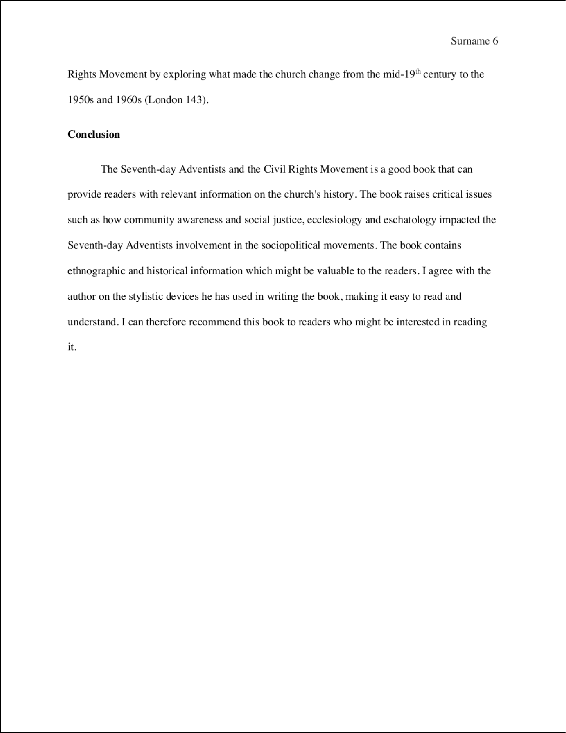

1

Surname?

Works Cited

Brown, Annie Woodley. "Rac ism and the Christian church in America: Caught between the knowledge of good and evil." *Social work in public health* 34.1 (20 19): I 3 4-144.

Williams, D.A., 2020. Unity in Diversity: How Music Helped Shape the Spiritual Identities of Black and White Seventh-Day Adventists, 1840–1944. *Liturgy*, *35*(2), pp.33-41.

Circle ‘The Civil War – America at its Worst, 1861-1865” (2002) Retrieved from <http://circle.adventist.org/search/?search_query=seventh-day+adventis+and+the+civil+movement> Accessed on 05/06/2021

Dynel, M., 20 I 7. T he irony of irony: Irony based on trut hfu l ness. *Corpus Pra gmati cs, 1(1),* 3-36.

London Jr, Samuel G. *Seventh-day Adventists and the civil rights movement.* Univ. Press of Mississippi, 2010.

Prochazkova, Michaela. *Martin Luther King, Jr. an£1 Malcolm X: Search for the Direction of the Civil Right s Movement.* Diss. Masarykova univerzita, Pedagogicka fakulta, 2019.: I 8-22

Surname 8

Van Haaften, **Ton.** "Argumentat i ve strategies and styli s tic devices. " *Informal Logic* 39.4 (2019 ): 301-328.

Williams, David A. "Unity in Diversity: How Music Helped Shape the Spiritual Ide ntitie s of Black and White Seventh-Day Adventists, 18 40- 1944. " *Liturgy* 35.2 (2020): 33-41.

a

ORIGINALITY REPORT

10

%

## SIMILARITY INDEX

9%

## INTERNET SOURCES

1%

## PUBLICATIONS

2%

## STUDENT PAPERS

PRIMARY SOURCES

# [www.holydrops.com](http://www.holydrops.com/)

1

4

Internet Source %

3

# circle.adventist.org

Internet Source %

2

1

# en.wikipedia.org

Internet Source %

3

1

# [www.austintxgensoc.org](http://www.austintxgensoc.org/)

Internet Source %

4

1%

# 5 David A. Williams. "Unity in Diversity: How Music Helped Shape the Spiritual Identities of Black and White Seventh-Day Adventists, 1840–1944", Liturgy, 2020

Publication

1

# [www.coursehero.com](http://www.coursehero.com/)

Internet Source %

6

1

# [www.questia.com](http://www.questia.com/)

Internet Source %

7

Exclude quotes On Exclude bibliography On

Exclude matches Oﬀ