**Date Submitted: 12-2-2018**

* Not sure what exactly to turn in since these assignments are just following tutorials. The results of the last task will be shown since the tasks beforehand build up to the final task.

**------------------------------------------------------------------------------------**

**Photo of setup:**

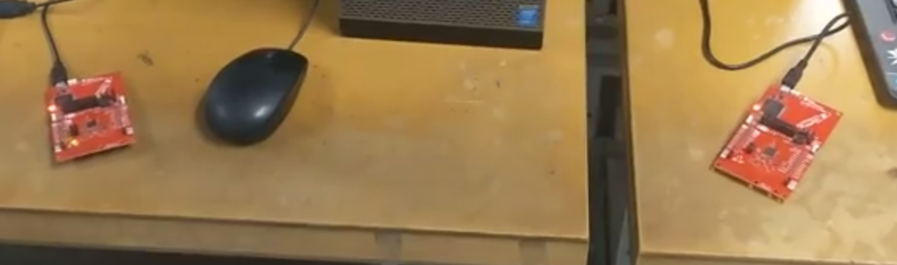

* **All the changes were done with smartRF studio**

**There is no terminal output from this, so the video is the only way to show the results of this lab:**

**Video of CCS TX project to CCS RX project:** [**https://www.youtube.com/watch?v=AJ0YyiKxcHw**](https://www.youtube.com/watch?v=AJ0YyiKxcHw)