**Date Submitted: 12-2-2018**

* Not sure what exactly to turn in since these assignments are just following tutorials. The results of the last task will be shown since the tasks beforehand build up to the final task.

**------------------------------------------------------------------------------------**

**Photo of terminal output:**

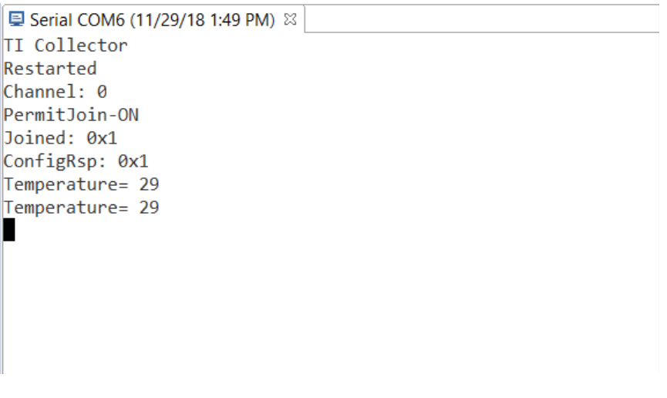

* **We were able to change the frequency in which the TX module sends temperature data to the TX node as shown in the video below**

**Video of changed send rate:** [**https://www.youtube.com/watch?v=Eqj1c1PpFtE**](https://www.youtube.com/watch?v=Eqj1c1PpFtE)