**Date Submitted: 12-2-2018**

* Not sure what exactly to turn in since these assignments are just following tutorials. The results of the last task will be shown since the tasks beforehand build up to the final task.

**------------------------------------------------------------------------------------**

**Photo of terminal output:**

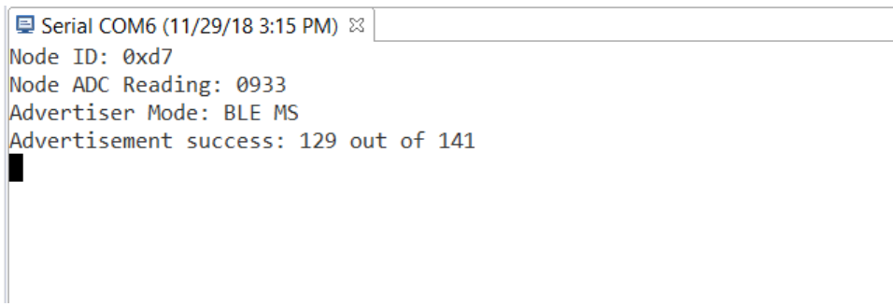

* **We were able to get the node and sensor to connect to send data to each other.**

**Video: https://www.youtube.com/watch?v=CTQCgotxOD4**