University of Toronto, Faculty of Applied Science and Engineering

Department of Electrical and Computer Engineering

**ECE 243S – Computer Organization – 2014**

**Project Proposal Form**

After ensuring that your project idea is unique, you will use this form to describe your project (point

form preferred), assess its difficulty, and outline what you expect to achieve each week of your project

work. You **must give the filled form to your TA at the beginning of the first project lab session (the week of March 14).**

The TA will advise you if changes are needed to your project proposal so it is sufficiently, but not overly

challenging. After you implement the changes, **the TA will then approve and sign your project proposal.** You will then make **two copies** of the final filled form: one will be kept by the TA, and the other one will be for your reference. Your ability to successfully implement all that was approved in your proposal will determine your project functionality marks.

**Group Info**

|  |  |  |  |  |
| --- | --- | --- | --- | --- |
| **Station**  **Number** | **Last Name** | **Last Name** | **Student Number** | **Contribution [0..100]**  **(filled during 3rd lab)** |
| 102 | Verma | Harsh | 998734482 |  |
|  | Vijay | Vaibhav |  |  |

**One Sentence Project Description (as posted on Piazza)**

Apple shooter game on the VGA:

* the player will use the keyboard keys to set the direction of the shot
* the bullet/shot will travel in a projectile path

**Technical Description of the Project**

Describe your project in more technical details and include a system block diagram.

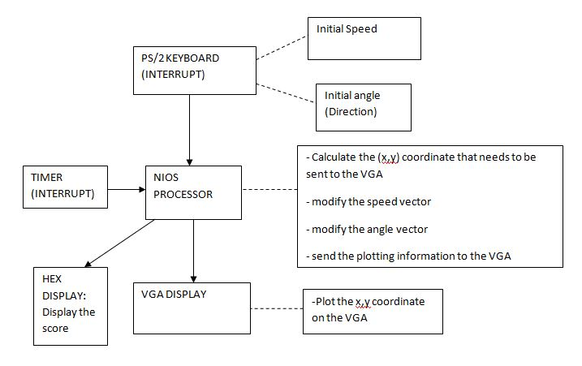

* Apple shooting game
* The target is an apple on one end of the VGA display
* The user will set the initial speed and the angle in which the bullet will be shot
* The bullet will travel in a projectile path
* The player will have a limited time to shoot the apple (target).

**Technical Description of the Project Core**

The project core is a minimum part of your project that you are committing to deliver. Failing to

implement this part will result in loss of functionality marks.

Describe your project core here.

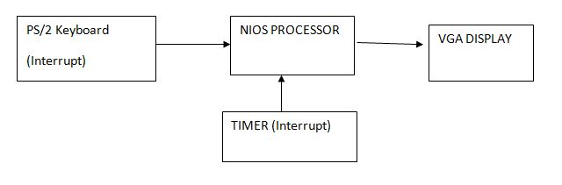

A simplified figure of the main components

**Assessment of Project’s Difficulty**

Please check off each accomplishment you propose in your project and indicate whether that

accomplishment is part of the project core and whether it is interrupt-driven (if applicable). For

accomplishments with multiple units such as the LEDs, switches, motors, etc., indicate the number of

such units used. For example if you are using two Lego motors place the number 2 in the column instead

of a checkmark.

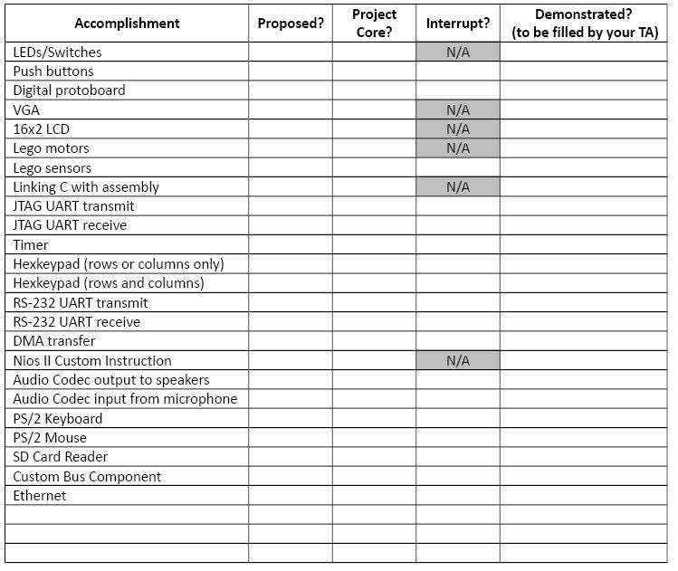

✓

✓

✓

✓

✓

✓

✓

✓

✓

✓

✓

**Please describe any other devices or complex software algorithms you will use. Remember to keep this relevant to ECE243 (not fancy electronic circuits or complex mechanical systems).**

Will have to write a function that calculates the x,y coordinates for the bullet. Since the bullet will follow a projectile path, the function will have to take into consideration the speed and the angle which may be a bit tricky.

**Project Milestones**

Describe what parts of your project you will have fully implemented in each of the three project lab

sessions. Keep in mind that you will have to demonstrate your project during the third project lab

session. The key here is to design incrementally: get something working quickly and keep adding to it.

TAs will not accept the “integrate everything in week 3” approach.

**First project lab session (week of March 14)**

* Ironing out the details of the project
* Prepare a plan for approaching the project
* Identify the main algorithms that need to be developed

**Second project lab session (week of March 28)**

* Animating the movement of the bullet
* Making it travel in a linear path
* Also, development of the algorithm to generate the x,y coordinates for a projectile motion

**Third project lab session (week of April 4) – Demo**

* The bullet should travel in a projectile path
* The collision of the bullet with the target should work

**TA Notes**

This page is filled by your TA.

**Approval**

Approved by __________________________________________________________________________

Date _________________________________________________________________________________

**First project lab session (week of March 14)**

**Second project lab session (week of March 28)**

**Third project lab session (the week of April 4) – Demo**