Website Test

Let’s try building a webpage with LibreOffice….

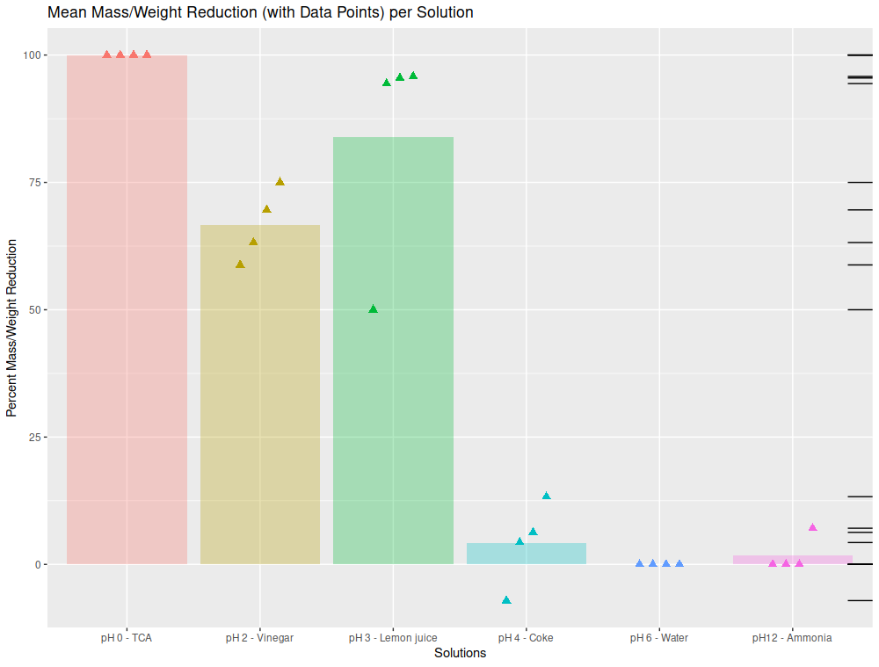
Here’s a link to Zechariah’s graph:

