Deploy GeoLookup Widget in Web AppBuilder

The GeoLookup widget lets you geo-enrich a list of supplied latitude and longitude points. This widget is developed for esri’s Web AppBuilder platform.

Widget deployment

Follow the steps to deploy this widget to the correct location:

1. Log on to the machine where your Web AppBuilder development machine resides and browse to your Web AppBuilder installation location.
2. Inside the installation location, navigate to *client > stemapp > widgets*.
3. Copy the GeoLookup folder to this location, now it is available for all themes to bring in as a widget.

Configure the widget

1. Create or open an existing application. On the left hand panel, click on the Widgets tab on top. On the list of widgets, click one of the empty widget slots, and choose GeoLookup from the dialog.
2. Once the GeoLookup is in the widget list, hover over the widget and click the pencil icon that shows up.
3. GeoLookup has a dependency on the map you choose for this application. If the map does not contain any polygon layers, this widget will no work. If the map does have polygon layers, you will see a list of them. Check the layer(s) you want to enrich.

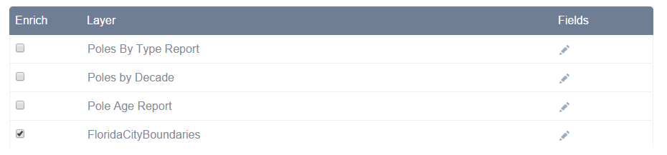

After checking the layer(s), click the pencil icon under the *Fields* heading. Select the fields you want the lat/lon to incorporate as part of the enrichment process. Click *Save Fields* once you’re done.

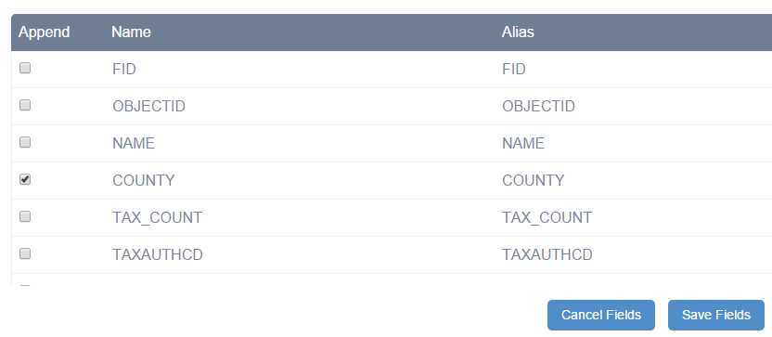

1. Next, specify two symbols that will represent the status of the enrichment process. The status is whether or not the lat/lon point intersects the enrichment layer(s). The non-enriched status will also represent the lat/lon if you choose only to plot the points and not to enrich.

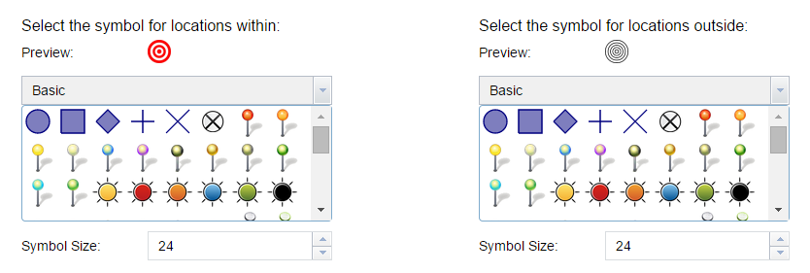

1. In certain cases, you might need to go into *Advance Settings*.

If the csv file has different columns for latitude and longitude, you can specify them here.

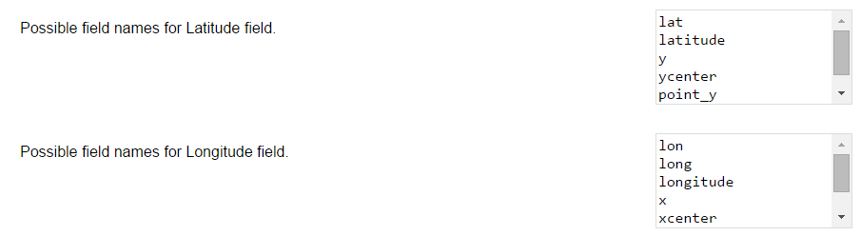

The next three parameters states the values to place on the lat/lon features if after the enrichment process.

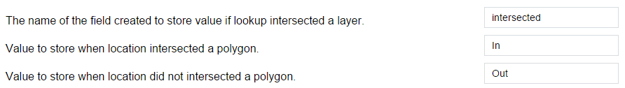

In order to make the enrichment process faster, this widget attempts to cache the enrichment layer(s) on the client machine. The number below reflects that threshold. If the layer you want to enrich against has more features in the map extent than the stated number, the widget will not cache it and do individual feature service lookup. The process will be slower, but will not impact the client performance. Layers with feature count less than the stated number below will be cached.

