GeoLookup Widget User Guide

The GeoLookup widget lets you geo-enrich a list of supplied latitude and longitude points. You supply the widget a CSV file and the widget will intersect it with layers on the map to get values associated with the point.

Launch the widget

1. In your application, look for the GeoLookup widget icon. By default, it’s under the search bar. It might be located at a different location if you are using a different application theme.



1. After clicking on the icon, you will be presented with a panel prompting you to **Select a CSV**. You can press the button and browse to a csv file, or you can drag and drop a csv onto the widget.

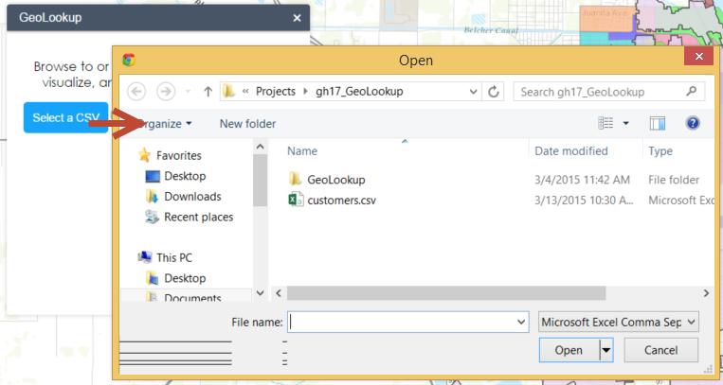

1. After selecting the csv file, the widget will also show the progress of the enrichment. You can see how many points were in the csv file, how many points were plotted, and how many were enriched. Once all the square indicators are green, the process is complete.

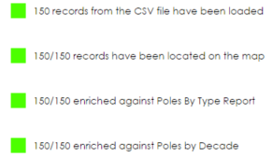

1. The map will zoom out and you will start to see the points being plotted. You will also start to see symbols for whether or not the point was geo-enriched.

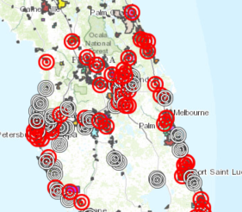

1. If you click on one of the “successful” features on the map, you will see attributes that have been enriched to it.

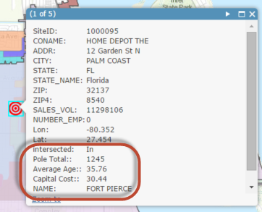

1. If you want to export the results back out to a csv file, use the table results panel at the bottom of the application. You may need to click the arrow to show it.

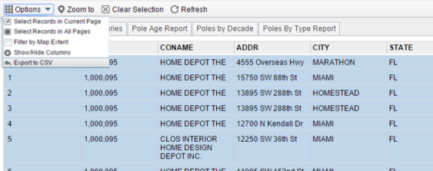

Just Plot Points

There might be times where you want to just check the lat/lon points in the csv file and not geo-enrich it yet. For example, you want to verify that all the points fall within your service area and there are no outliers. This widget helps you for this case.

1. If the widget is not open, click the icon and open the widget panel again. You will notice a **checkbox** that states **Only Plot Points**.

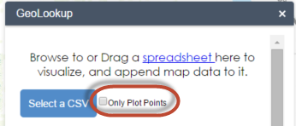

1. Check this box. Then browse to or drag and drop a csv onto the widget.
2. You will see the points start to plot on the map. The symbol should all be the same, and should be represented by the non geo-enriched symbol.

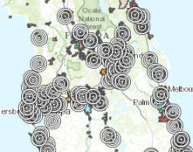

In the widget panel, you should see the record count and the status of how many were plotted. You should not see the progress of any of the enriched layer(s).

