Document Title: AutoBAHN System Deployment Guidelines SA2 Task5 Release 0.5.1
Document Details
Activity: | SA2
Work Item: | Task5
Nature of Deliverable: | O
Author: | Jacek Lukasik, Ophelia Neofytou, Afrodite Sevasti, Stella-Maria Thomas, Kostas Stamos, Giannis Zaoudis
Dissemination: | PP (Project Participants)

Document History
Version | Date | Description of work | Person
 | 26-02-08 | First draft issued | Jacek Lukasik
 | 05-03-10 | First version issued | Kostas Stamos
 | 08-03-10 | Comments added | Jacek Lukasik
 | 15-07-10 | Comments by Michal Giertych and other improvements | Kostas Stamos

Table of Contents
1 Introduction 2
2 Control plane: AutoBAHN software suite installation 5
2.1 AutoBAHN server specifications 5
2.1.1 Hardware 5
2.1.2 Default ports used (may be reconfigured) 5
2.2 Prerequisites for AutoBAHN system installation 5
2.2.1 Quagga Installation 6
2.2.2 RDBMS installation 6
2.3 Adding the network topology information 7
2.3.1 AutoBAHN topology information editing using cNIS 7
2.3.1.1 Inserting topology information in cNIS 8
2.3.1.2 Adding connections to the external domains 9
2.3.1.3 Connections to end points 9
2.3.2 Public identifiers 9
2.3.3 Configure DM to use cNIS as topology information source 10
2.4 Installation using the wizard (for Ubuntu, Debian and Fedora Linux) 10
2.4.1 Wizard guide 10
2.4.2 Generic Routing Encapsulation (GRE) tunnels setup example 14
2.5 Initializing the AutoBAHN service 15
2.6 Shutting down the service 16
3 Data plane configuration 17
3.1 Case A: End host at the domain’s ingress Point-of-Presence from GÉANT2 17
3.2 Case B: End host connected to any Point-of-Presence in the domain 17
4 Appendix 19
4.1 Sample reservation scenario 19
4.2 Manual installation 23
4.2.1 Database creation 23
4.2.2 Generic Routing Encapsulation tunnel configuration 23
4.2.3 AutoBAHN system configuration 24
4.3 AutoBAHN Web Services interfaces addresses 27
4.4 Installing LS 28
4.4.1 On Linux 28
4.4.2 Configuring LS 28
4.5 WebGUI deployment 30
4.5.1 Web Application Container installation 30
4.5.2 Web GUI installation 30
4.5.3 Web GUI configuration 30
4.5.4 Google Maps configuration 31
5 AutoBAHN references 32
6 Glossary 33
7 References 34

Introduction
The document describes the prerequisites needed, and sets out the instructions to follow, in order to deploy the Automated Bandwidth Allocation across Heterogeneous Networks (AutoBAHN) system in a domain.
To provide guaranteed end-to-end dynamic circuit service with resource reservation, service requests must be co-ordinated across domains. This role is undertaken by instances of the AutoBAHN system deployed in each involved domain.
AutoBAHN system comes with the following software components:
Single AutoBAHN instance – software suite to be deployed in each involved domain:
- InterDomain Manager (IDM)
- Domain Manager (DM)
- Technology Proxy (TP)
Additionally to make separate instances of AutoBAHN be aware of each other and operate as one environment following components need to be deployed (once per a whole AutoBAHN environment):
- Lookup Service
- Web based graphical user interface (Web GUI)
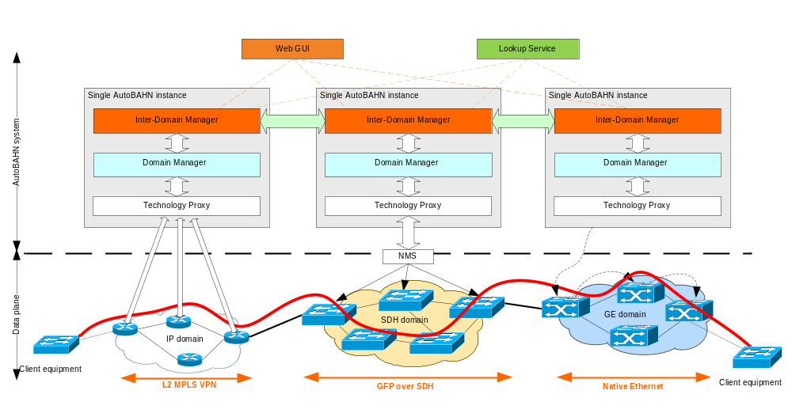

Below is a table with an overview of prerequisites for installing each part of the software (details are given in the corresponding sections):
Prerequisite | AutoBAHN software suite (IDM, DM, TP) | Lookup Service | WebGUI
Java 1.6 VM | Required | Required | Required
NTP server synchronization | Required | Required | Required
GRE kernel module (ip_gre.o) | Required | Not needed | Not needed
PostgreSQL 8.x or higher | Required  (see section 2.2.2) | Not needed | Not needed
Quagga 0.99.6 or higher | Required  (see section 2.2.1) | Not needed | Not needed
cNIS | Optional  (see section 2.3.1) | Not needed | Not needed
ncurses library-based Dialog application | Optional  (see section 2.4.1) | Not needed | Not needed
Tomcat | Not needed | Required  (see section 4.4.1) | Required  (see section 4.5.1)
perfSonar LS | Not needed | Required  (see section 4.4.1) | Not needed
eXist | Not needed | Required  (see section 4.4.1) | Not needed

Control plane: AutoBAHN software suite installation

AutoBAHN server specifications
The server that hosts the AutoBAHN system must fulfil the following requirements hardware:

Hardware
- Central Processing Unit (CPU) – minimum 500 megaherz (MHz), recommended 1 gigahertz (GHz).
- RAM – minimum 512 megabytes (MB), recommended 1 gigabyte (GB).
- Disk space – minimum 50 MB, recommended 500 MB (for long term logs).
- Network Information Centre (NIC) – 1 Fast Ethernet NIC.
- Operating System (OS) – any supporting Java. Ubuntu or debian Linux is recommended for easier installation (software has been tested on Fedora, Debian, Suse, Ubuntu, Windows XP).

Default ports used (may be reconfigured)
- 8443 – Inter-domain; Inter Domain Manager (IDM)-IDM.
- 8443 – Intra-domain; IDM-Domain Manager (DM) – as for inter-domain.
- 5432 – Database access within the domain.
- 25 – Simple Mail Transfer Protocol (SMTP) for sending mails with notifications (optional).
- 2607 – Intra-domain; IDM-Quagga Application Program Interface (API) access.
- 4000 – Inter-domain; sending Link State Advertisement (LSA) messages.
- 4001 – Inter-domain; receiving LSA.

Prerequisites for AutoBAHN system installation
AutoBAHN system require following software to be installed on the target machine:
- Java 1.6 VM
- GRE kernel module (ip_gre.o)
- PostgreSQL 8.x or higher (any other SQL RDBMS can be used, so long as it is supported by Hibernate).
- Quagga 0.99.6 or higher.

Important: It is recommended to use NTP based time synchronization on hosts that runs the AutoBAHN instance. Certain reservations events are launched at the strictly specified time in all domains across a path so it is highly important to have the hosts in synchronization.
Detailed instructions on how to install and configure PostgreSQL and Quagga is given below.
Optionally you may also install:
- cNIS for topology storage (details on installation and usage in section 2.3.1)
- ncurses library-based Dialog application for installation in Text User Interface (details in section 2.4.1)

Quagga Installation
Qugga is used as the routing daemon for the AutoBAHN system for exchanging topology information. One instance of Quagga must run on each AutoBAHN server. To install Quagga, install appropriate Quagga package from your system distribution or download the latest tarball from http://www.quagga.net/, and unpack it to a convenient location.
Configure (you may need to install some additional libraries to successfully fulfill this point, but it depends on your current configuration):
cd quagga-0.99.4
./configure --enable-opaque-lsa --enable-ospf-te
Check the output of the configure script for your config file directory (/usr/local/etc). You can alter this with the option --sysconfdir=dir at the configure script.
Compile and install:
make
make install
Insert the following lines into /etc/services, if they are not already present:
zebrasrv 2600/tcp # zebra service
zebra 2601/tcp # zebra vty
ripd 2602/tcp # RIPd vty
ripngd 2603/tcp # RIPngd vty
ospfd 2604/tcp # OSPFd vty
bgpd 2605/tcp # BGPd vty
ospf6d 2606/tcp # OSPF6d vty
ospfapi 2607/tcp # ospfapi
isisd 2608/tcp # ISISd vty

RDBMS installation
Install PostgreSQL 8.x or higher (You can download the latest release from http://www.postgresql.org/ and follow the installation instructions from the documentation).
Any other SQL RDBMS can also be used, so long as it is supported by Hibernate [Hibernate].
Make sure that local access to the database is allowed (e.g. you can connect to PostgreSQL by running psql). In order to do that, you can perform the following steps:
/etc/init.d/postgresql start
Then try to connect to the database to make sure that local access has been opened. In order to connect you have to be a user that is registered in the database. So connect as the default user (postgres) user, for example by running in Ubuntu:
sudo –i
su postgres
psql

Adding the network topology information
Network topology of your domain (including links connecting with neighbouring domains) should be stored in a topology database. You may use Geant cNIS software to describe your network topology and provide it to AutoBAHN.

AutoBAHN topology information editing using cNIS
In order to configure your domain’s internal topology using cNIS following steps have to be performed:
- Install cNIS (visit http://www.cnis.psnc.pl/ for instructions).
- Insert information about the topology of your domain using cNIS cma web application.
- Add connections to other AutoBAHN enabled domains or client end points (cNIS cma).
- Populate the public_ids.properties file in the configuration of AutoBAHN
- Change the DM configuration to use cNIS as a topology information source (dm.properties file).

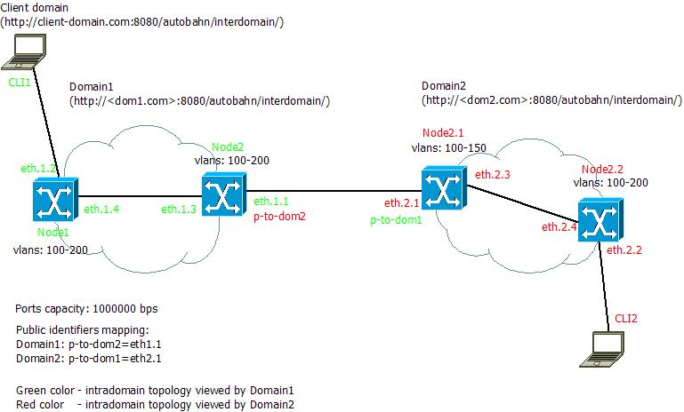
Figure 1 Sample physical topology (two ethernet domains)
Figure 1 shows a sample physical ethernet topology of two AutoBAHN enabled domains: Domain1 and Domain2. There is a single connection between these two domains, each domain has one client connected to it (CLI1 and CLI2).
This section describes the process of configuring AutoBAHN for this sample scenario. The scenario assumes two AutoBAHN domains, each of them is controlling separate network, cNIS and AutoBAHN instances have to be deployed and configured for each of them separately.

Inserting topology information in cNIS
Launch cNIS cma in your internet browser, credentials are admin/admin for the default installation. Insert the information about network elements using web forms.
You can learn more about editing a topology using cma by checking screencasts available at: http://cnis.psnc.pl/video.htm.
Topology for Domain1:
- Add 2 Ethernet nodes (Node1 and Node2)
  - Add specific interfaces for each node (you should at least specify name, capacity and state). In the example ports: eth1.4 and eth1.2 belongs to Node1.
  - Specify Vlan range available for ports on the given node (Autobahn tab/Vlan ranges)
  - Specify name of the node
- Add the link between eth1.4 and eth1.3
Process of adding the information about the topology for Domain2 is similar.

Adding connections to the external domains
To build a topology which can be utilized by AutoBAHN, the user needs to provide at least two connections to external domains. By “external domain” we assume a connection to other administrative domain (which is out of our management) or a connection to an end point (called client domain). AutoBAHN is designed to provide connection between a pair of end points across multiple heterogeneous domains.
Since cNIS 2.1.0 user is able to add an information on connections to external domains using cma.
Choose the Ethernet tab and Add Link from the left menu labeled ‘External domains links’. Then a form should be displayed. Following information must be provided:
- External domain ID:
  - Specify here an identifier of the external domain (i.e. PIONIER) if a Lookup Service instance is used. If your connection goes to an end point then the you can put an arbitrary identifier.
  - Otherwise you need to place here full URL of interdomain web service of IDM of the external domain (i.e. http://<domain>:8080/autobahn/interdomain)
- Bandwidth:
  - Specify here the capacity of the connection (in bps)
- Start port:
  - Choose an interface from the list. It is the termination of the connection that belongs to your domain.
- End port:
  - Specify publicly available identifier of the terminating interface in the other domain (i.e. p-to-dom1)
- VLAN ranges:
  - Specify range of available VLAN identifiers on you side of the connection. (it can be a range or a single value or combination i.e. 5,800-802,100-120)

Connections to end points
Proceed with steps needed to create a connection to an external domain. If the connection to an external domain you have just created is a connection to a client domain then you have to provide this information to the system.
Navigate to the ‘Tags’ tab, choose ‘Edit’ and in the text area put following information:
- client=true
- bodid=<your description> (i.e. Data calculation cluster in Poznan)
Click ‘Ok’ button to submit the data.

Public identifiers
As the domain administrators may not want to announce topology details such as port or node identifier to external domains, in AutoBAHN we introduced a concept of public identifiers hiding real ports/nodes physical identifiers.
In the sample diagram we can see that although the port connecting Domain2 with Domain1 has identifier ‘eth.2.1’, Domain1 sees it as ‘p-to-dom1’ while Domain2 sees ‘eth1.1’ as ‘p-to-dom2’. And this is the only information that Domain2 has got about the physical topology of Domain1. The topology information seen by Domain1 is shown by the green color and by Domain2 by the red one.
To store an information about the mapping a special property file is dedicated. put the information about the mapping in the <autobahn_home>/etc/public_ids.properties file:

Domain1:
#Public names for domain ports
p-to-dom2=eth.1.1
Domain2:
#Public names for domain ports
p-to-dom1=eth.2.1

Configure DM to use cNIS as topology information source
To plug cNIS to your DM you must edit the <autobahn_home>/etc/dm.properties file. Find line with cnis.address property and insert the correct address to the abs service of your cNIS instance.
For example:
cnis.address=http://192.168.74.128/abs/Autobahn

Installation using the wizard (for Ubuntu, Debian and Fedora Linux)
The easiest way to install the AutoBAHN system under Ubuntu, Debian or Fedora distributions is by using the automated installer (wizard) included in the distribution. If the automated installer is not suitable for your environment or you wish to have more control over the installation procedure, you can follow the manual steps at the appendix (section 4.2).
In order to run the wizard installation, perform the following steps:
- Extract AutoBAHN.zip
- Go to the installer folder
- Run the setupall.sh script with root priviledges (sudo setupall.sh)

The wizard configures properly the following:
- Database
- Quagga and its OSPF daemon
- GRE tunnels for Quagga communication with other domains
- System configuration parameters (detailed listing in appendix section 4.2.3)

Wizard guide
The wizard presents either a text-mode dialog-based interface or a simple command-line sequence, depending on the existence of the ncurses library in the system where the installation takes place.
Below is a sample screenshot of the command-line wizard interface.
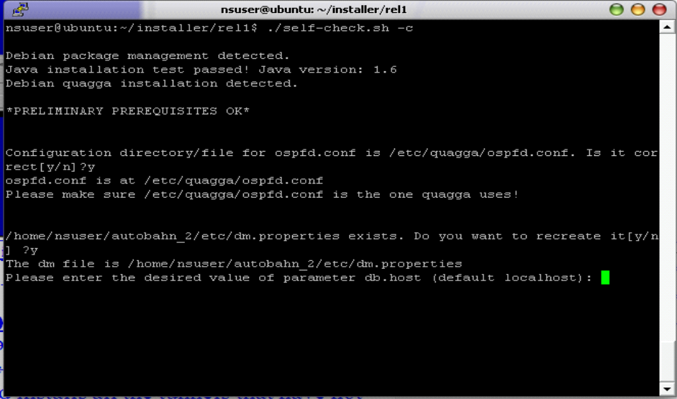

The following is a sample screen from the ncurses dialog-based wizard interface.
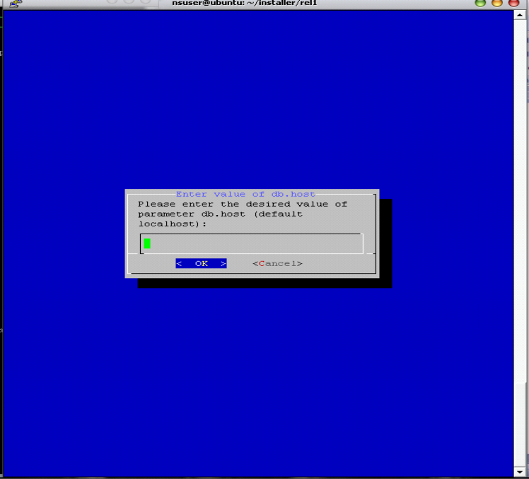

First, the wizard performs some tests to check whether all the required software dependencies exist, and informs about any possible problems. Click on the Exit button to progress through these screens as shown below.
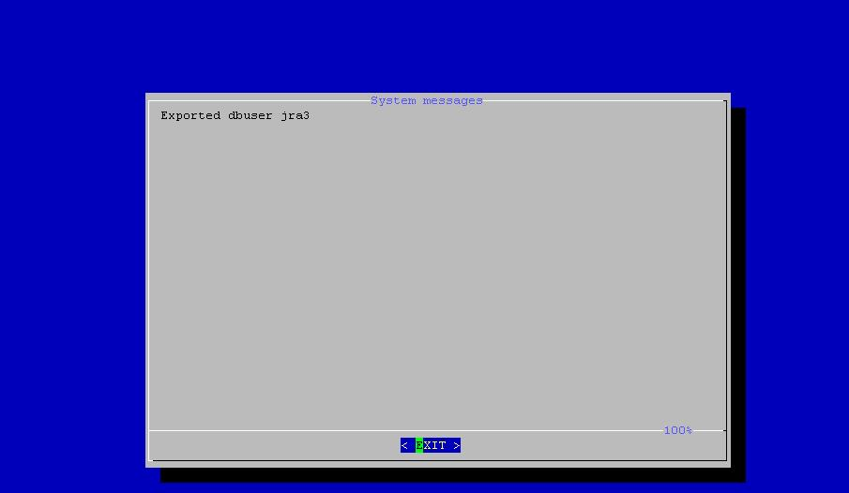

Then the wizard proceeds to configuration file editing as shown below. You can select a configuration file (ta.properties, dm.properties, idm.properties or calendar.properties) and change the operational parameters for the corresponding AutoBAHN modules (Topology Abstraction, DM, IDM, Resources Reservation Calendar). A complete listing of the available properties and their meaning can be found in section 4.2.3.

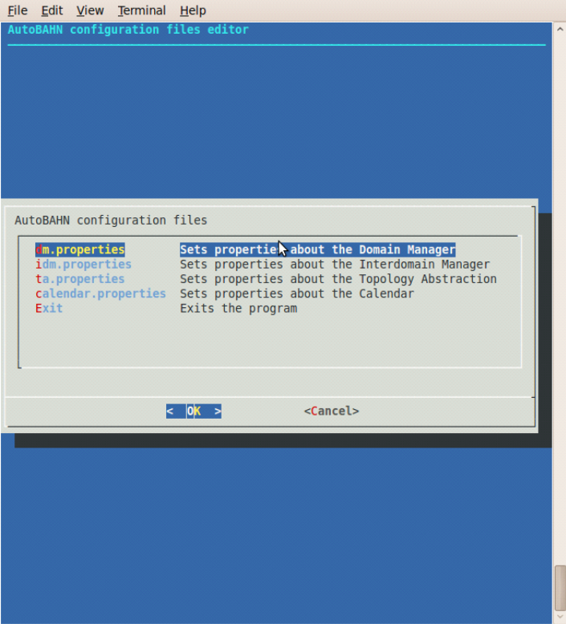

Below an example of editing the dm.properties file for changing the database connection properties is shown.

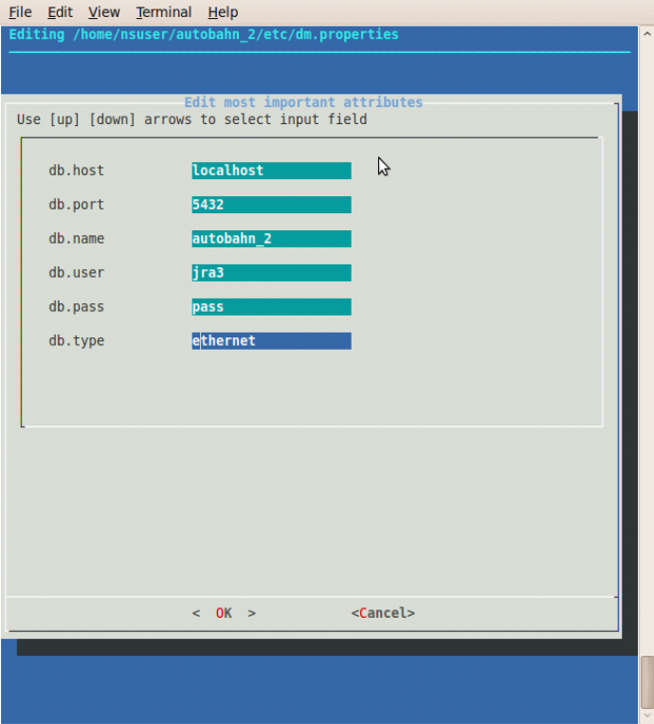

Then the wizard (if the ncurses dialog-based interface is available) presents the following menu.

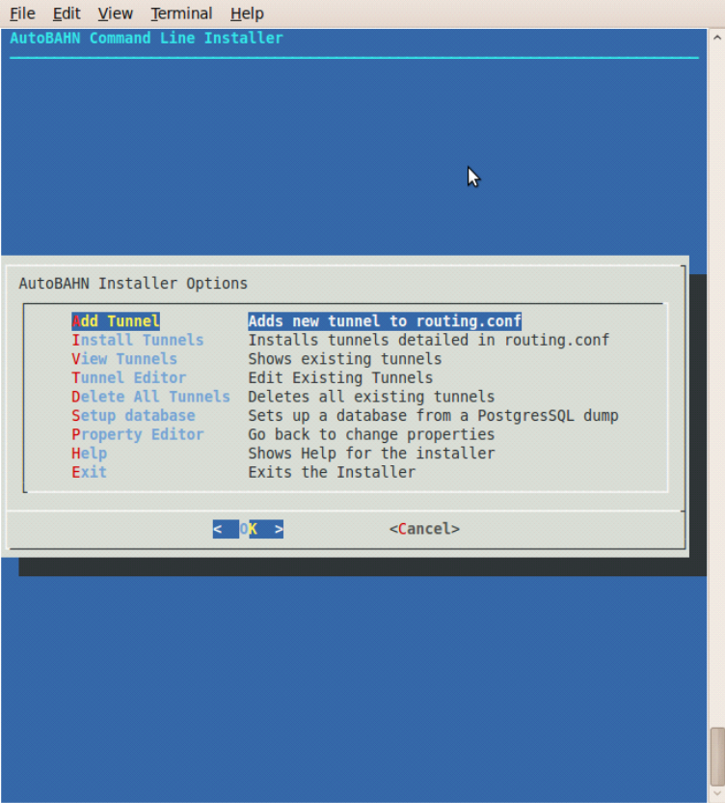

From this menu you can add, edit or view tunnels. These actions are recorded in a temporary file. In order to apply them to the OS you should then install the tunnels. Another menu option is to fill the database with an SQL script, if available. This step is optional, as you may choose to retrieve network topology via cNIS (which is also the preferred way). Finally, the menu gives you the option to go back to editing the system properties.

Generic Routing Encapsulation (GRE) tunnels setup example
Generic Routing Encapsulation (GRE) tunnels are needed for control plane communication; that is to implement communication channels between the different AutoBAHN servers in the domains participating in Bandwidth on Demand (BoD) service provisioning.
Suppose that the control plane for the example presented in section 2.3.1 is the following:

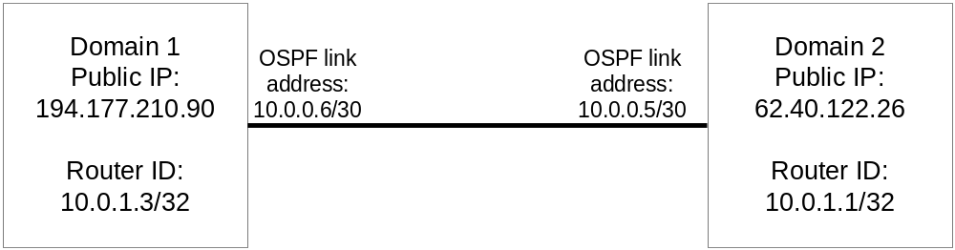

The Internet Protocol (IP) address of the local end of tunnel at Domain 1 is 194.177.210.90 (the IP address of the Domain1 AutoBAHN server) while the IP address of the remote end of the tunnel is 62.40.122.26 (the IP address of the Domain2 AutoBAHN server).
Assume that the following values were agreed on by the partners:
- Private addressing for Open Shortest Path First (OSPF):
OSPF area = 100
network 10.0.0.0/8 area 0.0.0.100
- HOST OSPF loopback address (router ID):
Domain1 10.0.1.3/32
Domain2 10.0.1.1/32
- Address for GRE tunnel (OSPF link addresses):
Remote to Local: 10.0.0.5/30 <----> 10.0.0.6/30

In order to create the tunnel at Domain 1, you have to select “Add tunnel” in the wizard menu and specify the following values:
- Remote IP: 62.40.122.26
- Local IP: 194.177.210.90
- Local Subnet: 10.0.0.6/30
- Local Router ID: 10.0.1.3
- Network: 10.0.0.0/8
- Area: 0.0.0.100

If you wish to edit an already existing tunnel, you can select “Tunnel Editor”. A screenshot of the relevant wizard menu is presented below.
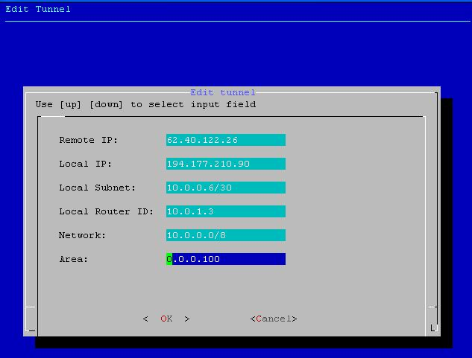

Then click OK and select “Install tunnels” in order for the tunnel to be installed in the OS environment.

Initializing the AutoBAHN service
In the distribution directory type: ./start.sh &
You may need Java in your classpath.
You may prevent displaying log messages on the console by typing:
nohup ./start.sh &
It will start AutoBAHN in the background and logs will be kept in nohup.out file.

If there are no mistakes in configuration or topology, you can see the log messages of the initialization process. You may also check whether the service is running by accessing the URL http://(your-host):8080/autobahn/uap?wsdl using your favourite browser.
Services are started at the 8080 port. You may change the default 8080 port by editing the etc/services.properties file. Remember to change the other configuration files as well.

Shutting down the service
Telnet to the Autobahn instance (port 5000 is default):
telnet localhost 5000
Then type:
halt

Data plane configuration
This section provides examples of the minimum configuration required to enable a domain to participate in the AutoBAHN service cloud.

Case A: End host at the domain’s ingress Point-of-Presence from GÉANT2
Here a host is connected on the Point-of-Presence (PoP) where the domain peers with the AutoBAHN cloud. The example is taken from GRNET (see Figure 3.2).
The configuration is minimal, with one end host with two 1GE NICs located in the GÉANT2 PoP in Greece, co-located with a GRNET PoP. One of the NICs is connected to the public Internet. The other terminates the AutoBAHN circuit on the host.
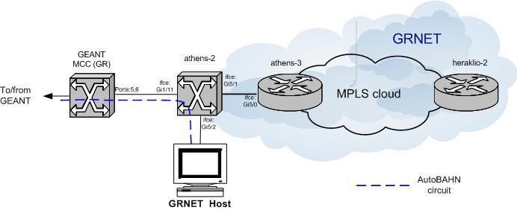
Figure 3.2: Case A: Minimal data plane configuration required to join the AutoBAHN cloud
The AutoBAHN circuit arrives at GRNET through one of the GE client interfaces on the GÉANT2 PoP Metro Core Connect (MCC) in Athens. The circuit is received at a Layer 2 (L2) switch on the border of GRNET and then switched directly to the host. In this case, the GRNET part of the AutoBAHN circuit data plane comprises a single L2 switch.

Case B: End host connected to any Point-of-Presence in the domain
Here the host is connected on any other PoP of the domain, other than the peering PoP with GÉANT2. The example is again taken from GRNET (see Figure 3.3).
The end-host has two 1GE NICs, one of which is connected to the public Internet. The other terminates the AutoBAHN circuit on the host.
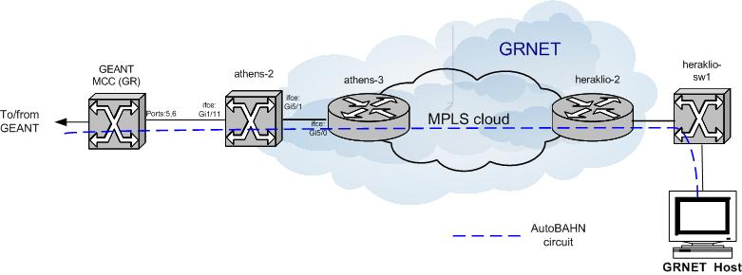
Figure 3.3: Case B: Minimal data plane configuration required to join the AutoBAHN cloud
GRNET implements AutoBAHN circuits within its core using L2 Multiprotocol Label Switching (MPLS) Virtual Private Networks (VPNs). The AutoBAHN circuit arrives at GRNET through one of the GE client interfaces on the GÉANT2 PoP MCC in Athens. The circuit is switched through a L2 switch to the border router of the GRNET MPLS cloud in Athens and then through a L2 MPLS VPN to the border router of the GRNET MPLS cloud in Heraklion (Crete). The circuit is then switched through another L2 switch to the end host.
In Figure 3.3 the host is assumed to reside in a PoP of the domain. If this is not feasible (for example, the end host is located in a campus, lab, or similar that does not belong to the domain), then the AutoBAHN circuit should reach the end host using a fixed or virtual L2 circuit. The detailed implementation depends on the existing technologies at the last mile.
The AutoBAHN group is investigating possible solutions to the last mile problem but at present manual configuration is required.

Appendix

Sample reservation scenario
This section presents a sample scenario of a reservation using the WebGUI. The underlying network topology is the one described in 2.3.
First, we are presented with a welcome screen.
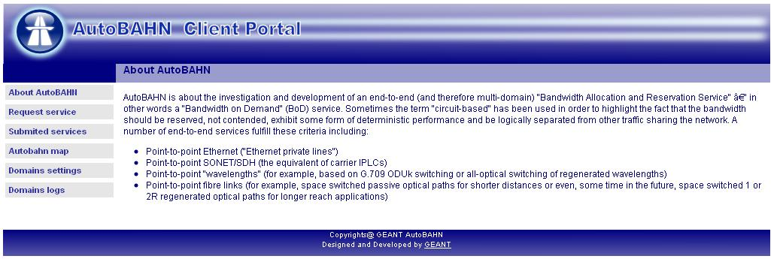

Clicking on any of the selections in the left side menu brings us to the login screen where appropriate credentials have to be provided. To configure user accounts please follow instructions in section 4.5.3.
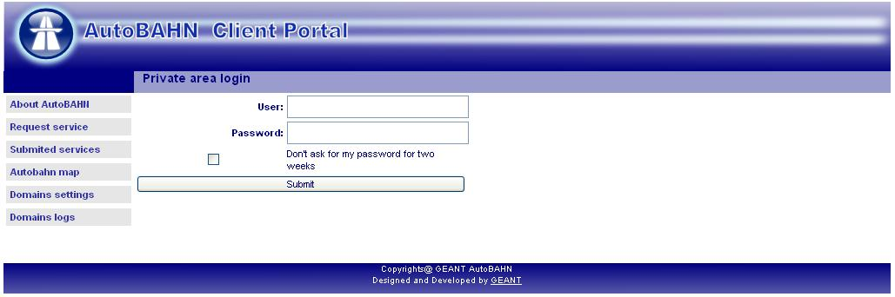

The first step is to request a service by selecting “Request service”. A service is a collection of requested reservations. In this screen we select the IDM from which the service is going to be requested from (among all the IDMs that have registered with the WebGUI). This IDM is going to be the Home Domain for the reservations. A justification text for the service also has to be provided. Then we click on the “Add reservation” button.
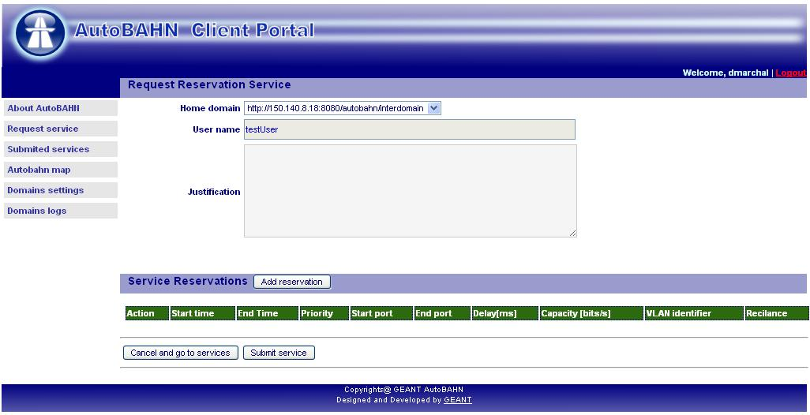

Here we select the parameters for the first reservation of the service, such as start and end port, start and end times, delay, capacity, possible required VLAN, possible routes (links and/or domains) that we want included or excluded from the selected path, resiliency and priority. We also write a text description for the reservation and click on “Test reservation” button.
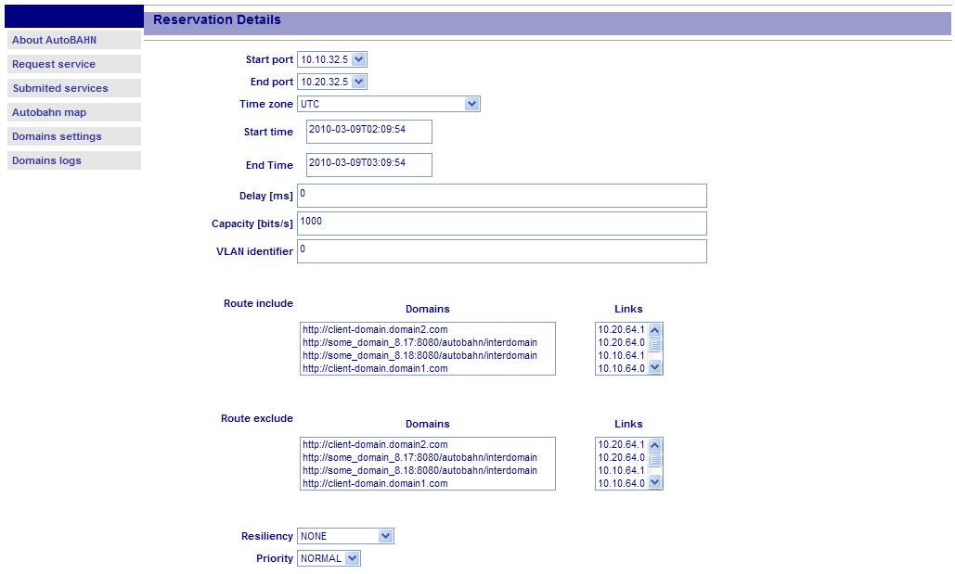

This instructs the WebGUI to send the reservation to the IDM and the IDM checks whether a path with the requested parameters is feasible. In case it is, we get a success message as shown below, which means that we can safely proceed with the actual reservation. We therefore now select “Submit reservation”.
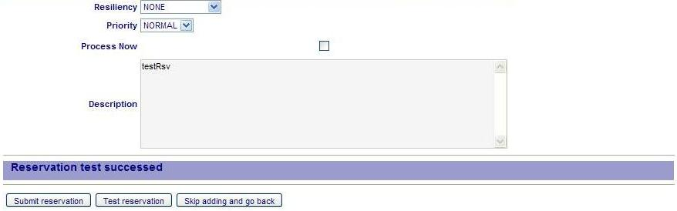

The reservation is now added to the service. We can add more reservations to a single service. As soon as we have finished adding reservations, we select “Submit service”.
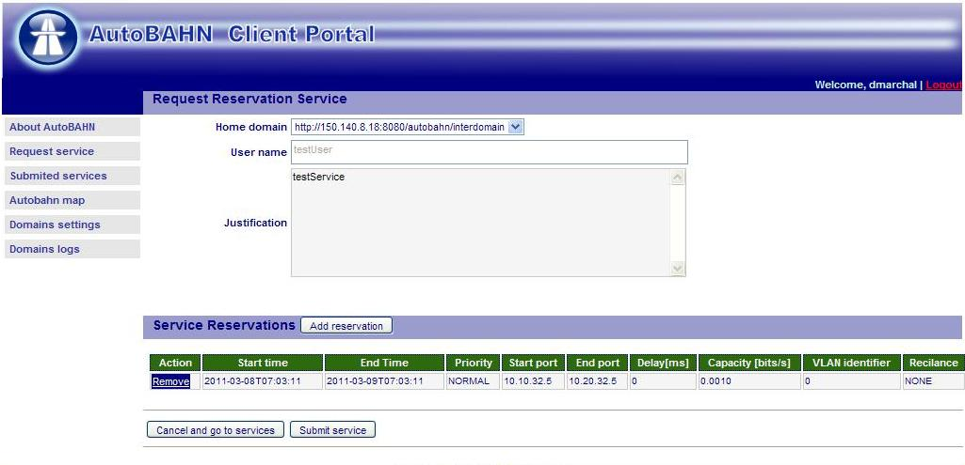

The system informs us that the service has been successfully submitted. We can now click on the provided link (or the “Submitted services” from the left side menu).
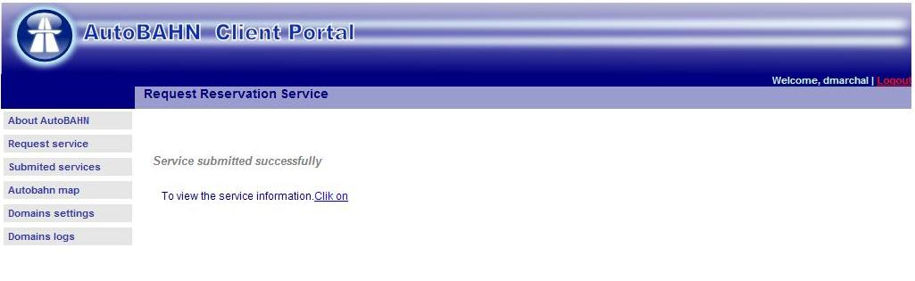

Here the services per IDM are displayed. Reservations are only activated when their actual time (according to the parameters set during their creation) is due.
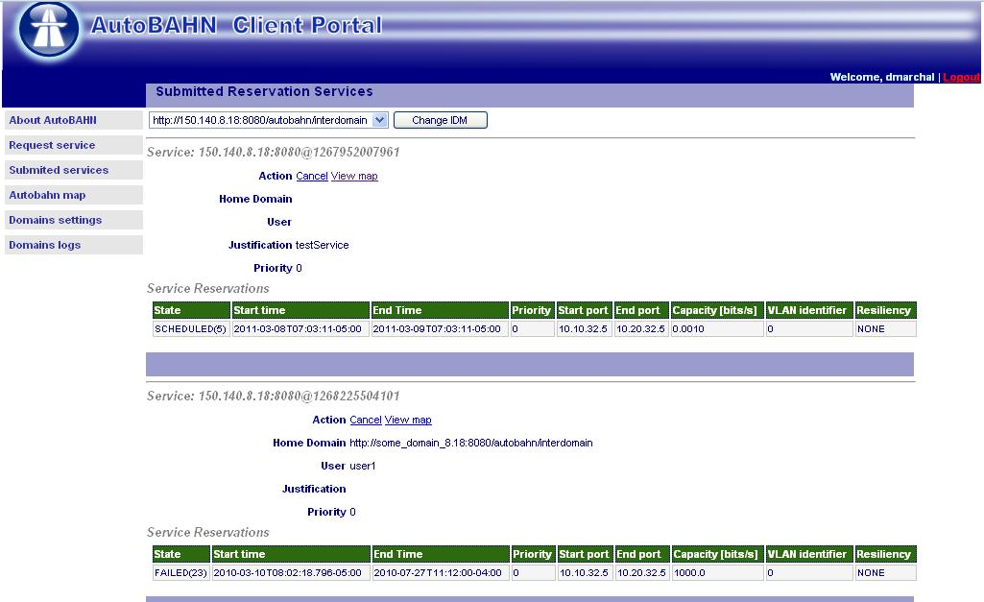

Manual installation
Under operational systems where automated installation is not supported, or if for any reason the automated installation is not available, you may perform the installation manually as described in this section.

Database creation
Create an empty database and execute .sql file located at: sql/create_db.sql.

Generic Routing Encapsulation tunnel configuration
Generic Routing Encapsulation (GRE) tunnels are needed for control plane communication; that is to implement communication channels between the different AutoBAHN servers in the domains participating in Bandwidth on Demand (BoD) service provisioning.
You need the ip_gre.o kernel module to configure the tunnels.
The example below shows the configuration use in the demonstration of AutoBAHN run during the 5th GÉANT2 Technical Workshop where four AutoBAHN servers were deployed for the GRNET, HEAnet, GÉANT2 and PIONIER domains (Figure 4.4).
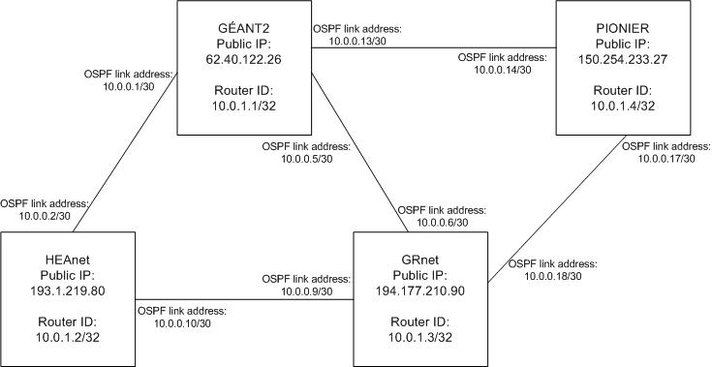
Figure 4.4: Control plane tunnel configurations used in the 5th GÉANT2 Technical Workshop demonstration
The example describes the tunnel between GRNET and GÉANT2.
The Internet Protocol (IP) address of the local end of tunnel is 194.177.210.90 (the IP address of the GRNET AutoBAHN server) while the IP address of the remote end of the tunnel is 62.40.122.26 (the IP address of the GÉANT2 AutoBAHN server).
Assume that the following values were agreed on by the partners:
Private addressing for Open Shortest Path First (OSPF):
- OSPF area = 100
network 10.0.0.0/8 area 0.0.0.100

HOST OSPF loopback address (router ID):
- GRNET 10.0.1.3/32
Address for GRE tunnel (OSPF link addresses):
- Remote to Local: 10.0.0.5/30 <----> 10.0.0.6/30
To configure the above, execute the following commands (where gre1 is the tunnel interface name):
#ip tunnel add gre1 mode gre remote 62.40.122.26 local 194.177.210.90 ttl 255
#ip link set gre1 up multicast on
#ip addr add 10.0.0.6/30 brd + dev gre1
Also, edit the ospfd configuration file so that it contains the following:
Sample of ospfd.conf:
!
! Zebra configuration saved from vty
router ospf
ospf router-id 10.0.1.3
network 10.0.0.0/8 area 0.0.0.100
capability opaque
!
password XXXX
log file /var/log/quagga/ospfd.log
!

The password is required to telnet to the ospfd (#telnet localhost ospfd, or see the documentation on the quagga site for more information). The log file is not mandatory, but may be useful for debugging.
Finally, start the zebra and ospf daemons:
#zebra –d
#ospfd -d -a -u <username>

AutoBAHN system configuration
The AutoBAHN configuration files can be found in the etc directory in your distribution. Following listing describes the most important properties that should be set to run the application properly. In general, when you do not want to supply a value to a property you may comment it out using the hash character (#), delete the line or enter the value none.
ta.properties:
- id.nodes, id.ports, id.links - ranges of private IP addresses to be used as labels to represent abstracted nodes, ports and links. For example: id.nodes=10.10.0.0/24 means that nodes of your domain will be given identifiers: 10.10.0.0, 10.10.0.1, 10.10.0.2 ... 10.10.0.255. Each domain has its own range of IP addresses, contact the AutoBAHN team to obtain the ranges to be used by your domain.
- public.ids.file - path to the file with mapping between device names and their public identifiers
- lookuphost - the URL of the location for the Lookup Service (if available)

dm.properties:
- domainName - the name of your domain (should match domainId value in the topology in your database)
- topology.file - path to an XML file describing network topology to be inserted in the database (this is normally not needed, as the topology is either retrieved from cNIS or inserted into the database as an SQL dump)
- db.host, db.port, db.name, db.user, db.pass, db.type - change them to the values you are using to access the database
- idm.address - IDM address to report of certain reservation events (same host by default)
- topologyabstraction.address - TA address to perform topology abstraction of the domain specific topology (same host by default)
- resourcesreservationcalendar.address - Calendar address to perform resources checking for reservations (same host by default)
- tool.address, tool.time.setup, tool.time.teardown - options for connecting to the Technology Proxy
- lookuphost - the URL of the location for the Lookup Service (if available)
- cnis.address - the URL of the cNIS service

calendar.properties:
- db.type - Select the network technology. Possible values are currently ethernet or sdh
- tool.time.setup - Extends a submitted reservation by the selected time in seconds before its start time to allow for setup time
- tool.time.teardown - Extends a submitted reservation by the selected time in seconds after its ending time to allow for teardown time

idm.properties:
- domain - Address of your AutoBAHN server - change the domain and port accordingly to the location where it is deployed.
- domainName - the name of your domain (should match domainId value in the topology in your database)
- latitude, longitude – Coordinates of your IDM instance – needed by AutoBAHN client portal to draw a map of IDMs
- ospf.use – Whether to use OSPF topology exchange mechanism
- ospf.address, ospf.port, ospf.ifAddr, ospf.areaId, ospf.lsaType, ospf.opaqueType, ospf.opaqueId – Address (host) of your Quagga router, listening port and other parameters needed to connect and retrieve abstracted topology information from the OSPF Quagga daemon
- db.host, db.port, db.name, db.user, db.pass - change them to the values you are using to access the database
- dm.address - DM address (same host by default)
- gui.address - the URL of the location for the WebGUI that this IDM will connect to
- gui.update - the number of seconds between successive update messages from the IDM to the WebGUI
- lookuphost - the URL of the location for the Lookup Service (if available)

framework.properties:
- framework.commandLine - Possible values are none, interactive, localhost and remote. Interactive means that commands can be entered at the command line, while localhost and remote allow a local or remote telnet connection accordingly.
- framework.port - If localhost or remote was selected above, it determines the commandLine server listening port

edugain/edugain.properties:
- net.geant.autobahn.edugain.activated - set to true if you want to activate security (message signing and validation is the default security mechanism). If set to false, no other property in this file is read.
- net.geant.autobahn.edugain.timestamp - set to true if you want to activate timestamping for exchanged messages. Please note that this option requires the communicating servers to be synchronized, so improper configuration may create communication problems.
- net.geant.autobahn.edugain.encrypt - set to true if you want to activate message encryption.
- org.opensaml.ssl.truststore - the location in the disk of the file containing the PKI keys (preferably use absolute path)
- org.opensaml.ssl.truststore-pwd - the password for accessing the file containing the PKI keys

edugain/client-sec.properties and edugain/server-sec.properties:
- org.apache.ws.security.crypto.merlin.keystore.password - the password for accessing the file containing the PKI keys
- org.apache.ws.security.crypto.merlin.keystore.alias - the alias for accessing the file containing the PKI keys
- org.apache.ws.security.crypto.merlin.file - the location in the disk of the file containing the PKI keys (preferably use the default relative paths).

AutoBAHN Web Services interfaces addresses
The basic modules of an AutoBAHN instance are bound by default to the following addresses (your-host is the address of the server hosting the modules):
- InterDomain Manager (IDM): http://(your-host):8080/autobahn/interdomain
- Domain Manager (DM): http://(your-host):8080/autobahn/idm2dm
- Topology Abstraction (TA): http://(your-host):8080/autobahn/topologyabstraction
- Resources Reservation Calendar: http://(your-host):8080/autobahn/resourcesreservationcalendar
The following addresses are also bound by the AutoBAHN system for various services:
- IDM interface for intradomain information: http://(your-host):8080/autobahn/dm2idm
- User Access Point for user interface access to IDM: http://(your-host):8080/autobahn/uap
- Administration interface: http://(your-host):8080/autobahn/administration
- Proxy interface for DICE IDCP [DICE] interoperability: http://(your-host):8080/autobahn/proxy
You may change the default 8080 port by editing the etc/services.properties file. Remember to change the other configuration files as well.

Installing LS
AutoBAHN instances can take advantage of the existence of a Lookup Service, which functions as a central registry for:
- Registration of friendly names of end ports
- Registration of AutoBAHN instances so that neigboring domains may discover them
- Registration of ports attached to interdomain links, so that neigboring domains can automatically discover their connected ports (at present this automated procedure only works if two neigboring domains have only a single interdomain link).
The current AutoBAHN implementation uses the Lookup Service module as developed by PerfSonar.
A single LS instance is therefore needed across the whole AutoBAHN federation. Below are instructions for the LS installation. If the LS has already been installed and a URL where it is located is available, then this section can be skipped.

On Linux
- Download apache-tomcat-6.x.x from the official site and install it (just place the apache folder in your preferred directory).
- Download the perfsonar-java-xml-ls.war file from the AutoBAHN site, a properly customized version of the perfSonar LS (http://wiki.geant.net/pub/SA2/T5WorkflowToolAutobahnReleases/perfsonar-java-xml-ls.war) and place it inside Tomcat webapps directory
- Download the exist.war file from the AutoBAHN site, a properly customized distribution of the eXist database, (http://wiki.geant.net/pub/SA2/T5WorkflowToolAutobahnReleases/exist.war) and place it inside Tomcat webapps directory.
- Restart Tomcat.

Configuring LS
The Lookup Service by default “clears” the xml database where information is stored after specific intervals. In order to properly configure the Lookup Service for usage by AutoBAHN this behaviour has to be disabled, Find the configuration.xml file that is located at the Tomcat folder /webapps/perfsonar-java-xml-ls/WEB-INF/classes/perfsonar/conf/. Set the value of the “status” tag inside the LSCleanup_1 action to “off”, as shown below (changed line in red bold).

<!-- Scheduler -->
<component name="scheduling"
className="org.perfsonar.base2.service.scheduler.SchedulingComponent">

<option name="schedulerClassName" value="org.perfsonar.base2.service.scheduler.SimpleScheduler"/>
<option name="interval" value="60"/> <!-- sec -->
<actions>

<action name="LSCleanup_1" className="org.perfsonar.service.lookupservice.LSCleanupSchedulerAction">
<option name="status" value="off" />
<option name="interval" value="1" />
<option name="lsTTL" value="1"/>
</action>

</actions>
</component>

After the changes in the configuration.xml file, restart Tomcat in order for the changes to take effect.

WebGUI deployment
The WebGUI is a web-based User Interface where the user can connect and submit reservations to associated AutoBAHN IDM instances.

Web Application Container installation
Install Tomcat 5.x or higher (another Web Container such as Jetty 6.x or higher may also be used).

Web GUI installation
Place the autobahn-gui.war file inside TOMCAT webapps and restart tomcat.

Web GUI configuration
- Find security.xml in webapps/autobahn-gui/WEB-INF/ folder.
- Add a new line under the <authentication-provider>/<user-service> tag in order to create a new WebGUI user (you can also use the existing accounts listed there). E.g. to be able to log into the WebGUI using the credentials testUser / testPass add the following line:
  - <user name="testUser" password="testPass" authorities="ROLE_USER" />
- Find webgui.properties in webapps/autobahn-gui/WEB-INF/etc/ folder.
- Set the proper URL for accessing the Lookup Service.
- Find edugain.properties in webapps/autobahn-gui/WEB-INF/etc/edugain/ folder.
- Set the org.opensaml.ssl.truststore and net.geant.edugain.validation.valid-components properties to absolute paths (e.g. /home/apache-tomcat-6.0.24/webapps/autobahn-gui/WEB-INF/etc/edugain/keystore-validate)
- Select if you want to activate communication security between the Web GUI and AutoBAHN components by setting the net.geant.autobahn.edugain.activated property to true. You can also select whether timestamps and encryption will be activated by setting the corresponding properties. Please note that in order for the Web GUI to communicate with AutoBAHN IDMs, it has to be configured with the same security properties as the IDMs.
- If you activate communication security, make sure all the properties in the edugain.properties file are correct:
  - org.opensaml.ssl.truststore: Absolute path to file containing eduGAIN PKI keys
  - net.geant.edugain.validation.valid-components: Absolute path to valid components file
  - org.opensaml.ssl.truststore-pwd: Password to access keystore file
  - net.geant.edugain.validation.crl.url: URL to retrieve Certificate Revocation List
  - net.geant.edugain.validation.crl.timeout: Timeout for checking Certificate Revocation List
- Restart TOMCAT and Web GUI is up and running.

Google Maps configuration
A page within WebGUI that depicts a map with the connected IDMs and the reservations is based on Google Maps support. A valid Google Maps API key is needed for each WebGUI installation. You can go to the related Google Maps page (search for “Google Maps API key” or go to http://code.google.com/apis/maps/signup.html) and generate an API key there.
- Generate the Google Maps API key by providing the installation URL at the Google Maps page.
- Locate the WEB-INF/classes/messages.properties file
- Copy this value to the google.maps.key entry

AutoBAHN references
- Project homepage: http://forge.geant.net
- Download page: http://downloads.geant.net/repository/public/AutoBAHN?artifactId=AutoBAHN
- Mailing list: gn3-sa2-t5-autobahn@geant.net

Glossary
API Application Program Interface
AutoBAHN Automated Bandwidth Allocation across Heterogeneous Networks
BoD Bandwidth on Demand
CPU Central Processing Unit
DICE Dante, Internet2, CANARIE, ESnet
DM Domain Manager
GB gigabyte
GHz gigahertz
GRE Generic Routing Encapsulation
IDCP InterDomain Controller Protocol
IDM Inter Domain Manager
IP Internet Protocol
L2 Layer 2
LHC Large Hadron Collider
LSA Large Hadron Collider Software Applications
MB megabyte
MCC Metro Core Connect
MHz megahertz
MPLS Multiprotocol Label Switching
NIC Network Information Centre
OS Operating System
OSPF Open Shortest Path First
PoP Point-of-Presence
RDBMS Relational DataBase Management System
SMTP Simple Mail Transfer Protocol
VPN Virtual Private Network

References

[ABAHN] AutoBAHN, http://forge.geant.net
[cNIS] Geant cNIS, http://cnis.psnc.pl
[PS] perfSONAR, http://www.perfsonar.net , https://wiki.man.poznan.pl/perfsonar-mdm/
[PS LS] PerfSONAR LS, https://wiki.man.poznan.pl/perfsonar-mdm/index.php/Lookup_Service_Release
[Quagga] Quagga, http://www.quagga.net/
[GRE] IP GRE kernel module, http://www.linuxfoundation.org/collaborate/workgroups/networking/tunneling
[Postgres] PostgreSQL, http://www.postgresql.org
[Hibernate] Hibernate, https://www.hibernate.org/
[DICE] DICE IDCP, http://www.controlplane.net/

