AutoBAHN installer proposed solutions, design & analysis

 | Pros | Cons
Shell script  An interactive shell utility, asking user for some input and configuring the environment. | - Easy access to the OS commands (i.e. creating tunnels)  - Does not require graphical env. | - OS dependent (win vs. unix)  - Does not allow to go back (process needs to be repeated from the beginning)
Ant script  An Ant based interactive shell utility, asking user for some input and configuring the environment. | - Easy to implement  - Does not require graphical env.  - User can build software from source | - Requires Ant  - Access to OS commands through Ant’s exec task (access rights issues)  - Does not allow to go back (process needs to be repeated from the beginning)
Graphical installer  A java based graphical application configuring the environment. | - Comfortable for the end user  - Easy to implement - generation can be integrated with build systems such as Maven | - Access to OS commands through java Process.exec (access rights issues)  - Requires graphical environment
Basic webapp with setup screens  A web based graphical application configuring the environment. | - Easy to implement – simple web forms  - Comfortable for the end user  - Does not require graphical env. (if the http connection is possible) | - Access to OS commands through java Process.exec (access rights issues)

Ant Script
Ant’s disadvantages are difficult to overcome. More specifically, implementing ‘going back’ would need either a graphical environment and/or extensive log file writing/reading, something difficult if not impossible (especially for GUI) to be implemented in Ant. Additionally, Ant is not particularly suited for running OS commands as a shell script is.
Moreover, although Ant is a very well known and widely used tool, users not familiarized with it may find be unsuccessful in their first attempts to run the tool and to install AutoBAHN. Being it a minor issue, it can degrade a lot user’s experience beforehand.

Proposed solution
In order to overcome the disadvantages of the proposed solutions above we suggest a combination of the above solutions. It would be very useful and flexible to separate the business logic of the installer from the user interface.

In general, if back processes of the installer are more transparent to the setup process, the user feels more comfortable. Nevertheless, interactive checkpoints provide more feeling of control over the tool and the installation process in general. This is the case of the shell scripting techniques.

Back-end
For a back-end of the installer the most well suited solution is a shell script. Shell scripts are traditionally used to execute a sequence of system commands and combine them. They are also capable enough to suit our purposes. It is true that they are OS dependent but this is not something to be troubled with as we mostly target Unix-like operating systems(and bash shell scripting is compatible with all of them) and there is some kind of compatibility with bash-scripting in Windows (using Cygwin). Additionally, the separation of business logic from the user interface makes it easy to rewrite only the back-end for a new operating system and still have the same installer (same user interface). The shell scripts could have a user interface of their own, perhaps a menu allowing the user to choose the desired parameters before any actual change is made. Furthermore, the scripts could take backup files of all of the configuration files and have a choice to return to previous settings. In this way the ‘going back’ problem is solved. Finally, creating shell scripts for the installation would make possible a ‘manual’ installation from command-line if needed.
One alternative for back-end would be to write it in Java. This would make the back-end portable and would be easier to integrate it with the front-end which will also be in Java. However, the portability offered is not ‘transparent’. The Java program would need to check on which operating system it runs on during run-time and then execute different parts of code. Additionally, executing lots of system-commands in Java can become tedious and perhaps error-prone. Therefore, in my opinion it is not worth it to trade-off rapid back-end development (using shell scripts) with portability which is not transparent.

Creating the back-end with multiple shell scripts may conform the easiest way to edit system parameters and execute system commands, as well as provides modularity to the installer itself.
Crank-back process is more complex, but is fully controllable in this kind of back-ends. A good execution sequence eases crank-backing.

Finally, it is easy to detect syntax mistakes using shell scripting, but it may take some time to debug the problem to the user.

Front-end
The front-end is recommended to be in Java, either as a webapp or a graphical environment. As a first try, creating a webapp would be more useful as it can possibly be used in non-graphical environments and it is easier to create the user interface. The separation of the installer in front-end and back-end makes it possible to implement various front-ends and experiment more easily.

Front-end, indeed, is always useful for a good user-to-system interaction. Graphical interfaces are highly recommended. Interface edition frameworks like the Eclipse Rich Client Platform (RCP) provide a set of libraries that offer the developer the possibility of managing components to be used to form a final rich client application (similar to Eclipse). However, systems like AutoBAHN are typically installed in servers located close to the equipment, most of the times inside a secure LAN in the NREN network or have restrictive firewall policies. In this case, a Web front-end is the most suitable solution, having the possibility of using Web Services for complex data exchange among entities.
The programming language is recommended to be Java, due to its flexibility and popularity among programmers nowadays. Moreover, Java libraries offer a lot of alternatives for editing system/user properties and parameters for/during the installation. In the case of using web services, Java also offers a good support for several frameworks, many of them supported by the Apache Foundation and therefore, open source.

User actions

Adding a tunnel
Adding a tunnel means adding a new record to the file routing.conf. Adding a tunnel does not mean that the tunnel is installed. The file routing.conf contains information about both installed and to-be-installed tunnels. This file is necessary because some information about a tunnel that are necessary to install the tunnel and configure quagga are very difficult to retrieve when the tunnel has already been installed and this information is not available

Installing tunnels
Installing tunnels involves reading routing.conf and installing the tunnels that are not already installed.

Setting up a psql dump
Setting up a psql dump asks for an sql file from the user and runs its commands using psql.

Editing a tunnel
Editing a tunnel involves changing information about already installed tunnels. In order to work properly this feature needs the relevant records in routing.conf. In the ncurses version of the installer there is a tunnel editor which helps the user to edit existing tunnels in a graphical manner. The user can also delete individual tunnels using the same interface.
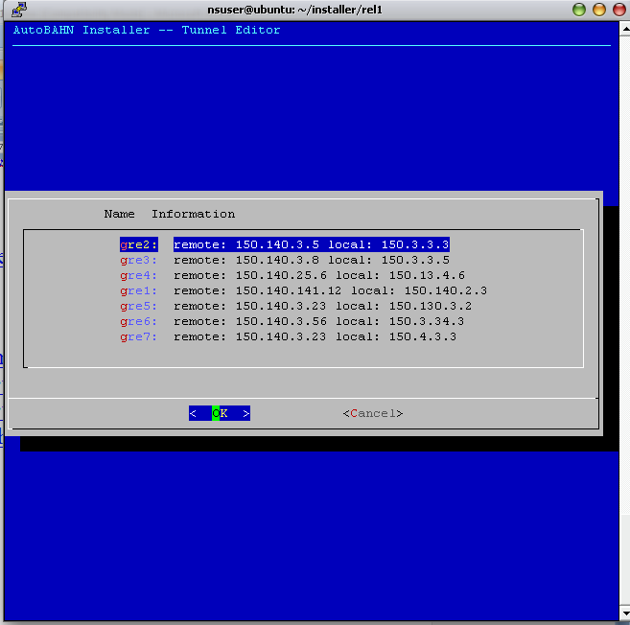
Figure 1. First screen of tunnel editor

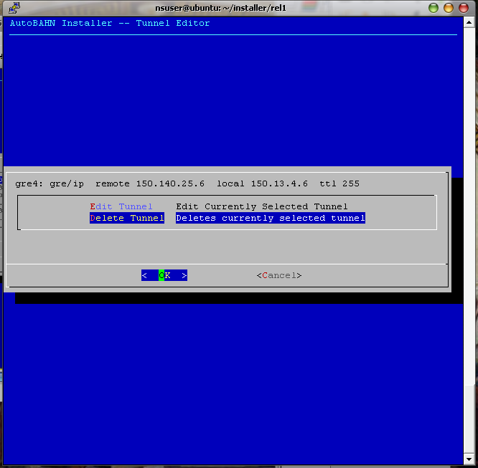
Figure 2. Tunnel editor lets you delete or edit each tunnel

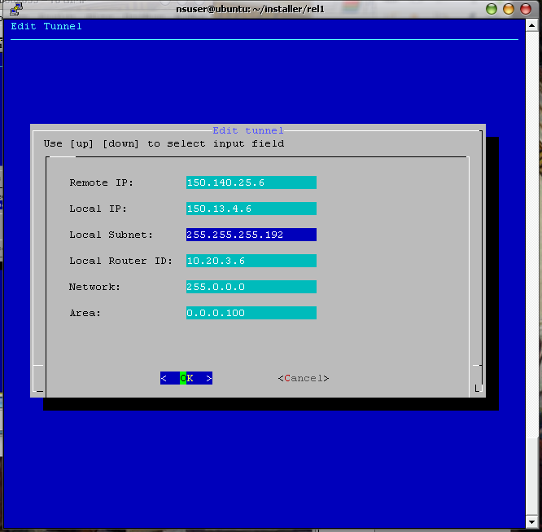
Figure 3. Editing a tunnel with the tunnel editor

Deleting a tunnel
Deletes an already installed tunnel.

Deleting all tunnels
Deletes all already installed tunnels and clears routing.conf

Installation procedure
When installing for the first time it is recommended to run setupall.sh which will guide you through the whole procedure. If the computer has the dialog command available the setupall.sh will initiate the ncurses interface. However, if you still want the command-line interface you can enter setupall.sh –c. The setupall.sh is equivalent to executing self-check.sh;setup.sh or setup.sh –n;setup.sh .

Selecting a file
In some cases the user needs to type in the path of a file. In the ncurses interface, this can seem tricky with the existing file-selecting component. Despite being shown the directories and files the user is not expected to select them by clicking or pressing enter at them. Instead the user is expected to enter the name in the available textbox. While typing the name the user can press spacebar to auto-complete the filename according to the path/filename shown above the textbox. An example is shown below:
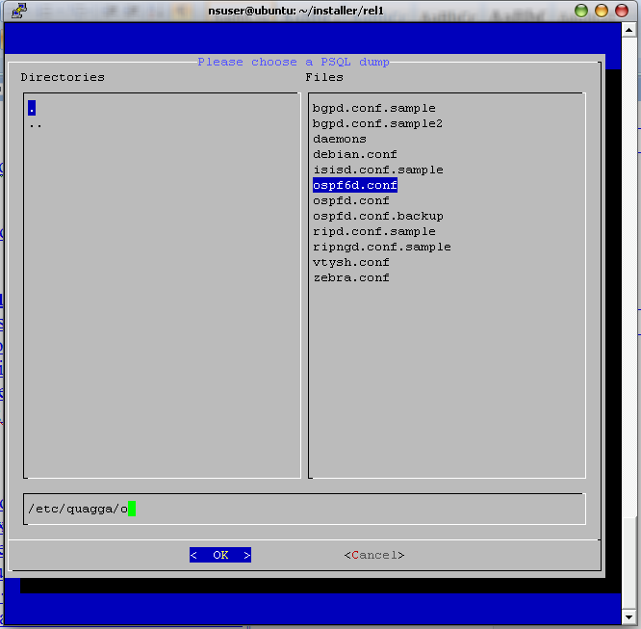
Figure 4. The user starts typing the path and its text can be auto-completed according to the ‘auto-selected’ path/file shown above the textbox

Back-end components
The following components would be essentially separate shell scripts.

Self-Check (implemented by self-check.sh)
The self-checking script when it runs, firstly checks if all the prerequisites are in place and inform about any possible problem. After checking for dependencies the self-checking script creates or modifies essential files for the installer such as installer.conf, ta.properties, dm.properties, idm.properties and calendar.properties. The self-checking script can function in both ncurses and simple command line mode.

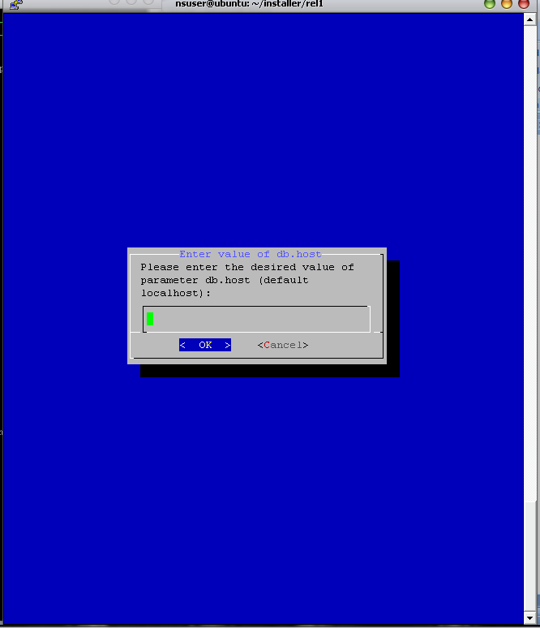
Figure 5. The self-check.sh in ncurses mode

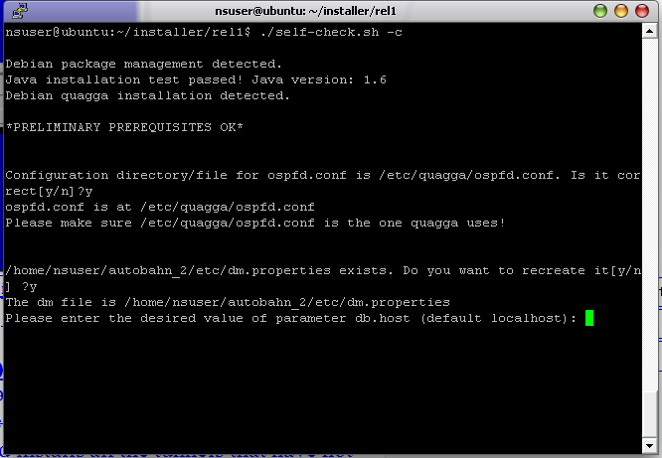
Figure 6. The self-check script in command line mode

The self-check script is meant to work either individually using these parameters,
./self-check.sh -h

AutoBAHN command line Help

Usage: ./self-check.sh [OPTION]

-c Begin command line interface

-p Perform only preliminary tests

-h Show help

or be called through the setup.sh. The self-check script if called without parameter detects if there is the “dialog” command available and initiates the ncurses interface or else initiates the command line interface. The self-check script functionality is also available through setup.sh. One can call setup.sh –n to initiate the self-check script with no parameter and setup.sh –cn to initiate the self-check script with the –c parameter (which initiates the command line interface).

Do-installation(implemented by do-install.sh)
The installation script reads routing.conf and installs all the tunnels that have not yet been installed. It can be run individually but it is recommended that it is called only by the command setup.sh –i.

Front-end components

AutoBAHN installer
The preferred user interface. It could be either a webapp or a GUI-based application. It would provide an easy way for the user to setup the program.
(i2CAT) A web application is recommended, for remote installation procedures allowing the user of graphical user interface.
There exists both a web and command line user interface.

Setup(implemented by setup.sh)
The setup script (setup.sh) is a front-end script which can function in 3 modes.
Firstly, if the dialog command has been installed (which requires ncurses), the script presents a graphical ncurses menu:

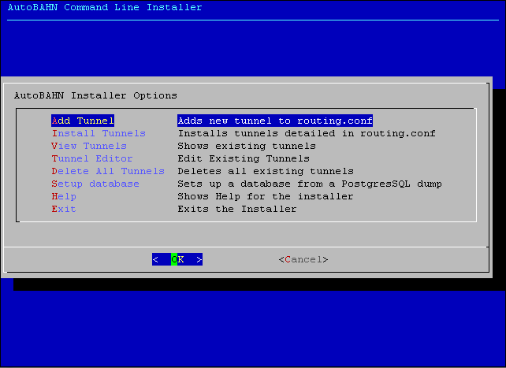
Figure 7. Installer ncurses menu

If the dialog command is not available setup.sh presents a text-only command-line wizard that guides the user step by step to add a psql dump, add tunnels and install tunnels:

Select sql file to setup database[y/n]:n
---------------------------------------------------------
AutoBAHN Command Line Installer - Command Line Interface
---------------------------------------------------------

***************************************************
STEP 1 - Adding tunnels
***************************************************

Do you want to enter a new tunnel[y/n]?y

---------------------------------------------------
Remote instance:
---------------------------------------------------

Remote AutoBAHN instance: 150.140.3.8
...
Do you want to enter a new tunnel[y/n]?n
Tunnel addition terminated.
---------------------------------------------------------
AutoBAHN Command Line Installer - Command Line Interface
---------------------------------------------------------

***************************************************
STEP 2 - Installing Tunnels
***************************************************

Installing tunnels ...

Installing returned:
----------------------------------------------------
Creating tunnel(gre3) for Remote: 150.140.3.8 Local:150.3.3.5 Local_subnet:255.255.255.192 ...
Installation complete.
----------------------------------------------------

The third way to use the installer is non-interactive by using its parameters. This non-interactive mode of usage is especially useful for getting results faster or building custom scripts. To see the available parameters type setup.sh –h:

AutoBAHN command line Help

Usage: ./setup.sh [OPTION]

-c Begin command line interface

-n Run first-time installation scripts

-b Setup database

-a Add a tunnel from command line

-x Add and install tunnel from command line (Equivalent to -ai)

-i Only install tunnels from routing.conf

-l Show installed tunnels

-L Show all tunnels [I for Installed]

-d [tunnel_name] Delete tunnel "tunnel_name"

-D Delete all existing tunnels (use with caution)

-h Show help

