User Guide

This document is intended to help users navigate and use the Six Nations Tracker Application. If anyone struggles to understand the layout or navigation of the application, this guide should help them become familiar with all parts of the system.

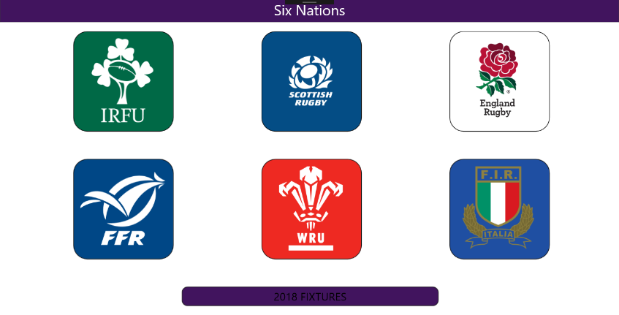**Main Page:**

The Main Page of the application is a series of buttons which navigate to the relative pages.

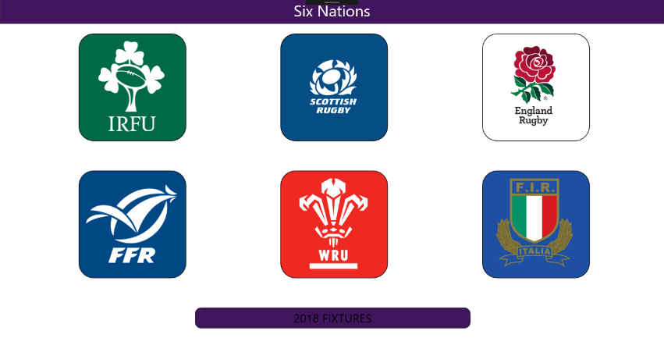

Simply click on one of the logos or the fixtures page button to navigate to it.

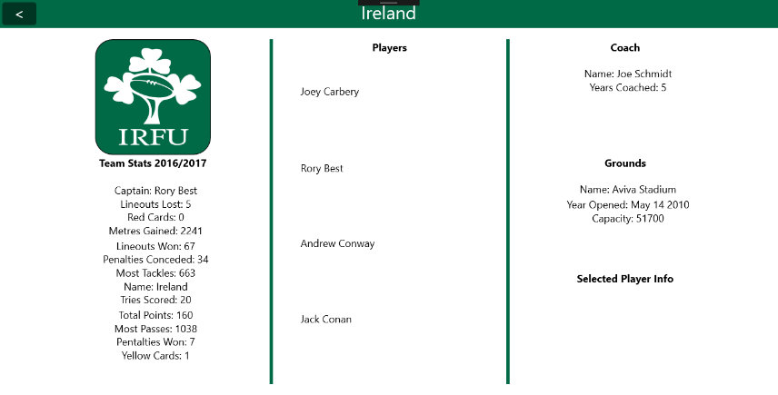**Team Page:**

The Team Page shows an overview of all the statistics for the selected team.

All the club’s information and overall statistics are shown here.

All the players who have been listed in the club’s team sheet since the year 2000 are listed here.

The list of players can be scrolled through and each players name can be clicked on for further information.

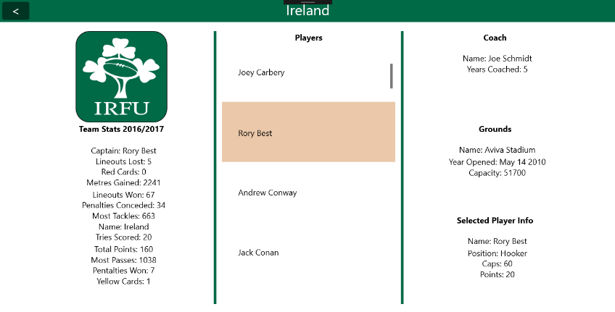

When clicked, the selected players information can be seen on the bottom right of the page.



The selected team’s coach information can be seen here.



The selected team’s grounds information can be seen here.

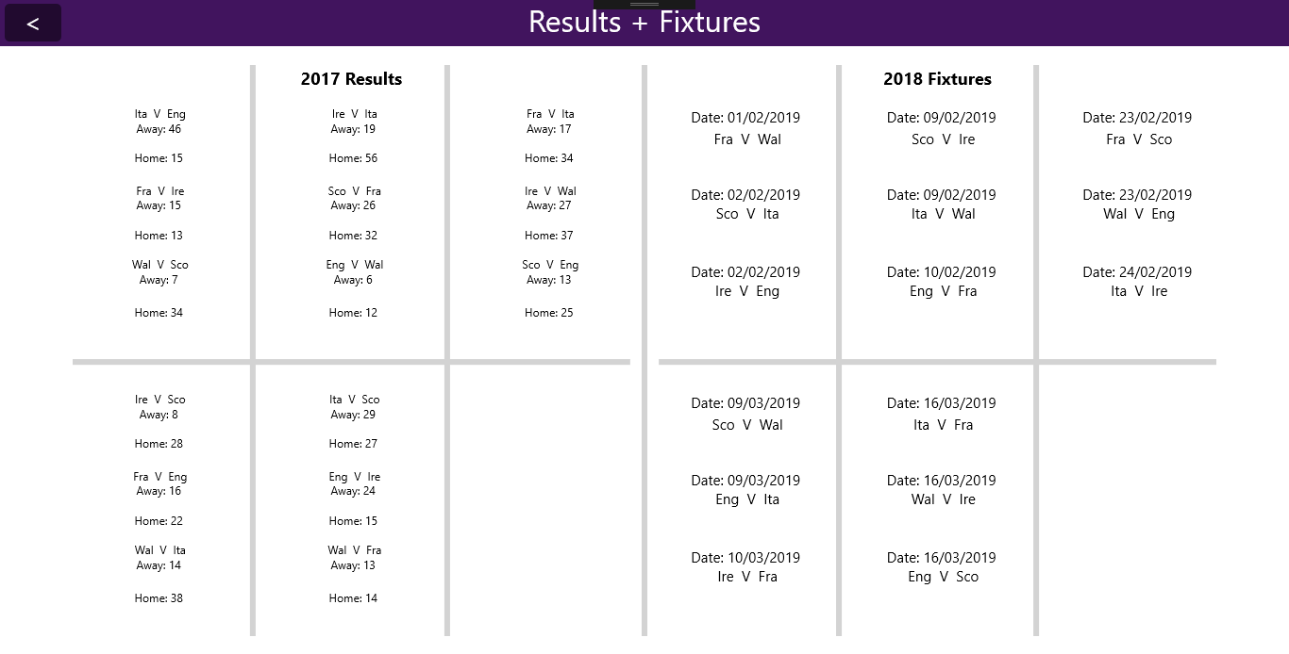**Fixtures Page:**

The Fixtures Page shows the previous Six Nations Championship results for each game, as well as all the upcoming fixtures for the next Six Nations Championship



The back button can be pressed on any of the pages to navigate back to the Main Page of the program.