United States Agricultural Farms 2017

drop down menu: States

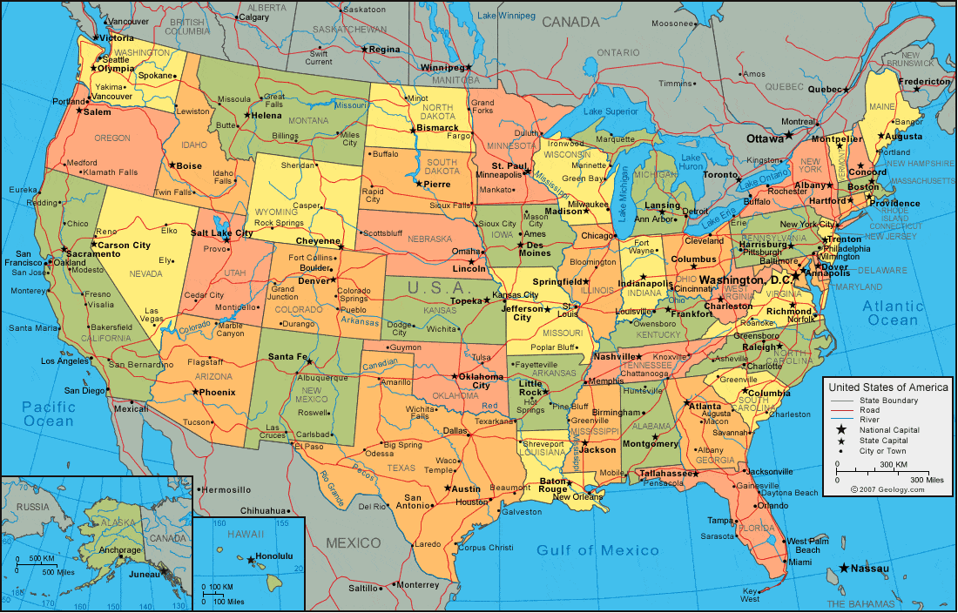

Growth of farms with insurance from 2010 to 2017

Sunburst of 50 states with number of acres used for farmland?

Map of United states:

Legend : gradiant color = % of acres of land used for farm

Mouse on function: popup of state and % of farm

Click on function: takes to state page

Or can use: zoom to bounding box and have text in middle

­­

Heat map of State counties of farm land : Hexbin map?

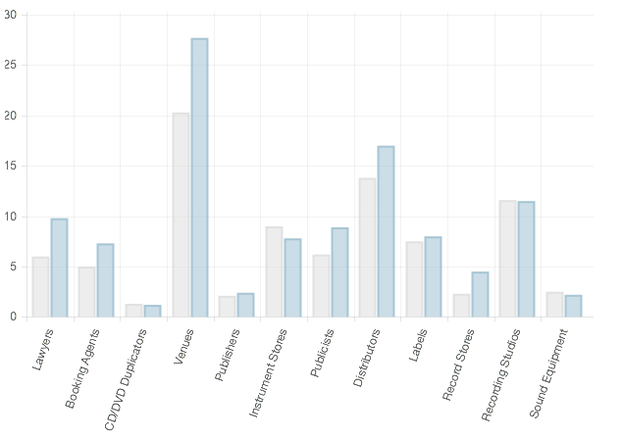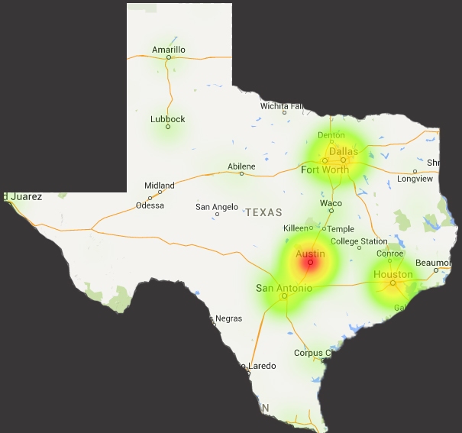

Chart (bar chart?)of farm types in State: pastureland, woodland, cropland

drop down menu: States