Data base entities

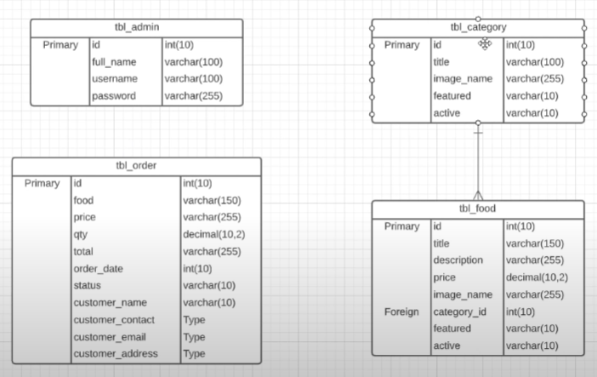

‘table_admin’ table

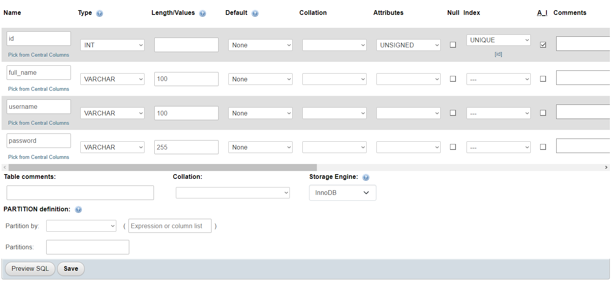

Id, unsigned for positive values only

Password will be encrypted, length 255

‘table_category’ table

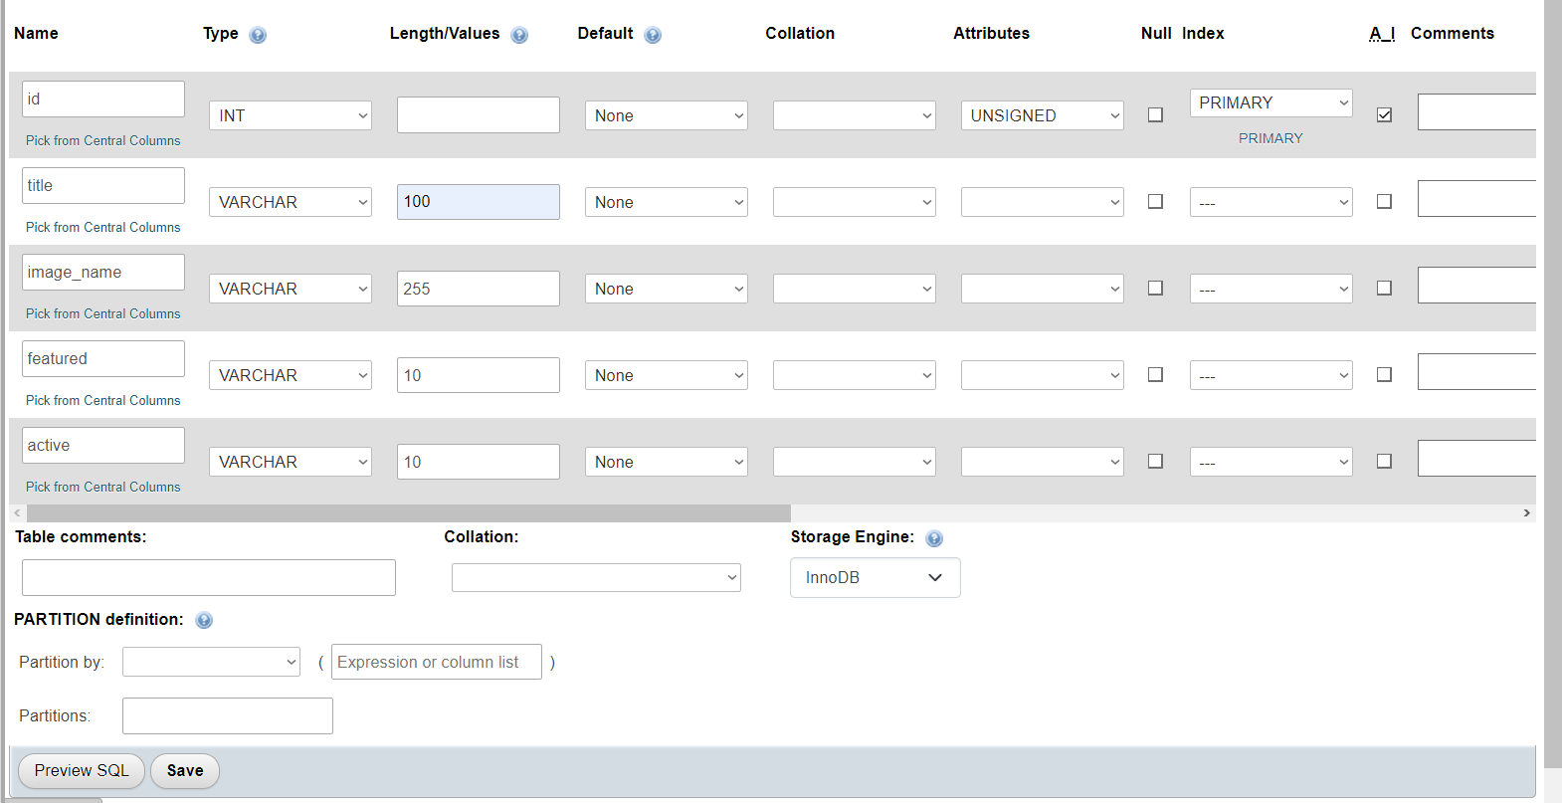

‘tabke_food’ table

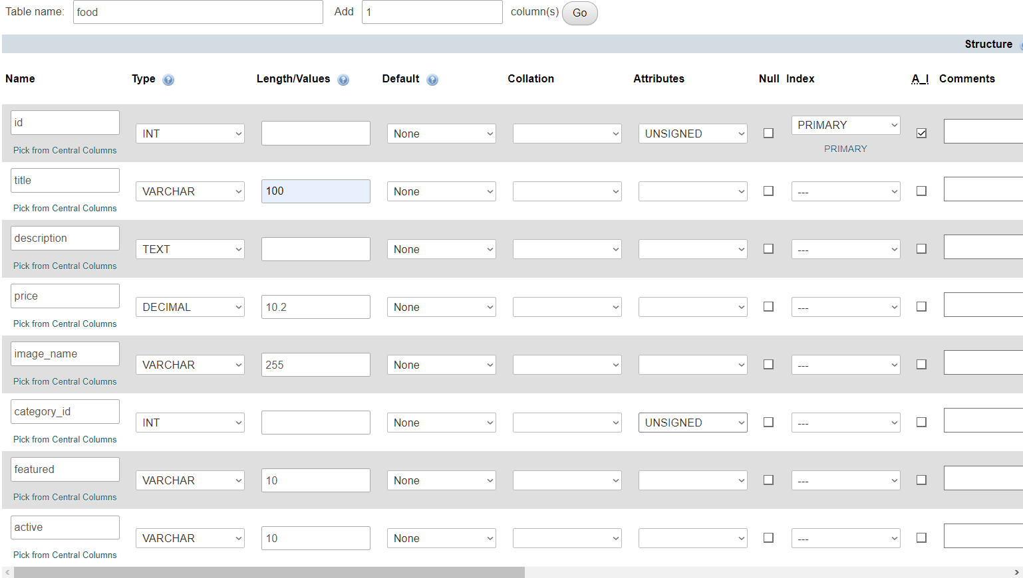

‘table_order’ table

