Northwind Trading – Key Business Activities
Northwind Trading consists of several departments, each responsible for one or more business activities.

Customer Experience Team
Customer Service: The Customer Experience Team respond to inquiries and support customers with issues they’re experiencing with the eCommerce service.
Customer Satisfaction Monitoring: The team collect feedback from customers using qualitive and quantitative analysis methods to identify areas for improvement.

Finance Team
Financial Planning: Northwind Trading frequently conducts financial planning. This involves planning that budgets, forecasts and financial resources are aligned to processes and activities to ensure stable business operations and growth.
Finance and Accounting Services: The finance team maintain financial records and conduct analysis to support key decision-making.

HR Team
Human Resources Planning: The HR team plan staffing needs, including recruitment of new staff and training and development of existing staff.
Human Resources Management: HR must recruit and hire employees, administer payroll and benefits and managing employee relations.

Operations Team
Information Technology (IT) Support: From the eCommerce website to its internal IT systems, the support of such systems is a key enabling activity.
Supply Chain Planning: The operations team plan efficient and timely delivery of goods and services. Coordinating with suppliers helps to avoid under and overstocking of required inventory.
Logistics and Distribution: The Operations Team manages transportation, warehousing, inventory and coordinating the movement of goods to help ensure timely delivery to customers.
Inventory Controls: The team have implemented controls to prevent theft and shortage of inventory.
Facility Management: Both the offices and warehouses must ensure a safe and comfortable working environment for employees as part of local employment legislation.

Sales Team
Bulk Sales: The sales team actively promotes products, prospect leads for bulk orders, and drive revenue to the business.

Northwind Trading – As-is Process State
Northwind Trading’s order fulfilment process has been determined as the root cause of decreased sales over the past year. The current process is outlined below.
- The process starts when an order is received.
- The finance team creates an invoice.
- The finance team sends it to the customer.
- An administrator creates a docket of the ordered items for the warehouse staff
- The warehouse staff retrieve the ordered items
- The warehouse staff package the ordered items
- The warehouse staff notify the administrator that the items are ready for shipment
- An administrator arranges collection of the items by a delivery driver
- Delivery driver collects the items
- Delivery driver delivers the items to the customer

Step 1: Create the Business Activity Model
Northwind Trading is successful due to its end-to-end management of the eCommerce customer experience. To achieve this, the company operates a broad range of activities. Your task is to model these activities in a Business Activity Model using Microsoft Visio.
- Review the file Northwind Trading Key Business Activities.docx
- Create a new drawing in Microsoft Visio
- Add an Ellipse to the Canvas for each business activity
- Connect the activities using Connectors
- Design your diagram for readability. Reduce overlapped connectors and use appropriate object and font sizes
Step 1: Create the Business Activity Model
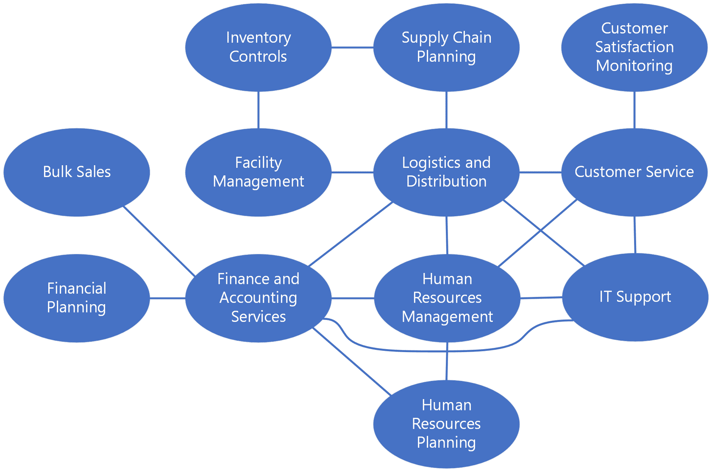

Step 2: Model the as-is process state
Before improving the fulfillment process, senior management has tasked you with creating a BPMN diagram of the as-is process state in Microsoft Visio. This will help identify the inefficiencies and bottlenecks in the process that are leading to unsatisfied customers.
- Review the file Northwind Trading As-is Process State.docx
- Create a new drawing in Microsoft Visio
- Create a BPMN diagram for the as-is process state, ensuring that the correct Events, Activities, Gateways, Connectors, Pools, and Artifacts are modeled.
As you model the as-is process state, consider the following questions:
- Which parts of the process are Events?
- How should the different departments be represented?
- What Artifacts are created by steps in the process?
- What is the output of the process?

Step 2: Model the As-is Process State
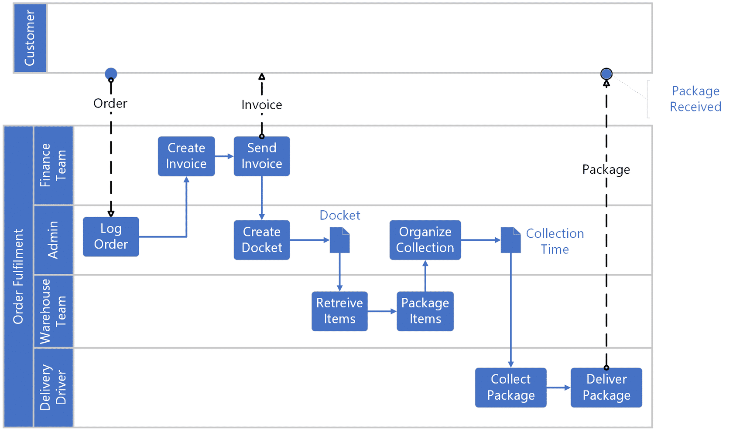
The diagram was built on the basis of the following:
There are four Lanes in the process:
- Finance Team
- Warehouse Team
- Administrator
- Delivery Driver
The process starts when an order is received.
- Receiving the order is the Start Event of the process.
- The order is sent to the Log Order Task.
The finance team creates an invoice.
- Creating the invoice is a Task in the process that produces an invoice Data Object (an Artifact).
The finance team sends the invoice to the customer.
- Sending an invoice is a Task in the process that has a Message Flow Connector to the Customer.
An administrator creates a docket of the ordered items for the warehouse staff
- Creating the docket is a Task in the process that produces a docket Data Object (an Artifact).
The warehouse staff retrieves the ordered items
- The staff receive the docket and retrieves the ordered items as a Task.
The warehouse staff package the ordered items
- The staff package the ordered items as a Task. The packaged item becomes a Data Object (an Artifact).
The warehouse staff notifies the administrator that the items are ready for shipment
- The staff notify the administrator that the order is ready for shipment as a Task.
An administrator arranges the collection of the items by a delivery driver
- The administrator notifies the Delivery Driver of the collection time as a Task.
The delivery driver collects the items
- The driver collects the packaged items as a Task.
The delivery driver delivers the items to the customer
- The driver delivers the item as a Task. The customer receiving the item is the End Event of the process.

Step 3: Model the to-be process state
Now that the as-is process state is modeled, analyze where improvements could be made. Consider the following questions:
- Are there any parts of the process that can run in parallel?
- Could some tasks be automated?
- Are there any redundant steps or bottlenecks in the process?
Based on your answers to these questions, your next task is to model the to-be process state to present to senior management.
- At the bottom of your as-is process diagram, right-click the page and rename it to as-is process
- Right-click the page again and select Duplicate
- In the new page, right-click the page name and rename it to to-be process
- Revise the diagram to reflect your proposed to-be process state
Step 3: Model the to-be process state
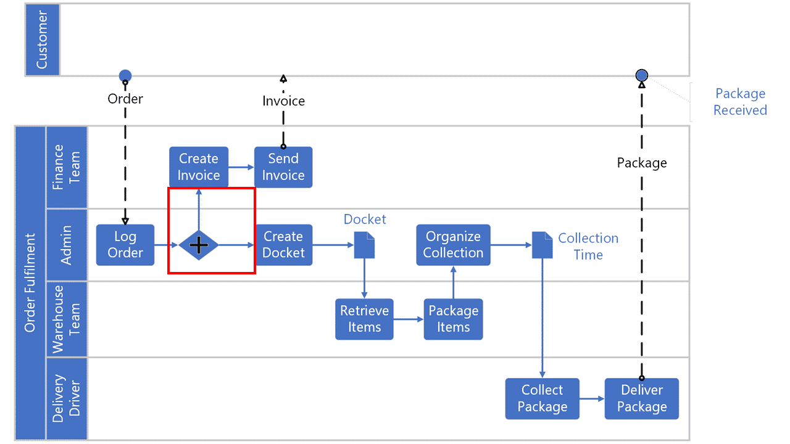
The linear nature of the as-is process state presents several process improvement opportunities.
By analyzing the as-is process state diagram, it is clear that the finance team tasks do not influence the remainder of the process. Therefore, this can be parallelized from the remainder of the process using a Parallel Gateway.
The Parallel Gateway splits the process when the order is received. The first path represents the responsibilities of the finance team. The second path represents the responsibilities of the administration and warehouse teams.
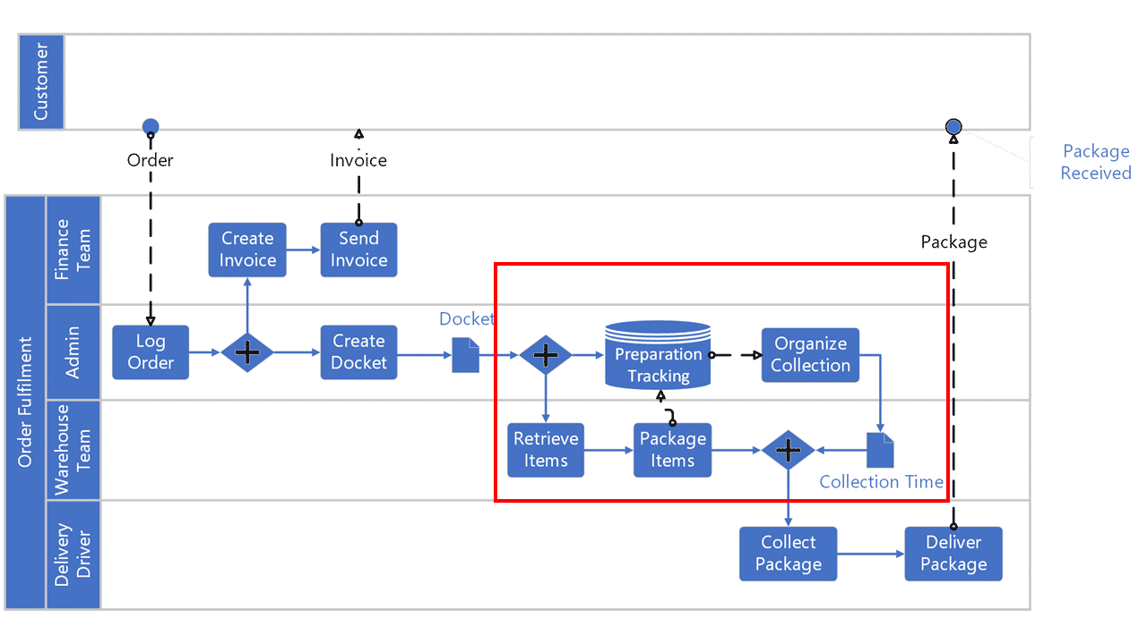
However, you can recommend a further level of optimization. If the delivery preparation time is tracked using a tracking system, then the item collection can be scheduled in parallel to the packaging of the items. These two paths of the process can then be rejoined using a second Parallel Gateway.
the items packaging task always notifies the tracking system of the preparation time. This is so that it can continuously maintain accurate collection times for the delivery driver.
This level of efficiency is very common in the logistics industry. It reduces delivery times, which leads to more satisfied customers.
But you could recommend another way to make this process more efficient. Some manual could be replaced with automation. As this diagram shows, installing an invoice software solution could free up the finance team to focus on other tasks. At the same time, the warehouse docket could be generated using a software solution.

