Problem Identification and Stakeholder Management – Exercise Answers Template

Step 1: Problem identification
DELIVERABLE 1: Qualitative and Quantitative Analysis and Recommendations
 | Feb-24 | Mar-24 | Difference
Sales Statistics | TOTAL | TOTAL | Value | %
Total Sales Value: | $71,626.00
Total Number of Transactions: | 477
Average Daily Sales Value: | $2,558.07
Average Number of Transactions per Day: | 17
Average Transaction Value | $150.16

Most common complaints:
Ref | Complaint type | Quantity | %

Conclusion:

DELIVERABLE 2: Root Cause Analysis Questions
Questions
1.

Root Cause Diagnosis:
DELIVERABLE 3 - User Role Analysis – Northwind Trading online store
User role | Role description | Concerns/Requirements

DELIVERABLE 4 - Stakeholders Analysis and Mapping.
Stakeholder | Project Responsibility | Interest/Concerns | Influence

POWER - INTEREST GRID
Low Interest – High Influence | High Interest- High Influence
Low Interest – Low Influence | High Interest – Low Influence

DELIVERABLE 5 - RACI MATRIX

 | Project Task
1 | Identify website issues (survey, focus groups, quantitative and qualitative analysis)
2 | Requirements analysis, prioritization and User stories
3 | Checkout process re-design (workshops)
4 | Usability testing
5 | Development of the new checkout and website re-design
6 | Website launch
7 | Monitor website performance and user feedback
8 | Provide customer support and assistance
9 | Review and analyze sales data and customer feedback
10 | Evaluate the effectiveness of implemented changes

Conclusion:

Step 3: Problem identification
You are assigned as a Business Analyst to manage this project. You need to investigate if there is an issue at Northwind Trading and, if you find an issue, to pinpoint the root cause of the problem. Then you need to write a short recommendation to the management as to what is the best course of action. Use the Excel spreadsheet for any calculations and then complete Deliverable 1 on page 1, and Deliverable 2 in page 2 of the Problem Identification and Stakeholder Management – Workbook, which you should have downloaded in Step 2.
Questions are provided below to guide you in this step.
Deliverable 1 - Quantitative and Qualitative Analysis (Questions 1 to 5)
- Scrutinize Northwind Trading March Sales Data (in the Sales Data and Statistics spreadsheet you downloaded) and see if you can spot any trends. Are the sales growing, declining, or fairly stable? What about website visits?
- Calculate March sales totals and average daily sales values, the number of transactions per day, and the average transaction value per period using the Sales Data and Statistics spreadsheet you downloaded. Once completed, please fill your answers in the DELIVERABLE 1 section of Problem Identification and Stakeholder Management – Workbook
- Compare February and March totals. Calculate the difference in sales value and difference in percentage. Record it in the Problem Identification and Stakeholder Management – Workbook.
- Read and analyze the customer complaints in the second download file - Sales Report and Customer Complaints. Is there a recurring theme? What are the customers unhappy about? You can add these complaints to the Sales Data and Statistics spreadsheet (create a new Customer Complaints Analysis tab). You must analyze and categorize the customer complaints. Read all the complaints and determine where complaints fall into the same category. The hashtags will help you with categorization but don't depend on them totally, read the complaint and use your own judgment to categorize it. In the next column of the Complaints Analysis tab create a heading called ‘Complaint type’ and enter in your categorization of each complaint, for instance Checkout-issues or website speed issues. Then count the number of complaints per complaint type; e.g., "Checkout-issues: 5 complaints.” You will need this count of each category for your final recommendation to the Northwind Trading Management (located in the next deliverable).
- Read the Sales Manager's report in the “Sales Report and Customer Complaints” file you downloaded in Step 1 of this exercise . Do you agree with her analysis of the situation?
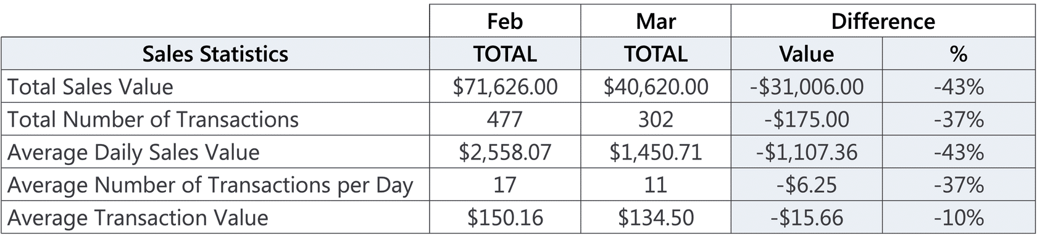
Stakeholder analysis and mapping
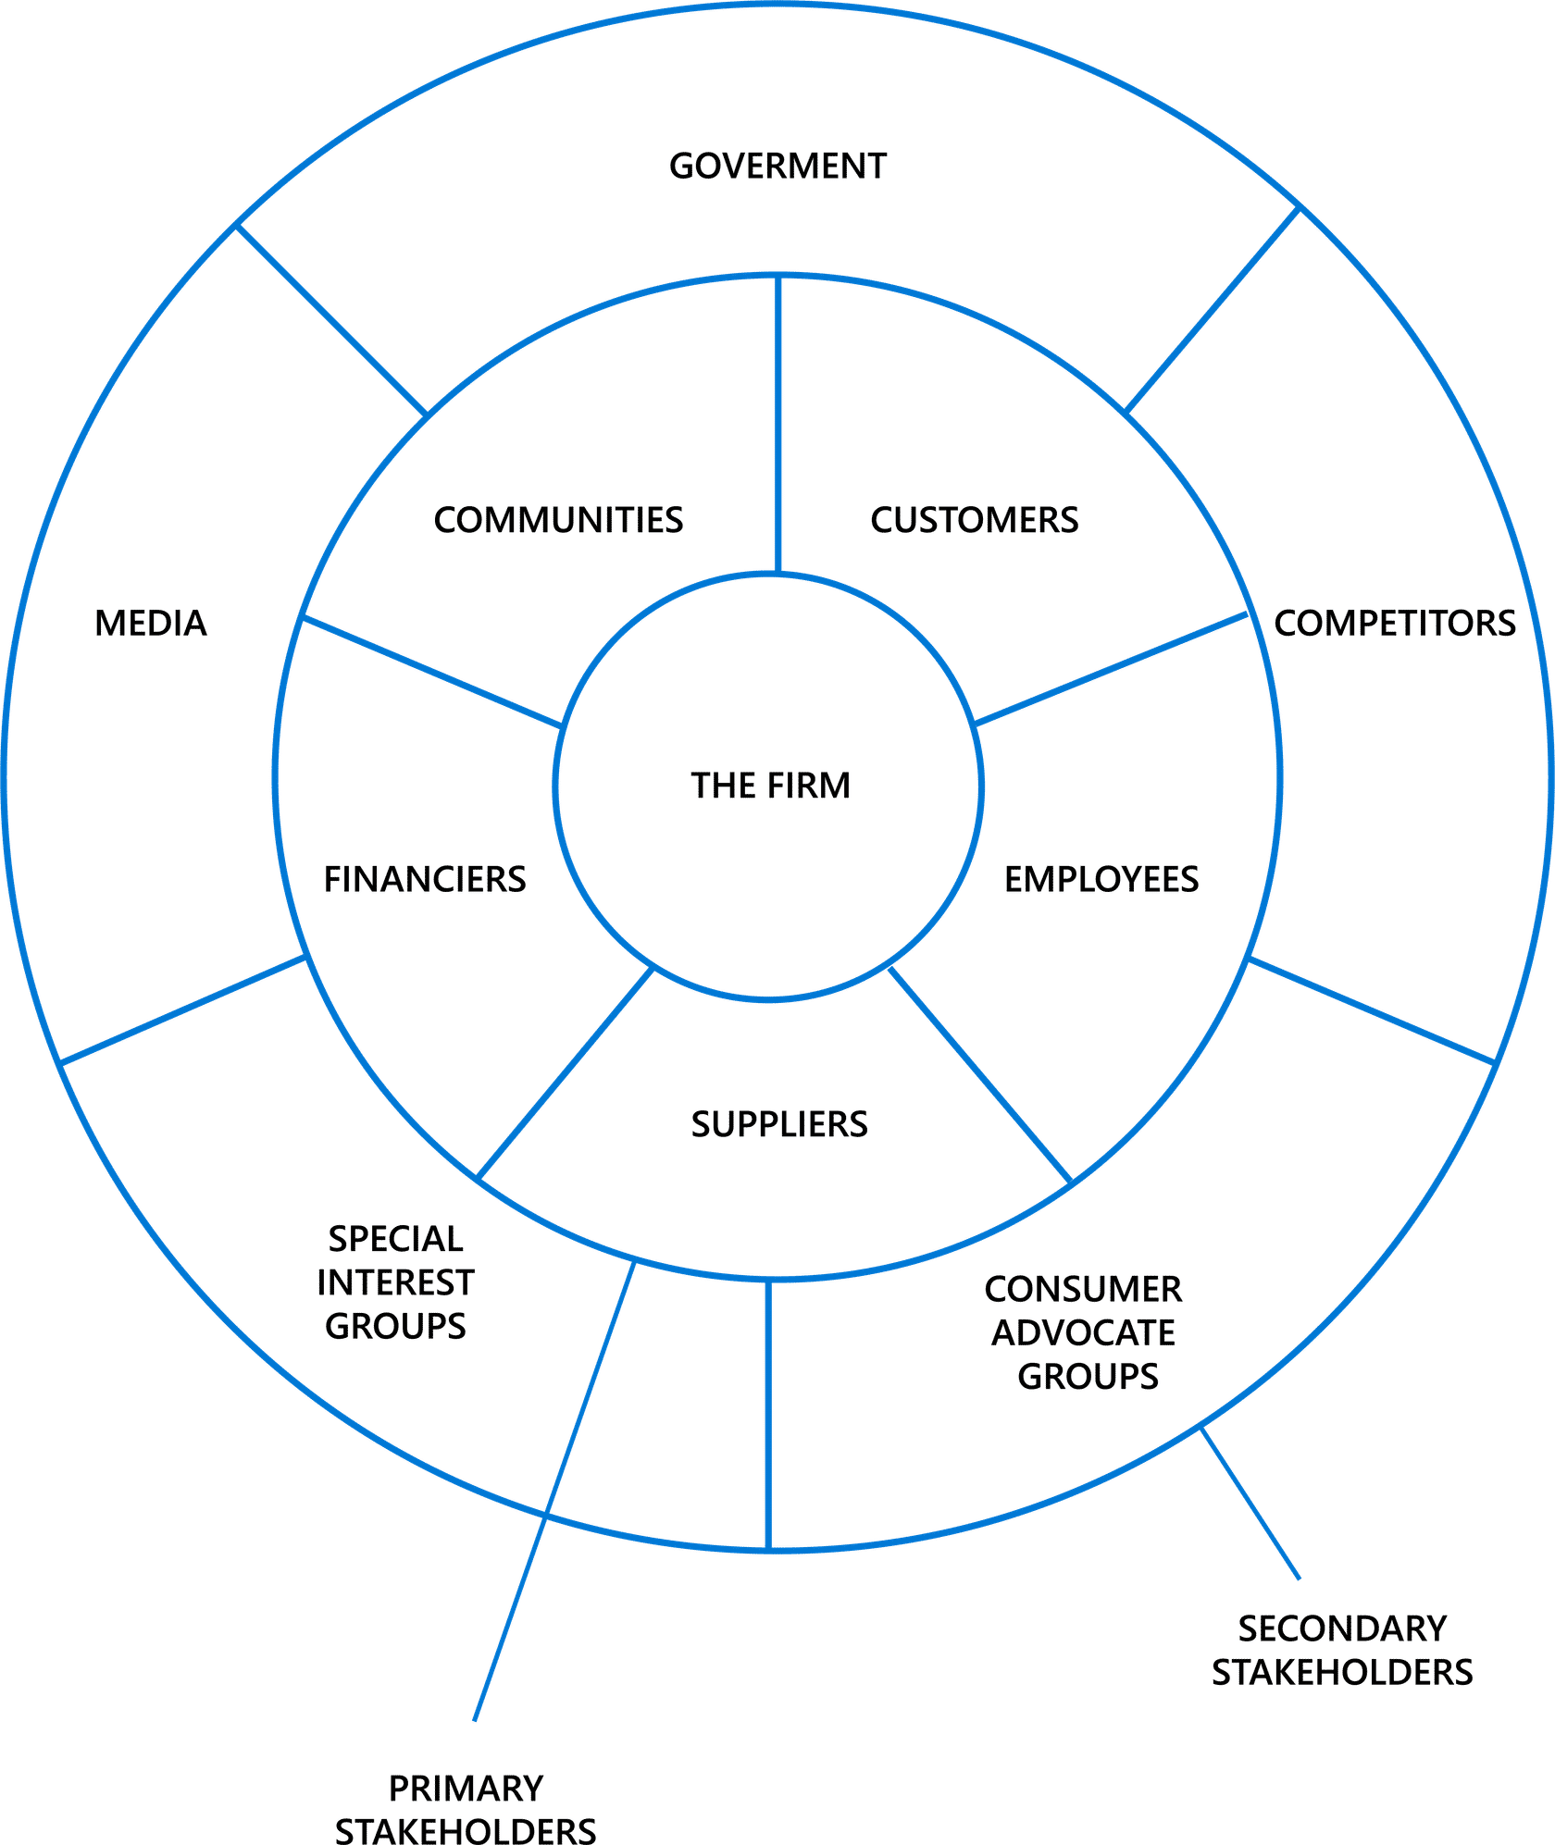
RACI matrix
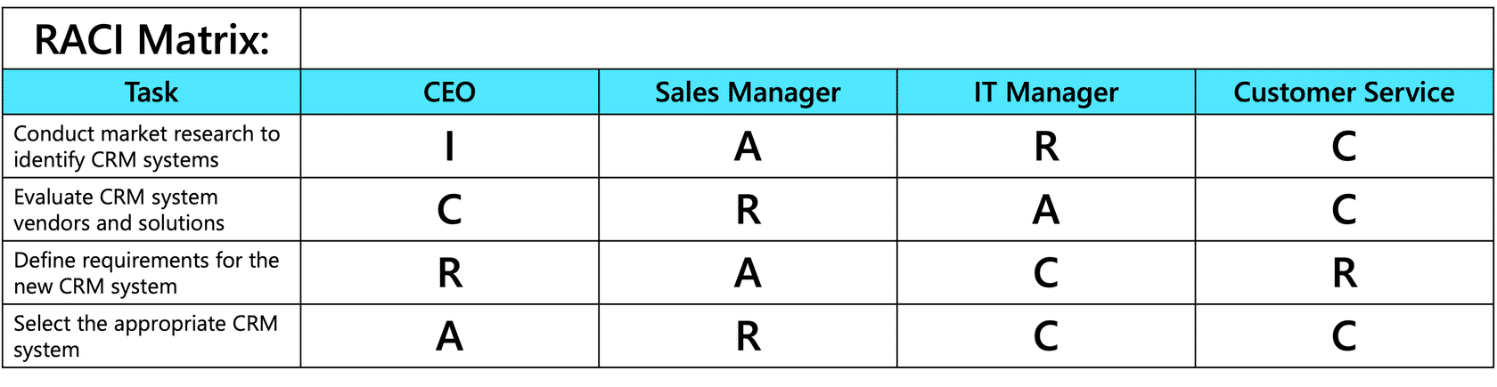
Deliverable 2 - Root cause analysis and Management Recommendations
- Root cause analysis—What questions would you ask to determine the root cause of this problem? Write down each question and a fictional response of one of the Stakeholders to demonstrate your understanding of the 5 Whys root-cause analysis method. Use Problem Identification and Stakeholder Management – Workbook
- Now, write down your recommendation to the Northwind Trading management team in the Problem Identification and Stakeholder Management – Workbook. Remember that all your opinions and recommendations must be backed by hard facts, so please quote the results of your analysis in your recommendations.
Root-cause analysis using the 5 Whys
Why Question 1
Why are the sales down?
Answer: Because the customers are not happy with the new website design.
Why Question 2
Why are the customers not happy with the website design?
Answer: The customers are not happy with the website design because:
- The checkout process is confusing and slow.
- There are limited payment options, only accepting credit cards.
- The store navigation is confusing due to inconsistent product grouping.
- There are technical issues, such as slow loading times.
Why Question 3
Why is the checkout confusing and slow and there are limited payment options?
Answer: The website requires customers to create an account before completing their purchase. There is no guest checkout, and for added security payment is only available using Paypal.
Why Question 4
Why does the website require customers to create an account?
Answer: Because the marketing department wants to gather customer data for marketing purposes and to track purchase history.
Why Question 5
Why does a marketing department want to gather customer data?
Answer: The company wants to gather customer data because they believe that having customer accounts will lead to increased customer retention and personalized marketing strategies.
Why Question 6
Why does the company prioritize gathering customer data over providing a smooth checkout experience?
Answer: Because they haven't conducted any market research to understand customer preferences and behaviors regarding checkout processes.

DELIVERABLE 3
User Role Analysis of the Northwind Traders web store users (Question 1).
As this was a fictional scenario, your descriptions and concerns/requirements may vary from the ones given here. Select each tab to continue.
Customers
Website Administrator
Sales Manager
Marketing Team
Customer Service Representatives
Web Developers/IT Team
Role description
Website administrator responsible for managing and updating the website (product listing, pricing, promotion) and maintaining customer accounts

Concerns/Requirements
Website Admin wants easy-to-use tools for updating product listings, images, pricing, and promotional banners. Also wants features allowing for easy management of user accounts, permissions, and access levels, features for implementing security protocols, managing SSL certificates, and protecting against cyber threats. Of interest are also features for monitoring and optimizing website performance. backup and recovery solutions.
This analysis will be used by the Northwind Traders IT team to better understand website user needs, prioritize website improvements, design user interfaces and validate website redesign objectives..
To summarize, user role analysis is a valuable tool for project teams to ensure that the products, services, or systems they develop are designed with the end-users in mind. By understanding the roles, responsibilities, and needs of different user groups, project teams can create solutions that are intuitive, efficient, and effective in meeting user needs and achieving project objectives.
DELIVERABLE 4
Stakeholders Analysis and Mapping (Question 2).
Your next deliverable was the Stakeholders Analysis and their mapping on the Power-Interest Grid. The suppliers have not been mentioned in the scenario. They may not even be regarded as stakeholders, but we added them just in case they were impacted.
Stakeholder | Project Responsibility | Interest/Concerns | Influence
Northwind Management | Overall strategic Direction, decision-making, project budget, approval of project plan. | Normally their interest in a website project would be low as they are responsible for the overall strategic direction of the company. However they are concerned about the company's financial performance and reputation, so this project is on their radar – High Interest. | High influence as they have the authority to allocate resources, approve budgets, and make strategic decisions regarding the project.
Marketing Manager | Oversees marketing efforts, including website design and promotional campaigns.  Monitors social media accounts. | High interest as they are responsible for marketing efforts, including website redesign and promotional campaigns. They are concerned about improving customer engagement, driving traffic to the website, and increasing sales. | High influence over website design and project success as they provide valuable insights into customer preferences and market trends. The marketing manager might be reluctant to re-design the checkout process as he will be losing valuable customer data.
Sales Manager | Oversees website sales | High interest as they are concerned about the impact of the project on sales performance and revenue generation. | High influence as they can provide input on customer preferences and drive website improvements.
Customer Service Team | Deals directly with customer inquiries and complaints related to the website. Provides sales support. | High interest as they deal directly with customer inquiries, complaints, and feedback related to the website. They are concerned about providing excellent customer service and addressing customer issues promptly. | Although they have firsthand knowledge of customer pain points and usability issues with the website, their influence over website design may not be very high.
IT Department | Involved in website development, maintenance, and technical support. | High interest as they are responsible for website development, maintenance, and technical support. They are concerned about the website's performance, security, and functionality. | High influence as they are responsible for implementing website changes and resolving technical issues.
Website Administrator | Responsible for managing and updating the website content (e.g. product listing, pricing) and maintaining customer accounts. | High interest in website design as they are directly responsible for updating the website. Provides insights into website performance. | Low influence as they only have control over website content.
Suppliers | Responsible for supplying products. May be impacted indirectly as depending how products are described and grouped on the website, it may impact the sales of these products. However, in this case the impact is negligible and you could omit this stakeholder from further analysis | May have some interest in website design, but it will be low. | Low Influence over website design.
Business Analyst – Project Manager | Responsible for leading and managing the website improvement project, running workshops, and ensuring project success within budget and timeline constraints. | Has a high interest in the project's success because they are responsible for gathering requirements, conducting stakeholder analysis, analyzing business needs, and ensuring that the project meets its objectives. | High Influence - Plays a central role in driving project success through effective analysis, planning, and stakeholder management.
Customers | Directly impacted by the usability and functionality of the online store. | High interest as they are the end-users of the website and directly impacted by its usability and functionality. They are concerned about finding products easily, navigating the website smoothly, and completing transactions hassle-free. Also concerned about payment security and personal data privacy. | Low influence individually, but collectively high as their feedback and behavior shape the design and ultimately success of the project.
Stakeholder analysis is a critical process in project management that involves identifying, assessing, and managing stakeholders' interests, involvement, and influence on a project.
It is used to identify all individuals, groups or organizations that may be impacted by the project, understanding their interests and influence over the project outcomes, and allocating the resources to manage stakeholder expectations, engagement and communications.
Stakeholder mapping is also a useful tool for mitigating project risks related to stakeholder’s resistance to change.
In this scenario, stakeholder mapping was used to carefully manage conflicting needs of the stakeholders - a Sales Manager (who was predominantly interested in growing sales), with the needs of a Marketing Manager who wanted to collect as much data as possible about the clients to improve effectiveness of the marketing team.
As both the Sales Manager and the Marketing Managers had significant influence over the project outcome, their expectations and communications needed to be carefully managed.
POWER - INTEREST GRID
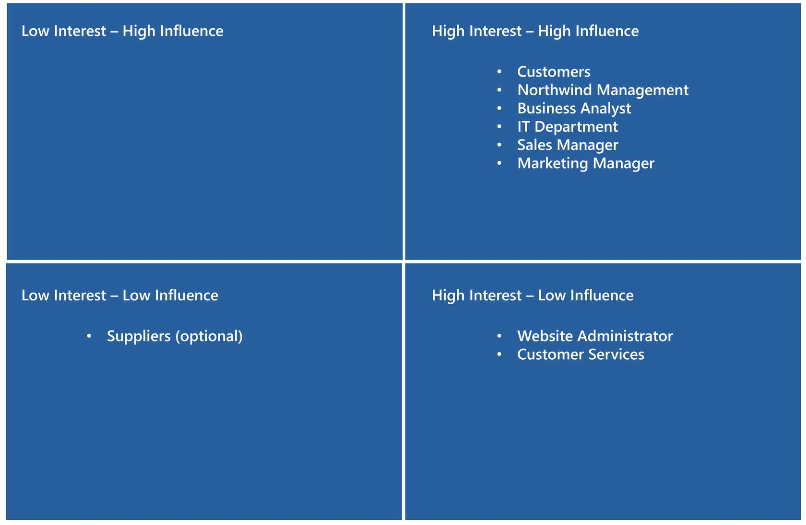
DELIVERABLE 5
RACI Matrix (Question 3)
Your last task in the exercise was to complete a RACI matrix. The purpose of completing a RACI matrix in this scenario was to clarify roles and responsibilities for each task and prevent ambiguity as to who is supposed to do what.
Here is a sample allocation of the tasks. To avoid confusion, it was important to make sure that Accountability for a task was allocated to only one person. While the responsibility for completing the task can be shared by several people, the accountability for the task completion shouldn’t really be shared.
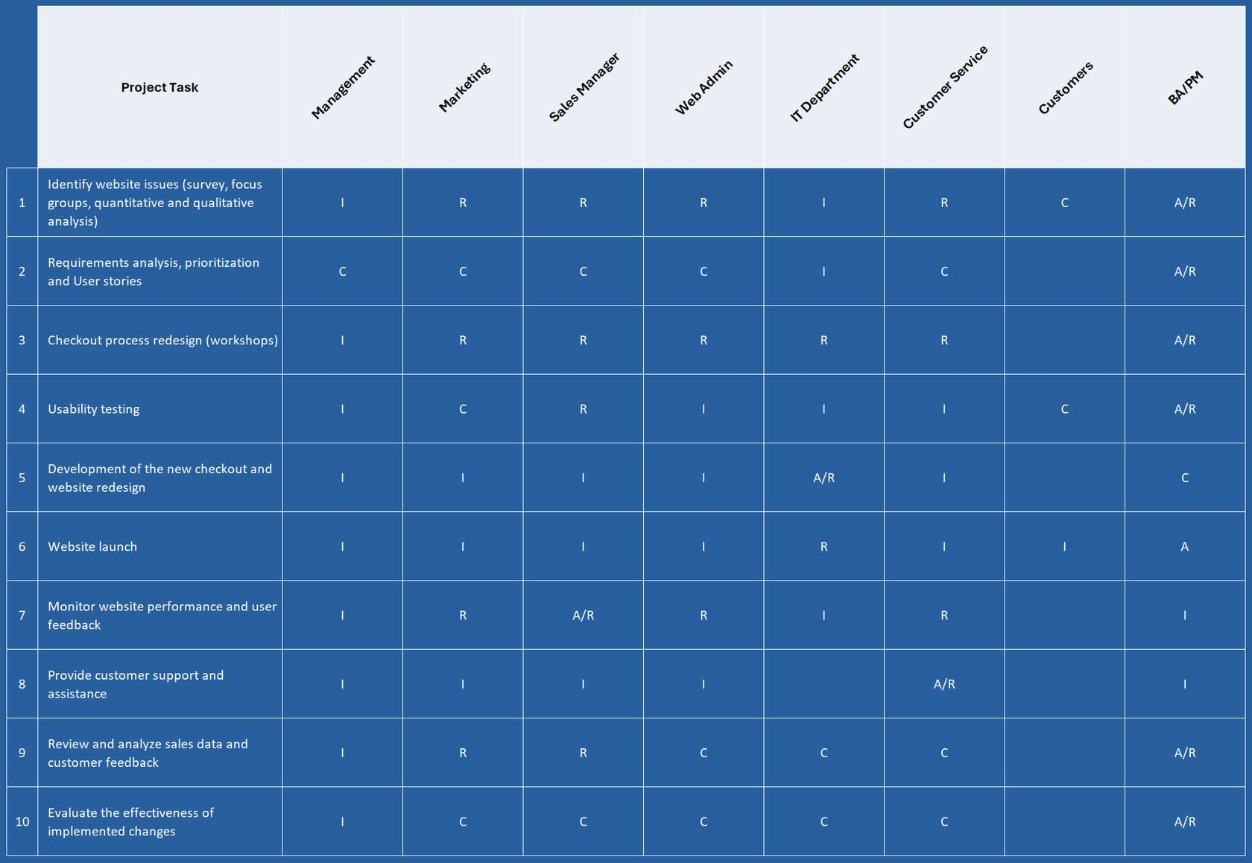
Each letter in the RACI matrix indicates stakeholder involvement in the respective activities.
R - "Responsible" refers to those responsible for completing tasks.
A - "Accountable" refers to those ultimately answerable for the tasks' completion.
C - "Consulted" refers to those whose input is sought during task completion.
I - "Informed" refers to those who need to be kept informed of progress and decisions.
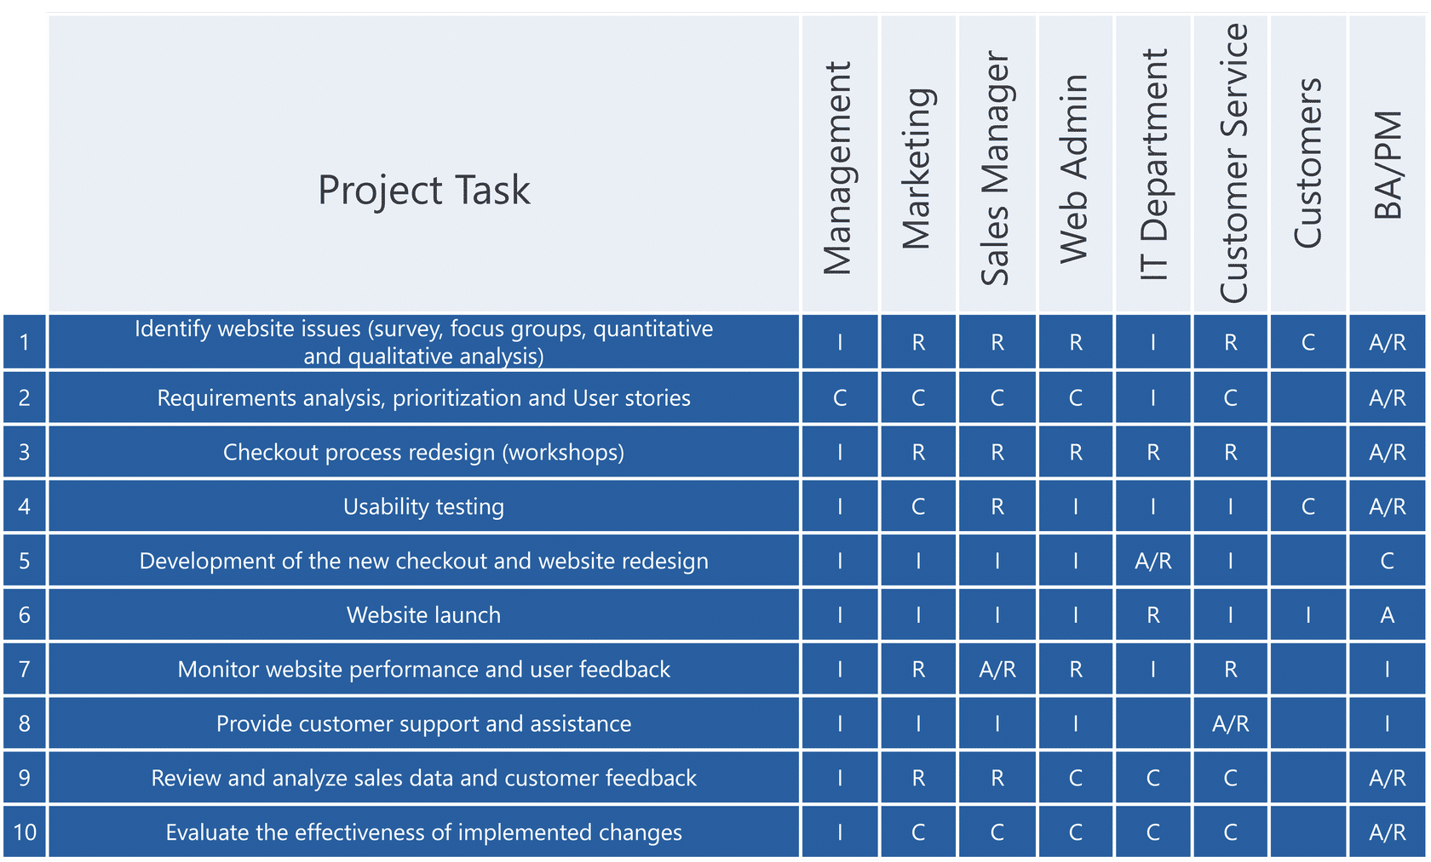
Please note that your allocation of responsibilities could have been different from the presented RACI Matrix example. It all depends how you decided to organize the project, whom you decided to invite to the workshops and who had the best skills and capacity to complete the task.

