CS 461
Spring 2017
Program 1
Due Sunday night, Feb. 5.

Your first programming assignment uses search to solve a game problem.

THE PROBLEM:
Backgammon is one of the world’s oldest games. Each player has 15 pieces, called men, stones, checkers, or just pieces (the terms are interchangeable). The board is a series of 24 spaces, called points, on which stones can land. The object of the game is to be the first to get all of one’s stones past the opponent into one’s own home board and to bear off (remove from the board) all of one’s stones. Here is the starting position, seen from Red’s side of the board:
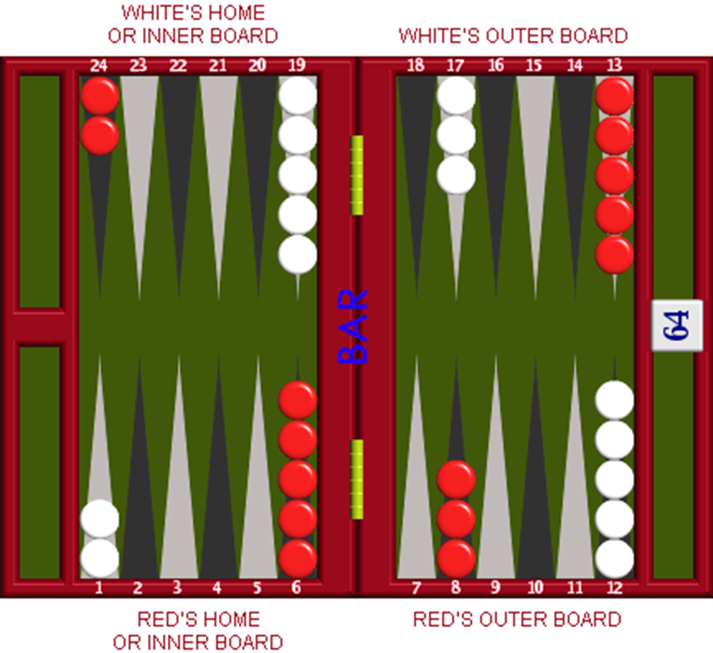
Detailed game rules are readily available elsewhere and mostly irrelevant here. In most games, at some point the two players’ stones have moved past each other and can no longer interfere with each other. From that point, the game is a race to bear off. Your task is to produce a database so that bearing-off decisions can be made quickly.

Game rules & principles:
- Points in the home board are numbered 1-6. Moving stones can be seen as moving them from higher-numbered to lower-numbered points, with ‘borne off’ represented as a point 0 just off the edge of the board. All moves are toward lower-numbered points; it is not possible to move backwards.
- The player rolls 2 dice to determine which stones can be moved. The dice are played separately. That is, if the player rolls a 3 and a 4, then one stone must be moved 3 points, and one stone (either the same or a different one) must be moved 4. It’s not a roll of 7; it’s a 3,4. Order of dice doesn’t matter; rolls of 4, 3 and 3, 4 are equivalent. Dice can be played in either order.
  - Doubles count double. That is, if both dice are the same, then the player has four of that move to make.
  - Both dice must be played if there is any legal way to do so. (For doubles, all must be played if legal; if not, as many as there are legal moves for must be played.)
  - If it is only possible to play one die, then that die must be played.
  - If it is possible to play one die or the other but not both, the larger must be played.
  - If there is no way to play either die, the player loses the turn and it is the opponent’s turn.
  - Not all of these rules will be relevant for this program, but some are.
- For a die roll of N, a stone on point N can be borne off, or a stone on a higher point can be moved N points.
  - It is not possible to bear off a stone on a lower point than N if point N or any higher point is occupied.
    - Example: If you roll a 4, you cannot bear off a stone from point 3 if there is a stone on point 4 or any higher point.
    - You could bear off from point 4, or, e.g., move a stone from point 5 to point 1.
- If there is no stone on point N or any higher point, then a stone on the highest occupied point may be borne off. (If all stones are on points 1-5, and the player rolls a 6, the 6 can be used to bear off a stone from the 5 point, but not from any of the lower points).

Program specifications:
- Your program may be written in C, C++, C#, Java, Python, or Clojure.
- Your program will deal with the restricted set of bearing-off positions involving 6 stones or fewer. (That’s enough to demonstrate correct functioning without getting swamped by the size of the full problem with 15 stones.)
- For each position, and each roll, you should determine and record: the expected number of turns until all stones are borne off; the maximum number of turns until all stones are borne off; and the optimum move to make with this roll in this position (defined as the move leading to the lowest expected number of turns until bearing off is complete). If there is more than one move leading to the same minimum expected number of moves, you may select among them using any convenient method.
- You may write a single program that generates and uses the database, or two programs, one that generates the database and saves it to a file, the other using the saved database to interact with the user. If you use the second option, upload the source code to both of your programs, and your database, as part of your Blackboard submission.
- Your program will offer the user two options: to analyze a position or to suggest a move.
  - In both cases, the user enters a position as a string of digits with no spaces between them, starting at point 1. For example, ‘000231’ would represent no stones on points 1-3, 2 stones on point 4, 3 stones on point 5, and 1 stone on point 6. The total number of stones may not exceed 6, but may be any other number greater or equal to 0.
  - If the user chose to analyze a position, your program will print (to the screen) a list of all possible rolls, and the expected and maximum number of turns needed to complete bearing off for each.
    - Your output should demonstrate that some thought has been given to ease of reading, using some sort of tabular format.
  - If the user chose the ‘suggest a move’ option, your program will ask the user to enter a roll (entered as 2 digits, so ‘34’ would be a roll of 3,4 and ‘66’ represents double-6). Your program will then recommend a move to be made, and report the expected and maximum number of turns to finish bearing off from the position that results.
  - If the total number of stones exceeds 6, your program should print a brief message informing the user of the 6-stone limit.
- The user should be able to choose either option, in any order, as many times as desired until explicitly choosing to end the program.
- Make strategic use of defined constants or clearly-marked specifications so your program could be modified to solve a larger subset (or the entire 15-stone problem space) if desired.
- You will submit your program source code, your saved database if your program uses one, and a document about your solution. This document (Word, LibreOffice, or Rich Text) will include, at a minimum:
  - A description of major data structures;
  - Discussion of major functions or sections of code (you don’t need to walk through how you ask the user for input, but what operations are carried out on the data structures is useful information);
  - How the database was built up;
  - A detailed argument demonstrating algorithmic correctness, including how you know the solutions you found were optimal. This argument need not be as rigorous as a formal proof but should be persuasive. And of course, a rigorous proof is acceptable.

