**Temperature Observations**

[Global Historical Climatology Network hourly (GHCNh)](https://www.ncei.noaa.gov/products/global-historical-climatology-network-hourly)

GHCNh consists of hourly and synoptic surface weather observations from fixed, land-based stations. This dataset is compiled from numerous data sources maintained by NOAA, the U.S. Air Force, and many other meteorological agencies (Met Services) around the world. These sources have been reformatted into a common data format and then harmonized into a set of unique period-of-record station files, which are then provided as GHCNh.

Data Access

HTTPS Access:

<https://www.ncei.noaa.gov/oa/global-historical-climatology-network/index.html#hourly/>

By station: <https://www.ncei.noaa.gov/oa/global-historical-climatology-network/index.html#hourly/access/by-station/>

Search Tools:

<https://www.ncei.noaa.gov/access/search/data-search/global-historical-climatology-network-hourly>

Coverage

[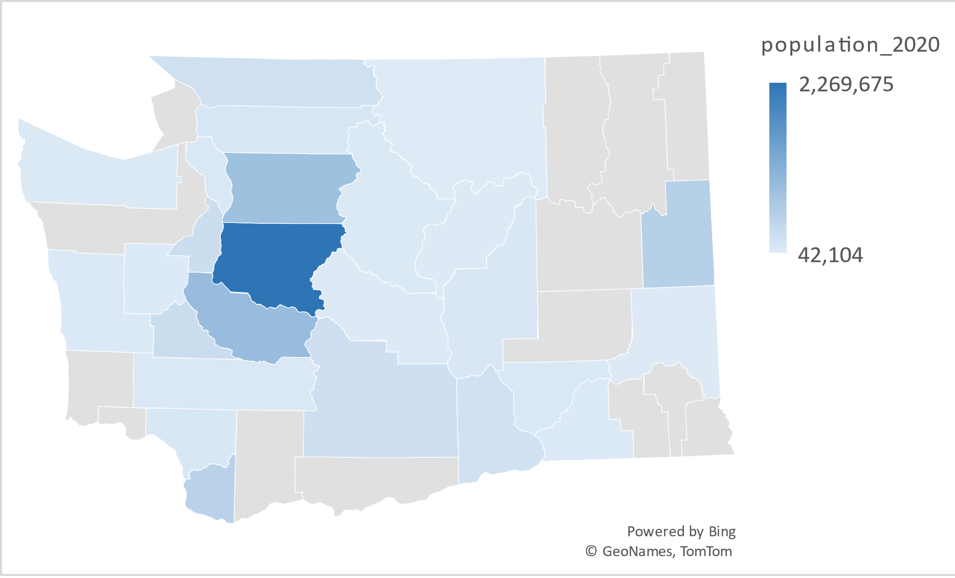](https://mailmissouri-my.sharepoint.com/personal/fzxzr_umsystem_edu/Documents/transfer_desktop/MU/2024-2025W_Modification_chapter1/county_station_list.xlsx?web=1)

plot_pop_county.html

**Population by County**

Office of Financial Management

[Historical estimates of April 1 population and housing for the state, counties, and cities](https://ofm.wa.gov/washington-data-research/population-demographics/population-estimates/historical-estimates-april-1-population-and-housing-state-counties-and-cities)

Postcensal estimates

Postcensal estimates are estimates that reference the prior census point. These estimates are provided for historical reference purposes.

**Electricity Sales and Prices**

[State Electricity Profiles](https://www.eia.gov/electricity/data.php)

Sales (consumption), revenue, prices & customers

Monthly Form EIA-861M (formerly EIA-826) detailed data (1990 - present)

Revenue, sales, customer counts, and retail price by state and sector

[Historical State Data](https://www.eia.gov/electricity/data/state/)

EIA-861M Monthly Electric Power Industry Report (released: 11/25/2024)

Monthly sales to ultimate customers by state and sector

**Nino 3.4**

<https://psl.noaa.gov/gcos_wgsp/Timeseries/Nino34/>

**CPI data**

Databases, Tables & Calculators by Subject

[Consumer Price Index for All Urban Consumers (CPI-U)](https://data.bls.gov/pdq/SurveyOutputServlet)

Other info, In General

[https://datacommons.org/place/geoId/53?utm_medium=explore&mprop=count&popt=Person&hl=en#](https://datacommons.org/place/geoId/53?utm_medium=explore&mprop=count&popt=Person&hl=en)