**Weather Observations**

[Global Historical Climatology Network hourly (GHCNh)](https://www.ncei.noaa.gov/products/global-historical-climatology-network-hourly)

GHCNh consists of hourly and synoptic surface weather observations from fixed, land-based stations. This dataset is compiled from numerous data sources maintained by NOAA, the U.S. Air Force, and many other meteorological agencies (Met Services) around the world. These sources have been reformatted into a common data format and then harmonized into a set of unique period-of-record station files, which are then provided as GHCNh.

Data Access

HTTPS Access:

<https://www.ncei.noaa.gov/oa/global-historical-climatology-network/index.html#hourly/>

By station: <https://www.ncei.noaa.gov/oa/global-historical-climatology-network/index.html#hourly/access/by-station/>

Search Tools:

<https://www.ncei.noaa.gov/access/search/data-search/global-historical-climatology-network-hourly>

Coverage

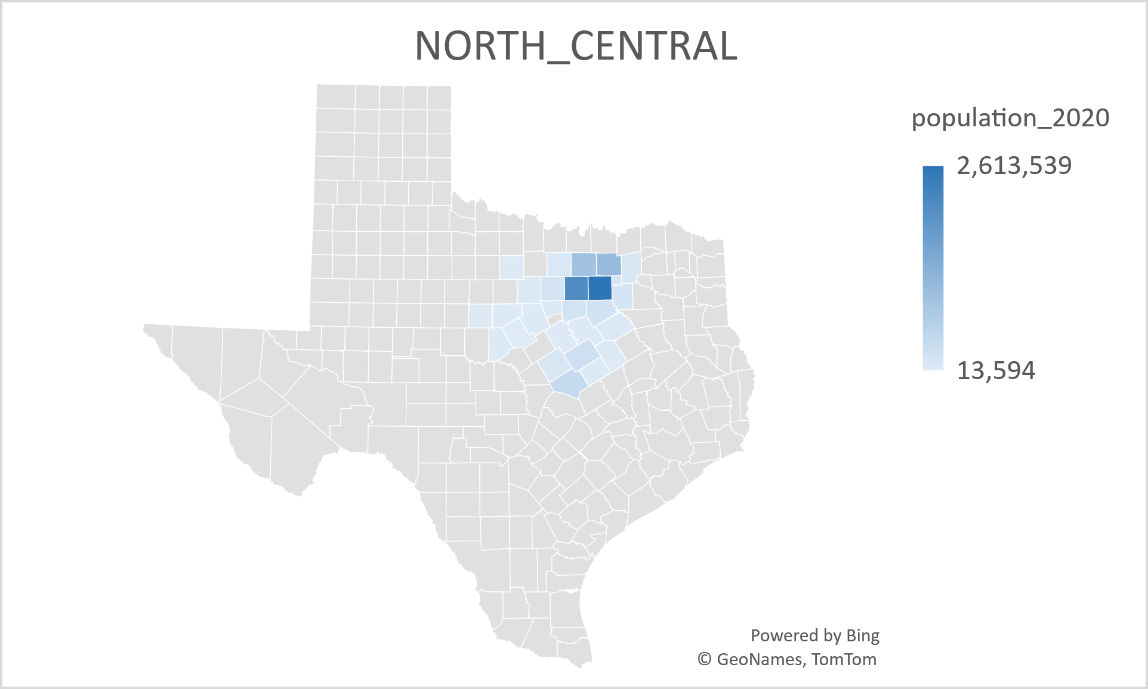

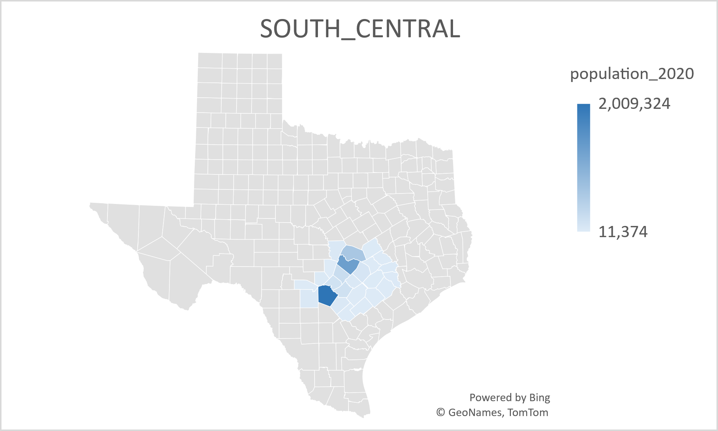

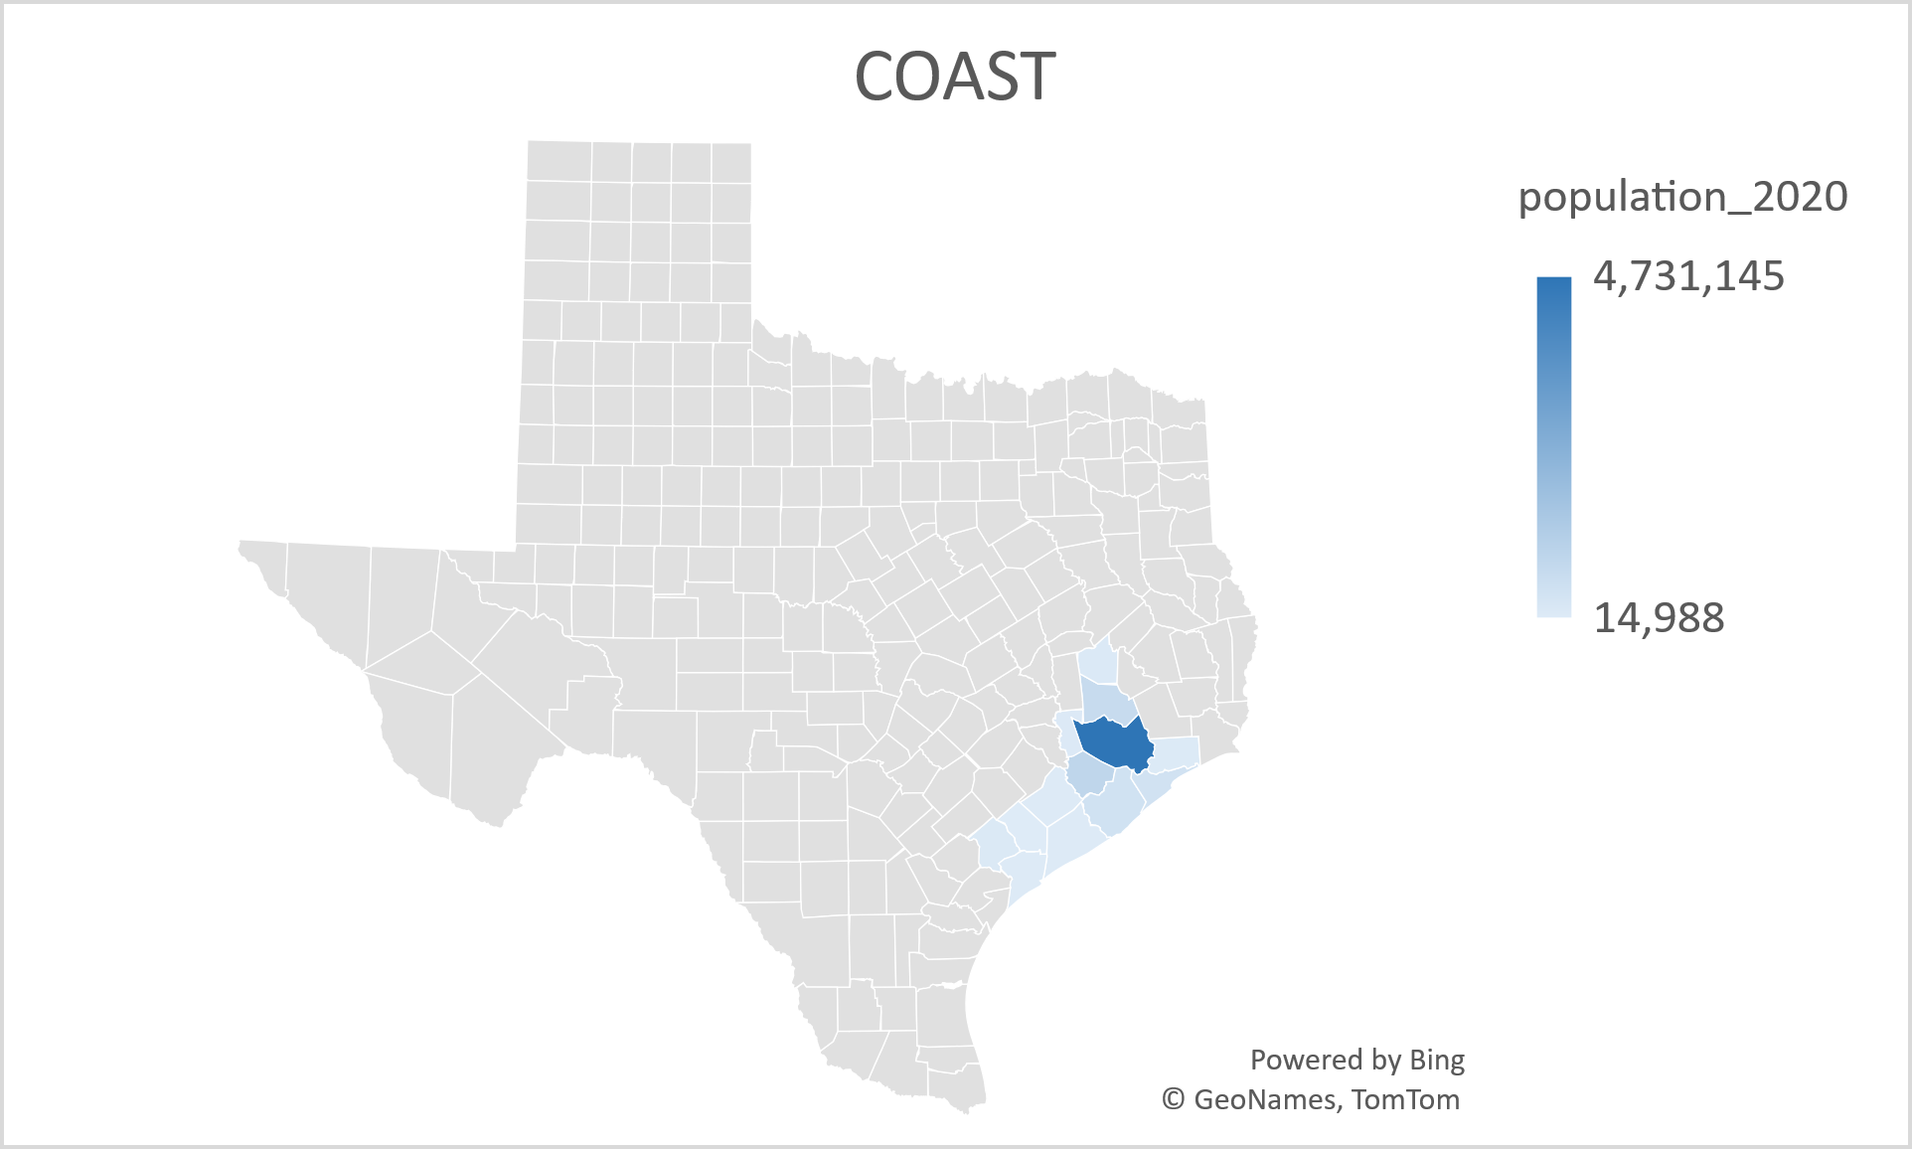

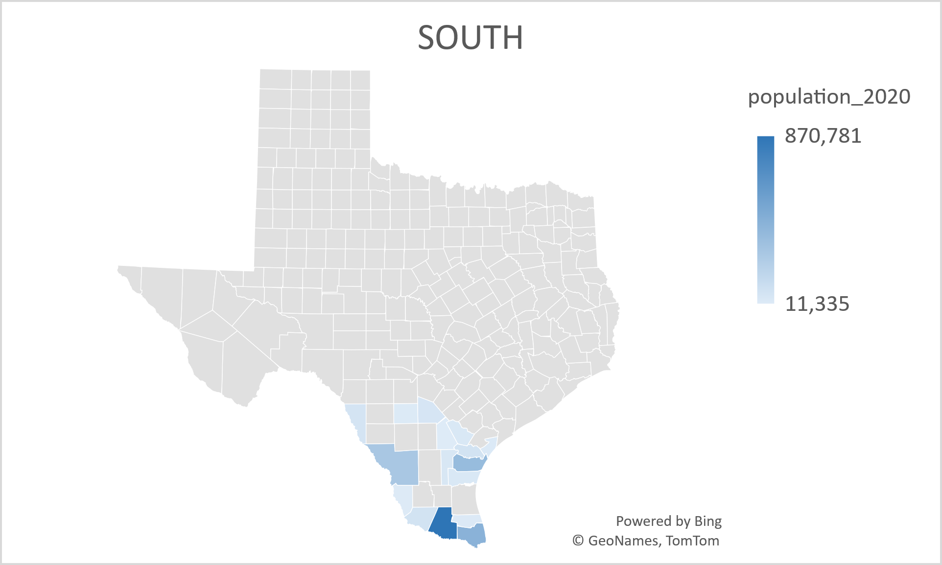

**Complement: Reanalysis**

[NCEP North American Regional Reanalysis (NARR)](https://psl.noaa.gov/data/gridded/data.narr.html)

The North American Regional Reanalysis (NARR) is a model produced by the National Centers for Environmental Prediction (NCEP) that generates reanalyzed data for temperature, wind, moisture, soil, and dozens of other parameters. The NARR model assimilates a large amount of observational data from a variety of sources to produce a long-term picture of weather over North America.

Original Source:

* Dataset was originally produced at NOAA's National Center for Atmospheric Prediction (NCEP) and is available in its original grib format through NOAA NCEI's access page and from NCAR. More information is at NCEP's NARR web page. [invalid links]

[https://psl.noaa.gov/data/narr/]

<https://downloads.psl.noaa.gov/Datasets/NARR/>

/NARR/monolevel

8 times daily

**Population by County**

2000-2010:

<https://www.census.gov/data/tables/time-series/demo/popest/intercensal-2000-2010-counties.html>

2010-2020:

<https://www.census.gov/data/tables/time-series/demo/popest/intercensal-2010-2020-counties.html>

After 2021:

<https://demographics.texas.gov/Estimates/2023/>

**Electricity Load**

Electric Reliability Council of Texas (ERCOT)

Public Utility Commission of Texas (PUCT):

<https://www.puc.texas.gov/>

documents search: <https://interchange.puc.texas.gov/>

GeoJSON Data Source:

<https://data.texas.gov/dataset/Texas-Counties-Cartographic-Boundary-Map/sw7f-2kkd/about_data>