

|  |
| --- |
| prototype_rough_v1 |
| 11/10/17 15:16 |
| **Author:** John Doe  **File name:** prototype_rough_v1.vp  **Version** 1.0 |

|  |
| --- |
| Site Map |
|  |

|  |
| --- |
|  |

01. Site Map / prototype_rough_v1 

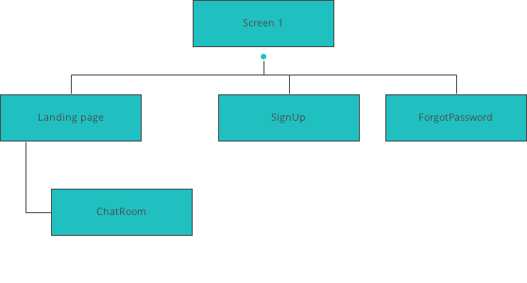

|  |
| --- |
| Screens |
|  |

|  |
| --- |
|  |

02. Screens / prototype_rough_v1 

Screen 1

|  |
| --- |
|  |

Interactions

|  |  |
| --- | --- |
| 1 | **on Click:** goes to 'Landing page' 🡪 |
| 2 | **on Click:** goes to 'SignUp' 🡪 |
| 3 | **on Click:** goes to 'ForgotPassword' 🡪 |

02. Screens / prototype_rough_v1 

Landing page

|  |
| --- |
|  |

Interactions

|  |  |
| --- | --- |
| 4 | **on Click:** goes to 'ChatRoom' 🡪 |

02. Screens / Landing page 

Other states

|  |  |
| --- | --- |
|  |  |

02. Screens / prototype_rough_v1 

SignUp

|  |
| --- |
|  |

Interactions

|  |  |
| --- | --- |
| 5 | **on Click:** goes to 'Screen 1' 🡪 |

02. Screens / prototype_rough_v1 

ForgotPassword

|  |
| --- |
|  |

02. Screens / prototype_rough_v1 

CreateView

|  |
| --- |
|  |

02. Screens / prototype_rough_v1 

AccountSettings

|  |
| --- |
|  |

02. Screens / prototype_rough_v1 

Create

|  |
| --- |
|  |

02. Screens / prototype_rough_v1 

ChatRoom

|  |
| --- |
|  |

|  |
| --- |
| Templates |
|  |

|  |
| --- |
|  |

03. Templates / prototype_rough_v1 

Template 1

|  |
| --- |
|  |

|  |
| --- |
| Scenarios |
|  |

|  |
| --- |
|  |

04. Scenarios / prototype_rough_v1 

default

|  |
| --- |
|  |

|  |
| --- |
| Data Masters |
|  |

|  |
| --- |
|  |

05. Data Masters / prototype_rough_v1 

Settings

|  |  |  |
| --- | --- | --- |
| Attribute name | Type | Values |
| Settings | text | values |