Brian Kang

HW Set # 14

Problems that included coding here…

By Hand problems are below…

# hw_lect24_1

# a)

x <- c(89, 177 ,189 ,354, 362, 442, 965)

y <- c(.40, .60, .48 ,.66 ,.61 ,.69 ,.99)

plot(x,y)

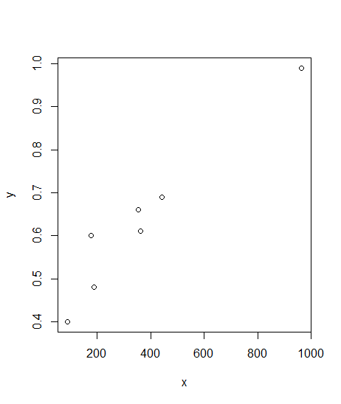

# b)

lm.1 = lm(y~x)

lm.1$coefficients[2] # beta coeff.

# 0.0006210758

# We estimate that with each increase in x by 1 will lead to an increase in y by 0.0006210758

# c)

summary(lm.1)$sigma # S_e

# 0.05404525

# The typical deviation of y about the fit is about 0.05404525.

# hw_lect25_1

# a)

set.seed(123) # Use this line to make sure we all get the same answes.

n = 20

y = 1 + rnorm(n,0,1)

x1 = runif(n,-1,1)

x2 = runif(n,-1,1)

x3 = runif(n,-1,1)

x4 = runif(n,-1,1)

x5 = runif(n,-1,1)

x6 = runif(n,-1,1)

x7 = runif(n,-1,1)

x8 = runif(n,-1,1)

x9 = runif(n,-1,1)

x10 = runif(n,-1,1)

lm.2 = lm(y~x1+x2+x3+x4+x5+x6+x7+x8+x9+x10)

# test of model utility

# look at "p-value" next to the fstatistic in summary

# 0.2846

# t test on each 10 coeffs

summary(lm.2)$coeff[,4]

# b)

# 0.2846 > alpha = 0.1, therefore there are no useful predictors

# c)

# There are 4 predictors with p-value < alpha = 0.1.

# hw_lect25_2

# c)

plot(pbinom(1,1:100,0.05,lower.tail = T),1:100)

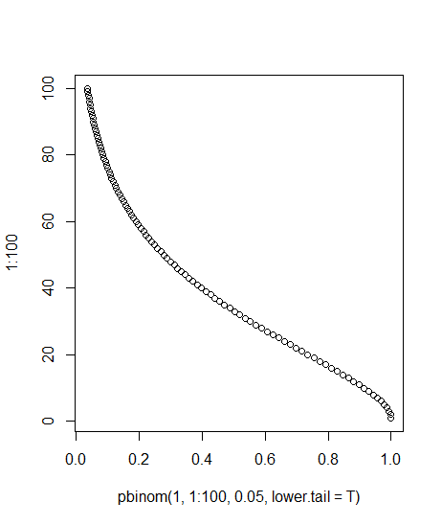

plot(pbinom(1,1:100,0.01,lower.tail = T),1:100)

