Brian Kang

HW Set #2

#1.7b

At most 5 (x <= 5): (7+12+13+14+6+3) / 60 = 55/60 = 11/12

Fewer than 5 (x < 5): (7+12+13+14+6) / 60 = 52/60 = 13/15

At least 5 (x >= 5): (3+3+1+1) / 60 = 8/60 = 2/15

#hw_lect3_1

a. bell shaped: Quantity x can be the weights of people (gender independent) because most people’s weights generally are around the typical value and fewer people are at the high (obese) and lower (bony/underweight) ends.

b. skewed: x can be the test scores for an extremely difficult exam. Most of the people will have very low scores but there will be always a few people that do extremely well relatively speaking, ultimately creating a right skew (tail to right)

c. exponential-looking: x can be life span of oysters. Oysters are type r strategists generally have short

life expectancies, mature early, and are type III survivors. Due to this characteristic, most oyster species

will die early, while few live very long, ultimately creating an exponential looking histogram.

d. bimodal: x can be number of customers in a restaurant during open hours. There will the first peak of the histogram during the lunch hours (typically around noon) and the second peak will during dinner hours (typically around 6 – 7 pm), assuming that this restaurant doesn’t open during mornings.

#hw_lect3_2

An example we went over during lecture is energy of particles and this reminded me a viable example that shows the exponential looking shape: radioactive decay of a particle, the half-life concept to be more specific. The x-axis will be time and the y-axis will merely be the count of a specific radioactive particles. After a certain amount of time, we know that the number of remaining radioactive particles will keep decreasing, which will create the exponential looking shape histogram.

(demonstrative graph next page…)

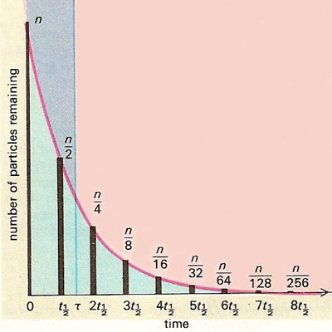

|  |  |  |  |
| --- | --- | --- | --- |
|  | |  |  |
|  |  | |  | # hw_lect3_3 |
|  |  | |  |  |
|  |  | |  | x <- read.table("https://www.stat.washington.edu/marzban/390/summer18/hw_lect3_dat.txt") |
|  |  | |  | par(mfrow = c(2,3)) # to disply all graphs at once |
|  |  | |  |  |
|  |  | |  | # the first column |
|  |  | |  | H1 = hist(x[,1], plot = F) # dont gragh the histogram |
|  |  | |  | plot(H1$mids, H1$density) # same as hist of x[,1] |
|  |  | |  | plot(H1$mids, log(H1$density), main = "Exponential") |
|  |  | |  | plot(log(H1$mids), log(H1$density), main = "Power-Law") |
|  |  | |  |  |
|  |  | |  | # the second column |
|  |  | |  | H2 = hist(x[,2], plot = F) # dont gragh the histogram |
|  |  | |  | plot(H2$mids, H2$density) # same as hist of x[,2] |
|  |  | |  | plot(H2$mids, log(H2$density), main = "Exponential") |
|  |  | |  | plot(log(H2$mids), log(H2$density), main = "Power-Law") |
|  |  | |  |  |
|  |  | |  | # The second column is suitable for an exponential histogram compared to first. |
|  |  | |  | # You can see a linear line created from connecting the plotted dots, compared to first which you can still see an exponential looking shape. |
|  |  | |  |  |
|  |  | |  | # In terms of the power-law histogram, I think the first column is more suitable. |
|  |  | |  | # You can see a linear line through half of the dots plotted and the rest also fit |
|  |  | |  | # relatively well to that line extended. On the other hand, from the second column's, |
|  |  | |  | # you can see a concave down and decreasing curve that fits well along the all dots. |
|  |  | |  | # I believe we will later learn a better way to determine by using residuals. |
|  |  | |  | C:\Users\slexi\AppData\Local\Microsoft\Windows\INetCache\Content.Word\Rplot.png |
|  |  | |  | # ---------------------------------------------------------------------------- |

HW_LECT4 AND MORE IN NEXT PAGES

|  |  |  |  |
| --- | --- | --- | --- |
|  |  |  |  |

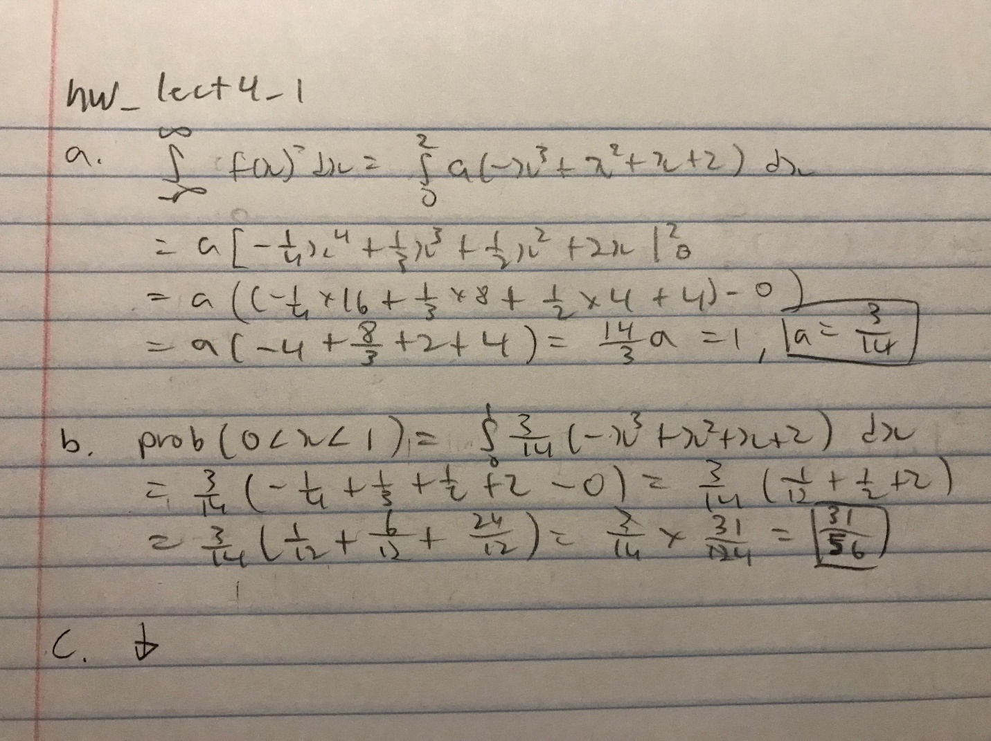

|  |  |  |
| --- | --- | --- |
|  | | # hw_lect4_1  # part c) |
|  |  | |
|  | | # f(x) from 0<x<2 |
|  | | xm = seq(0,2,0.005) |
|  | | ym = 3/14*(-xm^3+xm^2+xm+2) |
|  | | # actually from -Inf to 0 and from 2 to Inf |
|  | | xl = c(-2:0) |
|  | | xr = c(2:4) |
|  | | y = rep(0,length(xl)) |
|  | | plot(xm,ym,type = "l", ylim = c(0,1), xlim = c(-1,3)) |
|  | | lines(xl,y,type = "l") |
|  | | lines(xr,y,type = "l")  # graph below |

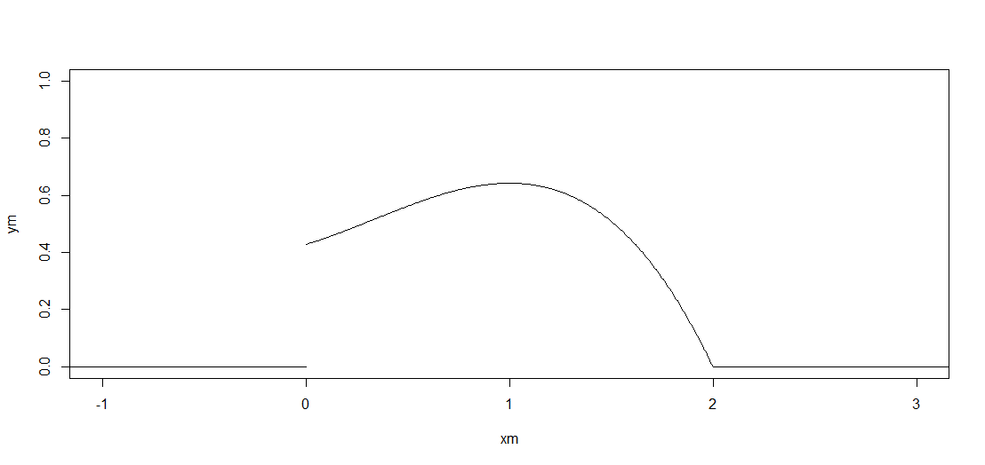

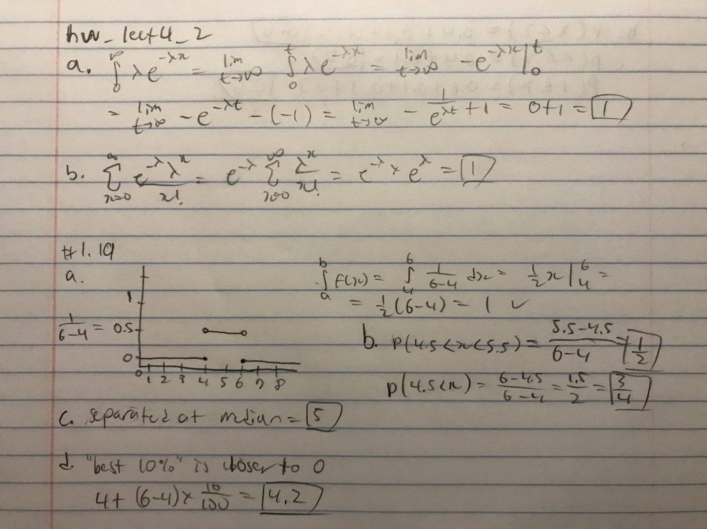# hw_lect4_2 & 1.19

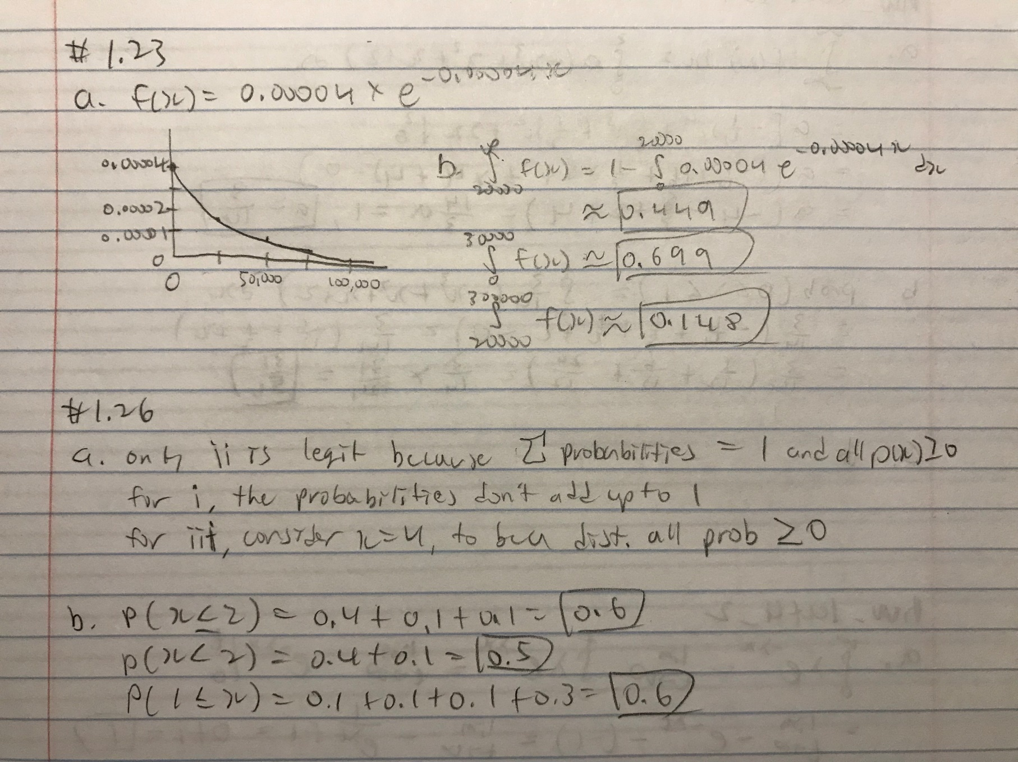#1.23 & 1.26