Brian Kang

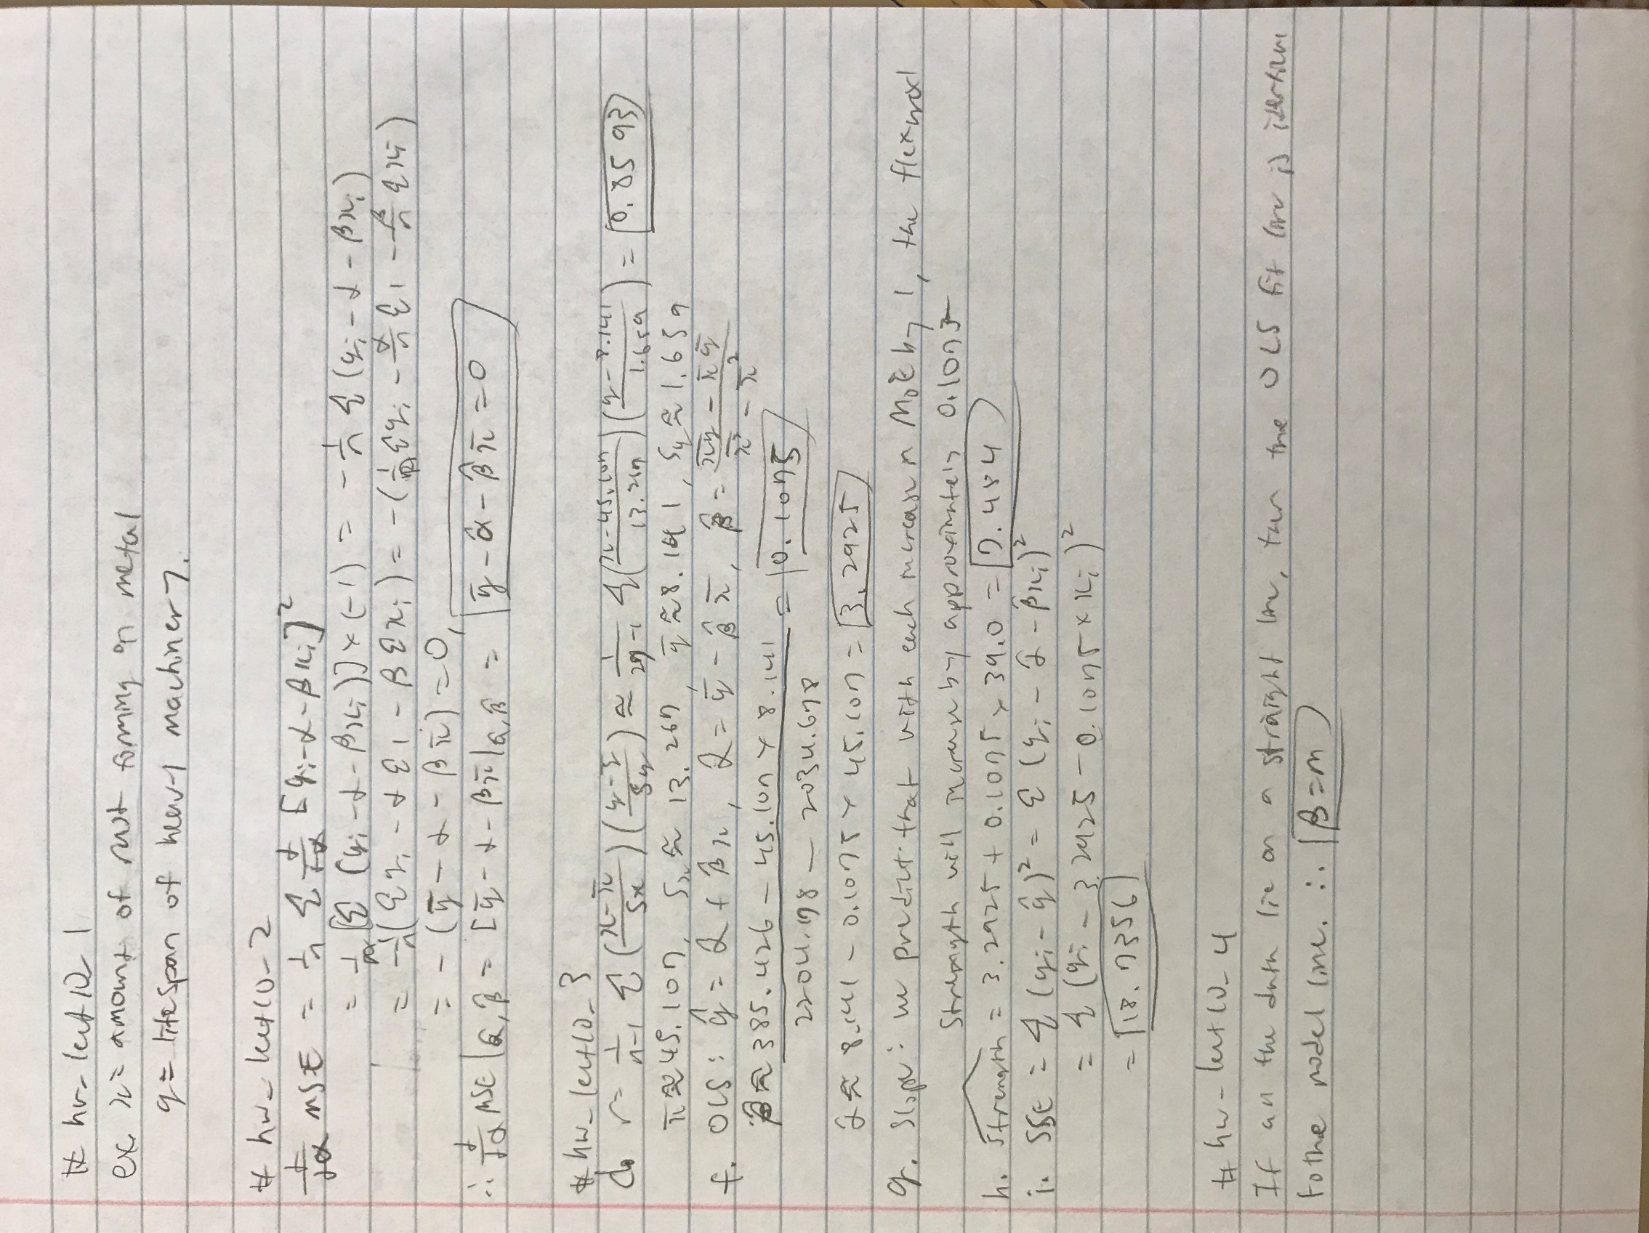HW Set 6

Here are the other parts of #hw_lect10_3

# hw_lect10_3

moe <- c(29.8,33.2,33.7,35.3,35.5,36.1,36.2,36.3,37.5,37.7,38.7,38.8,39.6,41.0,42.8,42.8,43.5,45.6,46.0,46.9,48.0,49.3,51.7,62.6,69.8,79.5,80.0)

strength <- c(5.9,7.2,7.3,6.3,8.1,6.8,7.0,7.6,6.8,6.5,7.0,6.3,7.9,9.0,8.2,8.7,7.8,9.7,7.4,7.7,9.7,7.8,7.7,11.6,11.3,11.8,10.7)

# a)

plot(strength,moe)

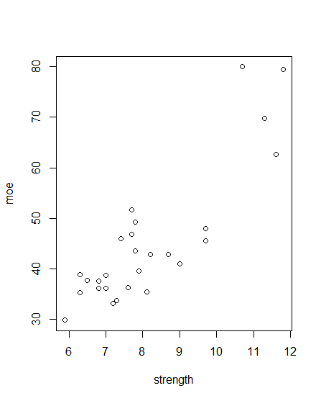

# b)

par(mfrow = c(1,2))

boxplot(moe)

boxplot(strength)

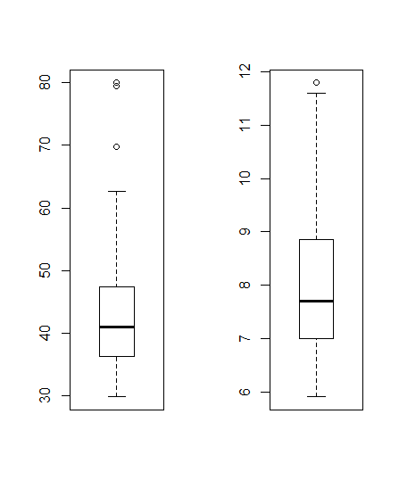

# c)

qqnorm(moe)

qqnorm(strength)

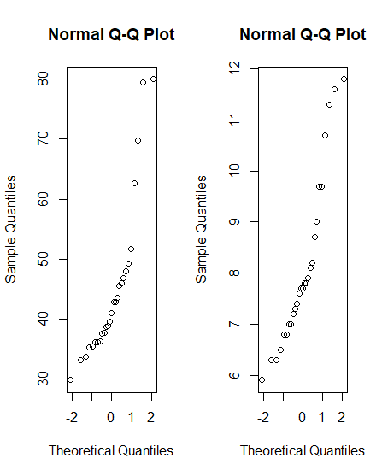

# e)

cor(moe,strength)

# The correlation coefficients from d and e are equal.

At bottom there are the rest of the problems

