Brian Kang

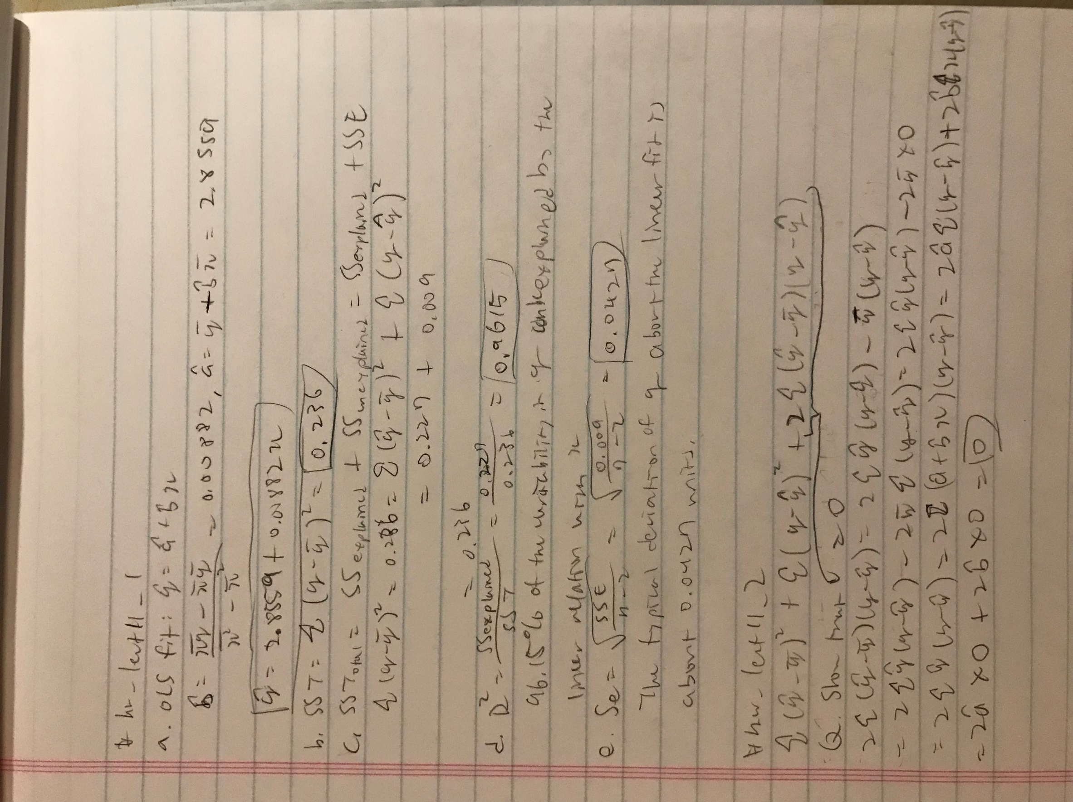HW Set #7

# hw_lect11_3

x = c(45, 58, 71, 71, 85, 98, 108)

y = c(3.20, 3.40, 3.47, 3.55, 3.60, 3.70, 3.80)

# a)

lm.r = lm(y~x)

lm.r

# Intercept = 2.855944, x (Slope) = 0.008822

# Interpretation:

# When the x value = 0, we predict that the y value is

# about 2.855944

# An increase in the x value by 1 is associated with an

# average increase in the y value by 0.008822

# b)

plot(x,y, main = "Scatterplot of X v. Y")

abline(lm.r)

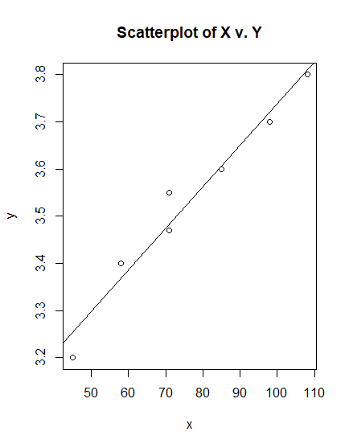

# c)

summary(lm.r)$r.squared

# R^2 = 0.9614587

# Interpretation:

# 96.146% of the variability in the y variable can be

# explained by the linear relation with x

# d)

summary(lm.r)$sigma

# s_e = sqrt(variance of error) = 0.04269537

# Interpretation:

# The typical deviation of y about the fit is about

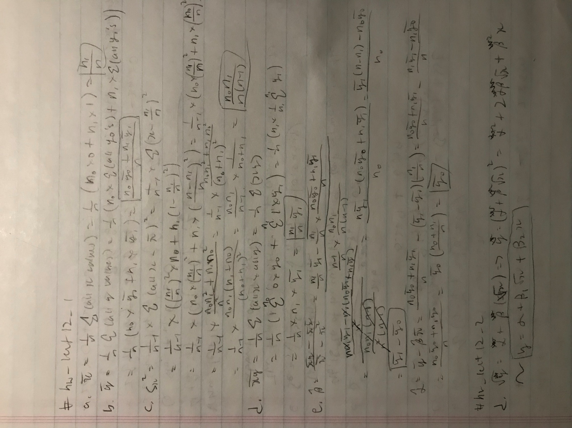# 0.0427 units.

# hw_lect12_2

# a)

dat <- read.table("https://www.stat.washington.edu/marzban/390/summer18/transform_dat.txt", header = T)

plot(dat[,1],dat[,2])

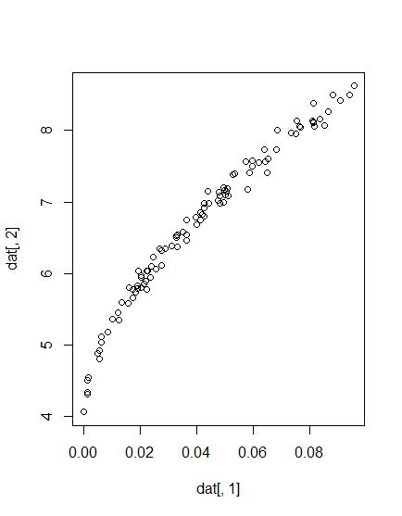

plot(sqrt(dat[,1]),sqrt(dat[,2]))

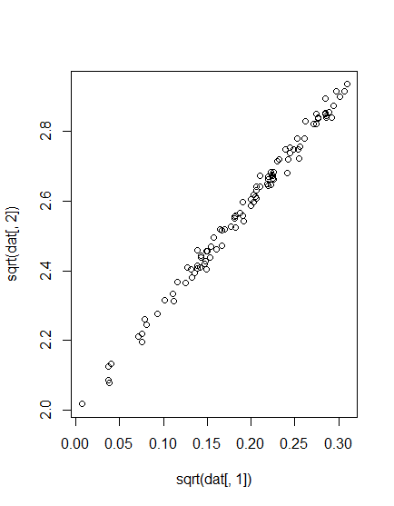

# b)

lm.1 <- lm(sqrt(dat[,2])~sqrt(dat[,1]))

abline(lm.1)

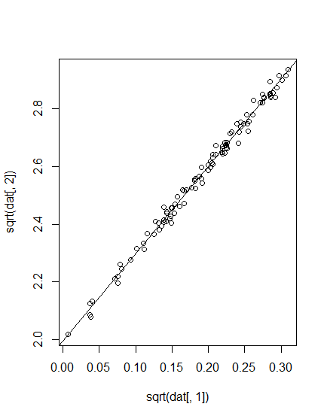

# c)

summary(lm.1)$r.squared

# 99.225% of the variability in the transformed y is

# explained by the transformed x

summary(lm.1)$sigma

# The typical error in the prediction of the transformed

# y is 0.01911

# d)

# NO R, BY HAND

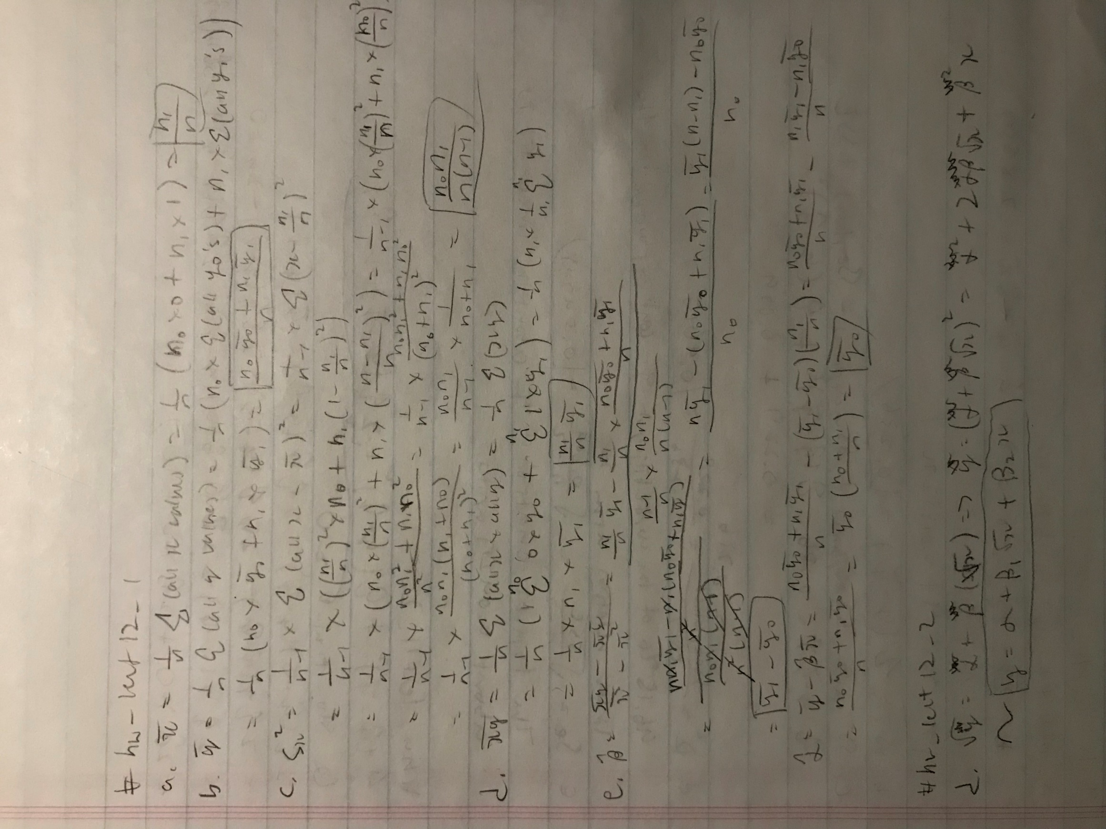

# e)

xx = dat[,1]

yy = dat[,2]

#plot(xx+sqrt(xx),yy)

lm.2 <- lm(yy ~ xx + I(sqrt(xx)))

# makes the predictions using model then connect

# those points with lines

#lines(xx+sqrt(xx),predict(lm.2))

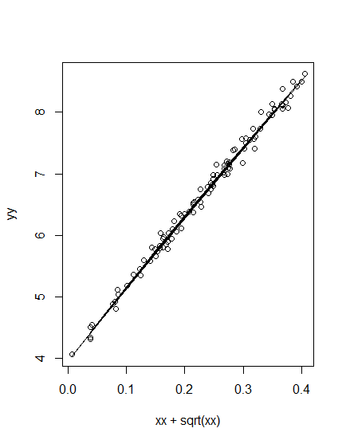

# f)

par(mfrow = c(1,2))

plot(sqrt(xx),predict(lm.1))

plot(xx+sqrt(xx),predict(lm.2))

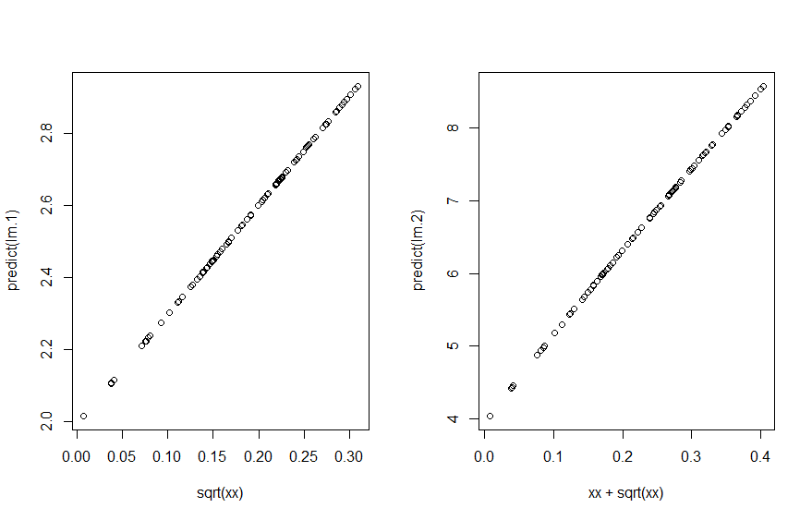

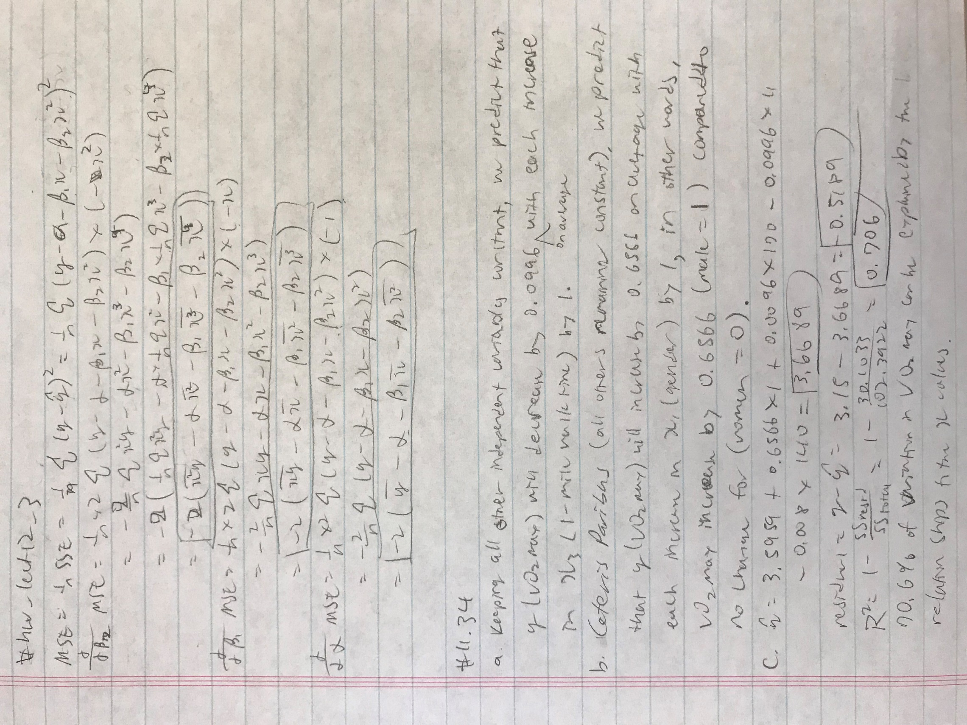

**d.**