**BANK ( PLEASE NOTE THE DATES ARE UNFORTUNATELY HARD CODED )**  
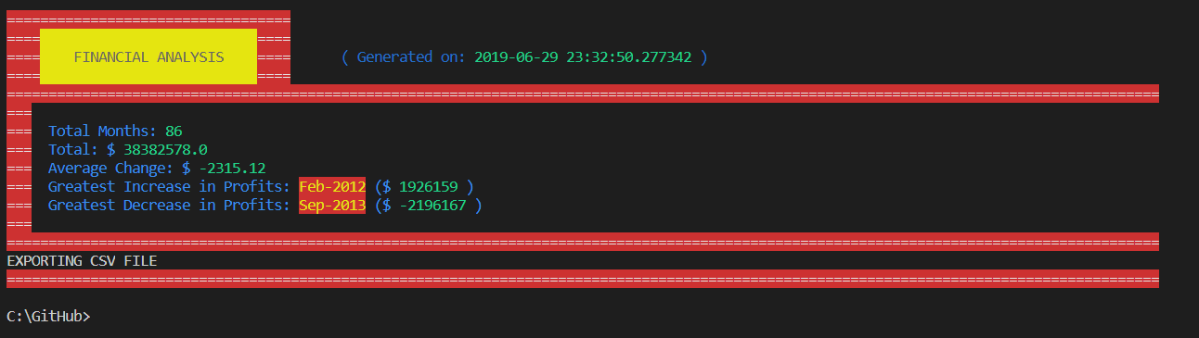 **POLL**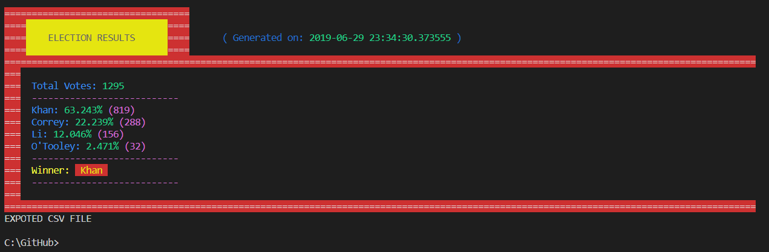

**Financial File Analysis Exported CSV file with code generated timestamp: financial_analysis-2019-6-29.csv  
  
  
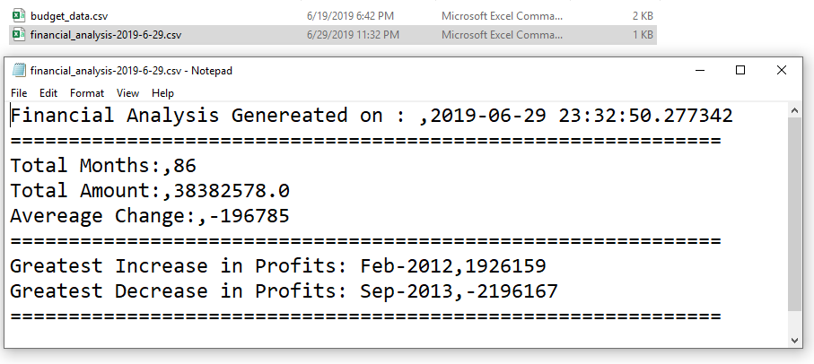  
  
Voting Results Exported CSV file with code generated timestamp: election_results-2019-6-29.csv  
  
