**WeatherPy Notes:**  
  
needed to install citipy, using run ananconda as administrator to do a pip install citipy which also required an install of msgpack  
  
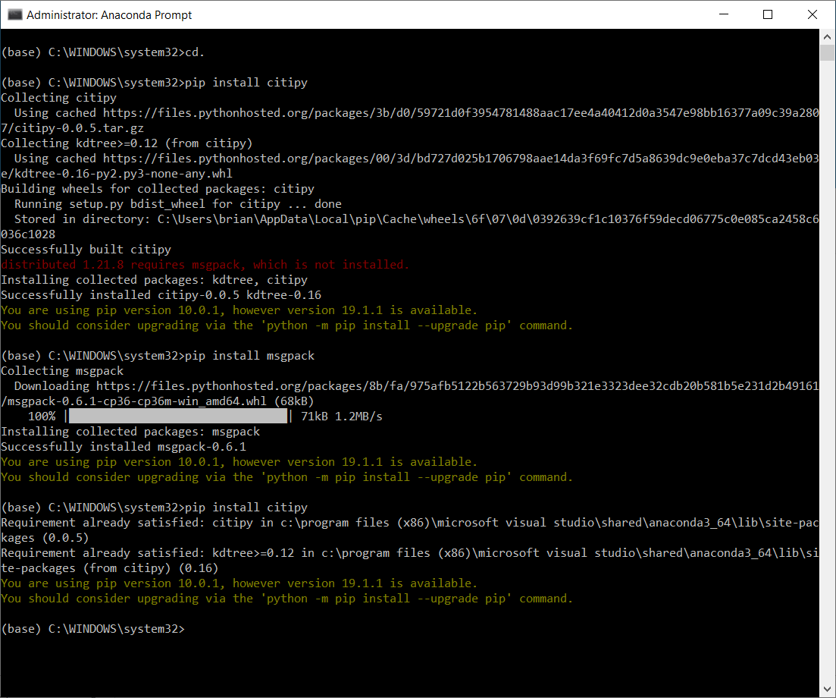  
  
pip installed openweathermapy

