Anthony Ha

Brian Lam

Jeffrey Lee Ye

Project Aqua

***Persuasive Goal***

The persuasive goal of our game is to inform people about the importance of the knowledge of water conservation. Sometimes, maybe unexpectedly, the player may not have enough water to simply be careless for. The player must live from day to day using water for various factors, such as drinking it, watering the lawn, and improving hygiene. However, limited water will start to hinder the excess amount of water a player can use from day to day. Water leaks will also happen throughout the game, informing the player of possible lost of water. The mood meters will help determine the player’s state of health, whether they still need to drink water or improve their hygiene, and the player must use their water wisely to raise these the right amount. This will help the player know that they shouldn’t use too much water for one thing or too less for another.

***Screenshots***

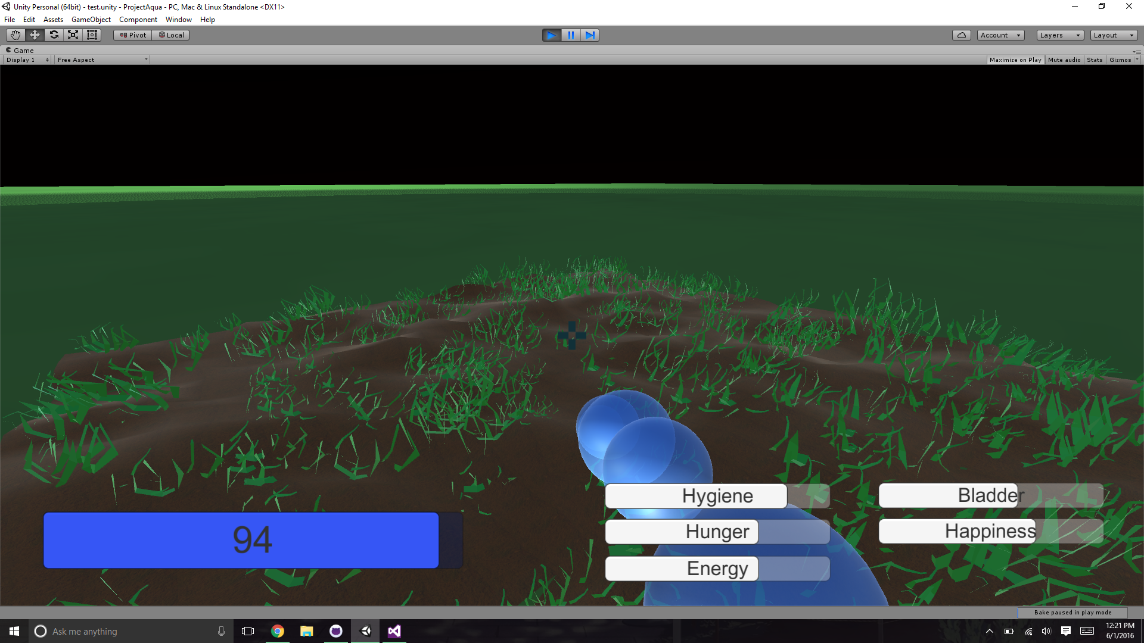

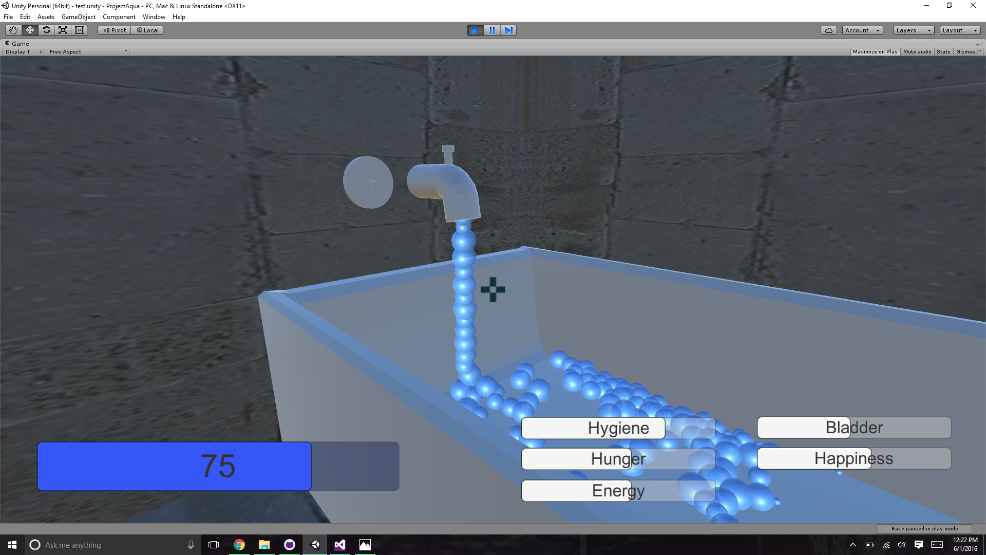***Assets not made by the team***

* First person mode, gotten from Unity Asset Store
* Wall Textures: Unity Asset Store, by [A dog's life software](https://www.assetstore.unity3d.com/en/#!/search/page=1/sortby=popularity/query=publisher:1894)
* Bed Texture :<http://fantasystock.deviantart.com/art/Red-Silk-Fabric-Texture-3-76856694>
* Pillow Texture: <http://www.photos-public-domain.com/2014/03/24/red-striped-fabric-texture/>
* Wood Texture: <http://bgfons.com/upload/wood_texture3848.jpg>
* Tree Wood Texture: <http://bgfons.com/upload/wood%20_texture546.jpg>
* HouseRoof Texture: <http://bgfons.com/upload/roof_tile_texture4132.jpg>
* Pipe Texture: <http://texturelib.com/Textures/grunge/leaking/grunge_leaking_0011_02_preview.jpg>
* Sound effects: <http://www.soundsnap.com/tags/splash> / <http://soundbible.com/tags-splash.html>