# FrontDesk Tobacco Screening Tool Result mapping to RPMS Tobacco Heath Factor

|  |  |  |  |  |  |  |  |
| --- | --- | --- | --- | --- | --- | --- | --- |
| Case # | **Does anyone in the home smoke tobacco (such as cigarettes, cigars, pipes, etc.)?** | **Do you use tobacco?** | Do you use tobacco for ceremony? | Do you smoke tobacco (such as cigarettes, cigars, pipes, etc.)? | Do you use smokeless tobacco? | Health Factor | Health Factor Code |
| 1 | Y | N | - | - | - | SMOKER IN HOME | F006 |
| 2 | N | N | - | - | - | SMOKE FREE HOME | F025 |
| 3 | N | Y | N | N | N | SMOKE FREE HOME | F025 |
| 4 | Y | Y | N | N | N | SMOKER IN HOME | F006 |
| 5 | N | Y | Y | N | N | CEREMONIAL USE ONLY | F035 |
| 6 | Y | Y | Y | N | N | CEREMONIAL USE ONLY AND SMOKER IN HOME | F035 |
| 7 | N | Y | N | Y | N | CURRENT SMOKER, STATUS UNKNOWN | F002 |
| 8 | Y | Y | N | Y | N | CURRENT SMOKER, STATUS UNKNOWN | F002 |
| 9 | N | Y | N | N | Y | CURRENT SMOKELESS | F003 |
| 10 | Y | Y | N | N | Y | CURRENT SMOKELESS AND SMOKER IN HOME | F003 |
| 11 | N | Y | Y | Y | N | CURRENT SMOKER, STATUS UNKNOWN | F002 |
| 12 | Y | Y | Y | Y | N | CURRENT SMOKER, STATUS UNKNOWN | F002 |
| 13 | N | Y | Y | N | Y | CURRENT SMOKELESS | F003 |
| 14 | Y | Y | Y | N | Y | CURRENT SMOKELESS AND SMOKER IN HOME | F003 |
| 15 | N | Y | N | Y | Y | CURRENT SMOKER & SMOKELESS | F030 |
| 16 | Y | Y | N | Y | Y | CURRENT SMOKER & SMOKELESS | F030 |
| 17 | N | Y | Y | Y | Y | CURRENT SMOKER & SMOKELESS | F030 |
| 18 | Y | Y | Y | Y | Y | CURRENT SMOKER & SMOKELESS | F030 |
| 19 | - | N | - | - | - | NON-TOBACCO USER | F001 |
| 20 | - | Y | N | N | N | NON-TOBACCO USER | F001 |
| 21 | Y | Any | Any | Any | Any | SMOKER IN HOME | F006 |
| 22 | Any | Any | Y | Any | Any | CEREMONIAL USE ONLY | F035 |
| 23 | Any | Any | Any | Y | Any | CURRENT SMOKER, STATUS UNKNOWN | F002 |
| 24 | Any | Any | Any | Any | Y | CURRENT SMOKELESS | F003 |

## Currently can be exported to RPMS

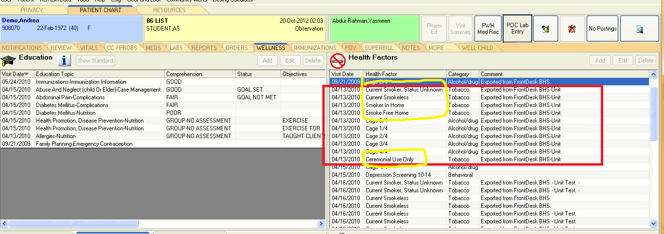

## TOBACCO Health Factor values supported by RPMS

|  |  |  |  |  |  |  |  |  |  |
| --- | --- | --- | --- | --- | --- | --- | --- | --- | --- |
| **ID** | **Category** | **CODE** | **DISPLAY ON HEALTH SUMMARY** | **ENTRY_TYPE** | **FACTOR** | **INACTIVE DATE** | **INACTIVE FLAG** | **MNEMONIC** | **SYNONYM** |
| 14 | TOBACCO | F030 |  | FACTOR | CURRENT SMOKER & SMOKELESS | 12/8/2011 | YES |  |  |
| 129 | TOBACCO | F068 |  | FACTOR | NEVER USED TOBACCO | 12/8/2011 | YES |  |  |
| 12 | TOBACCO (EXPOSURE) | F006 | YES | FACTOR | SMOKER IN HOME | (null) |  |  |  |
| 13 | TOBACCO (EXPOSURE) | F025 | YES | FACTOR | SMOKE FREE HOME | (null) |  | SFH |  |
| 39 | TOBACCO (EXPOSURE) | F031 |  | FACTOR | EXPOSURE TO ENVIRONMENTAL TOBACCO SMOKE | (null) |  | EETS |  |
| 3 | TOBACCO (SMOKELESS - CHEWING/DIP) | F003 |  | FACTOR | CURRENT SMOKELESS | (null) |  |  | SMOKELESS |
| 5 | TOBACCO (SMOKELESS - CHEWING/DIP) | F005 |  | FACTOR | PREVIOUS (FORMER) SMOKELESS | (null) |  |  | FORMER SMOKELESS |
| 16 | TOBACCO (SMOKELESS - CHEWING/DIP) | F023 |  | FACTOR | CESSATION-SMOKELESS | (null) |  |  |  |
| 142 | TOBACCO (SMOKELESS - CHEWING/DIP) | F107 |  | FACTOR | SMOKELESS TOBACCO, STATUS UNKNOWN | (null) |  |  |  |
| 143 | TOBACCO (SMOKELESS - CHEWING/DIP) | F106 |  | FACTOR | NEVER USED SMOKELESS TOBACCO | (null) |  |  |  |
| 1 | TOBACCO (SMOKING) | F001 |  | FACTOR | NON-TOBACCO USER | 3/22/2010 | YES | TNU | NON-SMOKER |
| 2 | TOBACCO (SMOKING) | F002 |  | FACTOR | CURRENT SMOKER, STATUS UNKNOWN | (null) |  | SMO | SMOKER |
| 4 | TOBACCO (SMOKING) | F004 |  | FACTOR | PREVIOUS (FORMER) SMOKER | (null) |  |  | FORMER SMOKER |
| 17 | TOBACCO (SMOKING) | F024 |  | FACTOR | CESSATION-SMOKER | (null) |  |  |  |
| 69 | TOBACCO (SMOKING) | F035 |  | FACTOR | CEREMONIAL USE ONLY | (null) |  |  |  |
| 138 | TOBACCO (SMOKING) | F108 |  | FACTOR | CURRENT SMOKER, EVERY DAY | (null) |  |  |  |
| 139 | TOBACCO (SMOKING) | F109 |  | FACTOR | CURRENT SMOKER, SOME DAY | (null) |  |  |  |
| 140 | TOBACCO (SMOKING) | F110 |  | FACTOR | NEVER SMOKED | (null) |  |  |  |
| 141 | TOBACCO (SMOKING) | F111 |  | FACTOR | SMOKING STATUS UNKNOWN | (null) |  |  |  |