I designed a webpage where you can advertise a car you want to sell and remove it using your reference code. If you are looking to purchase a car you can search all cars and view the information of each individual car.

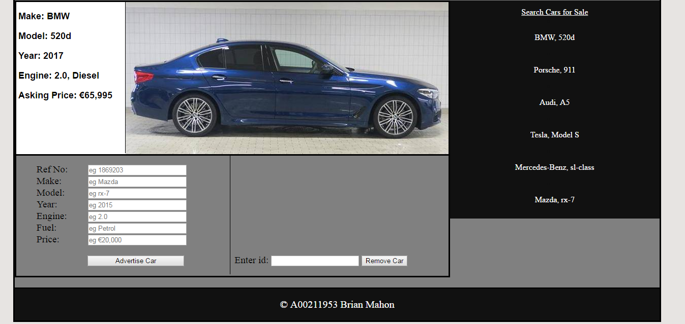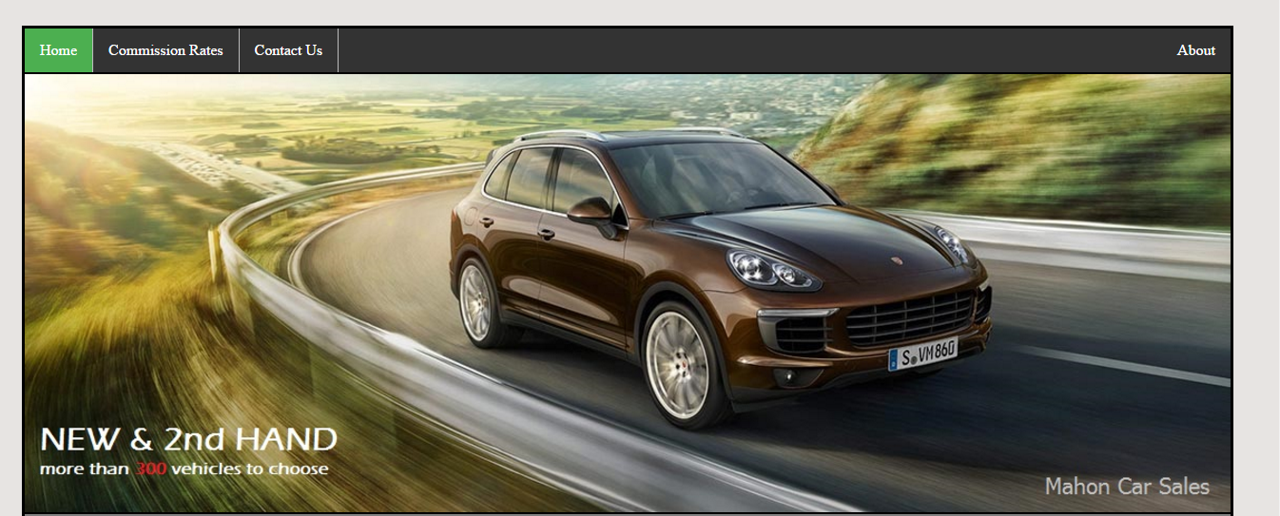

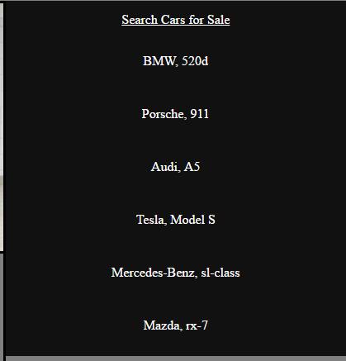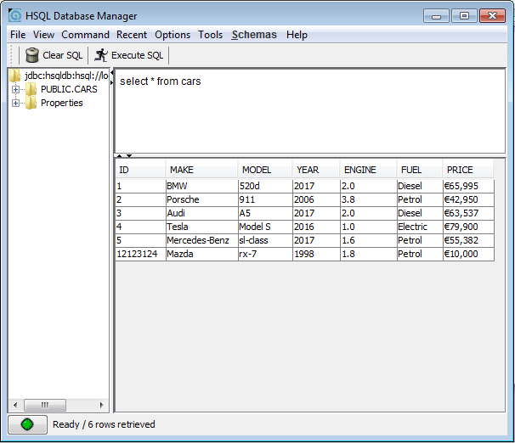When you add an entry to the database it is displayed in the list

The car selected is displayed as shown below

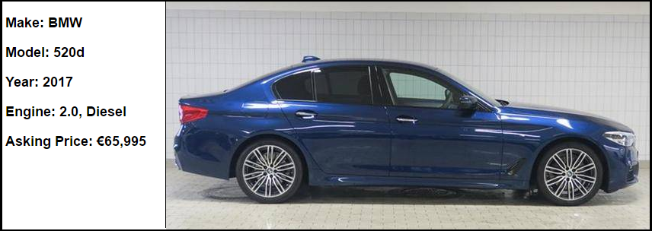

Because there is no JavaScript function to upload a picture the display of all new entries will look similar to this.

