I developed a player database, the player information is sent to the server and the database. New entries can be added to the database using a POST method. The information can then be retrieved using a Get method, parsed and displayed in a text field.

My application consist of two interfaces, the first one as seen below is used for CRUD actions on clicking the insert button the input is sent to both the database and the server using a POST method, the update button updates an entry in the database and uses a PUT method to update an entry on the server. The clear button clears the text fields and the delete button removes an entry from both the server and the database.

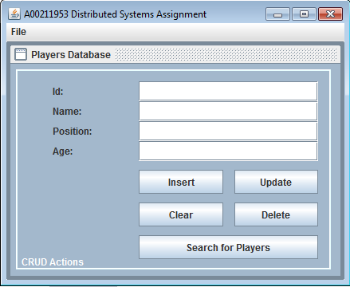

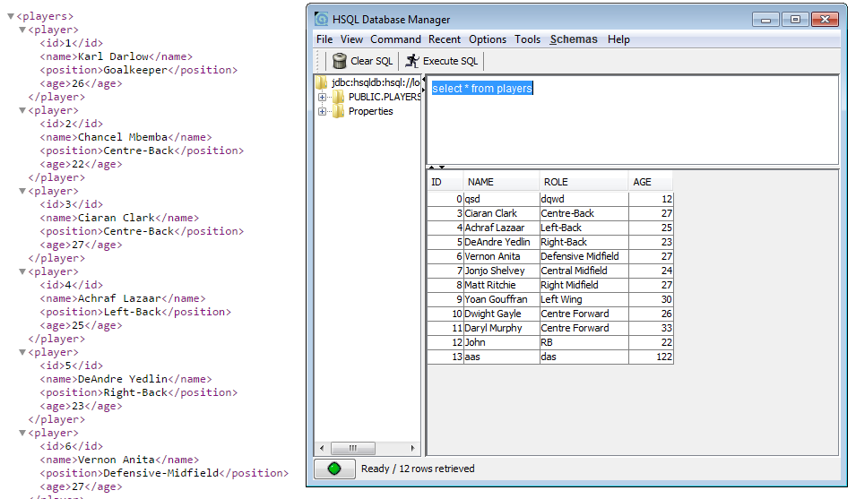

When the Search for Players button is pressed it opens the search interface this is where the user can search for a player by id or display all players in the database. The information is parsed and displayed in the text field for the user.

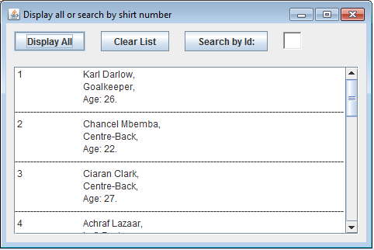

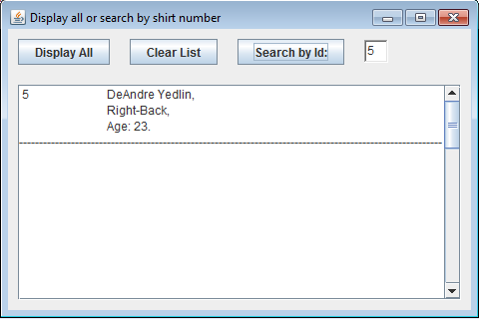

SQL used to display tables

CREATE TABLE players (id INTEGER IDENTITY,Name VARCHAR(15) NOT NULL,Role VARCHAR(20) NOT NULL,Age INTEGER NOT NULL,);

INSERT INTO players VALUES ( null, 'Karl Darlow','Goalkeeper', '26');

INSERT INTO players VALUES ( null, 'Chancel Mbemba', 'Centre-Back', '22');

INSERT INTO players VALUES ( null, 'Ciaran Clark', 'Centre-Back', '27');

INSERT INTO players VALUES ( null, 'Achraf Lazaar','Left-Back', '25');

INSERT INTO players VALUES ( null, 'DeAndre Yedlin','Right-Back', '23');

INSERT INTO players VALUES ( null, 'Vernon Anita', 'Defensive Midfield', '27');

INSERT INTO players VALUES ( null, 'Jonjo Shelvey', 'Central Midfield','24');

INSERT INTO players VALUES ( null, 'Matt Ritchie','Right Midfield','27');

INSERT INTO players VALUES ( null, 'Yoan Gouffran', 'Left Wing', '30');

INSERT INTO players VALUES ( null, 'Dwight Gayle','Centre Forward','26');

INSERT INTO players VALUES ( null, 'Daryl Murphy', 'Centre Forward', '33');

select \* from players;