Teachers Salary analysis Project Summary

Problem definition
Teachers in UK do a very good job despite the many challenges they face. Its only kind and human to reward them more for the “kind of harsh” conditions the face by the hands of the students and some poor school management. The Student success academically is a teachers major priority. Just as they make it their priority to make students succeed, The UK Department for Education should also make it a priority to ensure that our teachers are well cared for and healthy both Mentally and physically, Therefor use our solution to better Motivate ( in this case using salary ) our teachers.

Proof The Problem Exists Using Our Model
This Project is divided into 3 main Parts. That is :
- Data Preparation
- Explanatory Data Analysis
- Model Selection

Data Preparation
In this section all the data necessary data are imported for our analysis. We import two data sets ( ‘england_school_information.csv’ and ‘england_swf.csv’). I use the ‘england_swf.csv’ and populate it with some data from ‘england_school_information.csv’ to increase its diversity. The following columns are populated: MINORGROUP, SCHOOLTYPE, SCHNAME, GENDER and LANAME. Unecessary columns are dropped and all missing values dropped.

Explanatory Data Analysis
After All the data is cleaned, Different factors affecting teachers’ average salary are analyzed. The following relationships are analyzed; Mean Gross FTE Salary of All Teachers (£s) vs 'LANAME', 'School Phase', 'MINORGROUP', 'SCHOOLTYPE' and 'GENDER' . The results were as follows:
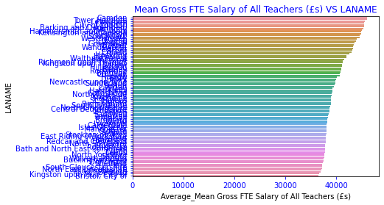
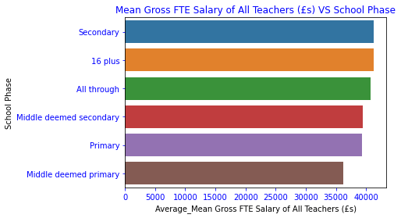

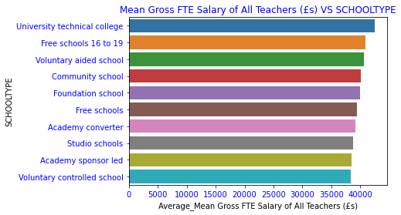

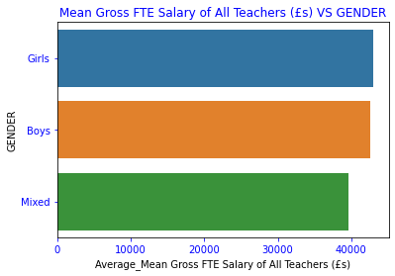

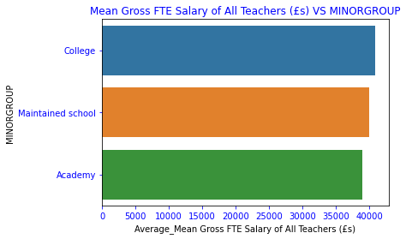

Linear relationships were also analyzed in this section.

Model Preparation
With the insight learned from data analysis, the data is prepared prior its fed into the model. Here all highly correlated features are removed leaving only the distinct ones. All the data in string form are encoded to integers. Label Encoding is used other than One-Hot-encoding ( It produced better results ).

Model Selection
With all the data in a Machine learn able format. Since the problem is a regression, I tested both Linear Regression and decision tree regression. The linear regression model performed better. I therefor picked it to analyze feature importance. The following were the results the model produced.
- Correlation feature importance

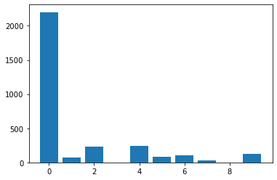

- Mutual Relationship feature importance

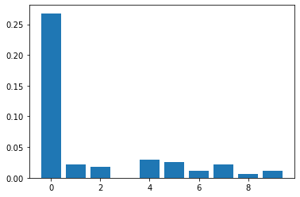

Model Application
This model achieved the following:
- It successfully predicted test data with a least mean absolute error of 2347.891 with 10 best features picked
- Successfully picked the 10 best features Using both correlation and Mutual Relationship of the data.
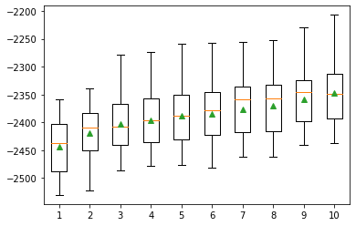
The model can therefor be used to predict salaries of teachers using the factors above and also determine if extra features introduced into the model have enough influence in determining the teachers salary. When implemented by The UK Ministry of Education, all Teachers Employed will receive well deserved salaries, therefor improving their mental and physical health in the long run.

