

Practices for Secure Software Report

Table of Contents
Practices for Secure Software Report 1
Document Revision History 3
Client 3
1. Algorithm Cipher 4
2. Certificate Generation 4
3. Deploy Cipher 5
4. Secure Communications 5
5. Secondary Testing 6
6. Functional Testing 6
7. Summary 7
8. Industry Standard Best Practices 8

Document Revision History

Version | Date | Author | Comments
1.0 | October 14, 2026 | Brian Minor | Completed project security report and evidence references

Client



Developer
Brian Minor

Algorithm Cipher

For Artemis Financial, I recommend AES-256-GCM for protecting sensitive financial data when encryption is needed. AES is a symmetric block cipher with a 128-bit block size; the 256-bit option uses a 256-bit secret key. GCM is an authenticated encryption mode, meaning it can protect confidentiality and detect unauthorized changes. A fresh, unpredictable 96-bit nonce is normally used for each encryption operation with the same key; nonce reuse with GCM can seriously weaken security. Keys should be generated using a cryptographically secure random-number generator and stored in a managed key store, not written directly into source code. AES is standardized by NIST and remains widely used. Older algorithms such as DES are no longer appropriate for protecting modern financial information.
For the application's web connection, HTTPS uses TLS to negotiate secure communication. The local project uses a 3072-bit RSA self-signed certificate signed with SHA256withRSA. RSA is an asymmetric algorithm involving a public and private key; the certificate supplies the public-key identity information, while the private key stays in the PKCS12 keystore. Modern TLS commonly uses asymmetric key agreement to establish session secrets and symmetric encryption to protect traffic. TLS configuration determines the negotiated algorithms; the certificate's RSA key is not the same thing as the data-encryption cipher.
For the checksum requirement, I implemented SHA-256 using Java MessageDigest. SHA-256 is a hash function, not a reversible encryption cipher: it produces a 256-bit (32-byte) digest, shown as 64 hexadecimal characters. It does not use an encryption key. The fixed input is encoded in UTF-8 before hashing. A checksum can help detect changes when compared against a trusted expected value, but simply showing a hash beside the data does not by itself authenticate the data. AES-GCM is a recommendation for future sensitive-data encryption; it was not added to this project code.

Certificate Generation
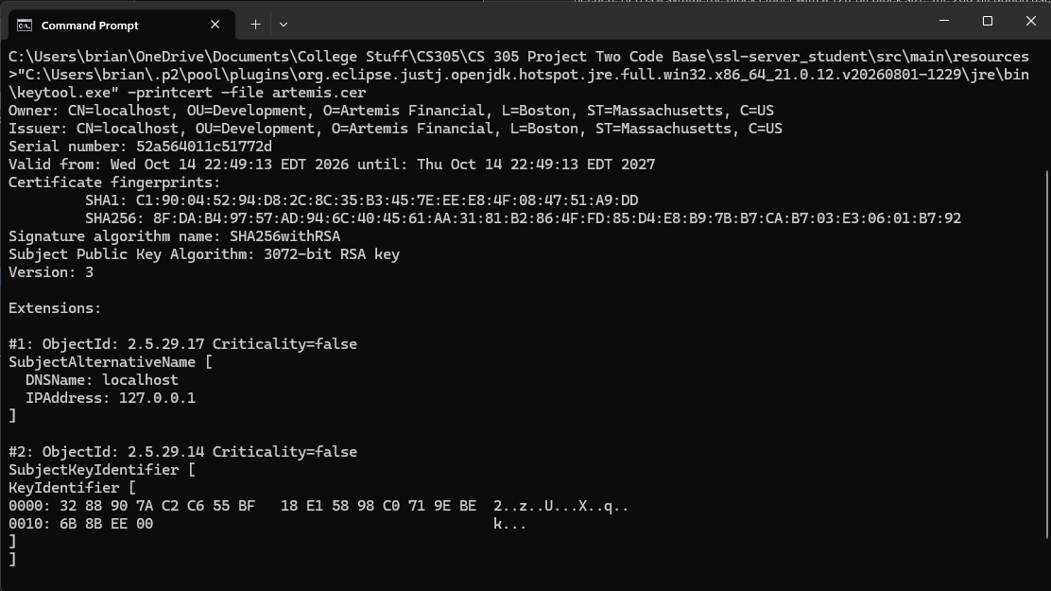

Deploy Cipher

Secure Communications

Secondary Testing
I compared the original Maven configuration with the refactored pom.xml to determine whether my changes introduced any additional application dependencies. The Spring Boot version and existing application dependencies remained unchanged. The only plugin change was updating OWASP Dependency-Check from version 5.3.0 to 12.1.0. My SHA-256 implementation uses Java's built-in MessageDigest class, so no additional hashing library was needed. Based on this comparison, I did not introduce any new third-party application dependencies. The vulnerability scan still identified issues in the older libraries included with the original project, which would need to be updated and tested before production deployment.

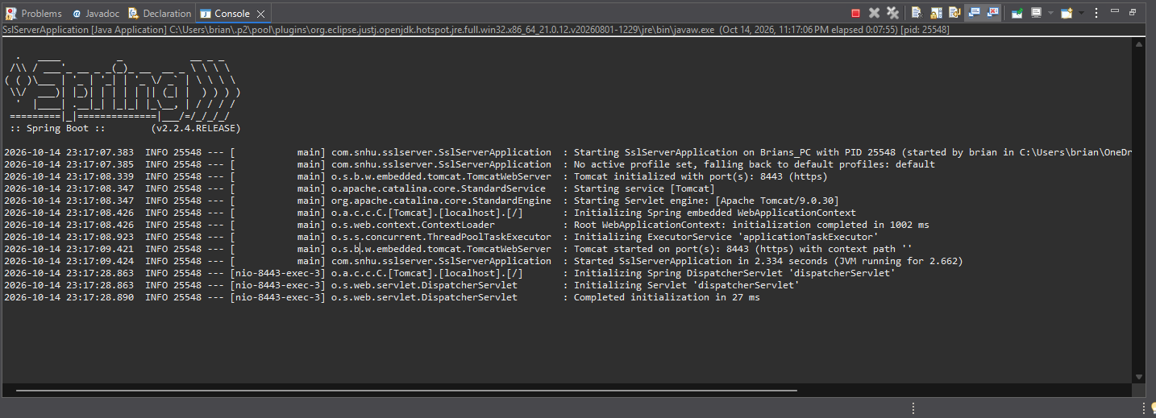

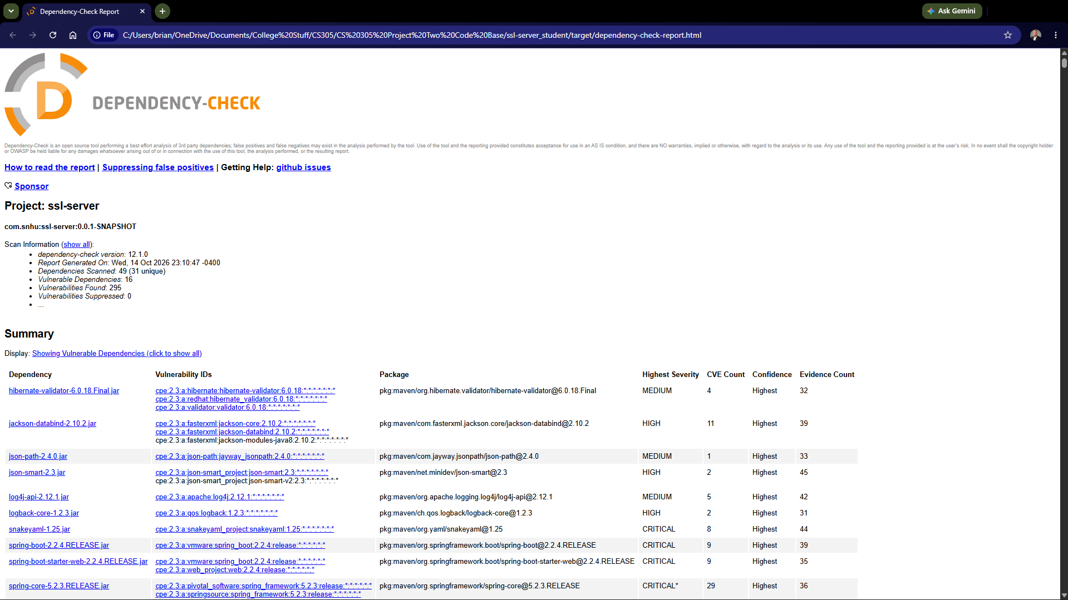

Functional Testing

Manual code review: imports and Spring annotations are appropriate; the /hash route is mapped using @GetMapping; the fixed string is converted to UTF-8 bytes; SHA-256 returns a 32-byte digest; each byte is formatted with %02x; and the response displays the original string and digest. The browser test confirms expected output. The earlier “port 8443 already in use” issue was caused by an older Java process (PID 12200), which was stopped before the successful restart (PID 25548). No user input is processed by this endpoint, so user-input validation is outside the current feature scope. The browser certificate warning and dependency vulnerabilities remain known security limitations.

Summary

I refactored the supplied Spring Boot application by adding a GET /hash endpoint, using Java's SHA-256 MessageDigest on a fixed UTF-8 string containing my name, and formatting the digest as hexadecimal text. I generated a local RSA 3072-bit self-signed certificate with Java Keytool, exported the public certificate as artemis.cer, and configured the PKCS12 keystore in application.properties. The application then started on HTTPS port 8443, and I verified the checksum response at https://localhost:8443/hash.
The changes address the vulnerability-assessment process areas of cryptography, secure communications, code review, and dependency testing. I first added a checksum for integrity checking, then enabled encrypted transport with HTTPS, reviewed the code manually, and ran a second dependency scan. The successful application startup and browser response demonstrate the implemented features work in this local test.
OWASP Dependency-Check 12.1.0 scanned 49 dependency entries (31 unique), flagged 16 vulnerable dependencies, and reported 295 vulnerability findings with none suppressed. Reported packages include older Spring Boot, Spring Framework, Jackson, SnakeYAML, and Tomcat components. These are important outstanding risks; the successful Maven scan is not evidence that the application has no vulnerabilities. I did not upgrade the framework as part of the checksum and HTTPS refactor, so remediation and retesting would be necessary before a production release. A comparison with an original baseline scan would be required to prove conclusively that no new dependency vulnerabilities were introduced.

Industry Standard Best Practices

I used Java's standard MessageDigest API rather than adding a separate hashing library, explicitly selected SHA-256, encoded the input with UTF-8, and converted the digest bytes consistently to hexadecimal. I used a self-signed certificate with localhost in its subject alternative name and configured HTTPS instead of leaving the endpoint on HTTP. I also checked the program's behavior in Eclipse and in a browser and ran OWASP Dependency-Check to identify known vulnerable dependencies.
For a production financial application, I would replace the self-signed certificate with one issued by a trusted certificate authority, protect the keystore password with a secret manager or environment configuration, restrict access to private keys, enforce supported TLS versions, and upgrade the outdated Spring dependencies. I would also add automated tests, repeat vulnerability scans in the build process, and review third-party advisories before releases. These practices help reduce the risk of exposing customer financial data, avoid preventable downtime, and maintain customer trust. The current application is a classroom demonstration, not a production-ready financial service.

Refactored code files for ZIP submission: src/main/java/com/snhu/sslserver/SslServerApplication.java; src/main/resources/application.properties; src/main/resources/keystore.p12; src/main/resources/artemis.cer; pom.xml; Maven project support files. Do not publish the private-key keystore or its password in a public repository. The classroom ZIP may contain it only if specifically required for grading, and the demo password should never be reused.

