First_Analysis_R.R

User

2021-11-19

InsectSprays

## count spray  
## 1 10 A  
## 2 7 A  
## 3 20 A  
## 4 14 A  
## 5 14 A  
## 6 12 A  
## 7 10 A  
## 8 23 A  
## 9 17 A  
## 10 20 A  
## 11 14 A  
## 12 13 A  
## 13 11 B  
## 14 17 B  
## 15 21 B  
## 16 11 B  
## 17 16 B  
## 18 14 B  
## 19 17 B  
## 20 17 B  
## 21 19 B  
## 22 21 B  
## 23 7 B  
## 24 13 B  
## 25 0 C  
## 26 1 C  
## 27 7 C  
## 28 2 C  
## 29 3 C  
## 30 1 C  
## 31 2 C  
## 32 1 C  
## 33 3 C  
## 34 0 C  
## 35 1 C  
## 36 4 C  
## 37 3 D  
## 38 5 D  
## 39 12 D  
## 40 6 D  
## 41 4 D  
## 42 3 D  
## 43 5 D  
## 44 5 D  
## 45 5 D  
## 46 5 D  
## 47 2 D  
## 48 4 D  
## 49 3 E  
## 50 5 E  
## 51 3 E  
## 52 5 E  
## 53 3 E  
## 54 6 E  
## 55 1 E  
## 56 1 E  
## 57 3 E  
## 58 2 E  
## 59 6 E  
## 60 4 E  
## 61 11 F  
## 62 9 F  
## 63 15 F  
## 64 22 F  
## 65 15 F  
## 66 16 F  
## 67 13 F  
## 68 10 F  
## 69 26 F  
## 70 26 F  
## 71 24 F  
## 72 13 F

with(InsectSprays, as.factor(spray))

## [1] A A A A A A A A A A A A B B B B B B B B B B B B C C C C C C C C C C C C D D  
## [39] D D D D D D D D D D E E E E E E E E E E E E F F F F F F F F F F F F  
## Levels: A B C D E F

par(mfcol=c(1,3))  
  
library(lattice)  
  
with(InsectSprays, densityplot(count))

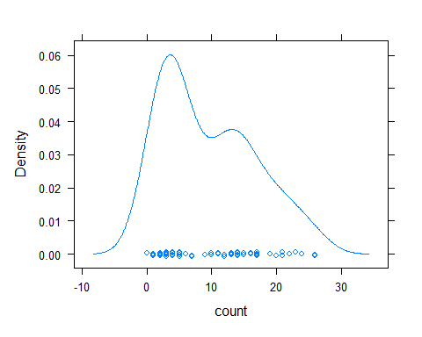

with(InsectSprays, hist(count, breaks=10, lwd=2,col=rainbow(10), main=("Histogram of Count Against Spray")))  
  
boxplot(count~spray, col=rainbow(7),data=InsectSprays, main="Boxplot of Insect Count by Spraytype")  
  
summary(InsectSprays)

## count spray   
## Min. : 0.00 A:12   
## 1st Qu.: 3.00 B:12   
## Median : 7.00 C:12   
## Mean : 9.50 D:12   
## 3rd Qu.:14.25 E:12   
## Max. :26.00 F:12

model1<-with(InsectSprays, lm(count~spray))  
  
with(InsectSprays, model1)

##   
## Call:  
## lm(formula = count ~ spray)  
##   
## Coefficients:  
## (Intercept) sprayB sprayC sprayD sprayE sprayF   
## 14.5000 0.8333 -12.4167 -9.5833 -11.0000 2.1667

summary(model1)

##   
## Call:  
## lm(formula = count ~ spray)  
##   
## Residuals:  
## Min 1Q Median 3Q Max   
## -8.333 -1.958 -0.500 1.667 9.333   
##   
## Coefficients:  
## Estimate Std. Error t value Pr(>|t|)   
## (Intercept) 14.5000 1.1322 12.807 < 2e-16 ***  
## sprayB 0.8333 1.6011 0.520 0.604   
## sprayC -12.4167 1.6011 -7.755 7.27e-11 ***  
## sprayD -9.5833 1.6011 -5.985 9.82e-08 ***  
## sprayE -11.0000 1.6011 -6.870 2.75e-09 ***  
## sprayF 2.1667 1.6011 1.353 0.181   
## ---  
## Signif. codes: 0 '***' 0.001 '**' 0.01 '*' 0.05 '.' 0.1 ' ' 1  
##   
## Residual standard error: 3.922 on 66 degrees of freedom  
## Multiple R-squared: 0.7244, Adjusted R-squared: 0.7036   
## F-statistic: 34.7 on 5 and 66 DF, p-value: < 2.2e-16

anva<-aov(sqrt(count)~spray, data=InsectSprays)  
anva

## Call:  
## aov(formula = sqrt(count) ~ spray, data = InsectSprays)  
##   
## Terms:  
## spray Residuals  
## Sum of Squares 88.43787 26.05798  
## Deg. of Freedom 5 66  
##   
## Residual standard error: 0.6283453  
## Estimated effects may be unbalanced

summary(anva)

## Df Sum Sq Mean Sq F value Pr(>F)   
## spray 5 88.44 17.688 44.8 <2e-16 ***  
## Residuals 66 26.06 0.395   
## ---  
## Signif. codes: 0 '***' 0.001 '**' 0.01 '*' 0.05 '.' 0.1 ' ' 1

plot(anva)

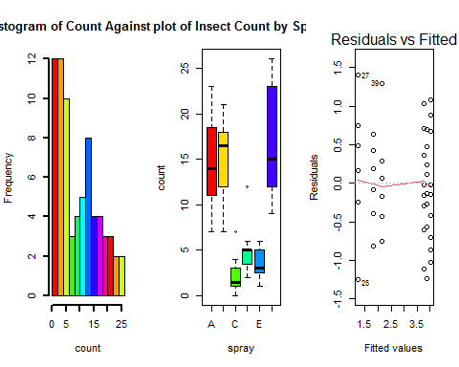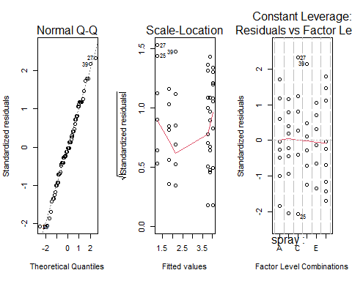

termplot(anva)

