Second_Analysis_R.R

User

2021-11-19

#Loading Age and Weight Data into R's Working Memory  
  
alpha<-read.table("C:\\Users\\User\\Desktop\\One.csv", header=TRUE, sep=(","), strip.white =TRUE)  
  
alpha

## AGE WEIGHT  
## 1 19 80  
## 2 55 344  
## 3 81 416  
## 4 115 348  
## 5 104 166  
## 6 100 220  
## 7 56 262  
## 8 51 360  
## 9 57 204  
## 10 53 144  
## 11 68 332  
## 12 8 34  
## 13 44 140  
## 14 32 180  
## 15 20 105  
## 16 32 166  
## 17 45 204  
## 18 9 26  
## 19 21 120  
## 20 177 436  
## 21 57 125  
## 22 81 132  
## 23 21 90  
## 24 9 40  
## 25 45 220  
## 26 9 46  
## 27 33 154  
## 28 57 116  
## 29 45 182  
## 30 21 150  
## 31 10 65  
## 32 82 356  
## 33 70 316  
## 34 10 94  
## 35 10 86  
## 36 34 150  
## 37 34 270  
## 38 34 202  
## 39 58 202  
## 40 58 365  
## 41 11 79  
## 42 23 148  
## 43 70 446  
## 44 11 62  
## 45 83 236  
## 46 35 212  
## 47 16 60  
## 48 16 64  
## 49 17 114  
## 50 17 76  
## 51 17 48  
## 52 8 29  
## 53 83 514  
## 54 18 140

#Seeking Descriptive and Graphical Statistics of the Data frame Alpha  
  
summary(alpha)

## AGE WEIGHT   
## Min. : 8.00 Min. : 26.0   
## 1st Qu.: 17.00 1st Qu.: 87.0   
## Median : 34.00 Median :150.0   
## Mean : 43.52 Mean :182.9   
## 3rd Qu.: 57.75 3rd Qu.:232.0   
## Max. :177.00 Max. :514.0

attributes(alpha)

## $names  
## [1] "AGE" "WEIGHT"  
##   
## $class  
## [1] "data.frame"  
##   
## $row.names  
## [1] 1 2 3 4 5 6 7 8 9 10 11 12 13 14 15 16 17 18 19 20 21 22 23 24 25  
## [26] 26 27 28 29 30 31 32 33 34 35 36 37 38 39 40 41 42 43 44 45 46 47 48 49 50  
## [51] 51 52 53 54

#Drawing up the Scatter plot of Weight against Age   
  
library(lattice)  
  
xyplot(WEIGHT~AGE, data=alpha, col="blue", main="Scatterplot of Weight against Age",auto.key =(list(x=0.5, y=0.5)))

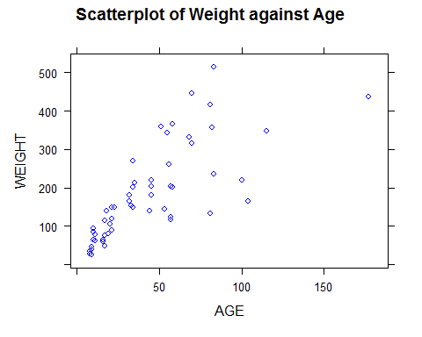

#Drawing up the Histograms of Weight and Age Side by Side for Comparison Purposes  
  
par(mfrow=c(1,2))  
  
with(alpha, hist(WEIGHT, breaks=21, col=rainbow(7), main="A Histogram Suggestive of WEIGHT's Distribution"))  
  
with(alpha, hist(AGE, breaks=21, col=rainbow(7), main="A Histogram Suggestive of AGE's Distribution"))

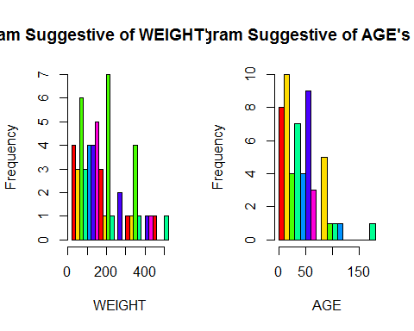

#Drawing up the Densityplots of Weight and Age Side by Side for Comparison Purposes  
  
par(mfrow=c(1,2))  
  
with(alpha, densityplot(WEIGHT, col=rainbow(7), lwd=2, main="A Densityplot of Weight"))

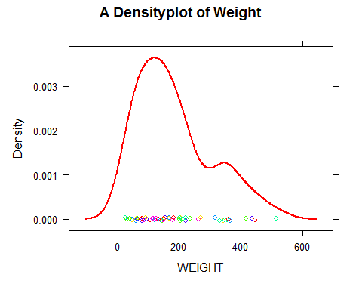

with(alpha, densityplot(AGE, col=rainbow(7), lwd=2, main="A Densityplot of Weight"))

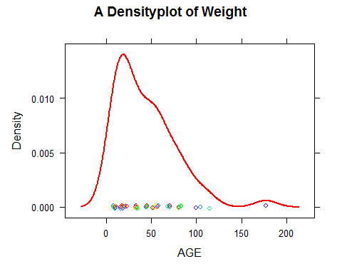

#Drawing up the Boxplots of Weight and Age Side by Side for Comparison Purposes  
  
par(mfrow=c(1,2))  
  
with(alpha, boxplot(WEIGHT, col="blue", main="A Boxplot of Weight"))  
  
with(alpha, boxplot(AGE, col="red", main="A Boxplot of Age"))

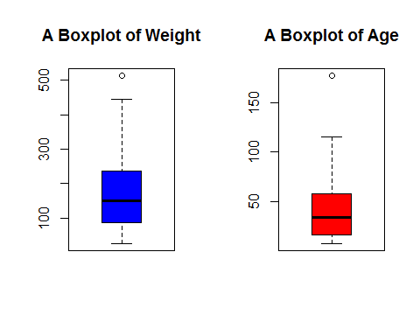

#linear Modelling Weight Against Age  
  
mod1<-lm(WEIGHT~AGE, data=alpha)  
  
mod1

##   
## Call:  
## lm(formula = WEIGHT ~ AGE, data = alpha)  
##   
## Coefficients:  
## (Intercept) AGE   
## 65.150 2.705

#Obtaining Information from the Above Linear Model  
  
summary(mod1)

##   
## Call:  
## lm(formula = WEIGHT ~ AGE, data = alpha)  
##   
## Residuals:  
## Min 1Q Median 3Q Max   
## -180.52 -47.44 -10.70 31.90 224.29   
##   
## Coefficients:  
## Estimate Std. Error t value Pr(>|t|)   
## (Intercept) 65.1504 18.2075 3.578 0.000759 ***  
## AGE 2.7055 0.3319 8.152 7.33e-11 ***  
## ---  
## Signif. codes: 0 '***' 0.001 '**' 0.01 '*' 0.05 '.' 0.1 ' ' 1  
##   
## Residual standard error: 81.47 on 52 degrees of freedom  
## Multiple R-squared: 0.561, Adjusted R-squared: 0.5526   
## F-statistic: 66.46 on 1 and 52 DF, p-value: 7.325e-11

#Results from the above model indicate a slight positive correlation between a person's weight and his/her age  
  
#The Adjusted R=squared suggests a correlation coefficient of 0.561. This figure implies that 56.1% of changes in weight is explained by changes in a person's age  
  
#Thus, the resulting predictive model is: WEIGHT= 65.1504 +2.7055*AGE