Special Academe Services

|  |  |
| --- | --- |
| Thandokuhle Brian Msane | 202203673 |
| Neliswa Maziya |  |
| Thandolwethu Agnes Nhlabatsi | 202203998 |

# Table of Content

1. Part One
   1. Introduction
   2. Problem Identification or Statement
   3. Project objective summary
2. Part Two
   1. The change we seek to solve
   2. The need or niche we want to address
   3. The solution we aim to obtain
   4. The stakeholders
   5. The value for our stakeholders
   6. The context that may affect and influence the project
   7. Project assumptions
3. Part Three
   1. Requirement gathering techniques
   2. Sample interview questions
   3. Sample questionnaire
   4. Functional and Non-Functional Requirements
4. Part Four
   1. Context Diagram
   2. Level 1 data flow diagram
   3. Level 2 data flow diagram
   4. Data dictionary
5. Part Five
   1. Source code submission
   2. Introduction

Often times when a student finishes writing the Form Five external examination they tend to focus or even project themselves as university students. Unfortunately, between this fantasy and the reality lies a hurdle which is the application process. This process has so many problems which are: unawareness of application dates, misinformation about programs they want to pursue and lots of money spent, to name a few. This information gap can lead to uninformed decisions, impacting their future careers and overall satisfaction during the course of their study. The need for a centralized system to assist students in making well-informed decisions is apparent.

* 1. Problem Identification

High school graduates encounter several critical issues during the university application process and those include the following.

1. Limited understanding of available programs: Students often select programs based on advice from others, media influence, or long-held aspiration without fully understanding the program content, admission requirements, or career prospects. This can result in dissatisfaction and hinders career progression. More often, students end up dropping out because they are required to do things they are not passionate about.
2. Costly application procedures: The traditional application process requires students to physically visit multiple universities and colleges to gather information and submit applications. This method is time-consuming, expensive, and inefficient, especially for those with limited financial resources. Also, the universities need more human labor to handle this process and that is ultimately costlier.
3. Unawareness of application timeline and costs: Many students are not informed about opening and closing dates of applications, acceptance periods, and costs associated with the entire process in different institutions. Many miss opportunities due to these reasons.

These challenges not only necessitate a centralized system but also highlight a systematic problem affecting students’ successful transition into tertiary education. The lack of accessible, comprehensive information and streamlined processes necessitate a solution to support students during this critical phase of their lives.

* 1. Project Objective Summary

The proposed system aims to alleviate the mentioned issues by building a very informative, user-friendly, and integrated system. The primary objective is to provide comprehensive program information to applicants. Detailed descriptions, prerequisites, admission criteria, curriculum details and potential career paths associated with each program will be provided. Further, we aim to simplify the application process by creating centralized, one-size-fits-all online platform which allows students to apply from the comfort of their homes to reduce physical visits and travelling costs. Lastly, to mention a few of our objectives, we aim to provide the awareness of application timelines and costs associated with applying.

# Part Two

1. The change we seek to solve

This project aims to address the inefficiencies and challenges associated with manual admission processes into tertiary institutions in Eswatini. The current system involves multiple applications, redundant paper work, delays in processing and lack of transparency which can result in abandoned admissions and missed opportunities for students. The project seeks to automate the admissions process and create a centralized platform that simplifies applications for both students and institutions and is advantageous to all parties involved as elaborated below.

1. The need or niche we want to address

The key needs identified include:

* Streamlining of the admissions process: Simplifying and unifying the application procedures for all institutions of higher education in the country.
* Transparency and accessibility: Allowing applicants to access real-time information on their admission status.
* Reduction of redundant work: Eliminating multiple applications to different institutions and the associated administrative burdens.
* Efficient document verification: Automating the verification of results and documents, reducing the chances of fraud or inaccuracies.
* Broader access to educational opportunities: Providing candidates with more choices and better visibility of available programs and funding opportunities.

Eliminating the chances of students applying for programs which they do not qualify for unknowingly and this results to an obvious rejection by the university or college.

1. The solution we aim to obtain

The SAS system will create a single, unified platform that automates the entire admission process, allowing applicants to apply to multiple institutions through a common application. The solution will automate application processing making it easier for candidates to apply and institutions to manage applications. This will also help curb instances where applications get lost in the hands of the institutions when they have been manually submitted as hard copies by students. The system also aims to enhance data security through document certification, ensuring that results and personal information of candidates are legitimate. Furthermore, our goal is to empower candidates by giving them access to more options and the ability to confirm provisional admissions. Our solution will also provide decision-making data for institutions and government entities, helping in educational planning and research. Application statistics (e.g., number of applications per institution, program preferences, acceptance rates), enrolment trends (e.g., which programs and institutions are most popular) and candidate performance data (e.g., exam scores, academic backgrounds) are the types of data to be collected from applicants and institutions (just to name a few) by the SAS system

1. The stakeholders

Project stakeholders are individuals or organizations who are actively involved in the project, or whose interests may be positively or negatively affected as a result of project execution or successful project completion. The stakeholders involved in this project include:

* Tertiary Institutions: Universities, colleges and technical institutions who are responsible for managing admissions.
* Applicants: Students applying for admission to undergraduate programs.
* Government bodies: Agencies seeing education in Eswatini, responsible for policy formulation and data collection.
* Sponsors and funders: Private organizations or individuals looking to sponsor students based on specific criteria.
* SAS development team: The team responsible for designing, implementing and maintaining the system.

1. The value for our stakeholders

The value the project will bring to the stakeholders:

* For applicants: A simplified and transparent admission process, reducing the need for multiple applications submitted to each and every institution in the country that one wishes to apply to and providing access to real-time status updates and more educational opportunities.
* For tertiary institutions: Increased efficiency in processing applications, better quality data on candidates and the ability to manage admissions in batches or instantaneously.
* For sponsors and funders: Easier access to a centralized pool of candidates with various criteria for selection, such as exam scores.
* For government bodies: Reliable data for educational planning, research and decision-making to improve policies.

1. The context that may affect and influence the project

Moreover, the context that may affect and influence the project includes the technological infrastructure which defines the level of internet access and digital literacy among candidates, and institutions may affect the adoption and usage of the SAS system. Another one being regulatory requirements, which are government policies related to admissions, data privacy and education. Institutional autonomy is another context which may influence how the system is implemented, therefore, maintaining the autonomy of institutions is crucial although the system is centralized. Also, we dived into funding and resources. This basically stresses on the availability of resources to develop, deploy and maintain the SAS system that could affect timelines and scope.

1. Project assumptions

We then had to consider a few assumptions as well which we could base our project on. The first one being that candidates and institutions have adequate internet access and basic digital skills to engage with the online system. Secondly, we assumed that all institutions will adopt the SAS system, despite the centralization aspect while still maintaining their autonomy. Thirdly, government and educational authorities will support the project by enforcing its use and providing relevant data as they are to benefit from the system as well.

# Part Three

* 1. Requirement gathering techniques

One of the requirements gathering methods is an interview. An interview is a collection of information from individuals or groups by interviewing i.e. having to converse with them. In the interview one wants to get the opinions of the interviewee and his or her feelings about the current state of the system, organizational and personal goals, and informal procedures for interacting with information technologies. The interview is also a valuable time to explore key Human-Computer Interaction (HCI) concerns, including the ergonomic aspects, the system usability, how pleasing and enjoyable the system is and how useful it is in supporting individual tasks.

The two types of interviews:

* Structured interview: Has standard questions which the user needs to respond to in either close (objective) or open (descriptive) format.
* Unstructured interviews: This form of interview is conducted in a question-answer session to acquire basic information of the system.

Advantages of Interviews

* Useful to those who cannot communicate effectively in writing or may not have time complete questionnaires.
* Misunderstandings can be immediately addressed during the conversation.
* Provides a deeper understanding of the user’s perspective.

Drawbacks of Interviews

* Interviewer and interviewee bias may affect the responses, leading to inaccurate data.
* Barriers of communication may hinder effectiveness of interview

Questionnaires are a set of written questions for obtaining information from individuals and they can be used to build an SRS document. Nowadays, most questionnaires are distributed in electronic form, either via email or on the Web but we cannot ignore that fact that some still use the paper-based type.

Types of questionnaires:

* Open-Ended Questions: Respondents provide their answers in their own words and are useful for exploring detailed opinions and gaining qualitative insights.
* Closed-Ended Questions: Respondents choose from predefined answers and are efficient for quantitative data analysis.

Advantages of Questionnaires:

* Respondents can complete questionnaires at their convenience and this makes them to be time-efficient.
* Can be anonymous, encouraging honest and open responses.
* Provides consistent questions for all respondents, allowing for easy comparison.

Disadvantages of Questionnaires:

* Some respondents may give socially desirable answers rather than their true opinion.
* Respondents may misunderstand questions, leading to inaccurate data.
* May not be efficient for people who cannot read and write.

3.2 Sample Interview Questions

The interview would primarily target key stakeholders such as:

* Tertiary institution administrators: To understand their admissions management.
* Government education officials: For policy and regulatory compliance requirements.
* IT staff or system architects: For technical requirements.
* Sponsors or private funders: For integration of sponsorship opportunities.

Sample Questions:

* What are the current challenges in managing admissions in your institution?
* Goal: To understand the pain points of the current system (e.g., manual processes, data handling).
* What kind of data or functionality would be essential for you to make informed decisions about applications?
* Goal: To identify the most important features and data points needed in the system for decision-making.
* How much autonomy do you want to retain in the admissions process while using the centralized platform?
* Goal: To balance the centralized system with institutional autonomy and ensure flexibility.
* What security measures would you require for handling sensitive applicant data?
* Goal: To understand the security concerns and compliance requirements.
* How would you like the SAS system interact with sponsors or funding organizations?
* Goal: To determine how sponsorships and funding opportunities should be integrated into the system.
  1. Sample Questionnaire

The questionnaire would be aimed at:

* Applicants: To gather insights on their needs and challenges in applying to multiple institutions.
* General public and sponsors: To gauge public interest and potential sponsor needs for the system.

Sample Questions:

* On a scale of 1-5, how difficult is the current admissions process for you?
* Goal: To assess the perceived complexity of the existing system.
* Which of the following features would you find most helpful? (Select all that apply):
* Single application for multiple institutions
* Real-time admission status updates
* Document certification
* Opportunities for scholarships and sponsorships

Goal: To prioritize system features based on applicant preferences.

* What problems have you faced during the current manual admissions process?
* Goal: To identify common challenges and issues that should be addressed in the new system.
* Would you be willing to provide your data for use in potential scholarships or sponsorship matching?
* Goal: To gauge interest in the marketplace and sponsor interaction features.
* Which devices do you primarily use to access online services (e.g., mobile, desktop)?
* Goal: To understand the technical requirements for platform accessibility.
  1. Functional and Non-Functional Requirements

**Functional Requirements:** Define the basic system behavior. They describe what the system must do to meet user’s needs and business goals. These requirements focus on specific behaviors and functions that the SAS system must provide.

* User Registration and Authentication:
* The system must allow applicants, institutions, sponsors and administrators to register and create accounts.
* The system should provide secure authentication methods (e.g., username and password for logging in).
* Application Submission:
* Applicants must be able to fill out and submit a single application for multiple institutions.
* The system should allow the upload of required documents (e.g., academic records, certificates).
* Admission Processing:
* Institutions must be able to review, accept, reject or waitlist applications.
* The system should notify applicants of the status of their applications in real-time.
* Provisional Admission Confirmation:
* Applicants must be able to confirm or decline their provisional admission offers through the system.
* Sponsorship Management:
* Sponsors should be able to search for eligible candidates based on predefined criteria (e.g., exam results)
* The system should allow sponsors to offer scholarships and funding directly to candidates.

**Non-Functional Requirements:** These describe the qualities and constraints of the system, ensuring it meets performance, security and usability standards.

* Performance:
* The system should handle up to 10,000 concurrent users without performance degradation.
* The system must process admission applications in real-time, ensuring responses are provided within a maximum of 2 seconds.
* Scalability:
* The system must be scalable to accommodate future growth, supporting the addition of more institutions, applicants and sponsors without requiring significant infrastructure changes.
* Security:
* The system must enforce strong encryption for sensitive data (e.g., personal information, academic records) using SSL/TLS protocols.
* The system must provide role-based access control (RBAC) to ensure that only authorized users can access specific features (e.g., administrators versus applicants).
* Multi-factor authentication (MFA) should be used for administrative and institutional access.
* Availability:
* The system must have a minimum 99.9% uptime, ensuring it is accessible to users nearly all the time.
* Backup and disaster recovery mechanisms should be implemented to prevent data loss in case of system failure.
* Usability:
* The system interface should be intuitive and easy to navigate for users with varying levels of technical proficiency.
* The system should support multiple languages, including English and SiSwati, to cater to all applicants in Eswatini.
* Compatibility:
* The system must be compatible with a wide range of devices, including mobile phones, tablets, laptops and desktop computers and support popular web browsers like Google Chrome, Firefox and Safari.
* Data Integrity:
* The system must ensure that data submitted by applicants is accurately stored, processed, and retrieved without errors.
* It should prevent unauthorized alterations to admission records or sponsorship offers.
* Legal and Regulatory Comppliance:
* The system must comply with data protection regulation, including Eswatini’s laws on personal data privacy and any relevant international standards
* Maintainability:
* The system must be easy to update and maintain, ensuring that future modifications and patches can be applied without disrupting ongoing operations.

Both the functional and non-functional requirements, when implemented, will ensure that the SAS Admissions Processing System is functional, secure, reliable and user-friendly for all stakeholders involved.

# Part Four

* 1. Context Diagram

The data flow diagram shows the movement of data within the systems and when drawing it we start from the special level called level 0 or the context diagram. This is special in a way such that it depicts the entire system as just one process, labelled process 0, which can be exploded further in the other levels of dataflow diagramming. This ensures a top down approach to system modelling while making sure that even non-technical users can understand the system. The context diagram is concerned about the major external entities and major data flows as it is with processes and data stores. Below we have the context diagram of our proposed system.

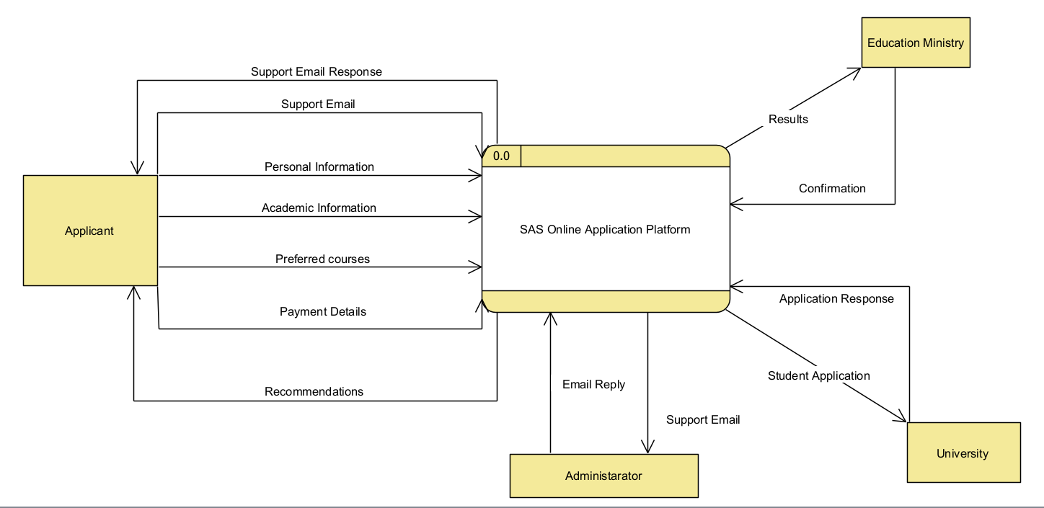

* 1. Level 1 data flow diagram

Exploding the process in the context diagram into 8 sub-processed within the system gives birth to the level one diagram. We further broke down the system into processes which include, processing data, requesting results verification from the education ministry, sieving relevant programs, shortlisting those programs, adding customer support, processing payment, process application.

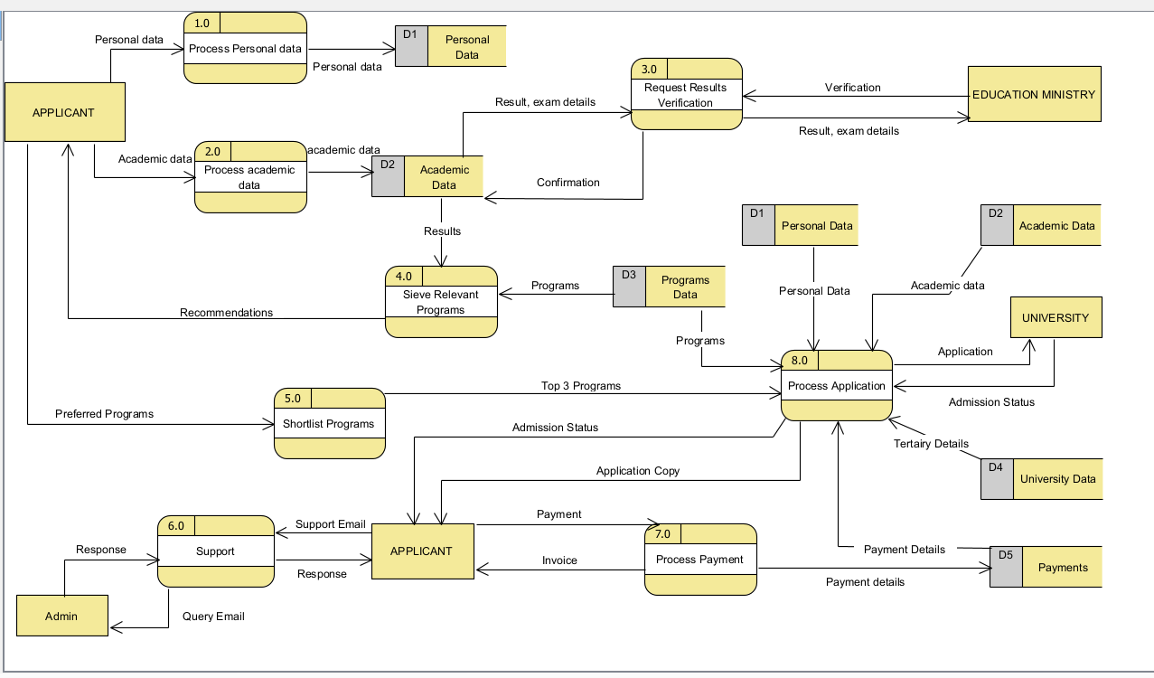

* 1. Level 2 data flow diagram

Exploding the processes can go further until all the processes in the diagram are primitive, that is, they are no longer divisible into sub-processes and as you go deeper, you tend to create as many levels of the logical dataflow diagram and it is sometimes leading to the physical dataflow diagram which has system implementation details.

It is important to note that some, if not all, of the processes can further be broken down or exploded so to create level two of the SAS data from diagram but we chose to go as further as this level. We needed to ensure that the diagram is free from technical jargons and it is a logical data flow diagram. Going further within the level could result in a physical data flow diagram which shows how the system will be implemented and almost often, the non-technical stakeholders do not understand that.

Only two processes are shown in the images below. The first process is the Process Academic Data which involves both the textual data and the scanned document of symbols or form five certificate. The two formats are handled separately and the text needs to be formatted in a way which makes it compatible with the database constraints and on the document we need to run optical character recognition to get the text on it and parse the symbols. Thereafter, we need to store the data in the data stores.

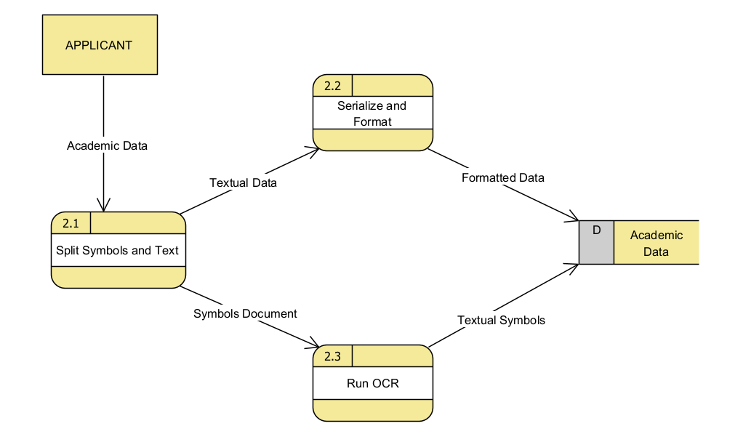

The second process which was exploded is the one for processing the application for the student and sending it to the tertiary institution they would like to apply to.

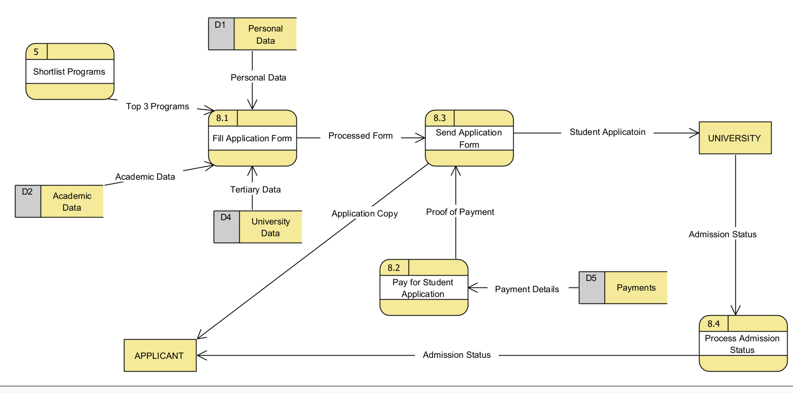

* 1. Data dictionary

--------------------

* 1. Source code submission

As advised, GitHub was used as a version control system that allowed the development team to seamlessly collaborate and track the progress of the project. There are also other services provided by this Git version control system which were used for the purpose of this project and those are GitHub issues, GitHub actions. We mainly incorporated CI/CD into the development while adhering to the SCRUM methodology principles and that necessitated the need to use GitHub issues to create backlogs and maintain changes while documenting the system features. We used a workflow to create a build pipeline which made it easy for us to run unit tests and integration testing to synchronously do system testing.

The link to the GitHub repository is [here](https://github.com/BrianMsane/mini-project.git).

GitHub repository: https://github.com/BrianMsane/mini-project.git